The Coch gene controls the subsequent differentiation
of pea axial meristems into lateral structures

Rozov, S.M.¹, Institute of Cytology and Genetics SD RAS, Novosibirsk, Russia
Voroshilova, V.A.², ²All-Russia Res. Institute for Agricultural Microbiology, St. Petersburg, Russia
Tsyganov, V.E.², Institute of Biology I, RWTH Aachen University, Aachen, Germany
Priefer, U.B.³,
Borisov, A.Y.² and
Tikhonovish, I.A.

The coch mutant is well known from Wellensiek (1) and Marx (2) initial studies and for many years it
was considered to affect only stipules and flowers of pea plants. The coch phenotype is characterized with
strongly reduced, sometimes filimorpha stipules. In some cases, particularly in the middle nodes of the
plant, stipules can transform into small additional, adventitious leaves with leaflets and tendrils. The
flowers of the coch mutants have numerous abnormalities, such as additional vexillum and wings instead
of keel petals, an irregular number of stamens and low fertility due to abnormal opening of flowers (1, 2,
3).

In the last ten years it has been established that the compound leaf of pea forms as a result of interactions
within a pool of homeiotic genes including Uni, Coch, Tl and Af. Interactions of genes Uni and Coch
determine stipule formation, whereas interactions of Uni, Tl, and Af determine the formation of leaflets
and tendrils (4). In addition, Coch is strongly involved in flower morphogenesis (unlike genes Tl and Af),
affecting the shape and number of its elements (4, 5). All these data indicate that Coch could be one of the
key factors in the formation of meristems of numerous organs and tissues of the plant, maybe not only
pea, but in other Fabaceae as well. In addition, we found that coch had strictly visible effects on the pea
root nodule meristem development and differentiation (6). The effects of the coch mutation on root
nodule development have been confirmed by Ferguson and Reid (7).

In earlier research we found three new EMS and y-ray induced mutants. Two of them showed a
phenotype similar to coch — SGE239 (EMS) and SGR856 (y-ray) (6,8,9), and one displayed a phenotype
resembling het (heterophyllus) — SGE624 (9). The SGE624 mutant phenotype was characterized by
stipules that were less strongly narrowed than in coch, but varied in shape and nearly normal flower
formation. A number of allelic tests performed between these mutants and classic coch-lines NGB1743
(Nordic Gene Bank) and Wt11745, Wt11303 (Wiatrowo) revealed that all three new mutants are alleles
of coch (9). SGE624 appeared to carry a weak coch allele — coch²
^{het} (9).

Root systems of the above mutants and standard coch lines were in general visually normal. All mutants
formed active nitrogen-fixing nodules evidenced by pink coloration due to leghemoglobin synthesis. In
contrast to the wild-type, small well-developed roots were formed at the tips of the mutant nodules.
Only SGE624 (coch^{het}) did not produce this root-like structure, or produced only a few of them.

EMS-induced coch mutant line SGE239 was selected for further study because it had relatively good
fertility and decreased plant size. A portion of the root system and an individual nodule of both SGE239
and ancestor line SGE is shown in Figure 1. It seems clear, that the coch mutant nodules produce
additional rootlets. These rootlets develop from the nodular lateral meristem that forms a heavy root-
tissue layer around the nodule. It was presumed that these abnormal nodules were able to fix nitrogen
normally because the mutant plants did not show any signs of nitrogen starvation.
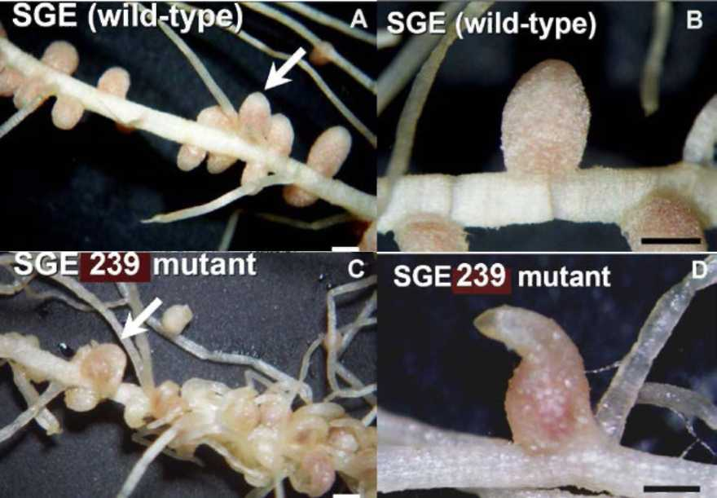
The stage at which nodules in the SGE239 mutant were transformed to a rootlet was identified by
Figure 1. The root nitrogen-fixing nodules of mutant coch line SGE239 (C,D) and SGE ancestor line (A, B).
microscopic analysis. It was found that early stages of root nodule development in the mutant were
similar to the parental line SGE.

Both wild type and mutant plants show the normal process of root hair curling, infection thread growth,
nodule induction and primordium formation. Then similarly in both lines the infection thread penetrates
nodule primordium, bacteria endocytosed into plant cell cytoplasm and immature nodular circular
meristem is differentiated at the distal end of the nodule primordium. The meristem of mature
indeterminate nodules is formed from one part of the circular meristem at the next stage of wild-type
nodule development. But at the same time in SGE239 nodules a root meristem is developed from the part
of nodular immature circle meristem at the distal end of young nodules. At a later stage, root growth in
the mutant is observed at the tip of the nodule and the vascular system of this rootlet is connected to one
of the vascular bundles of the nodule (Fig. 2). Thus, the pea gene Coch acts at the stage of mature
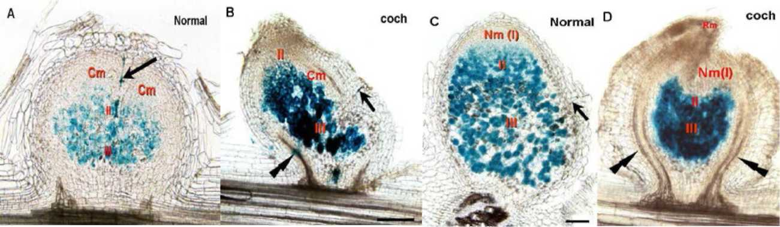
indeterminate nodule meristem development, specifying nodule or root meristem identity.
Figure 2. Two late stages ofpeea root nodule formation. A,C — ancestor line SGE; B,D — coch mutant line SGE239. Arrows indicate the infection threads; Double arrows specify the formingroot vascular system. Cm — immature circular nodular meristem; Nm (I) — mature nodular meristem; II—infection (endocytosis) zone; III—nitrogen-fixation zone; Rm — rootlet meristem.
SGE239 mutant plants formed elliptical or spatulate stipules (Fig. 3A). These stipules resembled simple
leaves with petiole and one leaf blade. Mismatched stipule pairs were also observed. For example,
stipules of the same pair could be different in size or only one stipule was developed. Nevertheless, it is
well known that some mutant alleles of coch can transform stipules into additional lateral compound
leaves (1, 2, 4), as shown on Fig. 3C (4).
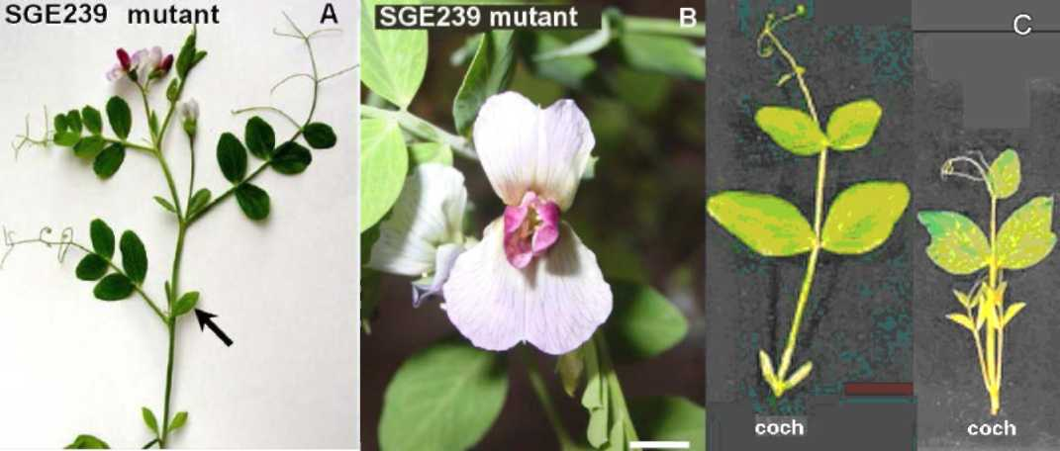
Figure 3. Stipules and flower of coch mutants. A — SGE239plant. Arrow indicates reduced stipules. B — Double-vexillum opened flower ofline SGE239. C — Pea compound leaves with coch variegatedphenotype: with reduced stipules (left) and additionally formed lateral compound leaves (right) (figure from Yaxley et al. 20001 (4)).

SGE239 mutant flowers are open and the pistil and stamens are not hidden by the two fused keel petals
which are free and frequently transformed into extra vexillum or wing structures. The general number of
petals is often increased and they are of variable shape. The double-vexillum opened flower of SGE-239 is
shown on Figure 3B. Stamen number is also frequently increased and their bases are not fused into a tube.
Usually one carpel is observed in mutant flowers but bicarpellum flowers were also found. Flowers are
partially sterile due to the opened-flower type and mutant plants have more lateral branches in
comparison with the wild type.

Thus, it was found that development of stipules, flowers and nodules are impaired in the SGE239 mutant
line which is typical for all coch mutants.

According to Gourlay et al. (10), Coch acts in the course of compound pea leaf development at the stage of
stipule meristem formation determining its fate to be a stipule meristem. This apparently gives evidence
of a common mechanism of the Coch gene action to determine the fate of meristems during formation of
various pea organs.

The current model of the formation of compound pea leaf (11) considers the gene Uni as a key gene in
determination of meristems of lateral structures of a compound leaf. According to this model Uni, alone
or in interaction with other genetic factors, "tries" to transform any indeterminate meristem of the leaf
primordium into the rachis meristem, i.e. converting the leaflet meristem to the one producing a shoot-
like structure. Expression of the genes Tl and Af in the corresponding lateral meristems of the leaf leads to
inhibition of Uni action and determines their fate to be meristems of leaflets and tendrils. Coch also
inhibits the effect of Uni at the base of the leaf that leads to the isolation of the future stipule meristems
from partly undifferentiated cells of rachis meristems and to its differentiation into the stipule meristem.

In coch mutants a prolonged expression of Uni in the stipule primordia leads to the situation where the
stipule meristem does not differentiate at a time and retains its original predetermination to be a leaf

PISUM GENETICS
2011-VOLUME 43
RESEARCH PAPERS

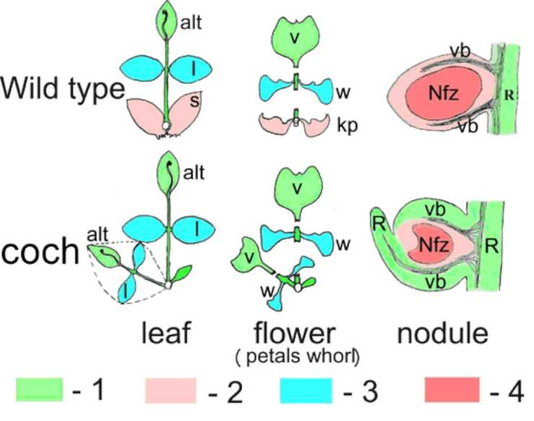
Figure 4. Effects of mutation in the Coch locus on various lateral meristem
determination. 1 — organs with basic axial Coch-independent meristem
determination; 2 — lateral organs with Coch meristem determination;
3 —lateral organs with meristem determination by other homeioticgenes;
4—nodule nitrogen-fixation zone. alt — apical leaflet of tendril; l—leaflet;
s — stipule; v — vexillum; w — wings; kp — keel petal; R — rootlet; vb —
vascular bundles; Nfz — nitrogen-fixation zone.

rachis. As a result, depending on the
duration of elevated expression of
Uni, either a simple leaf (short
action) or a lateral compound leaf
(long action) are formed instead of a
stipule. Thus, the coch mutation
deprives the corresponding
meristem of the ability to further
differentiate and its development
progresses toward basic axial
differentiation.

During compound leaf formation in
coch mutants the lateral meristem at
the base of future leaves loses the
ability to differentiate into stipules,
but maintains basic differentiation
of the compound leaf rachis, and as a
result an adventitious lateral
compound leaf is formed (Fig. 4).

We do not know what meristematic
factor is inhibited by Coch during the
flower corolla and root nodule
formation, but taking into account that the meristem-determination mechanism is highly conserved (12),
we may conclude that if this is not Uni, it is a close homolog. Obviously, one of the external circles of the
flower, the corolla, can be considered as a separate shoot. If the lateral meristem located at the base of the
axis of this shoot loses its ability to differentiate into the keel petals in coch mutants it differentiates in a
basic shoot-corolla way and as a result the coch plants fail to develop true keel petals, but have additional
slightly differentiated wing-like petals and sometimes a second additional vexillum (Fig. 4).

During symbiotic root nodule formation in coch mutants the lateral part of its circular meristem
apparently loses the ability to differentiate into nodule tissues leading to its reversion to root type. As a
result, the lateral (cortical) part of the nodule gets thicker, total nitrogen fixation zone is reduced and a
part of nodule meristem produces roots instead of nodule tissues (Fig. 4).

It is assumed that mechanisms of formation of various plant meristems are highly conserved (12). The
genes controlling meristem formation and functioning could be recruited in evolution to control pea
compound leaf and root nodule meristem formation and functioning. Therefore, genetic studies of legume
compound leaf and nodule formation can be important not only for understanding the morphogenesis of
organs specific to the Fabaceae family, but also for understanding the basic mechanisms of plant
development.
References
1. Wellensiek, S.J. 1962. Genetica (Netherlands) 33:145-153.
2. Marx, G.A. 1969. Pisum News Letter 1:20-21.
3. Blixt, S. 1972. Agri Hort. Genet. 30:1-293.
4. Yaxley J. L., Jablonski W. and Reid J. B. 2001. Ann Bot. 88:225-234.
5. Kumar S., Sharma V., Chaudhary S., Kumari R., Kumari N. and Mishra P. 2011. J. of Genet.
90:309-314.
6. Voroshilova V.A., Tsyganov V.E., Rozov S.M., Priefer U.B., Borisov A.Y. and Tikhonovich, I.A.
2004. In: Biology of Plant-Microbe Interactions, 4, Molecular Plant-Microbe Interactions: New
Bridges Between Past and Future. Edited by Tikhonovich, I., Lugtenberg, B. and Provorov, N.
pp. 376-379. International Society for Molecular Plant-Microbe Interactions, St Paul, MN, USA.

7. Ferguson B.J. and Reid J. 2005. Plant Cell Physiol. 46:1583-1589.
8. Gorel F.L., Rozov S.M. and Berdnikov V.A. Pisum Genetics 30:9-11.
9. Rozov S.M., Gorel F.L. and Berdnikov V.A. Pisum Genetics 24:82.
10. Gourlay C.W., Hofer J.M.I. and Ellis T.H.N. 2000. The Plant Cell 12:1279-1294.
11. Hofer J.M.I. and Ellis T.H.N. 1998. Trends in Plant Science 3: 439-444.
12. Ezhova T.A. 2007. Russian Journal of Developmental Biology 38:363-373.

