Registration of JI 3564 'Karl's Longpod' a Heritage Pea

variety into the John Innes Pisum Collection

Mike Ambrose John Innes Centre, Norwich, UK

In July 2010 correspondence and seeds of a heritage vegetable pea from a Mr. Karl Andrews of Lowestoft
in Suffolk was received with a note to say that the line had been handed down to him by his Uncle Albert
who was a keen lifelong amateur vegetable allotment grower (1920's to the late 1980's). Advice passed on
by Uncle Albert was that "They are best grown from the 3rd week of March onwards" and "to allow
plenty of air to circulate to avoid mildew". Mr. Andrews still grows this line every year in his garden (Fig.
1a) and finds the peas to be "Very tender and sweet and produce a very good crop of big peas in most
years".
Figure I. a. Karl Andrew standing next to plants of his 'Longpod' peas. b. mature pods.
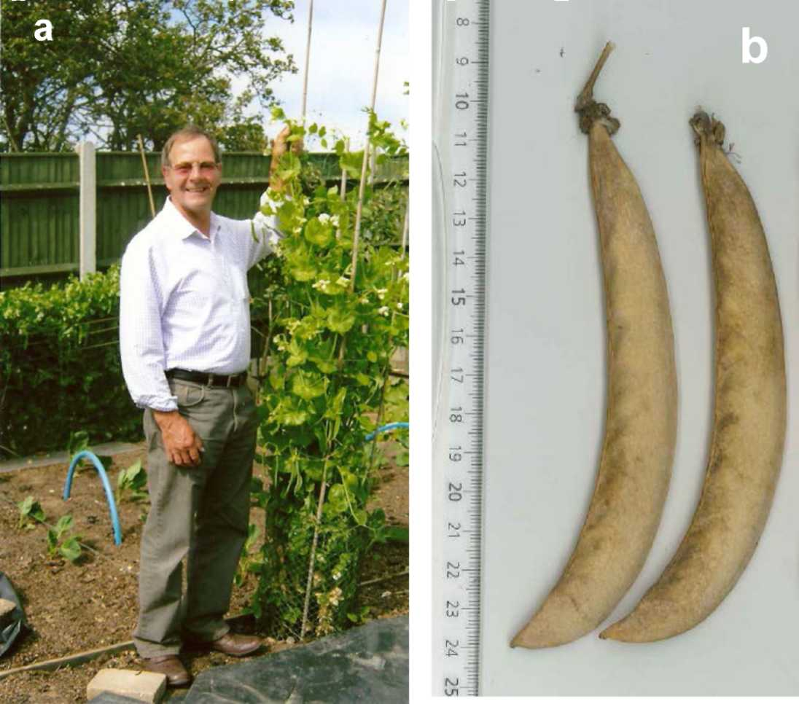

The variety is a long vined main crop picking variety best suited for growing up a support. Seed of this
line were grown out against wire and data recorded on a full range of morphological traits, the primary
plant characteristics of which are summarised in Table 1. No direct or close match was found between
this line and any other within the JI Pisum collection so its origin could not be established. Uncle Albert
was reputed to "Never have bought seed and was much more likely to have obtained it from another

BRIEF COMMUNICATION
2011-VOLUME 43
PISUM GENETICS

gardener." The exact nature of this line cannot be established without comparing to a much broader
range of comparable material which is not currently possible.

Table 1. Plant characteristics of JI3564.  Internode length 150mm  Large leaflets and stipules  Nodes to flowering 14  Ht. to flowering 65cm  Final plant height. 200cm  White flower colour  1 flower per pedicel | Pod length 150mm (maximum)  Pointed pod apex  12 ovules per pod  Wrinkled and green cotyledons  Seed weight 360mg  Susceptible to powdery and downey mildew

The most notable characteristic of the line is the consistent production of very long pods (Fig1. b). The
longest pod (150mm) sets a new maxima for pod length in the JI collection of any wrinkled seeded line.
The next longest are those of Hurst Greenshaft (JI 430) at 120mm which received a Royal Horticultural
Society Award of Gardening Merit (AGM) in 1993 and is still marketed by numerous seed companies
today. In a plot of pod length versus pod width this line clearly stands out as an outlier within normal
podded types (Fig. 2).

Figure 2. Pod width versus pood length for 886 accessions of normal pod types (none inflated or mangetout). JI 3564 is the data point highlighted as pale on the extreme right hand side.
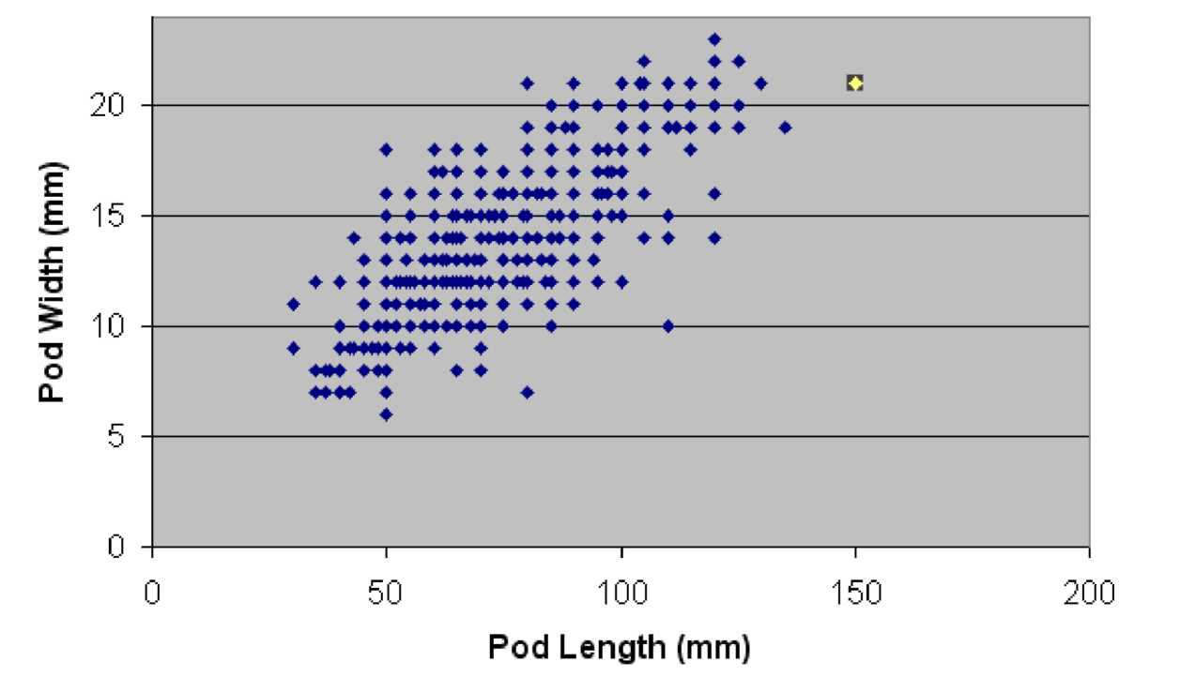

On the basis of its outlier status for pod length the line has been registered into the JI Pisum collection as
JI 3564 as a heritage variety and given the name 'Karl's Longpod' and is available on request.

4

