Can we reconstruct the most ancient words for pea (Pisum

sativum)?

Mikic, A. Institute of Field and Vegetable Crops, Novi Sad, Serbia

Introduction
Pea (Pisum sativum L.) primarily originated in the Near East and subsequently diversified in the
Mediterranean and Ethiopia (1). The ancestors of modern humans came in touch with pea and other
grain legumes and cereals in the earliest stages of their colonization of Eurasia, taking place between
69,000 and 59,000 years ago via Sinai (2). The fossilized starch grains in calculus of the skeletons from
Shanidar Cave in Iraq show that Neanderthals cooked both cereals and grain legumes such as pea,
chickpea (Cicer arietinum L.) and lentil (Lens culinaris Medik.) about 46,000 years ago (3). The diets of
European Homo sapiens hunter-gatherers during the last Ice Age were dominated mostly by lentil and
bitter vetch (Viciaervilia (L.) Willd.), as witnessed by the remains from Franchthi cave in Greece, from
11,000 BC (4), and the eastern coast of Spain, nearly 12,000 years ago (5). Pea is also one of the first
cultivated crops in the Old World (6), with archaeological findings from present Syria dating back more
than 10,000 years (7). The domestication of pea, lentil, bitter vetch, chickpea and faba bean (Viciafaba L.)
could even predate cereals with firm evidence still missing (8).

A rather complex relationship between human genetics, ethnology and linguistics has already been
attested (9). It was also demonstrated that a combined lexicological and etymological analysis may
explain the paths of crop domestication, together with genomic and archaeobotanical approaches (10, 11).
The first farmers in the Fertile crescent descended from those who left Africa in the first wave of
migration. It is still extremely uncertain how their ancestors diversified during their long voyage from
Africa to Eurasia, as well as if all their descendents managed to survive the last Ice Age. There are theories
that it is possible that at least one of these groups was given this unique opportunity. In that way, what
is designed as Borean could be the hypothetical language of this group of humans surviving the Last
Glacial Maximum from 18,000 to15,000 years BC, welcoming the Upper Paleolithic between 17,000 and
15,000 years BC (12, 13) and subsequently developing into both Eurasian Palaeolithic hunter-gatherers
and Near East Neolithic proto-farmers.

Since the speakers of the hypothetical Borean language are thought to be the progenitors of those who
domesticated the first plants and animals, this essay aims to assess the possibility of reconstructing the
Borean word or words denoting pea or other closely related grain legume crops.

Materials and methods
This palaeolinguistic venture by one plant scientist was carried out in several stages. The first step was to
search all available printed and electronic etymological resources for the words denoting pea and its
closest agronomic and botanical relatives, namely lentil, bitter vetch, chickpea or faba bean, in both
recognized and controversial language families. This step was essentially assisted by the electronic
etymological databases of the Evolution of Human Language project (14).

In the second stage, all the collected roots related to pea and other ancient Eurasian grain legumes were
linked together on the scale of two suspected language megafamilies stemming directly from Borean (12,
15, 16). The first Borean-descending megafamily is Nostratic, comprising Indo-European, Uralic, Altaic,
Kartvelian, Dravidian, Paleosiberian and Afroasiatic families (17, 18) and with a single ultimate ancestor
called Proto-Nostratic (19). Another one is Dene-Daic (15, 20), consisting of Dene-Caucasian and Austric
superfamilies (Figure 1).

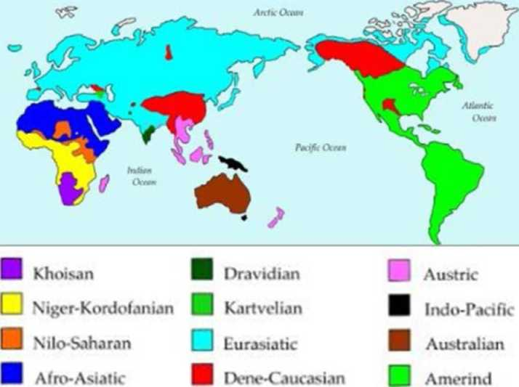
The third and the final stage of this
Figure L Widely recognized language families of the world (74): Eurasiatic
comprises Indo-European, Uralic, Altaic and Paleosiberian.
study was to examine the
possibility of the existence of the
Borean roots (13) related to either
pea or other ancient Eurasian grain
legumes.

The families comprising languages
of humans who never left Africa,
namely Khoisan, Niger-
Kordofanian and Nilo-saharan,
and who left it in another
migration, such as indo-Pacific,
Australian and Amerind, were not
the subject of this research.

Results
Indo-European. The diversity of the words denoting pea in modern Indo-European languages reveals
several Proto-Indo-European roots related to pea and leguminous plants in general (21). Those in the
majority of the modern Romance and Celtic languages, as well as in modern English, owe their origin
primarily to the Latin pisum, denoting pea, and ultimately to the Proto-Indo-European *pis-, meaning to
thresh (22, 23). The words denoting pea in most of the modern Germanic languages originated from the
Proto-Germanic *arwait, denoting the same (23). Together with the Latin ervum, denoting bitter vetch,
this Proto-Germanic root was a development of the Proto-Indo-European *er9g^{w}(h)-, denoting a kernel of
leguminous plant (34, 49). All modern Slavic languages have the origin of their words denoting pea
directly in the Proto-Slavic *gorxu, denoting the same (24), and genuinely in the Proto-Indo-European
*ghArs-, denoting a leguminous plant (22, 23). The words denoting pea in the modern Baltic languages are
derived from the Proto-Baltic *zirn-ia, with the same meaning, and ultimately from the Proto-Indo-
European *g^{e}r(a)n-, denoting grain (22, 23). The extinct Old Prussian and Old Indian reveal the Proto-
Indo-European root *kek-, denoting primarily pea (22, 23). This root began to denote chickpea in Latin
and Armenian (24).

Other' Nostraticfamilies. There is no attested Proto-Uralic root directly associated with pea (25). However,
the modern Uralic languages, spoken rather close to the supposed Uralic homeland in west Siberia (26),
have their own and non-borrowed words denoting pea. They reveal the potential Proto-Uralic root,
identical or similar to *kaca, denoting either a hole or cavity or a wooden vessel (25). The existing
compendium of the words denoting pea in modern Altaic languages owes its origin to the Proto-Altaic
*bukrV, denoting pea, nut and cone (27). No Proto-Kartvelian root associated with pea has been
identified yet (28). On the other hand, there is a Proto-Dravidian root *parup denoting pea, pigeon pea
(Cajanus cajan (L.) and other traditional grain legumes (29). There is also only one Proto-Afroasiatic root
directly related to pea, *lay/w- ~, *?Vll- ~, *w/yVlal- (30).

Dene-Caucasian. There are two proto-roots denoting grain legumes in the Dene-Caucasian macrofamily
(31). One of them is *hVwlV, denoting faba bean and evolving into the Proto-Caucasian *hdwl[a], where it
denotes both bean and lentil (32), and the Proto-Basque *ilhar~ denoting faba bean, pea or vetch (33).
Another Proto- Dene-Caucasian root is *xqor?a (~-r/i-), denoting a cereal and producing the Proto-
Caucasian *qor?a (~-rh-) where it denotes pea (32), the Proto-Sino-Tibetan *kra (~g-), denoting a kind of
grain (34) and the Common Burushaski *yarqs, denoting pea (35). No root directly associated to pea or
other grain legumes was found in Proto-Yenisseian (36).

Austric. There are no attested Proto-Austric roots related to pea, but there are two roots denoting grain
legumes, *Pbaj and *tVk (37).

Discussion
Nostratic. The Proto-Nostratic language is considered to have split into Proto-Indo-European, Proto-
Uralic and Proto-Altaic by 5000 BC (19, 38). This may give a solid basis to search for the common roots
related to pea within these three groups (17, 18). The Indo-European family is by far the most studied and
the most reconstructed of all within the supposed Nostratic macrofamily. The attested richness of the
words denoting pea and other ancient Eurasian grain legumes witness a rather high level of the
agricultural knowledge of the speakers of Proto-Indo-European (24) in their original homeland in the
Pontic-Caspian steppe (39). This agrees well with the recent archaeological evidence that the Proto-
Indo-European society was largely based upon agriculture (40), unlike some initial views as dominantly
pastoral (41). The Proto-Indo-European *kek- and the Proto-Uralic *kaca could be the descendants of the
single Proto-Eurasiatic root, with the latter being a memory of the times before the Proto-Uralic speakers
inhabited the eastern slopes of the Urals and gradually give up agriculture in favor of fishing and hunting.
still there are no attested corresponding words in other Nostratic families. However, there are certain
roots morphologically similar with these two in Proto-Indo-European and Proto-Uralic. They are the
Proto-Altaic *k[a]p~a, denoting the act of covering or a sack (27) and the Proto-Kartvelian *kwrim-,
denoting a kind of millet, and *kaka, related to grain, fruit stone or walnut (28). There is also an attested
Proto-Nostratic root *kVSV, denoting nut or acorn (42). All these roots have an obviously descriptive
character and once could refer to pea and other grain legumes as well.

Dene-Daic. The Proto-Dene-Caucasian root related to pea, *xqdr?a (~-rh-), has more numerous descendants
related to pea as compared to another, *KVwlV, related to pea only in Basque. It is noteworthy there are at
least two additional Proto-Dene-Caucasian roots denoting cultivated crops and with a similar
morphological development as two described above. These are *Gul?e (~ *xG-), denoting a kind of cereal,
and *xq(w)VrV, denoting both a kind of weed and cereal (43).

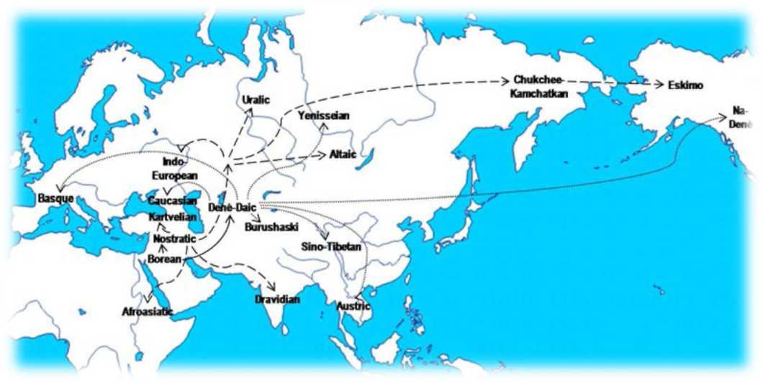
Borean.
Figure 2. Map of the hypothetical evolution of Borean (solid lines) into Nostratic (dashed lines) and Dene-Daic (dotted lines) languages (16).
According to one
of the most
developed
models (16),
Borean split
primarily into
Nostratic and
Dene-Daic
branches, with
the former
comprising
Eurasiatic and
Afroasiatic
groups and the
latter consisting
of Dene-
Caucasian and
Austric groups
(Figure 2).

RESEARCH PAPERS
PISUM GENETICS
2011-VOLUME 43

The Dene-Daic group was the first to separate from Borean, soon afterward dividing into Dene-Caucasian
and Austric branches. Many see Dene-Caucasian as a group of remains of the older Paleolithic
inhabitants of Eurasia that in many cases, such as the speakers of Basque, Caucasian and Burushaski,
retreated to isolated pockets difficult to access and, therefore, easy to defend, remaining surrounded by
the Nostratic proto-farmers coming from the Near East (44). In comparison to Nostratic, Dene-
Caucasian is supported by weaker and less clear evidence, indicating that the geographic spread of Dene-
Daic did occur before that of Nostratic (45). Recent genetic research shows that the Basque people have
the most ancestral phylogeny in Europe based on the rare mitochondrial subhaplogroup U8a, placing
their origin in the Upper Paleolithic and in West Asia (46). The second of two expansion periods from
Central Europe occurred around 15,000-10,000 years ago (46). This could suggest that the starting point
of the internal differentiation of the Dene-Daic macrofamily truly was in West-Central Asia.

On the other hand, the Borean-speakers remaining in the Near East could be direct precursors of the
Nostratic-speakers, with the original homeland within the Fertile Crescent. Their evolution is
represented by the Kebaran (18,000-10,500 BC) and the Zarzian cultures (12,400-8500 BC), with the
broad spectrum revolution associated with microliths, the use of the bow and arrow and the
domestication of the dog (47). At the end of the Last Ice Age, the speakers of Nostratic continued to
develop their material culture and definitely invented agriculture and animal husbandry. Proto-Nostratic
could be spoken in Epipaleolithic, between 15,000 and 12,000 BC, and started to differentiate by 8000
BC. It covered the entire Fertile Crescent and beyond to Egypt and along the Red sea to the Horn of
Africa, bringing forth Proto-Afroasiatic (19). It spread into the Caucasus, producing Proto-Kartvelian, the
Iranian Plateau, evolving into Proto-Elamo-Dravidian, and into Central Asia, where Proto-Eurasiatic
further subdivided by 5000 BCE into Proto-Indo-European, Proto-Uralic and Proto-Altaic (19).

These results show that the words related to pea or other related ancient Eurasian grain legume crops are
more or less satisfactorily attested in a few direct or indirect descendants of Borean. If we apply the
identification of easily recognizable similarities as the very first step in any kind of comparative
linguistics (48), is it feasible to connect the Proto-Indo-European *kek-, the Proto-Uralic *kaca and the
Proto-Dene-Caucasian *xapr?a (~-rh-). Could they be related to each other or is it a pure coincidence or a
simple borrowing from each other? It is true that the roots for many crops were developed from either
verbs or adjectives they had been very closely associated with (49, 50). There are two examples of the
reconstructed Borean roots that are morphologically similar to what one may expect the Borean root
denoting pea looked like. These are *KVCV (Figure 3) and *KVNKV (Figure 4), with a hypothetical
evolution developed in most of their direct and indirect languages. Are these two roots related to the
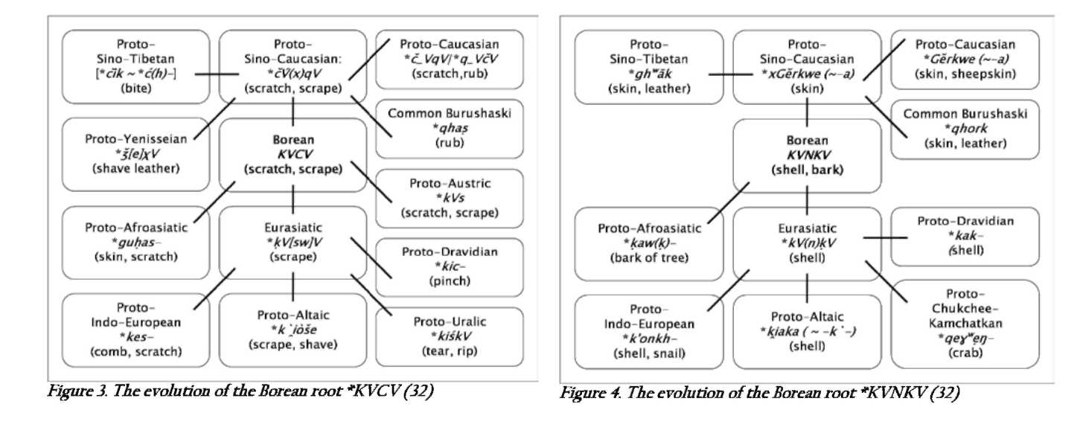

9

hypothetical and non-attested root related to pea in any way, regardless if the pea pods were simply
gathered from wild flora or cultivated? Could it be that the verbs to scratch and to scrape were somehow
associated with the very action of shelling pea seeds out of its pods? Also, could the nouns shell and bark
refer to shell-like and skinny pea pods containing precious grains? This issue will surely remain open
until a more detailed historical linguistic analysis is carried out. It is to be anticipated that its outcome
could bring a root or the roots that were not necessarily associated with solely one species such as pea.
Pea, lentil, chickpea and bitter vetch were surely easily recognizable for their shell-like and skinny pods
with grains eaten cooked. In that way, this essay could equally assess the possibility of reconstructing
the most ancient words not only for pea, but also for lentil, chickpea or bitter vetch: in the end, all of
them could easily be considered very similar to each other or even identical in the everyday life of the
ancient hunter-gatherers or proto-farmers of Eurasia.

Conclusions
Evidence of the use of pea in the diets of both Neanderthals and modern humans is confirmed with new
findings. If the speakers of the Proto-Dene-Daic dominated Eurasia during the last stages of the
Paleolithic, pea and other related ancient grain legumes were well known to them from wild flora, as they
gathered them with cereals. On the other hand, speakers of the Proto-Nostratic, the first farmers of the
Old World, domesticated pea together with other grain legumes and cereals. The existing linguistic
thesaurus related to pea and other grain legumes in the descendants of the hypothetical Borean is rather
rich and surely deserves more attention. A solid and deep reconstruction of the Borean words for pea and
related grain legumes should be carried out, as it has been successfully done for other numerous everyday
terms. such linguistic attempts could assist in learning much more on the use of pea and other basic food
crops by our ancestors and the individual steps in their domestication. This modest attempt represents
an invitation to all those interested in crop history, namely archaeologists, archaeobotanists, plant
scientists and linguists, to work together and develop multidisciplinary approaches offering answers to
the issues related to the very dawn of mankind.

Acknowledgements
This research is a part of the projects TR-31024 of the Ministry of Education and Science and the
SEELEGUMES within the EU programme SEE-ERA.NET Plus under the auspices of the EU Seventh
Framework Programme (FP7).

To all the readers of Pisum Genetics, with deepest respect.

In memory of A.B. Popovic, V.R. Duric and S.A. Starostin.

References
1. Zeven, A.C. and Zhukovsky, P.M. 1975. Dictionary of Cultivated Plants and Their Centres of
Diversity. Centre for Agricultural Publishing and Documentation, Wageningen, pp. 219.
2. Maca-Meyer, N., Gonzalez, A.M., Larruga, J.M., Flores, C. and Cabrera, V.M. 2001. BMC
Genomics 2: 13.
3. Henry, A.G., Brooks, A.S. and Piperno, D.R. 2011. Proceedings of the National Academy of
sciences of the United states of America 108: 486-491.
4. Farrand, W.R. 1999. Depositional History of Franchthi Cave. Indiana University Press,
Bloomington, pp. 528.
5. Aura, J.E., Carrion, Y., Estrelles, E. and Perez Jorda, G. 2005. Vegetation History and
Archaeobotany 14: 542-550.
6. Zohary, D. and Hopf, M. 2000. Domestication of Plants in the Old World: The Origin and Spread
of Cultivated Plants in West Asia, Europe and the Nile Valley. Oxford University Press, Oxford,
pp. 316.
7. Tanno, K. and Willcox, G. 2006. Vegetation History and Archaeobotany 15: 197-204.
8. Kislev, M.E. and Bar-Yosef, O. 1988. Current Anthropology 29: 175-179.
9. Cavalli-Sforza, L.L. and Seielstad, M. (2001) Genes, Peoples and Languages. Penguin Press,
London, pp. 227.
10. Diamond, J. and Bellwood, P. 2003. Science 300: 597-603.
11. Mikic, A., Medovic, A., Cupina, B., Mihailovic, V., Ignjatovic-Cupina, A., Dordevic, V. and
Kobiljski, B. 2011. Nature Precedings doi:10.1038/npre.2011.5837.1.
12. Gell-Mann, M., Peiros, I. and Starostin, G. 2009. Journal of Language Relationship 1: 13- 30.
13. starostin, s. 2006. Long-range etymologies. The Tower of Babel. http://starling.rinet.ru/cgi-
bin/query.cgi?root=config&morpho=0&basename=\data\eura\globet.
14. Evolution of Human Languages. 2005. An International Project on the Linguistic Prehistory of
Humanity coordinated by the Santa Fe Institute. http://ehl.santafe.edu/.
15. Fleming, H.C. 1991. Mother Tongue. Newsletter V: 14.
16. starostin, s. 2006. Borean Tree Diagram. The Tower of Babel.
http://starling.rinet.ru/images/globet.png.
17. Greenberg, J. 2000. Indo-European and its Closest Relatives. The Eurasiatic Language Family.
Grammar. Stanford University, Palo Alto, pp. 326.
18. Greenberg, J. 2002. Indo-European and its Closest Relatives. The Eurasiatic Language Family.
Lexicon. Stanford University, Palo Alto, pp. 216.
19. Bomhard, A.R. 2008. Reconstructing Proto-Nostratic: Comparative Phonology, Morphology, and
Vocabulary. Brill, Leiden, pp. 976.
20. Ruhlen, M. 2011. Language Families of the World (after Greenberg).
http://www.merrittruhlen.com merritt at merrittruhlen.com
21. Mikic, A. 2009. Pisum Genetics 41: 29-33.
22. Nikolayev, S. 2007. Indo-European etymology. The Tower of Babel. http://starling.rinet.ru/cgi-
bin/query.cgi?root=config&morpho=0&basename=\data\ie\piet.
23. Pokorny, J. 1959. Indogermanisches etymologisches Worterbuch. Francke, Bern.
24. Mikic, A. 2011. Indogermanische Forschungen 116: 60-71.
25. Starostin, S. 2005. Uralic etymology. The Tower of Babel. http://starling.rinet.ru/cgi-
bin/query.cgi?root=config&morpho=0&basename=\data\uralic\uralet.
26. Janhunen, J. 2009. Memoires de la Societe Finno-Ougrienne 258: 57-78.
27. Starostin, S. 2006. Altaic etymology. The Tower of Babel. http://starling.rinet.ru/cgi-
bin/query.cgi?root=config&morpho=0&basename=\data\alt\altet.
28. Starostin, S. 2005. Kartvelian etymology. The Tower of Babel. http://starling.rinet.ru/cgi-
bin/query.cgi?root=config&morpho=0&basename=\data\kart\kartet.
29. Starostin, G. 2006. Dravidian etymology. The Tower of Babel. http://starling.rinet.ru/cgi-
bin/query.cgi?root=config&morpho=0&basename=\data\drav\dravet.
30. Militarev, A. and Stolbova, O. 2007. Afroasiatic etymology. The Tower of Babel.
http:/ / starling.rinet. ru/cgi-
bin/query.cgi?root=config&morpho=0&basename=\data\semham\afaset.
31. Mikic, A. 2011. Mother Tongue XVI (in press).
32. Starostin, S. 2005. North Caucasian etymology. The Tower of Babel. http://starling.rinet.ru/cgi-
bin/query.cgi?root=config&morpho=0&basename=\data\cauc\caucet.
33. Bengtson, J. 2007. Basque etymology. The Tower of Babel. http://starling.rinet.ru/cgi-
bin/query.cgi?root=config&morpho=0&basename=\data\sinocauc\basqet.
34. Starostin, S. 2005. Sino-Tibetan etymology. The Tower of Babel. http://starling.rinet.ru/cgi-
bin/query.cgi?root=config&morpho=0&basename=\data\sintib\stibet.
35. Starostin, S. 2005. Burushaski etymology. The Tower of Babel. http://starling.rinet.ru/cgi-
bin/query.cgi?root=config&morpho=0&basename=\data\sinocauc\buruet.
36. Starostin, S. 2005. Yenisseian etymology. The Tower of Babel. http://starling.rinet.ru/cgi-
bin/query.cgi?root=config&morpho=0&basename=\data\yenisey\yenet.
37. Peiros, I. and Starostin, S. 2007. Austric etymology. The Tower of Babel.
http://starling.rinet.ru/cgi-bin/query.cgi?root=config&morpho=0&basename=\data\austr\austr.
38. Renfrew, C. 1991. Cambridge Archaeological Journal 1: 3-23.
39. Anthony, D.W. 2007. The Horse, the Wheel, and Language: How Bronze-Age Riders from the
Eurasian Steppes Shaped the Modern World. Princeton University Press, New Jersey, pp. 361.
40. Krell, K. 1998. In: Archaeology and Language, II, Routledge, London & New York, Chapter 11.
41. Gimbutas, M., Dexter, M.R. and Jones-Bley, K. 1997. The Kurgan Culture and the Indo-
Europeanization of Europe: selected articles from 1952 to 1993. Institute for the Study of Man,
Washington, pp. 404.
42. Starostin, S. 2005. Nostratic etymology. The Tower of Babel. http://starling.rinet.ru/cgi-
bin/query.cgi?root=config&morpho=0&basename=\data\nostr\nostret.
43. Starostin, S. 2007. Sino-Caucasian etymology. The Tower of Babel. http://starling.rinet.ru/cgi-
bin/query.cgi?root=config&morpho=0&basename=\data\sinocauc\sccet.
44. Ruhlen, M. 1998. Dene-Caucasian: A new linguistic family. In The Origins and Past of Modern
Humans—Towards Reconciliation, World Scientific, Singapore, pp. 231-246.
45. Ruhlen, M. 1994. The Origin of Language: Tracing the Evolution of the Mother Tongue. John
Wiley & Sons, New York, pp. 239.
46. Gonzalez, A.M., Garcia, O., Larruga, J.M. and Cabrera, V.M. 2006. BMC Genomics 7: 124.
47. Weiss, E., Wetterstrom, W., Nadel, D. and Bar-Yosef, O. 2004. Proceedings of the National
Academy of Sciences of the United States of America 101: 9551-9555.
48. Bengtson, J.D. and Ruhlen, M. 1994. In On the Origin of Languages: Studies in Linguistic
Taxonomy, Stanford University Press, Stanford, pp. 277-336.
49. Mikic-Vragolic, M., Mikic, A., Cupina, B., Mihailovic, V., Vasiljevic, S., Krstic, D. and Vasic, M.
2007. Ratarstvo i povrtarstvo / Field and Vegetable Crops Research 44: II: 91-96.
50. Mikic, A. and Stoddard, F.L. 2009. Grain Legumes 51: 34.

