Some agronomic aspects of the intercrops of semi-leafless
and normal-leafed dry pea cultivars

Antanasovic, S.¹, Mikic, A.²,
Cupina, B.¹, Krstic, D.¹,
Mihailovic, V.², Eric, P.and Milosevic, B.
University of Novi Sad, Faculty of Sciences, Novi Sad, Serbia
²
¹
²Institute of Field and Vegetable Crops, Novi Sad, Serbia

Introduction
Pea (Pisum sativum L.) is present in both wild and agricultural floras of Serbia and other Balkan countries.
The subspecies arvense is traditionally cultivated as a forage crop, while the subspecies sativum is a
widespread garden plant. During the last two decades of the last century, the first dry pea cultivars,
mostly of Canadian and Czechoslovakian origin, were introduced in the then Yugoslav, and now Serbian,
agriculture. Today, dry pea, usually known among the Serbian farmers as protein pea, is grown mostly for
feed, with an average harvested area of between 20,000 ha and 25,000 ha (1). The only institution
involved in dry pea breeding in Serbia today is the Institute of Field and Vegetable Crops in Novi Sad (2),
with nearly 20 cultivars registered in the country and a moderately large pea collection (3).

Dry pea shows good agronomic performance when used as a companion crop in the establishment of a
perennial forage legume such as red clover (4). Especially suitable are 'semi-leafless' cultivars, with all
leaflets of the compound pea leaf transformed into tendrils. There are many advantages in comparison
with normal-leafed dry pea cultivars. Among these is better penetration of sunlight into a pea stand and
all green parts of a plant are included in photosynthesis. Additionally, there is enhanced airflow and
which results in less favorable conditions for developing pea diseases and pests (5). Recently, an idea was
developed to attempt intercropping semi-leafless (af) and normal-leafed (AF) pea cultivars for both
forage and dry grain production, with a possible reduction of weeds (W) in the former and lodging in the
latter (Figure 1), resulting in better utilization of both stand area and volume.

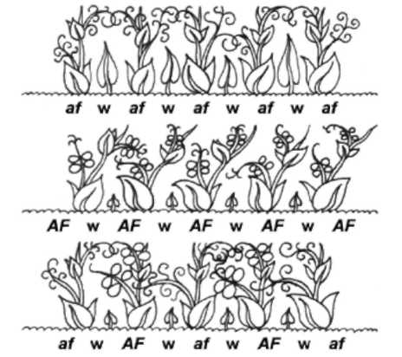
The initial objective of this research is to assess the
Figure 1. Theoretical aspects of intercropping
semi-leafless and normal-leafedpea cultivars.
agronomic performance of the intercrops of semi-leafless
and normal-leafed dry pea cultivars as affected by stand
density and their proportion in the mixture.
Materials and methods
Small-plot trials were carried out during 2010 and 2011 at
the Experimental Field of the Institute of Field and
Vegetable Crops at Rimski Sancevi, in the vicinity of Novi
Sad on a slightly carbonated chernozem soil. The trial
included three stand densities, namely 80 plants m⁻², 100
plants m⁻² and 120 plants m⁻². Within each stand density,
there were five proportions of one semi-leafless (af) : one
normal-leafed (AF) cultivars: 100% : 0%; 75% : 25%; 50% :
50%; 25 % : 75% and 0% : 100%. The semi-leafless cultivar
'Partner' and the normal-leafed cultivar 'Dukat' were both
developed at the Institute of Field and Vegetable Crops
and registered in Serbia in 2007. Both cultivars are characterized by a short vine length, on average from
45 cm to 60 cm in both. The two cultivars mature at approximately the same time and have very uniform
maturity. The size of a trial plot was 5 m², with three replicates. The weeds were controlled by the
application of 1 l ha⁻¹ an appropriate post-sowing and pre-emergence herbicide, Prometrin®. The plots
were not inoculated with rhizobia, since chernozem is rich in its strain specialized for pea. Inorganic
fertilizer containing 45 kg ha ⁻¹ of phosphorus (P) and potassium (K) each was applied in the preceding
fall.

In both trial years, all intercrops were sown in mid-March, as soon as the field conditions allowed, and
harvested during the second half of June when the seeds in the first pods had reached full maturity. Since
the determinate stem growth in both cultivars and a prominent maturing infirmity, there were no green
pods at this stage. Each plot was harvested by hand. Each cultivar was separated from the other and they
were combined separately with a Wintersteiger Nurserymaster. The grain yield of all intercrops was
measured at a seed moisture content of 14%.

The economic reliability of grain yield in each intercrop was determined by calculating the Land
Equivalent Ratio (LER) as (6):

LER = afic / afsc + AFIC / AFSC,

where af_{IC} is the grain yield of the semi-leafless cultivar in the intercrop, af_{SC} is the grain yield of the semi-
leafless cultivar in its sole crop, AF_{IC} is the grain yield of the normal-leafed cultivar in the intercrop and
AF_{SC} is the grain yield of the normal-leafed cultivar in its sole crop.

The analysis of variance (ANOVA) of the results was performed using Statistica 8.0 software. Means
were separated using Fisher's Least Significant Difference (LSD), P = 0.05, for a combined analysis of the
two sole crops and the intercrop.

Results and discussion
There were significant differences in grain yields, both between different stand densities and different
proportions of individual dry pea cultivars (Table 1). In general, both cultivars reacted positively to

Table 1. A verge values of grain yield (kg ha¹) and Land Equivalent Ratio in the intercrops of semi-leafless and
Stand density(plants m⁻²) | Treatment | GYaf | GYAF | GYIC | LER
80 | 100% af + 0% AF | 3438 | 0 | 3438 | 1.00
80 | 75% af + 25% AF | 2700 | 1050 | 3750 | 1.17
80 | 50% af + 50% AF | 2100 | 1300 | 3400 | 1.09
80 | 25% af + 75% AF | 1525 | 1675 | 3200 | 1.06
80 | 0% af + 100% AF | 0 | 2700 | 2700 | 1.00
100 | 100% af + 0% AF | 4625 | 0 | 4625 | 1.00
100 | 75% af + 25% AF | 3350 | 1225 | 4575 | 1.27
100 | 50% af + 50% AF | 2325 | 1575 | 3900 | 1.20
100 | 25% af + 75% AF | 1425 | 1788 | 3213 | 1.10
100 | 0% af + 100% AF | 0 | 2250 | 2250 | 1.00
120 | 100% af + 0% AF | 4975 | 0 | 4975 | 1.00
120 | 75% af + 25% AF | 3475 | 1275 | 4750 | 1.14
120 | 50% af + 50% AF | 2525 | 1513 | 4038 | 1.04
120 | 25% af + 75% AF | 1925 | 2113 | 4038 | 1.12
120 | 0% af + 100% AF | 0 | 2863 | 2863 | 1.00
Average | 100% af + 0% AF | 4346 | 0 | 4346 | 1.00
Average | 75% af + 25% AF | 3175 | 1183 | 4358 | 1.18
Average | 50% af + 50% AF | 2317 | 1463 | 3779 | 1.09
Average | 25% af + 75% AF | 1625 | 1858 | 3483 | 1.09
Average | 0% af + 100% AF | 0 | 2604 | 2604 | 1.00
LSD0.05 |  | 778 |  |  | 0.07

increasing their stand densities in both intercrops and their sole crops, from 80 plant m⁻ to 120 plant m⁻ .

The two-year average grain yield in the sole crops of the semi-leafless cultivar ranged from 3438 kg ha⁻¹ at
80 plants m⁻² to 4975 kg ha⁻ at 120 plants m⁻². The two-year average grain yield in the sole crops of the
normal-leafed cultivar ranged from 2250 kg ha⁻¹ at 80 plants m⁻² to 2863 kg ha⁻¹ at 120 plants m⁻². In a
two-year average, the semi-leafless cultivar had significantly higher yield than the normal-leafed cultivar.
This agrees with previous research in the same conditions (7) and may be basically explained as the
consequence of a better balance between grain yield components in comparison to those in the normal-
leafed cultivar.

In all intercrops, the semi-leafless cultivar had significantly higher proportion in the total dry grain yield
than the normal-leafed one. The averages ranged from 3175 kg ha⁻¹ to 1183 kg ha⁻¹ at 75% : 25% and from
2317 kg ha⁻¹ to 1463 kg ha⁻¹ at 50% : 50%. The normal-leafed cultivar had a higher proportion in the total
dry grain yield when planted as 75% of the intercrop (1858 kg ha⁻¹), but not significant in comparison to
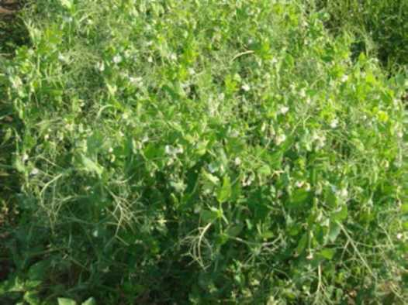
the remaining 25% of the semi-leafless cultivar (1625 kg ha⁻¹).
Figure 2. An intercrop of the serai-leafless and normal-leafed drypea cultivars at a ratio of 75%: 25% at Rimski Sancevi in 2011.

The LER values were higher than 1 in all intercrops,
regardless of the stand density and the proportion
of individual components with different leaf types.
However, the highest LER values, as affected by
crop density, were in the intercrops of 75% of the
semi-leafless and 25% of the normal-leafed
cultivars, with 1.17, 1.27 and 1.14, respectively
(Figure 2). This proportion proved economically
most reliable in average as well, with its LER value
of 1.18 significantly higher than 1.09 in both other
proportions. It is noteworthy that the intercrops of
semi-leafless and normal-leafed pea cultivars are
reliable in forage production, as documented by
another pioneer study in the same conditions (8).

These results pose opportunities for further research. These two cultivars were intentionally chosen for
intercropping due to similar growing habit and developmental stages. However, future research could
provide a more stringent evaluation of intercropping by developing F5- or F6-derived near isogenic semi-
leafless and normal-leafed varieties (9).

Conclusions
This initial study needs to be repeated over years and in diverse environments. However, this study
documents the intercropping of semi-leafless and normal-leafed dry pea cultivars as an alternative
solution for enhanced grain production in temperate regions such as serbia. Future research will target
more detailed analysis of grain yield components in the intercrops and diverse physiological parameters,
as well as numerous underground aspects such as plant-microbial interactions and nutrient dynamics.

Acknowledgements
This research is a part of the project TR-31016 of the Ministry of Education and Science of the Republic of
serbia.
References
1. Mihailovic, V., Mikic, A., Cupina, B. and Eric, P. 2005. Grain Legumes 44: 25-26.
2. Mihailovic, V., Mikic, A., Katic, S. and Karagic, D. 2009. Pisum Genetics 41: 26-28.
3. Mihailovic, V., Mikic, A., Cupina, B., Krstic, D. and Milosevic, B. 2009. Pisum Genetics 41: 44-45.
4. Cupina. B., Krstic, D., Mikic, A., Eric, P., Vuckovic, S. and Pejic, B. 2010. Turkish Journal of
Agriculture and Forestry 34: 275-283.
5. Mikic, A., Mihailovic, V., Cupina, B., Kosev, V, Warkentin, T., McPhee, K., Ambrose, M., Hofer, J.
and Ellis, N. 2011. Ratarstvo i povrtarstvo / Field and Vegetable Crops Research 48: 275-284.
6. Kadziuliene, Z., Sarunaite, L. and Deveikyte, I. 2011. Ratarstvo i povrtarstvo / Field and Vegetable
Crops Research 48: 183-188.
7. Mihailovic, V., Mikic, A., Katic, S., Karagic, D., Milosevic, B., Pataki, I. and Radojevic, V. 2009.
Plant Breeding and Seed Production 23: 51-56.
8. Cupina, B., Krstic, D., Antanasovic, S., Eric, P., Pejic, B., Mikic, A. and Mihailovic, V. 2010. Pisum
Genetics 42: 11-14.
9. Mikic, A., Cupina, B., Mihailovic, V., Krstic, D., Antanasovic, S., Dordevic, V. and Peric, V. 2011.
Book of Abstracts, EUCARPIA 29th Fodder Crops and Amenity Grasses Section Meeting.

