In situ evaluation of a Pisum sativum subsp. elatius

population from the valley of the river Pcinja in southeast Serbia

Cupina, B.¹, Zlatkovic, B.², University of Novi Sad, Field and Vegetable Crops, Novi Sad, Serbia
Smykal, P.³, Mikic, A.⁴, ²University of Nis, Department of Biology and Ecology, Nis, Serbia
Jajic, I.¹, ³Palacky University at Olomouc, Dept. of Botany, Olomouc, Czech Republic
Zeremski-Skoric, T.⁴ ⁴Institute of Field and Vegetable Crops, Novi Sad, Serbia
and Medovic, A.⁵ ⁵Museum of Vojvodina, Novi Sad, Serbia

Introduction
There is a taxon within the genus Pisum L. colloquially called elatius, commonly considered a subspecies
within common pea (P. sativum L.), namely P. sativum L. subsp. elatius (Steven ex M. Bieb.) Asch. &
Graebn. (1). In further text referred to as P. elatius, it is regarded as a direct progenitor of cultivated pea
(2), although with not satisfactorily described process of domestication yet. In a wider sense from an
ecological viewpoint, P. elatius is a Mediterranean element with native distribution in Albania, Algeria,
Azerbaijan, Bulgaria, Croatia, Cyprus, Egypt, France, FYR of Macedonia, Georgia, Greece, Iran, Israel,
Italy, Lebanon, Libya, Montenegro, Morocco, Portugal, Russia, Romania, Serbia, Spain, Syria, Tunisia,
Turkey and the Ukraine (3).

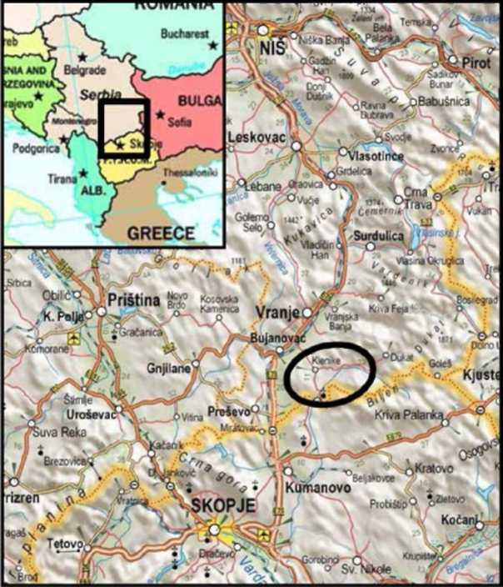
The first records on the presence of P. elatius in
Figure 1. The upper flow of the river Pcinja where P. elatius was re-discovered in 2009.
the flora of Serbia come from the second half of
nineteenth century by the father of modern
Serbian biology and ecology, Josif Pancic (4).
This species is known to be distributed in
several regions of the country and most
abundantly in the south. Also, there are
reports of a white-flowered variety (var.
albiflorum) unlike the usual violet-flowered
ones (5). However, existing information on the
distribution of P. elatius in Serbia is incomplete.
Recently, this pea taxon has been rediscovered
in the southeastmost regions of Serbia, namely
in the area of the upper Pcinja river and quite
close to the modern border between Serbia
and Former Yugoslav Republic of Macedonia
(Figure 1). In that area, P. elatius inhabits the
lower zone of northerly exposed slopes of
Mount Kozjak, on the left side of the valley,
amidst the slopes covered by termophilous
submediterranean forests and scattered scrub
vegetation on siliceous rocky soil (6).

The aim of this preliminary research was to
carry out an initial in situ evaluation of the
population of P. elatius growing in the upper
Pcinja River.
Materials and methods
Two expeditions were made in 2011 with an ultimate goal of collecting samples for a more detailed in situ
evaluation of the P. elatius population from the region of the Pcinja River (Fig. 1), with emphasis on
agronomic characteristics, such as yield components, and chemical composition, stressing the nutritive
value.
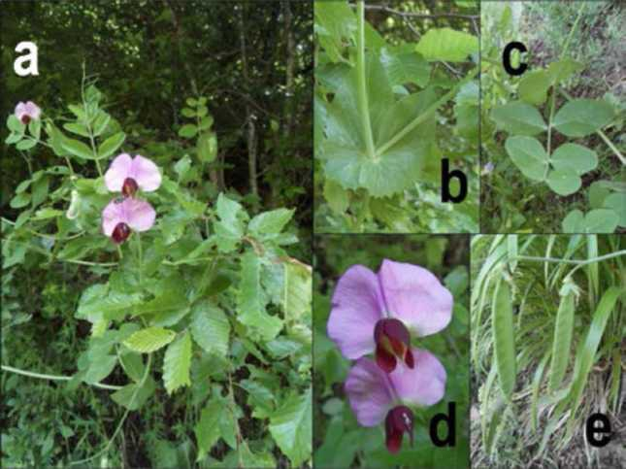
The first expedition was performed on 28
Figure 2. Some features of the P. e/atius population from the upper flow of the river Pcinja in southeast Serbia in 2011: (a) a plant climbing up a beech tree; (b) stipules; (c) leaflets; (d) flowers; (e) pods.
May 2011, targeting the same area where P.
elatius was re-discovered in 2009. A group
of several plants was found on the edge
between the foothills of the Mount Kozjak,
between the forest and the meadow in the
very vicinity of the Pcinja River and the
monastery of Saint Prohor Pcinjski from
11th century. The plants were in the full
bloom stage and forming the first pods
(Figure 2), in further text referred to as
Stage 1. Not far from this group, up the
slopes of the Mount Kozjak and amidst the
dense canopy of trees and shrubs, another
population was found in the same stage,
with plants either creeping over the rocky
ground or climbing up and hanging from
branches. By several plants growing on
inaccessible slopes between these two
groups, it may be assumed that the first group is a progeny of the second one, developing from the seeds
that gradually rolled downwards, although this must remain speculative until a comparative research of
these two populations is done with molecular markers. Fourteen plants were sampled in total from both
groups and used for the analysis of agronomic characteristics and chemical composition related to forage.

The second expedition on 25 June 2011 visited the same population of P. elatius near the Pcinja River.
Intact, both groups were in full maturity of the oldest pods, with a few pods already shattering their
seeds. This was referred to as Stage 2. The pods stood erect and followed the direction of their peduncles,
unlike the hanging ones of cultivated pea. Another set of fourteen plants was sampled from both groups
and for the analysis of agronomic characteristics and chemical composition of the seeds. At least a dozen
plants were left for regeneration of the population.

The agronomic analysis comprised determining the main yield components including (Stage 1) stem
length (cm), number of stems (plant⁻¹), stem mass (g plant⁻¹), leaf mass (g plant⁻¹), plant mass (g plant⁻¹),
stem proportion (%) and leaf proportion (%), as well as (Stage 2) stem length (cm), number of stems
(plant⁻¹), number of pods (plant⁻¹), number of grains (plant⁻¹), stem mass (g plant⁻¹), leaf mass (g plant⁻¹),
pod mass (g plant⁻¹), seed mass (g plant⁻¹), plant mass (g plant⁻¹) and harvest index.

The analysis of chemical composition at both stages comprised determining the content (g kg⁻¹) of crude
protein, crude fat, crude fiber, neutral detergent fiber (NDF), acid detergent fiber (ADF), lignin, crude
ash and nitrogen-free compounds (NFC).

The data related to the agronomic characteristics in both stages are presented as minimum, maximum
and average values. The results of the chemical composition and nutritive value in both stages were
processed using Statistica 8.0 software, with analysis of variance (ANOVA) performed and a Fisher's
Least Significant Difference (LSD) test used at P = 0.05.
Results and discussion
The analysis of agronomic characteristics of the P. elatius population that are of interest in its cultivated
relatives revealed wide variation of certain morphological traits that are also important forage yield
characteristics (Table 1). it is neither possible nor appropriate to compare these results with those
obtained in related species under field conditions, although P. elatius grew together with many other
plants, mostly grasses and legumes, such as vetches (Vicia spp.). At any rate, the average dry plant mass in
the stage of full bloom and forming the first pods may provide a basis that this pea taxon has good
potential for forage production. In addition, the leaf proportion was higher than 50%, indicating the
potential for good forage quality.

Table 1. In situ forage related characteristics of the P. elatius population from the upper Pcinja River in southeast Serbia in 2011
^{(Stagge} ^{1).} , , , L , , ,
 | Stem length  ^{(cm)} | Number of  stems (plant⁻¹) | Stem mass  ^{(g} ^{plant-1)} | Leaf mass (g  plant⁻¹) | Plant mass  ^{(g} ^{plant-1)} | Stem  proportion | Leaf  proportion
Minimum | 31 | 1 | 4.48 | 7.70 | 12.18 | 0.13 | 0.48
Maximum | 192 | 8 | 35.14 | 63.42 | 98.56 | 0.52 | 0.87
Average | 68 | 3.8 | 11.04 | 22.44 | 33.48 | 0.33 | 0.67

Average stem length and stem number did not change significantly from Stage 1 to Stage 2 (Table 2).
Average seed mass (5.60 g plant⁻¹) may be regarded as rather high, being perhaps another indicator of the
domestication level of this pea taxon. Its harvest index, the ratio between the mass of mature seeds and
the remainder of the mature and dry plant parts is also considerably high for a wild relative of a crop
plant (0.38).

Table 2. In situ seed related characteristics of the P. elatius population from the upper Pcinja River in southeast Serbia in 2011
^{(SStagge} ^{2).} , , , , , , , , , ,
Stage 2 | Stem  length  ^{(cm)} | Number of  stems  (plant⁻¹) | Number of  pods (plant⁻  ¹) | Number of  grains  (plant⁻¹) | Stem mass  (g plant⁻¹⁾ | Leaf mass  ^{(g} ^{plant-1)} | Pod mass  ^{(g} ^{plant-1)} | Grain mass  ^{(g} ^{plant-1)} | Plant mass  ^{(g} ^{plant-1)} | Harvest  index
Minimum | 52 | 1 | 2 | 12 | 2.82 | 1.28 | 0.61 | 2.46 | 7.17 | 0.34
Maximum | 168 | 7 | 11 | 74 | 14.34 | 5.25 | 2.35 | 15.71 | 37.65 | 0.42
Average | 72 | 4.1 | 4.3 | 27.3 | 5.52 | 2.38 | 1.24 | 5.60 | 14.74 | 0.38

The average protein content (Table 3) in P. elatius forage dry matter (201 g kg⁻ ) is slightly higher than in
typical forage pea cultivars (7) and is closer to those in vetches (8). The average crude protein content in
grain dry matter (343 g kg⁻¹) is much higher than in dry pea cultivars or other important grain legume
crops (9, 10) and close to another interesting legume crop wild relative (11), Vavilovia formosa (Stev.) Fed.
As expected, crude protein content in Stage 1 is highest in leaf tissue. When combined with the already
mentioned high leaf proportion in total plant mass, it may be interesting for forage pea breeders. On the
other hand, the content of crude fiber, together with its fractions like ADF, NDF and lignin, was higher
than in typical perennial forage legume crops (12).
Conclusions
Table 3. In situ nutritive value of the P. elatius population dry matter (g kg) from the upper Pcinja river in southeast Serbia in 2011.
 | Crudeprotein | Crude fat | Crude fiber | NDF | ADF | Lignin | Crude ash | NFC
Stage 1
Stem | 115 | 8 | 483 | 619 | 532 | 136 | 61 | 333
Leaf | 244 | 25 | 265 | 353 | 320 | 62 | 76 | 391
Plant | 201 | 19 | 337 | 441 | 390 | 86 | 71 | 372
LSD0.05 | 32 | 6 | 123 | 45 | 35 | 15 | 6 | 29
Stage 2 |
Stem | 69 | 12 | 528 | 674 | 587 | 128 | 88 | 303
Leaf | 146 | 41 | 291 | 324 | 307 | 76 | 131 | 390
Pod | 98 | 5 | 437 | 573 | 415 | 93 | 70 | 391
Grain | 343 | - | 188 | 242 | 205 | 19 | - | -
LSD0.05 | 67 | 11 | 211 | 69 | 55 | 27 | 33 | 31

This preliminary research will be continued on several levels. This newly found population of P. elatius
will be maintained ex situ and further evaluated within the field collection of the Institute of Field and
Vegetable Crops in Novi Sad. Also, this population will be monitored in situ and visited before the winter,
to check if there is any fall growth of new plants, as well as in early spring next year, with the same
purpose. In addition, more locations will be searched for P. elatius, thus verifying previous reports of its
presence in the flora of Serbia.

Acknowledgements
This research is a part of the projects 168 SEELEGUMES within the European Union FP7-supported
SEE-ERA.NET Plus programme, Towards Comprehensive Pea Germplasm Management for Future Use within the
AEGIS programme of the Bioversity International and TR31016 and TR31024 of the Ministry of
Education and Science of the Republic of Serbia.

The authors are grateful to Mike Ambrose and T. H. Noel Ellis for their advice and encouragement and
Svetlana Antanasovic and Dorde Krstic for their assistance.

References
1. Davis, P. H. (1970) In: Flora of Turkey and East Aegean Islands 3, University of Edinburgh,
Edinburgh, UK, pp. 370-373.
2. Zeven, A.C. and Zhukovsky, P.M. (1975) Dictionary of Cultivated Plants and Their Centres of
Diversity. Centre for Agricultural Publishing and Documentation, Wageningen.
3. Maxted, N. and Ambrose, M. (2001) In: Plant Genetic Resources of Legumes in the
Mediterranean. Kluwer, Dordrecht, the Netherlands, pp. 181-190.
4. Pancic, J. (1874) Flora Knezevine Srbije. Drzavna stamparija, Belgrade.
5. Kojic, M. (1972) In: Flora SR Srbije 4. Srpska Akademija Nauka i Umetnosti, Belgrade, Serbia, pp.
386-388.
6. Zlatkovic, B., Mikic, A. and Smykal, P. 2010. Pisum Genetics 42: 15-17.
7. Mihailovic, V., Mikic, A., Eric, P., Vasiljevic, S., Cupina, B. and Katic S. 2005. Biotechnology in
Animal Husbandry 21:5-6:1: 281-285.
8. Mikic, A., Cupina, B., Katic, S. and Karagic, D. 2006. Ratarstvo i povrtarstvo / Field and Vegetable
Crops Research 42: I: 91-103.
9. Mihailovic, V., Mikic, A., Vasic, M., Cupina, B., Duric, B., Duc, G., Stoddard, F.L., Hauptvogel, P.
2010. Ratarstvo i povrtarstvo / Field and Vegetable Crops Research 47: 27-32.
10. Mikic, A., Mihailovic, V., Cupina, B., Duric, B., Krstic, D., Vasic, M., Vasiljevic, S., Karagic, D. and
Dordevic, V. 2011. Food and Chemical Toxicology 49: 650-654.
11. Zeremski-Skoric, T., Mikic, A., Sarukhanyan, N., Vanyan, A., Akopian, J., Gabrielyan, I., Smykal,
P., Kenicer, G., Vishnyakova, M. and Ambrose, M. 2010. Pisum Genetics 42: 28-30.
12. Mihailovic, V., Mikic, A., Cupina, B., Milic, D., Krstic, D., Katic, S., Vasiljevic, S. and Karagic, D.
2011. Ratarstvo i povrtarstvo / Field and Vegetable Crops Research 48: 417-424.

