Use of Supernodulating Mutants in Pea Breeding

Sidorova, K.K. Russian Academy of Sciences - Siberian Branch, Novosibirsk, Russia

Our genetic studies of symbiotic pea mutants have shown that the Pisum genome has multiple genes
controlling the following traits: (1) capability of symbiosis with Rhizobium nodule bacteria; (2) the
number and efficiency of root nodules; (3) nitrogen fixation rate intensity, assessed from nitrogenase
activity; (4) duration of active nitrogen fixation; and (5) root biomass accumulation. We conclude that
the macrosymbiont plays the key role in the genetic control of nitrogen fixation in nodules and that
breeding of legume macrosymbionts for greater efficiency of their symbiosis with rhizobia is promising
given that rhizobia are present in any substrate or soil, in the field or in a greenhouse.

Supernodulating mutants deserve special attention of breeders as a means for increasing nodulation and
nitrogen fixation. However, these mutants suffer from low productivity. The first attempts to involve
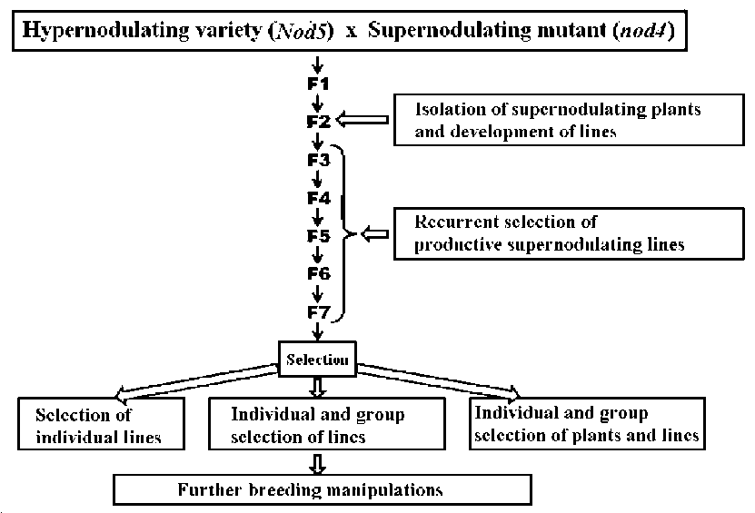
supernodulating mutants in breeding
Figure 1. Breeding program for increasing nitrogen fixation in pea Pisum sativum L.
were done with soybean, despite
being unsuccessful (1). To test the
feasibility of utilizing
supernodulating mutants in legume
breeding as tools for intense nitrogen
fixation, we performed large-scale
field and greenhouse experiments
with pea and investigated the
expression of the nod4 and nod3
supernodulating genes against
various genetic backgrounds (2). The
results were used in the development
of a breeding program for improving
the efficiency of the legume-
rhizobium symbiosis (Figure 1).

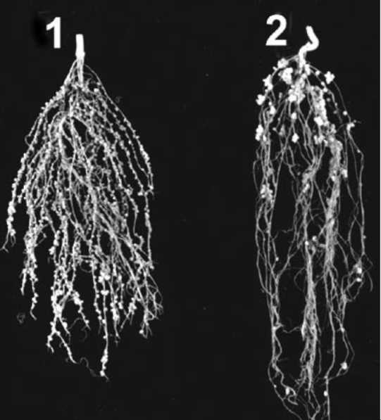
Figure 2. Pea roots: (1) supernodulating; (2) hypernodulating.

it is important to choose a proper variety, which
should be highly productive and hypernodulating.
Hypernodulation is characterized by large nodules,
forming mainly in the upper and middle portions of
roots. The nodules are considerably fewer in number,
but larger than in supernodulating forms (Figure 2).
Hypernodulation is governed by the dominant allele at
the Nod5 locus located on linkage group (LG) III (3, 4).
The pea germplasm collection at Novosibirsk includes
pea mutants and varieties with hypernodulation for
Nod5. The supernodulation in mutant K301, used in our
study, has the recessive allele at the nod4 locus located
in LG V (5).

Our method of breeding for elevated nitrogen fixation in pea was successfully applied to the development
of the pea cultivar Druzhnaya.

Materials and methods
Supernodulating plants were selected in F₂, and individual lines were raised. Productive lines with
supernodulation and intense nitrogen fixation were recurrently selected in generations F₃ to F₇.
Performance and nodulation indices in mutant K301, cv. Druzhnaya, and recurrent lines are illustrated in
Figure 3.

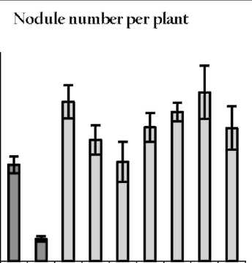
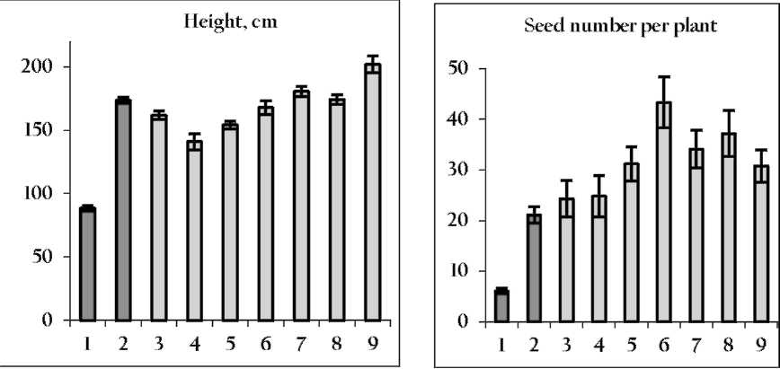
123456789
3000
Figure3. RecurrentFjlines obtained from crosses of cv. Druzhnaya to supernodulating mutantK301.Lane 1, K301;lane 2, Druzhnaya; and lanes 3-9, recurrent lines.

2500

2000

1500

1000

500

0

Results and discussion
The supernodulating mutant was both shorter and had less seed production than either Druzhnaya or
the recurrent lines. The recurrent lines were slightly taller than Druzhnaya. Many recurrent lines had
higher seed yield than Druzhnaya. The recurrent lines considerably outperformed Druzhnaya in
symbiosis-related traits, i.e. number of nodules (Figures 3 and 4) and nitrogen fixation rate (Table 1).

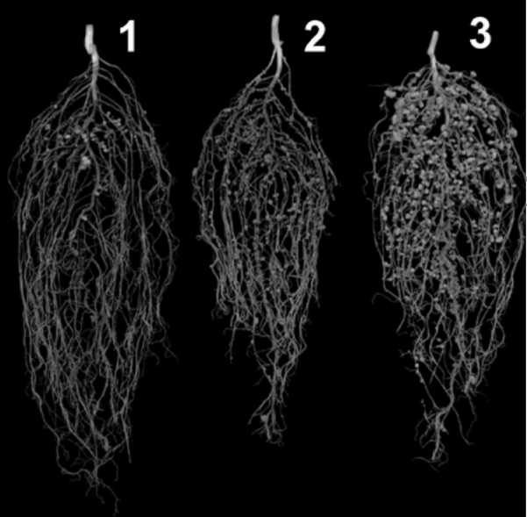
Table 1. Nitrogen fixation in pea cv. Druzhnaya and the recurrent
lines.
Form | Nitrogenase activity,nmol C2H4/plant/h
cv. Druzhnaya | 424
Supernodulating K301 mutant | 1242
Recurrent lines:K301 * Druzhnaya | 1123-1226
Druzhnaya * K301 | 2312-2380

Figure 4. Representative examples of pea root biomass ofcv. Druzhnaya (Nod5) (1), supernodulating mutant K301 (nod4) (2); and recurrent line K720ultrasuper (nod4 Nod5) (3).

RESEARCH PAPERS
PISUM GENETICS
2011-VOLUME 43

Individual and group selection of recurrent lines was done in the F₇. The lines were subjected to further
breeding procedures. Similar results were obtained with cv. Novosibirskaya, also crossed to K301.

Conclusion
Legumes are good rotation crops. We have shown that broad expansion of the pea root system is possible
based on results from the recurrent lines. All recurrent lines significantly surpassed cv. Druzhnaya in
vegetative root biomass and nitrogen content (Figure 5).
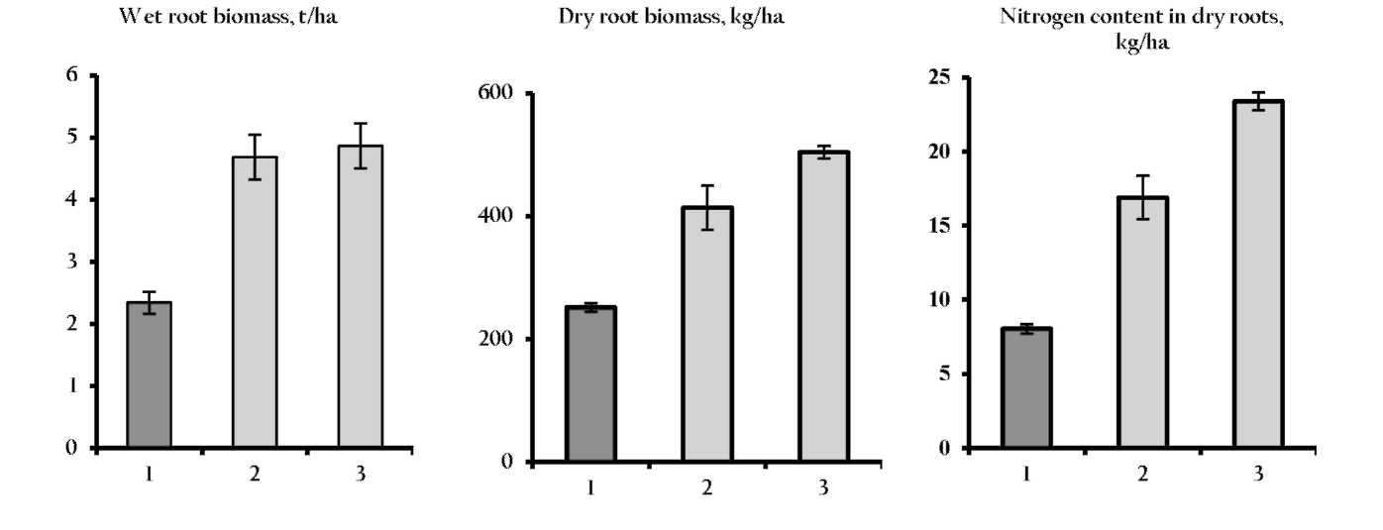
The calculations were performed by the conventional method: 1,800,000 plants per hectare.

Figure 5. Accumulation of crude root biomass andnitrogen contents in pea forms: 1 cv. Druzhnaya; 2, 3, recurrent lines.

Our results indicate that forms approaching commercial varieties in performance and symbiosis
parameters and even outperforming them in the accumulation of root biomass can be obtained by
combining dominant and recessive alleles of different symbiosis-related genes. The cultivation of such
forms will improve soil fertility and save mineral fertilizers, which is important with respect to
environment protection and energy saving.

References
1. Bhatia C.R., Nichterlein K., and Maluszynski M. 2001 Euphytica, 120: 415-432.
2. Sidorova K.K., Shumny V.K., and Nazaryuk V.M. 2006 Symbiotic nitrogen fixation: genetic,
breeding, ecological, and agrochemical aspects, Geo, Novosibirsk, P. 134 (in Russian).
3. Sidorova K.K. and Shumny V.K. 1997 Doklady Akademii Nauk 353(5):703-704. (in Russian).
4. Sidorova K.K., Shumny V.K., and Mishchenko, T.M. 1999 Doklady Akademii Nauk 367(6):851-
852 (in Russian).
5. Sidorova K.K. and Uzhintseva L.P. 1994 Doklady Akademii Nauk, 1994 336(6):847-849 (in
Russian).

7

