A new chlorophyll gene (xach, xantha chlorescens) in Pisum

sativum L. located on LG II

Swiecicki, W.K., Institute of Plant Genetics, Polish Academy of Sciences, Poznaii, Poland
Gawlowska, M.
and Nawrot, cz.

Induced mutations substantially increase the range of genetic variation in Pisum (eg. new genes orp, art, nec, lum etc.).Numerous accessions maintained in the Polish Pisum Gene Bank are mutations induced at the

Plant Experiment Station at Wiatrowo (1, 2). Some of these, such as the one discussed in this paper, were
obtained after treatment of both physical and chemical mutagens.

Dry seeds of cv. Paloma (Wt 3527) were treated with 200 rNf +0.014% NEU, and a chlorophyll mutant
from the terminalis group was selected in the M₂ generation. During germination and initial growth (up
to 4-5 leaves) mutant plants are gold-yellow-green (Figure 1A) and could be used as an ornamental pea.
After this initial growth the plant becomes green and is fertile (Figure 1B). The phenotype is clearly
different from other described chlorophyll mutations of this group. The mutant has been included in the
Polish pea collection under the name xantha-chlorescens (accession number Wt 10889).
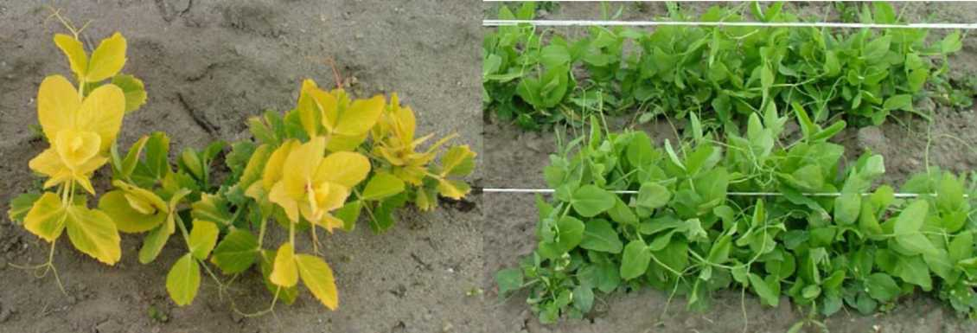
Figure 1. Mutantplants of cultivar Paloma snowing chlorosis during early vegetative growth (A) and recovery of normal green folage color (BB).

This line was crossed to following testerlines with gene markers: Wt 11540 - A, wb, Pgm-p (LG II); gp, tl,
Acpl (LG V); Aat-m, Skdh, Estl, Est-2 (LG VII); Wt 11288 - A (LG II); st, b, (LGIII) and Wt 15860 - A (LG II);
creep, ce (LG V). Segregation of the mutation in the F₂ in 1999 showed no deviations from an expected
monohybrid segregation (Table 1). The gene symbol, xach, is suggested for the xantha-chlorescens mutation
in the type line Wt 10889.

PISUM GENETICS
2011-VOLUME 43
RESEARCH PAPERS

Analyses of the dihybrid segregation in the three mapping populations showed independent assortment
Table 1. Monohybrid segregation for the investigated gene xach (xanta-chlorescens) and gene markers in the linkagegroup II
in F2 populations of the linkage test crosses.
Cross no. | Parents | Gene | Dom | Rec | Total | chi²
K. 2022 | Wt 11540 x Wt 10889 | Xach | 70 | 25 | 95 | 0.09
 |  | A | 74 | 17 | 91 | 1.94
K. 2024 | Wt 11288 x Wt 10889 | Xach | 72 | 22 | 94 | 0.13
 |  | A | 72 | 10 | 82 | 7.17
K. 2026 | Wt 10889 x Wt 15860 | Xach | 69 | 25 | 94 | 0.13
 |  | A | 62 | 11 | 73 | 3.84
K. 2718 | Wt 10886 x Wt 16054 | Xach | 97 | 29 | 126 | 0.26
 |  | Rms3 | 79 | 20 | 99 | 1.22
K. 2795 | Wt 10886 x Wt 15869 | Xach | 108 | 38 | 146 | 0.08
 |  | A | 88 | 41 | 129 | 3.16
 |  | Pal | 118 | 20 | 138 | 8.13
K. 2894 | Wt 10886 x Wt 11300 | Xach | 89 | 30 | 119 | 0.00
 |  | A | 89 | 30 | 119 | 0.00
 |  | Crd | 95 | 24 | 119 | 1.48
K. 3012 | Wt 3838 x Wt 10888 | Xach | 174 | 55 | 229 | 0.12
 |  | A | 161 | 60 | 221 | 0.54
 |  |  | 161 | 55 | 216 | 0.02

between xach and all genes listed in Table 2. In contrast, substantial deviations were observed for Xach-A
with the joint chi square from 21.4 to 50.8 and Cr-O values 8.27 in K.2022, 12.3 in K.2024 and 15.5 in
K.2026. This suggests localization of xach on LG II (3).

Table 2. Distribution of phenotypes in F2 populations (Wt10889xach type line x testerlines) and the linkage testfor the new gene.
Testerline (Cross  no.) | Pair of genes | DD | Dr | rD | rr | Total | Joint chi  square | Cr-o (±S.E) (per  cent) |  | Phase
Wt 11 540 (K.  2022) | Xach-Gp | 53 | 16 | 14 | 4 | 87 | 0.01 | 49.2 | 8.11 | R
 | Xach-Tl | 52 | 18 | 17 | 2 | 89 | 1.98 | 35.1 | 9.16 | R
 | Xach-Wb | 54 | 15 | 15 | 3 | 87 | 0.22 | 45.4 | 8.44 | R
 | Xach-Ac | 57 | 9 | 16 | 5 | 84 | 0.08 | 46.7 | 8.48 | R
 | Xach-Aat-m | 32 | 7 | 9 | 2 | 50 | 0.00 | 50.2 | 10.6 | R
 | Xach-Skdh | 28 | 10 | 9 | 2 | 49 | 0.30 | 43.3 | 11.5 | R
 | Xach-Acpl | 27 | 11 | 10 | 1 | 49 | 1.82 | 69.1 | 12.8 | C
 | Xach-Pgm-c | 32 | 7 | 10 | 1 | 50 | 0.50 | 39.1 | 11.8 | R
 | Xach- Pgm-p | 25 | 11 | 9 | 1 | 46 | 1.72 | 68.7 | 13.2 | C
 | Xach-Est-1 | 30 | 9 | 9 | 2 | 50 | 0.12 | 45.8 | 11.1 | R
 | Xach- Est-2 | 28 | 11 | 9 | 2 | 50 | 0.45 | 58.0 | 11.5 | C
Wt 11 288  (K.2024) | Xach-St | 56 | 16 | 10 | 5 | 87 | 0.84 | 57.7 | 7.32 | R
 | Xach-B | 51 | 17 | 2 | 2 | 72 | 1.22 | 64.7 | 7.29 | R
Wt 15 860  (K.2026) | Xach-Creep | 51 | 17 | 11 | 6 | 85 | 0.73 | 56.8 | 7.50 | R
 | Xach-Ce | 38 | 15 | 1 | 2 | 56 | 1.98 | 70.9 | 7.45 | R

K.2024 and K.2026 single plants were selected from F₂ segregating populations and lines were multiplied
with linked genes xach-A in repulsion phase (Wt 10888 and Wt 10886, respectively). These lines were
crossed to additional LG II marker lines: Wt 16054 (rms3), Wt 15869 (pal), Wt 11300 (crd) and Wt 3838
(lf) (Table 1.). Analysis of the dihybrid segregation in the F₂ confirmed that xach is linked with A,
although Cr-O values in repulsion were larger (from 19.6 to 29.3) than in coupling (Table 3). No linkages
of xach with markers rms3, pal and crd were observed. However, in the population K.3012 substantial
deviations from the expected dihybrid segregation were stated for three gene pairs: Xach-A, Xach-Lf and
A-Lf. Cr-O values suggest the following gene order: Xach-14-Lf-19-A.

Table 3. Distribution of phenotypes in F₂ populations (xach lines x testerlines) and the linkage test for the new gene.
Cross no. | Pair of genes | DD | Dr | rD | rr | Total | Joint chi  square | Cr-O (±S.E)  (per cent) |  | Phase
K. 2022 | Xach-A | 68 | 2 | 5 | 14 | 89 | 50.8 | 8.27 | 3.07 | C
K.2024 | Xach-A | 68 | 3 | 4 | 7 | 82 | 31.4 | 12.3 | 3.92 | C
K.2026 | Xach-A | 59 | 5 | 3 | 6 | 73 | 21.4 | 15.5 | 4.68 | C
K.2718 | Xach-Rms-3 | 73 | 20 | 6 | 1 | 99 | 1.27 | 43.0 | 8.10 | R
K.2795 | Xach-A | 68 | 40 | 20 | 1 | 129 | 9.26 | 19.6 | 8.40 | R
 | Xach-Pal | 89 | 19 | 29 | 1 | 138 | 3.26 | 26.0 | 7.84 | R
 | A-Pd | 74 | 13 | 35 | 6 | 128 | 00.0 | 50.3 | 6.65 | C
K.2894 | Xach-A | 61 | 28 | 28 | 2 | 119 | 8.31 | 25.6 | 8.47 | R
 | Xach- Crd | 69 | 20 | 26 | 4 | 119 | 1.11 | 41.1 | 7.52 | R
 | A-Crd | 83 | 6 | 12 | 18 | 119 | 40.0 | 16.4 | 3.78 | C
K.3012 | Xach-A | 113 | 55 | 48 | 5 | 221 | 10.3 | 29.3 | 6.07 | R
 | Xach-Lf | 111 | 54 | 50 | 1 | 216 | 19.5 | 14.0 | 6.64 | R
 | A-Lf | 138 | 16 | 22 | 38 | 214 | 65.2 | 18.9 | 3.03 | C

References
1. Swiecicki W.K. 1984. Pisum Newslet. 16: 84-86.
2. Swiecicki W.K. 1998. Crop Gene Resources. Nation. Conf. Pulawy: 53-54.
3. Weeden N.F., T.H.N. Ellis, G.M. Timmerman-Vaughan , W.K. Swiecicki, S.M. Rozov and V.A.
Berdnikov. 1998. Pisum Genetics 30: 1-4.

