RESEARCH PAPERS
PISUM GENETICS
2011-VOLUME 43

The new xantha-variegata-viredescens mutation in pea

xavs
Rozov, S.M.

Institute of Cytology and Genetics SD RAS Novosibirsk, Russia

Leaf chlorophyll variegation is occasionally observed in many plants. Usually it looks like white, yellow
or dark green spots or irregular regions on leaves. Mutations in both nuclear and organelle genomes
reportedly may cause this leaf variegation (1). It raises a question why and how two neighboring sectors
containing different cell types, a green cell with normal-appearing chloroplasts and a white cell with
abnormal plastids, can be formed in one leaf tissue when the genome of all cells is identical. The precise
mechanism leading to such pseudochimeric chloroplast development in the same leaf tissues remains
poorly understood. One possible explanation for generation of non-identical variegated sectors in each
leaf is a threshold level of factors that arrest proplastid differentiation into chloroplasts (2).

Variegated-type mutants are more rarely observed in plants than the ordinary chlorophyll mutants. In
Arabidopsis thaliana, only four loci are known to cause the variegated phenotype (3). During experimental
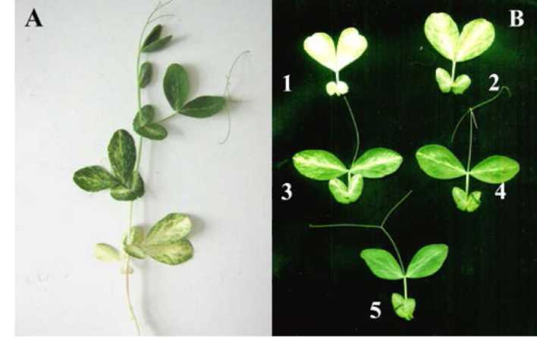
mutagenesis, pea mutants with varicgata or
maculata phenotypes appear two orders of
magnitude less frequently than the other
chlorophyll mutants (4, 5). Only four to six
pea variegated mutants have been previously
reported and almost all of them appeared to
be extinct (6). For the above reasons, isolation
of a new pea variegata mutant is of great
interest in the course of studying the
mechanisms of variegated plant appearance
and chloroplast differentiation and survival.

Screening M₂ progeny of the EMS-treated pea
line SGE revealed a new mutant SGE0802
Figure 1. SGE0802 (xavs) seedling (A) andproggressive greenish gradient along seedling (B). Digits 1-5 indicate number of node.
characterized with the strong xantha effect on
shoots and leaflets of the first expanded leaf
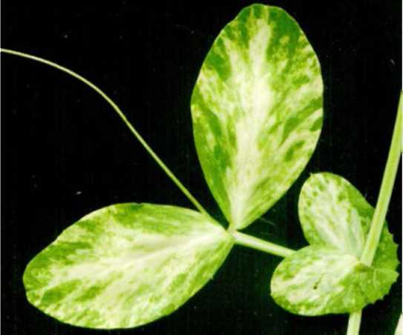
(Figure 1).These structures are brilliant
yellow, without any green spots even grown
in the sunlight. Leaflets at the next three nodes (2-4) of
SGE0802 sequentially and progressively become green —
yellow sectors become pale or even white and green
sectors arise in geometric progression from one node to
the next (Figure 2). The 5^{t} node of the mutant plants
becomes completely green without any allusion of yellow
or other colored sectors. It is notable, that among nearly
5000 plants analyzed, none become fully green at the 4th or
6th node — it was always the 5th node in all cases. The
upper part of the SGE0802 plant is completely normal and
fertility is not affected.

To determine the inheritance type of SGE0802 mutation,
we crossed it with the parental line SGE in both Figure2. The 3rdnode of a SGE0802 (xavs) seedling. Pale
directions, using the mutant as either the male or female yellow, green and dark green sectors are visible.

6

parent. In both cases, all F₁ progeny were normal, without any variegation on leaves and all shoots were
green. Segregation results in the F₂ for these crosses are shown in Table 1. In both crosses, the ratio of
normal and variegated seedlings segregated did not differ significantly from 3:1 (p > 0.5). The mutation
appears to be inherited as a single recessive nuclear gene. We designated the observed SGE0802
phenotype as xavs — xantha-variegata-viridescens seedlings.

Table 1. Segregation of F₂ hybrids from crosses of line SGE00802 (xavs) with parental line SGE.
Hybrid | F₂ segregation phenotype |  | Segregation 3:1 | Probability  P
Hybrid | Xavs | xavs | Segregation 3:1 | Probability  P
SGE0802 x SGE | 184 | 64 | 0.086 | 0.7-0.8
SGE x SGE0802 | 152 | 56 | 0.410 | 0.5-0.6

We tried to localize xavs on the pea genetic map. Line SGE0802 was crossed with a number of tester
lines, but we failed to find linkage of xavs with any of the genetic markers involved. Xavs is not positioned
near genes i, r, d, wb, k, st, b, a, le, gp, wlo, oh, p, pl. The question concerning its location on pea gene map
remains unanswered.

In Arabidopsis thaliana, two genes, var1 and var2 produce the variegation pattern, very similar to the pattern
observed in xavs pea plants, but the Arabidopsis phenotype is constitutive during all plant ontogenesis
(7). Arabidopsis variegated mutations also form three sector types: white, pale green and dark green,
again as was observed in the xavs mutant. In Arabidopsis mutants, dark green sectors contain normal
chloroplasts whereas plastids in the white sectors are vacuolated with obscure inner membrane
structures. Cells of pale green sectors contain plastids of both types. Proplastids in shoot apical
meristems in var Arabidopsis mutants are normal, and abnormal plastids lacking inner membrane
structures begin to form at later stages (3). Var genes belong to a small gene family of 12 nuclear genes
coding for special chloroplast-localized FtsH metalloproteases, homologous to bacterial metalloproteases
and responsible for degradation of photodamaged proteins within the photosynthetic machinery.
Without this protease activity photosynthetic complexes become corrupted and that leads to irreversible
chloroplast degradation (8).

As was shown by scanning electron microscopy, the pea shoot apical meristematic region involves well
differentiated primordium for 4-5 nodes (9). Pea seeds possess a well-developed embryo, so we can
suggest that it also contains well-expanded primordium for the 4-5 first leaves of the future seedling. In
Arabidopsis FtsH genes are stage-specific and only two loci from 12 can produce variegated phenotypes
similar to xavs. We can suggest, that xavs is a homolog of one of the FtsH-family representatives and is
expressed specifically during seed development and maturation, at the stage of initiation of the 1st lateral
meristem primordium formation. The mutant allele xavs produces a non-functional protease product, but
this product can migrate into proplastids and bind with inner thylakoid membranes where normal
metalloproteases are usually located. A little bit later, during formation of the 4th and 5th node meristems,
expression of the other FtsH genes begin and producing two opposite FtsH gradients along primordium
1-5. At primordium 5 the concentration of functional FtsH metalloproteases becomes enough to result in
normal plastid development. The concentration during initiation of the 2nd - 4th primordiums is at a
threshold level and that leads to a variegated phenotype appearance where some plastids may or may not
develop normally. certainly, pea gene xavs may produce some factor other than FtsH metalloprotease,
but the general mechanism of variegated phenotype origin must be the same.
References
1. Von Wiren N., Mori S., Marschner H. and Romheld V. 1994. Plant Physiology 106:71-77.
2. Miura E., Kato Y. and Sakamoto W. 2010. Journal of Experimental Botany 61:2433-2445.
3. Sakamoto W., Tamura T., Hanba-Tomita Y., Sodmergen and Murata M. 2002. Genes to Cells
7:769-780.
4. Blixt S., 1972. Agri Hortique Genetica 30:1-293.
5. Lamprecht H. 1974. Monographie der Gattung Pisum. Steiermarkische Landesdruckerei, Graz,
Austria.
6. Pisum Genetics Association Genelist: http://www.jic.ac.uk/GERMPLAS/pisum/Zgc4g.htm
7. Martinez-Zapater J.M. 1993. J. Hered. 84:138-140.
8. Sakamoto W. 2003. Genes Genet. Syst. 78:1-9.
9. Gourlay C.W., Hofer J.M.I. and Ellis T.H.N. 2000. The Plant Cell 12:1279-1294.

