Hybridization barrier between Pisum fulvum Sibth.
et Smith and P. sativum L. is partly due
to nuclear-chloroplast incompatibility

Bogdanova, V.S. and Kosterin, O.E. Inst. of Cytol. and Gen., Siberian Dept.,
Russian Acad. of Sci., Novosibirsk, Russia

Pisum fulvum Sibth. et Sm. is the most divergent species in the genus Pisum and has limited compatibility with Pisum sativum L. In a study of cross-compatibility of pea forms, low-fertility hybrids could be obtained in crosses using P. fulvum as a pollen parent, the reciprocal crosses produced only non-viable shrunken seeds (1). Crosses between wild subspecies P. sativum subsp. elatius and P. fulvum gave similar results: hybrid F₁ plants produced seeds only when P. fulvum was used as the male parent (1). This observation clearly points to the role of cytoplasm in maintaining the hybridization barrier. Earlier we found that crosses of the VIR320 accesssion of P. s. subsp. elatius as a female parent with P. sativum produced F₁ plants with low-fertility and marked anomalies of chlorophyll pigmentation (3). Ben-Ze'ev & Zohary (1) described a similar phenotype of F₁ hybrids formed in the crosses of P. fulvum as female parent pollinated by their 'P. elatius' and 'P. humile' (wild peas, both of which we regard as P. s. subsp. elatius). We were interested to know if this peculiar phenotype of chlorophyll variegation would form in F₁ hybrids of ♀ P. fulvum x P. sativum ♂ provided that the cross was successful. We performed about 100 crosses of WL2140 (=JI224, P. fulvum) flowers with pollen of Sprint-1 (P. sativum), that is, in the direction supposed to be incompatible, and obtained one seed. The plant grown from this seed evidently resulted from a successful cross and had a phenotype intermediate between the parental forms. In contrast to our expectation, it had normal chlorophyll pigmentation. This F₁ plant produced four F₂ seeds that were grown into F₂ plants. Of these, one plant had small sectors with chlorophyll deficiency on its lower leaves. In addition to chromosome translocations in P. fulvum as compared to P. sativum (5), poor compatibility of these two species, as noted above, is somehow related to cytoplasm.
We therefore analyzed organelle DNA markers in the WL2140 x Sprint-1 F₂ hybrids. As a plastid DNA marker we used the rbcL gene (the pea chloroplast gene for ribulose 1,5-bisphosphate carboxylase), which carries a recognition site for AspLEI restriction endonuclease in the WL2140 but has no such a site in Sprint-1. Forward primer 5'- TTATTATACTCCTGACTATCAAACC and reverse primer 5'- TACAGAATCATCTCCAAATATCTCG matched accession X03853 (4). As a mitochondrial DNA marker we used the atpA gene (for F1ATPase alpha-subunit), PCR-amplified and digested with Tru9I endonuclease. Forward primer 5'-TAAGAGCTGCGGAACTAACAACTC and reverse primer 5'-GCCTTGCACCTCTATTGAGTAATG were designed to match accession D14698.
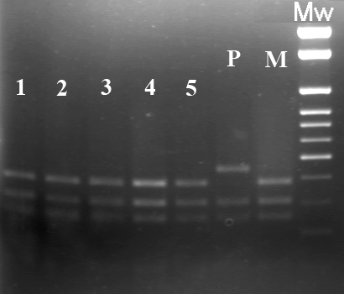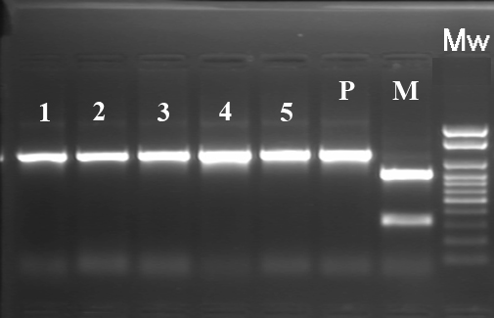

Fig. 1A. Products of Tru9I digestion of the PCR-amplified mitochondrial atpA gene. Fig. 1B. Products of AspLEI digestion of the PCR-amplified plastid rbcL gene. Lanes 1 to 5 - individual F₂ plants from the cross WL2140 x Sprint-1; lane 3 represents sectors with chlorophyll variegation of the same plant as in lane 2; P - paternal form Sprint-1, M - maternal form WL2140, Mw - molecular weight marker 100-1000 bp + 1.5 Kb + 2 Kb.
As expected, all four F₂ plants had the maternal type of the mitochondrial DNA marker, however, the plastid DNA marker in all four plants was found to be of the paternal type (Fig. 1). Based on these results we conclude that the plastids of P. fulvum are incompatible with the nuclear genome of P. sativum and interspecific crosses involving P. fulvum as a maternal parent can produce viable progeny only in the case of non-canonical paternal inheritance of plastids. This interpretation is similar to the phenomenon of biparental plastid inheritance associated with nuclear-cytoplasmic incompatibility manifested as chlorophyll variegation and low fertility observed in crosses involving the P. s. subsp. elatius accession VIR320 (2).
However, in the case of P. fulvum, the nuclear-cytoplasmic conflict seems to be more profound so that no viable plants are formed if the plastids are maternally inherited.

Acknowledgment: This work was supported by the project ‘Biosphere origin and evolution’ of the Russian Academy of Sciences, and Russian Foundation for Fundamental Research, grant 07-04-00111-а.

1. Ben-Ze’ev, N. and Zohary, D. 1973. Israel J. Bot. 22: 73-91.
2. Bogdanova, V.S. 2007. Theor. Appl. Genet. 114: 333-339.
3. Bogdanova, V.S. and Berdnikov, V.A. 2001. Pisum Genetics 33: 5-8.
4. Bogdanova, V.S. and Kosterin, O.E..2005. Pisum Genetics 37: 40-42.
5. Errico, A., Conicella, C. and Venora, G. 1991. Genome 34: 105-108.

