Pea mutant line sprint-2Nod-3 represents
a new mutant allele of pea symbiotic gene sym19

Zhukov V.A., Borisov A.Y., Tikhonovich I.A. Lab. of Gen. of Plant-Microbe Interactions
(http://www.arriam.spb.ru/eng/lab9) All-Russia Res. Inst. for Agri. Microbiol., St. Petersburg, Russia

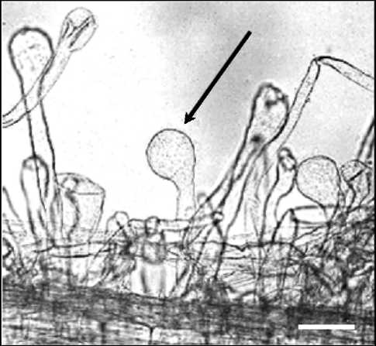
Fig. 1. A characteristic deformation of
root hair tips in Sprint-2Nod-3 mutant
(sym19). Arrow points to deformed root
hair tip. Scale bar 0.05 mm
Pea (Pisum sativum L.) remains an important model object
studying genetics of symbiotic systems, despite the fact that it
a large genome and a relatively low capability for genetic
transformation. A large collection of well-characterized
symbiotic mutants with unique phenotypic manifestation has
been obtained (1).
Here we describe the mutant Sprint-2Nod⁻- 3 obtained in the
background of laboratory line Sprint-2 after EMS mutagenesis
more than 15 years ago. The line Sprint-2Nod⁻-3 is derived from
M2 plant that had gray and green nodules and was deficient in
nitrogen fixation (Fix⁻ phenotype). Four plants of the next
generation (M3) also had gray and green nodules, but all the
progenies in M4 totally lacked nodules. The line was finally
phenotypically characterized as Nod⁻ mutant forming specific
deformations of root hairs resembling drumsticks by shape (Fig.
This phenotype is specific for pea mutants in sym8 and sym19
genes (2, 3). Allelism tests with pea lines carrying mutations in "early" symbiotic genes sym8, sym9, sym10 and
sym19 demonstrated that the line Sprint-2Nod⁻-3 is a mutant of sym19.
How could a Fix-mutant turn out to be a Nod⁻-phenotype? The explanation we could propose is the
following. The initial M2 plant (Fix⁻) was grown in summer under "outdoor" conditions, where the temperature
varied from 10°C to 25°C. Next winter M₃ plants (Fix⁻) were grown in a greenhouse where the temperature also
varied from 10°C to 25°C. All the following generations were cultivated in the climatic chamber (Vb'tsch
Industrietechnik VB 1014, Germany) under strictly controlled temperature conditions (21 ± 1°C) and
demonstrated Nod⁻-phenotype. Lowering the night temperature to 15°C is usually enough for manifestation of
temperature-sensitive phenotype in pea symbiotic mutants. Therefore, we suggest that Sprint-2Nod⁻- 3 is an
example of temperature-sensitive mutation of sym19.
for
has
1
1).

The fact that the mutation blocks the development of symbiosis at a definite stage does not mean that this
gene "works" only at this stage. Mutations in the gene dmi2 of Medicago truncatula Gaertn. lead to inability in
developing infection process (4, 5), but experiments of Limpens et al. (6), knocking out DMI2 by inducible RNA
interference, demonstrated that activity of DMI2 is also essential for symbiosome formation at late stages of
symbiosis development. The gene in pea that corresponds to DMI2 in M, truncatula (also to NORK in Medicago
sativa L. and SymRK in Lotus japonicus (Regel.) K.Larsen) is Sym19 (7, 8). The presence of the mutation in pea
sym19 that could cause Nod⁻ or Fix⁻ phenotype depending on growth conditions is good evidence of the role of this
gene on early and late stages of symbiosis development.
1. Borisov, A.Y., Danilova, T.N., Koroleva, T.A., Naumkina, T.S., Pavlova, Z.B., Pinaev, A.G., Shtark, O.Y.,
Tsyganov, V.E., Voroshilova, V.A., Zhernakov, A.I., Zhukov, V.A. and Tikhonovich, I.A. 2004. Biologia 59:
137-144.
- Borisov, A.Y., Rozov, S.M., Tsyganov, V.E., Kulikova, O.A., Kolycheva, A.N., Yakobi, L.M., Ovtsyna, A.O.
and Tikhonovich, I.A. 1994. Russ. J. Genet. 30: 1284-1292.
- Sagan, M., Huguet, T. and Duc, G. 1994. Plant Sci. 100: 59-70.
- Catoira, R., Galera, C., de Billy, F., Penmetsa, R.V., Journet, E.P., Maillet, F., Rosenberg, C., Cook, D.,
Gough, C. and Denarie, J. 2000. Plant Cell. 12: 1647-66.
- Wais, R.J., Galera, C., Oldroyd, G., Catoira, R., Penmetsa, R.V., Cook, D., Gough, C., Denarie, J. and Long,
S.R. 2000. Proc. Natl. Acad. Sci. 97: 13407-13412.
- Limpens, E., Mirabella, R0., Fedorova, E., Franken, C., Franssen, H., Bisseling, T. and Geurts, R. 2005. Proc.
Natl. Acad. Sci. 102: 10375-10380.
- Endre, G., Kereszt, A., Kevei, Z., Mihacea, S., Kalo, P. and Kiss, G.B. 2002. Nature 417: 962-966.
- Stracke, S., Kistner, C., Yoshida, S., Mulder, L., Sato, S., Kaneko, T., Tabata, S., Sandal, N., Stougaard, J.,
Szczyglowski, K. and Parniske, M. 2002. Nature 417: 959-962

