Relationship between different fasciated lines of pea
Sinjushin, A.A. and Gostimskii, S.A. Gen. Dept., Biol. Faculty of Moscow State Univ., Moscow, Russia
Introduction
Although data on genetic control of fasciation in pea (Pisum sativum L.) appeared together with genetics
itself (5), some aspects of it remain unclear. Until recently, even the number of genes involved in the
development of this trait was under discussion: the hypothesis of monogenic control (5) was in controversy with
one proposing the existence of two polymeric genes (2). At present, the former seems more probable, being
supported by numerous experiments (4). The Fa locus proposed to be identical to that studied by Mendel, is
localized on linkage group (LG) IV (2). Nevertheless, a few additional genes are known to cause fasciation: Fas
(LG III, 1), Fa2 (LG V, 12), Nod4 (LGV, 8), and ,Sym28 (no linkage data, 7).The two latter also take part in the
nodulation process.
Currently, a wide range of fasciated mutants, lines, recombinants and cultivars of pea are known. Their
origin in some cases is unclear and samples from different germplasm collection may have different designations,
obscuring the genetic relationship between them. For this reason, the relation between different fasciata lines
needs to be investigated to finally determine the number of genes influencing this character, and to avoid
synonyms. In addition, further study of fasciation in pea is needed, not only for practical purposes (some highly
productive fasciated pea cultivars exist, reviewed in (11)) but also to solve the fundamental problem of genetic
control of stem apical meristem (SAM) in higher plants.

Materials and Methods
The following fasciated pea lines from the collection of Genetics Department of Moscow State University
(MSU) served as the plant material for the current study: 'Shtambovy' mutant originating from
'Nemchinovsky' cultivar via ethylmethane sulfonate treatment (6), 'Rosacrone' cultivar (provided by Vavilov
Institute of Plant Industry, St. Petersburg, Russian Federation), 'Lupinoid' line from All-Russia Research
Institute of Legumes and Groats Crops (Orel, Russian Federation), lines from John Innes Collection (Norwich,
UK) (JI 5, JI 2671, JI 2771), and P 64 (sym28) from the collection of All-Russia Research Institute of
Agricultural Microbiology (Pushkin, Russian Federation). The lines and F1 hybrids were planted in open field
conditions of Skadovskii Biological Station of MSU (Zvenigorod, Moscow District). Quantitative trait
measurements were taken on growing plants and then processed with usage of Statistica 6 software package
(Statsoft, Inc., Tulsa, OK, U.S.A.). The following characteristics were compared: number of the first node with
clustered leaves (the phyllotaxis abnormalities reflect stem apical meristem size, 9) and width of internode
preceding the node of flower initiation (NFI).
PCR-based microsatellite markers were used to confirm the hybrid origin of some F1 plants (when no
morphologic markers' segregation confirmed it). The primer sequences and conditions of PCR were chosen
according to those described in Lorindon et al. (3). The restriction products were separated via electro-phoresis
in agarose gel (Amresco) and then stained with ethidium bromide and visualized under UV-light.

Results and Discussion
Table 1 represents the results of allelism tests based on the phenotype of F1 hybrids of clearly confirmed
origin (Fig. 1). It is evident that three genes are responsible for fasciation inheritance in the lines. Studied lines
'Shtambovy' and JI 2771 are mutants at a gene on LG III (10) which is the only known fasciata gene on LG III
and thus needs to be designated Fas, as has been discussed in work cited previously. Currently, however, line JI
2771 is designated as fas-2 (Catalogue of Pisum Genetic Stock in John Innes Centre, http://www.jic.ac.uk/
germplas/pisum/pgs2.txt), which seems improper.
Table 1. Results of allelism test-crosses between the lines examined.
 | Shtambovy | Rosacrone | Lupinoid | JI 5 | JI 2671 | JI 2771 | P 64
Shtambovy
Rosacrone | n/a
Lupinoid | n/a | a
JI 5 | - | a | -
JI 2671 | - | a | - | -
JI 2771 | a | n/a | - | - | n/a
P 64 | n/a | n/a | - | - | - | -
Key: a, allelic; n/a, nonallelic; dash, cross not made or data absent.

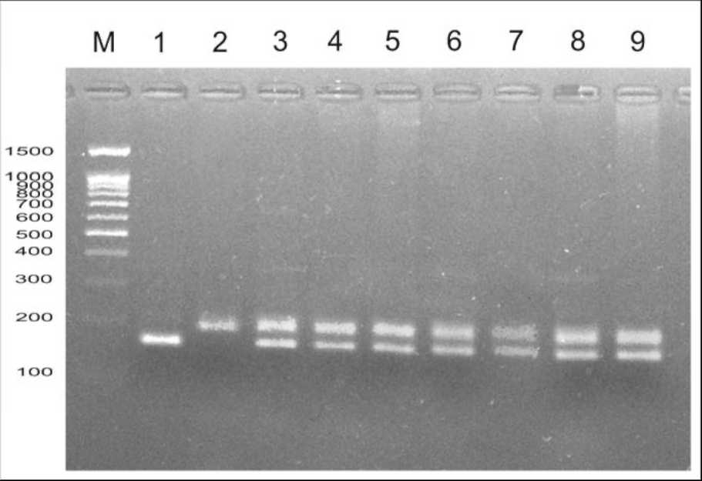
Fig. 1. Confirmation of hybrid origin of F₁ plants from cross between
'Shtambovy' and JI 2771 via amplification of AA122 microsatellite marker.
Key: M, marker of molecular weight (100 bp + 1.5 Kb, Sibenzyme); 1,
'Shtambovy'; 2, JI 2771; 3-9, spectra of individual F hybrids.
Lines 'Rosacrone',
'Lupinoid', JI 5 ('Mummy
Pea'), and JI 2671 are all
allelic. The fasciation in them
is caused by gene Fa localized
on LG IV, as JI 5 ('Mummy
pea', syn. WL 6) is regarded as
type line for fa (11) identical to
one described in Mendel's work
(2, 5). Line JI 2671 also needs
to be designated as fa instead
of fas.
Line P 64 shows no allelism
with any of the other mutants,
but rather is homozygous at
gene sym28 as stated in (7).
The study of quantitative
traits in fasciated lines
provides additional data
confirming the relationship
between fasciated lines (Fig. 2).
The two fas forms are
characterized with strongly expressed fasciation resulting in development of widely flattened main stem and
phyllotaxis distortions, which can be clearly seen even in seedlings. Usually two or three leaves form in the third
node, i.e. true (not scalar cataphylls) leaves exhibit abnormalities in their arrangement. In contrast, fa lines are
weakly fasciated and features of stem flattening and clustering of leaves can be seen only at late stages of
development. The line 'Lupinoid' has unusual leaf arrangement: the formation of leaf whorls is usually observed
on the first nodes and then on 10-11th (and more). Such enhancement of fasciation expression can be explained
by existence of modifying genes altering manifestation of fa in different recombinants. The stem and leaf
arrangement in the P64 line (sym28) are also weakly affected. Such differences were seen even during
observations in the very dry summer of 2007 when all features of fasciation were expressed weaker then usual
due to drought stress.
In conclusion, fasciation for the lines studied is produced by three independent genes, and its manifestation
in different genotypes is phenotypically distinguishable. Certain changes in the designation of type lines are
recommended. Further investigations on gene interactions including analysis of F2 and double mutants are
needed to get more information on genetic control of SAM development in pea and higher plants in general.

Distribution of quantitative traits in studied fascials linesto25
23/ o
Oith abnormal phyllotax21
19
17
15'-^ \/° ° ""<t
□>;- o-<<> o0)
■o
o
c
to13
11\o. ofthe•■♦
□Shtambovy
P 64 z5
3m . •♦A ♦ ♦ Am
0
ARosacrone — ■ ~
Lupinoid .....
JI5
JI 2771 1,5 2,5 3,54.56,5 7,5oJI2671 Width of internode
Fig. 2. Scatterplot distribution of quantitative traits in fasciated lines (explanation in text).
Acknowledgment: The authors would like to express their gratitude to Prof. Noel Ellis and Dr. Mike Ambrose (John Innes
Centre), Dr. Viktor E. Tsyganov (All-Russia Research Institute of Agricultural Microbiology), and Dr. Anatoly N. Zelenov
(All-Russia Research Institute of Legumes and Groats Crops) for kindly providing them with the seeds of fasciated lines.
This study was supported by Russian Foundation for Basic Research (grant no. 07-04-00652).
- Blixt, S. 1976. Agri Hort. Genet. 34: 83-87.
- Lamprecht, H. 1952. Agri Hort. Genet. 10: 158-167.
- Lorindon, K., McPhee, K., Morin, J. et al. 2005. Theor. Appl. Genet. 111: 1022-1031.
- Marx, G.A. and Hagedorn, D.J. 1962. Heredity 53: 31-43.
- Mendel, G. 1866. Verh. Naturf. Ver. Brunn 4: 3-47.
- Rehmatulla, A. and Gostimskii, S.A. 1976. Biologicheskie nauki. 5: 107-112. In Russian.
- Sagan, M. and Duc, G. 1996. Symbiosis 20: 229-245.
- Sidorova, K.K. and Uzhintseva, L.P. 1995. Pisum Genetics 27: 21.
- Sinjushin, A.A. and Gostimsky, S.A. 2006. Russ. J. Dev. Biol. 37: 375-381.

- Sinjushin, A.A., Konovalov, F.A. and Gostimskii, S.A. 2006. Pisum Genetics 38: 19-20.
- Swiedcki, W.K. 2001. Pisum Genetics 33: 19-20.
12. Swiecicki, W.K. and Gawlowska, M. 2004. Pisum Genetics 36: 22-23.

