A new mutant allele of the symbiotic
gene sym40 of pea (Pisum sativum L.):
dynamics of arbuscular mycorrhiza development

Nemankin, T.A., Shtark, O.Y.,
Zhernakov, A.I., Borisov A.Y. and Tikhonovich, I.A.
All-Russia Res. Inst. for Agri. Microbiology
St.Petersburg, Russia

Introduction
Pea (Pisum sativum L.) forms symbioses with soil bacteria Rhizobium leguminosarum bv. viciae and
arbuscular mycorrhizal (AM) fungi belonging to the phylum Glomeromycota (Schiissler et al., 2001), and is one
of the actively used model species for studying beneficial plant-microbe interactions. Research on these types of
symbioses is critical because there exists a high degree of genetic integration between the partners and because
these plant-microbe systems are very important in agriculture.
The mutation in the gene sym40, SGEFix⁻-1, was characterized previously revealing a change of dynamics in
arbuscule development and turnover when compared to the wild type line SGE (2). The present study was
focused on studying AM development in a new mutant, SGEFix⁻-6, in the same gene.

Materials and methods
Plant material. Pea (Pisum sativum L.) lines, SGE (4), SGEFix⁻-1 (sym40) (2) and SGEFix⁻-6 (ssym40) (9) were
obtained from the ARRIAM collection (Saint Petersburg, Russia; www.arriam.spb.ru/eng/lab9/collections/
sge.html).

Plant growth conditions and inoculation technique. Pea seeds were surface-sterilized, scarified and germinated at
room temperature under sterile conditions. Three-day seedlings were planted into a nurse-plant inoculation
system (NPIS) (6) modified with a chive (Allium schoenop rasumh) as the nurse plant. The plants were grown in
the growth chamber under following conditions: day/night, 16h/8h, temperature, 21º C, relative air humidity,
75%, light intensity, 300 Llmol m⁻²s⁻¹. The potting mix was a sterile mixture of equal parts (v/v) of quartz sand
and expanded clay, containing Ca3PO4 (1 g per kg of the mixture). The plants were watered once a week with
^-strength Hoagland's solution (Hoagland & Arnon, 1938) without phosphates.

Arbuscular-mycorrhizal fungus. An isolate of Glomus intraradices Schenck and Smith CIAM8 (ARRIAM, Saint-
Petersburg, Russia; deposited in The International Bank for the Glomeromycota as BEG144) was used for
inoculation. The isolate demonstrates high effectiveness in symbiosis with most of agricultural plants (5).

Measurements and analysis of the results. Pea plants were collected six, eight, and 11 days after planting into
NPIS, as well as at the following stages: 1) early flowering and 2) almost mature but not dry first pod because
both mutant lines differ from the wild type in timing of plant development (1). Whole root systems were used
for analysis of AM formation. The roots or the root pieces were collected from 9-15 plants per treatment. Ink
staining for visualization of fungal structures in the roots was performed according to Vierheilig et al. (10). AM
development in the roots was estimated as described in Trouvelot et al. (8) by two parameters: intensity of
mycorrhizal colonization in the root system (M%), and arbuscule abundance in mycorrhizal root fragments
(a%), using a standard light microscope. Data presented were obtained from two independent experiments.

Results
Wild type line SGE. The wild type line SGE displayed a gradual increase in number of appressoria on the
surface of the root during plant growth in the period of growth in NPIS from six to 11 days (Fig. 1). The

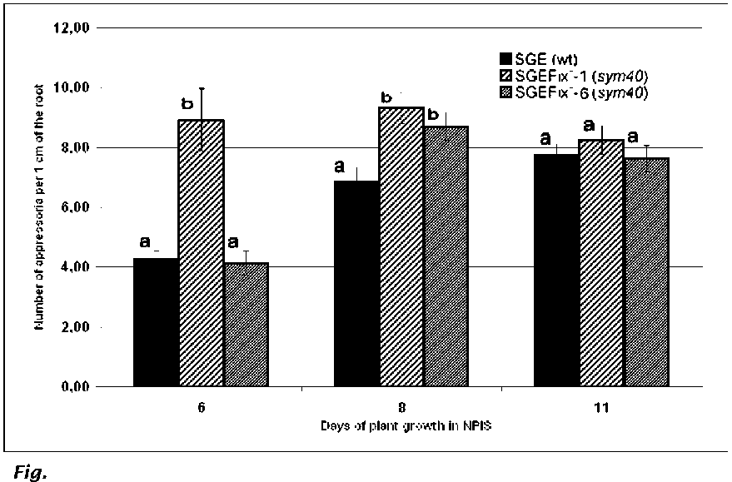
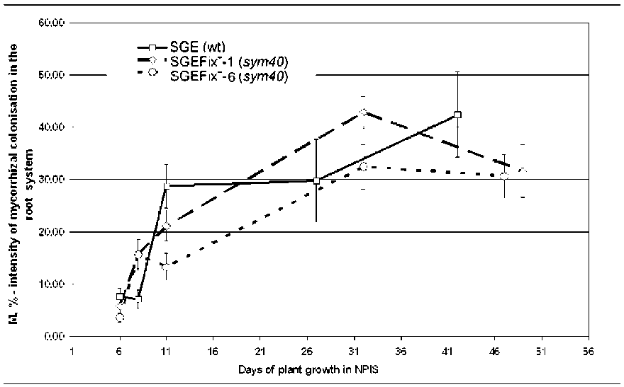
1. Number of appressoria per 1 cm of the root in pea symbiotic
mutants SGEFix-1 (sym40), SGEFix-6 (sym40) and the wild-type line SGE.
Standard errors show variance of mean values at certain time points.
Values marked with the same letters do not statistically significant differ
at PZ0.95 at certain time points.
Fig. 2. Intensity of mycorrhizal colonization in the root system (M%) in
pea symbiotic mutants SGEFix-1 (sym40), SGEFix-6 (sym40) and the wild-
type line SGE. Standard errors show variance of mean values at certain
time points. Values marked with the same color (white, gray) do not
differ at PZ0.95 at certain time points.
dynamics of arbuscule
development and turnover was
similar to that described before in
Jacobi et al. (2) (Fig. 2, 3).
Mutant SGEFix:-1. Many more
appressoria were formed on the
roots of the mutant line SGEFix⁻- 1
(sym40) than on those of SGE or
SGEFix⁻- 6 (sym40) (Fig. 1). Plants
of the mutant line SGEFix-1
showed an intensity of
colonization close to that of the
wild type at the early time points
(Fig. 2) and high speed of
arbuscule development
accompanied with their fast
turnover (Fig. 3) as was described
previously (2).

Mutant SGEFixc-6. In contrast to
SGE, by eight days of growth in
NPIS the mutant line SGEFix⁻- 6
(sym40), exhibited a similar high
number of appressoria as SGEFix⁻-
1 (sjm40) (Fig. 1). Plants of
SGEFix⁻- 6 ( sym40) differed from
the other two lines by the reduced
speed of mycorrhization (Fig. 2).
Although the speed of arbuscule
development in the roots of line
SGEFix⁻- 6 (sym40) is slightly
slower in comparison with the
other mutant line, the process of
arbuscule turnover in this line was
similar to that of the line SGEFix⁻-
1 (sym40) (Fig. 3).

Discussion
The difference between the
wild type line SGE and the
mutant line SGEFix-1 (sym40) in
number of appressoria in process of AM development (at six and eight days of plant growth in NPIS) has
been shown for the first time. In contrast, the mutant line SGEFix-6 (sym40) at six days of growth in
NPIS did not differ significantly from the wild type line SGE, whereas at eight days the two mutant lines
did not differ from each other, but they both differed from the wild type line. Intensity of mycorrhizal
colonization (M%) in the root system of the both mutant lines was similar until eight days of plant growth
in NPIS, but after eight days statistically significant differences between these lines existed. All the lines
differed from each other in dynamics of arbuscule development and turnover, especially at the early time

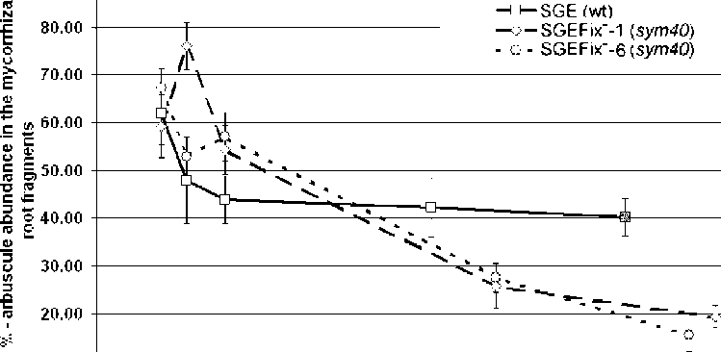
90.00
10,00
0.00 -I,,,,,,,,,,1
16 11 16 21 26 31 36 41 46 51 56
□ays of plant growth in NPIS
points. However, arbuscule
abundance of the both mutant
lines was identically changed
after 11 days of plant growth in
NPIS.
Thus, two independently
obtained allelic mutations
characterized in the present study
differ by phenotypic
manifestation, especially at the
early time points. Consequently,
we may suppose that we deal with
mutations in different structural
domains of the gene sym40.
Perhaps, new independently
obtained mutants in this gene will
have new phenotypic
manifestations.

Acknowledgments: This work was
financially supported by Government contracts 02.445.11.7492, 02.434.11.7122, Grant of the President of Russia (HIII-
9744.2006.04), Russian Foundation for Basic Research (04-04-48457, 04-04-48462, 07-04-01558, 07-04-01171), CRDF (ST-
012-0), and NWO (047.117.2005.006).
1. Jacobi, L.M., Petrova, O.S., Tsyganov, V.E., Borisov, A.Y. and Tikhonovich, I.A. 2003a. Mycorrhiza.
13: 3-7.
2. Jacob,i L.M., Zubkova, L.A., Barmicheva, E.M., Tsyganov, V.E., Borisov, A.Y. and Tikhonovich, I.A.
2003b. Mycorrhiza 13: 9-16.
- Hoagland, D. R. and Arnon, D. I. 1938. The Water-Culture Method for Growing Plants Without Soil. Circ.
347, Univ. California, College of Agric., Berkeley.
- Kosterin, O.E .and Rozov, S.M. 1993. Pisum Genetics, 25: 27-31.
- Muromtsev, G.S., Marshunova, G.A. and Jacobi, L.M. 1989. USSR Inventor's Certificate no. 1501509.
- Rosewarne, G., Barker, S.L. and Smith, S.E. 1997. Mycol. Res. 101: 966-970.
- Schiifiler, A., Schwarzott, D. and Walker, C. 2001. Mycol. Res. 105: 1413-1297.
- Trouvelo,T.A., Kough, J.L. and Gianinazzi-Pearson, V. 1986. In: Gianinazzi-Pearson, V. and Gianinazzi,
S. ( eds.) Physiological and Genetical Aspects of Mycorrhizae. INRA. Paris, pp 217-221.
- Tsyganov, V.E., Morzhina, E.V., Stefanov, S.Y., Borisov, A.Y., Lebsky, V.K. and Tikhonovich, I.A. 1998.
Mol. Gen. Genet. 259: 491-503.
10. Vierheilig, H., Coughlan, A.P., Wyss, U. and Piche, Y. 1998. Appl. Environ. Microbiol. 64: 5004-5007.
Fig. 3. Arbuscule abundance in the mycorrhizal root fragments (a%) in
pea symbiotic mutants SGEFix⁻- 1 (sym40), SGEFix⁻- 6 (sym40) and the wild-
type line SGE. Standard errors show variance of mean values at certain
time points. Values marked with different colors (white, gray) differ at
PZ0.95 at certain time points.

