Characterization of microsatellite loci using selected pea accessions
and recombinant inbred lines (RILs)

Moreno, R.R. and Polans, N.O. Dept. of Biol. Sci. and Plant Molecular Biol. Center
Northern Illinois Univ., DeKalb, IL, U.S.A.

Most microsatellite DNA sequences are comprised of short, rapidly evolving tandem arrays located in
untranslated DNA. They are unlikely to be affected directly by natural selection, making them highly
informative neutral molecular markers (4-5). In a previous study (6), we developed and characterized novel pea
microsatellite loci and evaluated their applicability as polymorphic molecular markers primarily by employing
the Randomly Amplified Microsatellite Site (RAMS) protocol (3). In the present study, we extend these
analyses by examining banding patterns produced by the microsatellite-specific primer sequences cited in the
original RAMS project (3). Once again, RAMS profiles for a variety of pea accessions are used to assess band
pattern variability, and a Sequence-Tagged Microsatellite Site (STMS) is characterized and mapped using
Recombinant Inbred Lines (RILs).

Materials and Methods
DNAs from 17 pea accessions representing the range of the genus Pisum are amplified with each of 15
primer sets (3) and separated on polyacrylamide gels to evaluate detectable differences using the RAMS method
(see 6). Clearly discernable polymorphic and monomorphic bands between 90-300 bp in size are scored as
"present", "absent" or "uncertain" for each accession. Primer sets that provide at least one polymorphic band
are surveyed using a more comprehensive set of 64 pea DNAs.
A STMS for primer set PSMPA6 is isolated by applying an increased primer annealing temperature (60º C).
The STMS locus is evaluated for a similar set of 17 pea DNAs using 3% agarose gels stained with ethidium
bromide and viewed with UV transillumination. The locus is mapped on the pea genome using the
MapManagerQTX computer package (2) and a set of 57 RILs derived from a cross between parent plants
A1078-234 and PI179449.

PrimerNo. Bands -
across TaxaNo. Polymorphic
bands - across TaxaPSMPA672PSMPA71412PSMPA972PSMPB1665PSMPC20114PSMPAA3171PSMPAD14475
Table 1. Number of polymorphic bands produced by selected
Results and Discussion
Eight of the 15 primer sets examined in this study provide only monomorphic bands when evaluated on the
initial 17 individuals selected to represent the genus Pisum. The remaining seven primer sets reveal varying
degrees of polymorphism for the same accessions and produce 59 total bands when scored across the more
comprehensive set of 64 pea DNAs. Thirty-one of these bands are polymorphic, while 28 of the bands are
monomorphic. Primer PSMPA7 yields the greatest number of bands (14 bands), of which 12 bands are
polymorphic (Table 1 and Fig. 1). Primer PSMPB16 yields the fewest number of bands (6 bands), of which 5
bands are polymorphic (Table 1). None of the primers yields only polymorphic bands when evaluated for all 64
pea accessions.
The STMS bands amplified
with primer set PSMPA6 appear to
follow some general pea
phylogenetic relationships. Little
or no amplification of the STMS
band is evident for P. fulvum, P.
sativum ssp. abyssinicum or P.
sativum ssp. southern humile (one
of the two P. fulvum individuals
may display a weak band near

154bp), while all of the P. sativum
ssp. northern humile, ssp. elatius
and ssp. sativum display one or
more strong bands between 154
and 298bp (Fig. 2).
Because the PSMPA6 STMS
site appeared to segregate with
plant height in ssp. sativum
accessions during the survey
process, the STMS marker is
analyzed further using a set of 57
RILs. The results reveal that the
polymorphic bands do segregate
according to plant height with the
single exception of RIL 46, a short
plant phenotype that produces the
"tall" STMS marker (Fig. 3).
Upon combining the STMS data
with previously gathered
morphological, isozyme, RAPD
and ISSR data, tight genetic
linkage (within 0.9 cM) is
established between the PSMPA6
STMS and morphological marker
Le.
The addition of these pea
microsatellite-based molecular
markers to current data sets
should be useful for a number of
applications, including both the
delineation of relationships among
detailed genetic linkage maps.
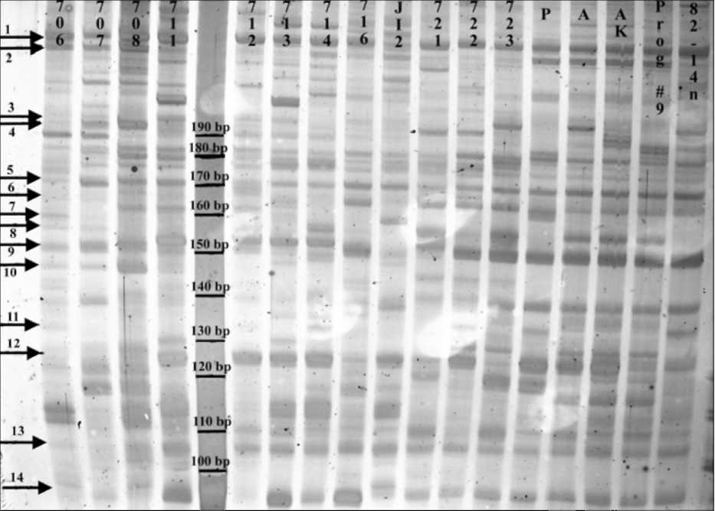
Fig 1. RAMS band patterns produced using primer set PSMPA7 with pea DNA.
From left to right: fulvum (706, 707 and 708), southern humile (711, 712, 713
and 714), northern humile (716), abyssinicum (JI2), elatius (721, 722 and 723)
and sativum (P=PI179449, A=A1078-234, AK=cv. Alaska, Prog #9= cv. Progress
#9 and 82-14n). JI denotes accessions from the John Innes collection, population
isolates 706-723 are from the Ben Ze'ev and Zohary (1) collection, cv. Alaska is
from J. Mollema and Son, Inc. (Grand Rapids, MI), cv. Progress #9 is from Ferry-
Morse Seeds (Mountain View, CA) and accessions 82-14n, PI179449 and A1078-
234 were kindly provided by G. Marx and N. Weeden. Both monomorphic bands
(1 and 5) and polymorphic bands (2-4 and 6-14) are observed. The marker lane
contains a 10-bp molecular size standard. The 6% polyacrylamide gel is treated
with silver stain and preserved in cellophane. Digital image is captured using a
Nikon CoolPix L5 digital camera mounted above a white light box. Molecular
marker sizes, arrows and accessions are added using Adobe PhotoShop v. 6.0.

cultivated peas and their wild relatives and the development of highly-

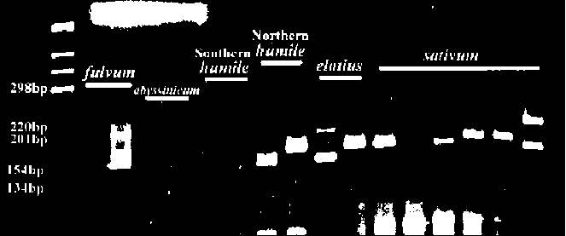
Fig 2. Primer PSMPA6 STMS band patterns detected in
pea DNA. From left to right: fulvum (703 and 707),
abyssinicum (JI2 and JI225), southern humile (713 and
714), northern humile (716 and JI1794), elatius (721 and
722) and sativum (JI228, JI264, JI787, JI1035, JI1372
and cv. Alaska). JI denotes accessions from the John
Innes collection, population isolates 703-722 are from
the Ben Ze'ev and Zohary (1) collection and cv. Alaska is
from J. Mollema and Son, Inc. (Grand Rapids, MI). PCR
products are run on a 3% agarose gel and stained with
ethidium bromide. The digital image is captured using a
Gel Logic 200 Imaging System with UV transillumination.
Molecular marker sizes, arrows and accessions are 11
added using Adobe PhotoShop v. 6.0.
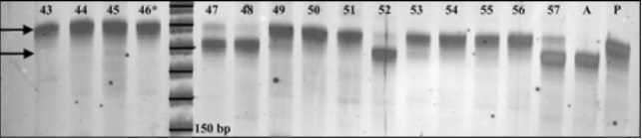
Fig 3. Primer PSMPA6 STMS band patterns for a
selection of Recombinant Inbred Lines derived from an
initial cross between accessions PI179449 and A1078-
234. Parent PI179449 is a tall plant and displays a
band at ~190bp. Parent A1078-234 is a short plant
and displays a band at ~180bp. RIL individuals 43, 44,
45, 49, 50, 51, 53, 54, 55 and 56 are all tall
individuals that display the 190bp-"tall" band. RIL
individuals 47, 48, 52 and 57 are all short individuals
that display the 180bp-"short" band. RIL individual #46
is a short plant that displays the "tall" band, thus
suggesting genetic recombination between the STMS
locus and the morphological marker Le. The 6%
polyacrylamide gel is treated with silver stain and
preserved in cellophane. Digital image is captured
using a Nikon CoolPix L5 digital camera mounted
above a white light box. Molecular marker sizes,
arrows and accessions are added using Adobe
PhotoShop v. 6.0.

Acknowledgement: This work was supported by funds from the Department of Biological Sciences and the Plant Molecular
Biology Center, Northern Illinois University.
- Ben Ze'ev, N. and Zohary, D. 1973. Israel J. Bot. 22: 73-91.
- Chmielewicz, K.M. and Manly, K.F. 2002. MapManager QTX Software for genetic mapping of Mendelian
markers and quantitative trait loci.
- Ford, R., Le Roux, K., Itman, C., Brouwer, J.B. and Taylor, P.W.J. 2002. Euphytica 124: 397-405.
- Goldstein, D.B. and Pollock, D.D. 1997. J. Hered. 88: 335-345.
- Jarne, P. and Lagoda, P.J.L. 1996. Tree 11: 424-429.
- Moreno, R.R. and Polans, N.O. 2006. Pisum Genetics 38: 7-12.

