Contents

PGA Notes.......................................................................................................................................................................................ii

Research Papers
A mitochondrial DNA marker frequently found in wild peas
Bogdanova, V.S., and Kosterin, O.E. ..........................................................................................................................1
Two Argonaute1 genes from pea
DeMason, D.A. and Weeden, N.F. ..............................................................................................................................3
Development and characterization of microsatellite loci in pea
Moreno, R.R. and Polans, N.O. .................................................................................................................................10
A new allele at the Tl locus — tl na
Rozov, S.M .....................................................................................................................................................................15
Two new pea mutations simultaneously affecting tendrils and leaflet shape and
plant internode length.
Rozov, S.M......................................................................................................................................................................17
A gene for stem fasciation is localized on linkage group III
Sinjushin, A.A., Konovalov, F.A. and Gostimskii, S.A.........................................................................................19
Symbiotic gene Sym33 is located on linkage group I
Tsyganov, V.E., Rozov,. S.M., Borisov, Y. and Tikhonovich, I.A.......................................................................21
Fs and U appear to be alleles of a locus near the end of linkage group V
Weeden, N.F...................................................................................................................................................................23

Brief Communications
A new dominant-acting necrosis mutation in pea
S. M. Rozov.....................................................................................................................................................................31
New mutation in pea affecting tendrils (taa):lateral tendrils grow at an acute angle
S. M. Rozov.....................................................................................................................................................................32

Announcements
Formation of PeaGRIC: An international consortium to co-ordinate and utilize the
genetic diversity and agro ecological distribution of major collections of Pisum
Furman, B.J., Ambrose, M. , Coyne, C.J. and Redden, B......................................................................................34

Membership List.........................................................................................................................................................................37

Pisum Genetics Association Notes

Membership
and Dues

Submission of
Manuscripts

Format of
Manuscripts

Brief
Communications

The Pisum Genetics Association (PGA) is a non-profit, unincorporated organization established to foster genetic study of the pea, to facilitate the exchange of information and to ensure preservation of valuable genetic stocks. The journal, Pisum Genetics, is the principal means of meeting these aims. Published annually in one issue, Pisum Genetics contains reports of research findings and other information of interest to researchers studying the genus Pisum.
Membership in the PGA is open to all interested persons and organizations. Dues are US $15.00 per year. These dues are used to help defray the costs of publishing and mailing Pisum Genetics. Members are requested to send checks or bank drafts in US currency only. Such efforts avoid bank charges, which can exceed $10.00 per check in some currencies. Starting in January, 2007, financial transactions of the Association will be handled by Dr. Kevin McPhee at Pullman, Washington USA. Please make checks payable to Pisum Genetics Association and send to Dr. K.E. McPhee, USDA, Department of Agronomy, 303 Johnson Hall, Washington State University, Pullman, WA 99164-6434 USA. Pisum Genetics will be sent upon receipt of dues. Electronic payment is also a possibility. Contact the current editor (nweeden@montana.edu) for instructions.
All members of the PGA are welcome to submit manuscripts on topics appropriate for Pisum Genetics. The deadline for such submittals is usually September 1 of the year of publication, allowing for sufficient time for review and revision of manuscripts. The journal provides opportunities for both refereed and non-refereed manuscripts, publication is within 3 to 6 months of submittal, and there are no page charges. The editor is pleased to announce that Pisum Genetics will now also be indexed in CAB International. As has been the case for the last decade, a web-based version is available shortly after publication of the hard copy (http://hermes.bionet.nsc.ru/pg/).
When submitting an electronic copy of a manuscript, please use Microsoft Word when possible. Other formats can be handled, but these will usually be converted to Word for processing. It is also helpful if authors avoid the use of extra formatting in their submissions (headers, sections, automatic indentation) as these generally have to be eliminated when preparing the manuscript for final printing. Tables created in Word using the table function are most likely to survive the formatting process intact. We have severe limitations on support staff, and the removal of interfering formatting can occasionally be quite time-consuming. Graphics reproduce best at 300 dpi.
Manuscripts are generally separated into two types, research papers and brief communications. Manuscripts submitted as research papers will be subjected to peer review. Research papers should be written concisely, with a short introduction presenting the purpose for the study, a materials and methods section with essential details and references to techniques, a results section and discussion section interpreting the results and integrating findings with those of other workers. Section headings are not obligatory. The length of manuscripts is flexible. Manuscripts under five journal pages are encouraged. Longer papers will be considered on their merits and space availability in the volume. All research papers must be treated similarly to submissions to other refereed journals in that they should contain original work not currently submitted to any other journal.
Brief communications are to encourage a rapid sharing of new results that may not meet the standards of a research paper (i.e. allelism tests not completed, map locations only approximate). Brief communications can also be used to describe the availability of new germplasm. Brief communications will not be subjected to peer review,

Member News

Financial Report

although the editor reserves the right to screen papers for appropriateness and to review submissions for clarity and brevity. Such submissions will be limited to approximately one page and should be narrowly focused. Otherwise, the format of brief communications (tables, references, etc.) should correspond to that of a research paper. Publication of a brief communication in Pisum Genetics does not preclude publication of a full paper on the same subject in a later issue or in another journal.
In addition to performing his usual excellent job of placing the most recent issue of Pisum Genetics on to the PGA website, Dr. Serge Rozov has also been working on making older issues of the journal available on the site. Although extra copies of some volumes are available from the editor, copies of volumes 1 through 9 and 21 through 29 are no longer available. Volumes 21 through 29 in particular contain much information that needs to be generally accessible. Placing this material on the PGA website appears to be the most appropriate method for providing this access. In support of this effort, the Coordinating Committee agreed to provide a $1,000 grant to Dr. Rozov from the PGA account. Volumes 25, 27, 28 and 29 are now available at the website in both html and pdf format, and the Coordinating Committee would like to congratulate Dr. Rozov on his excellent progress.
This October Dr. F.J. (Fred) Muehlbauer retired from the USDA after 37 years of service as pulse breeder, geneticist and Research Leader of the Grain Legume Genetics and Physiology Research Unit. Under Fred’s expert guidance, the unit moved pulse breeding into the molecular age and released many cultivars of pea, lentil and chickpea that have been widely grown in the Pacific Northwest and elsewhere. Fred plans to stay in Pullman and continues to spend time in the office this winter. However, as 2007 progresses the focus of his activities may shift slightly to fishing and family pursuits. We wish Fred the best in all his future endeavors and thank him for his efforts and advice in support of the Association.
Dr. Kevin McPhee, the USDA pea and lentil breeder/geneticist at Pullman has agreed to serve as associate editor and chief financial officer for the Association. Dr. McPhee will also take Dr. Muehlbauer’s place on the PGA Coordinating Committee. As detailed below, the bulk of the PGA funds will be transferred to Pullman once the certificate of deposit matures. Dr. McPhee will assume the editorship of Pisum Genetics for volume 40 in 2008. For volume 39, manuscripts can be submitted to either the associate editor or the editor before the September 1, 2007 deadline.
The Association continues to be on sound financial footing. Except for the grant to place additional volumes of Pisum Genetics on the website, the income from dues and subscriptions was very close to the expenditures. For at least the next year, the PGA accounts will be split between Pullman and Bozeman. When the certificate of deposit matures, those funds will be transferred to Pullman to set up the major account for the PGA. New dues will be deposited primarily to this account. I will continue to access the funds in the savings account at Bozeman to pay printing and mailing expenses for volumes 38 and 39.

Account balances as of October 1, 2005
Account balance (savings and time deposit) 8349.37
Cash on hand 23.02
Total assets 8372.39

Income
Subscriptions 600.00
Bank interest (savings) 6.65
Bank interest (certificate of deposit through
maturity (January 11, 2007) 118.00
Total income 724.65

Expenditures
Printing costs 478.40
Mailing expenses 240.40
Supplies 161.51
Grant for web posting of Pisum Genetics 1000.00
Electronic transfer of funds 40.00
Total expenditures 1920.31

Account balances
Savings (Sept. 30, 2006) 1500.80
Certificate of deposit at maturity (Jan. 11, 2007) 6020.97
Cash on hand at end of fiscal year (20.27)

Net balance for Pisum Genetics Association 7501.50

N.F. Weeden for the Coordinating Committee

M. Ambrose F.J. Muehlbauer S.M. Rozov
T.H.N. Ellis I.C. Murfet W.K. Święcicki
O.E. Kosterin J.B. Reid N.F. Weeden

18 | 35 | 23 | 76 | 1.13
91 | 27 | 118 | 0.28 |  | Fas
30 | 120 | 0.00 |  |  | Table 2. Segregations and joint chi-square values for the selected loci in F.
 | Loci | Classes in segregation | N | Joint χ2
CH | CA |  | CB | AH | AA
 |  |  |  | Fas-Le | 70

Pepcn

21

 | Fas-Egl1 |  |  |  |  |  |  |  |  |  |  |  | 44 |  |  | 10
 | 14 | 0 |  | 101 |  | 067.14 |  |  |  | Fas-Pepcn |  | 28 |  | 5
5 | 8 |  |  |  | 0 |  | 063 |  | 038.36 |  |  |  |  |  | Fas-PK4
8 | 17 |  | 7 |  | 16 |  | 3 |  | 074 |  | 122.81
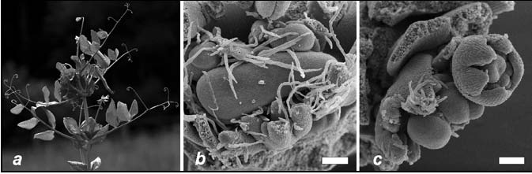 |  |  | Fig. 1. Fasciated plant of “Shtambovy” mutant line (a) and scanning electronic microphotographs depicting stem apical meristems of “Shtambovy” mutant (b) and wild type plant (Nemchinovsky cultivar, c). Scale bar = 100 μ. |  | 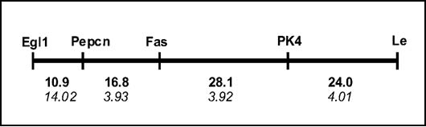 |  |  |  | Fig. 2. Region of LG III containing gene Fas. Top numbers are genetic distances (cM), bottom numbers (in italics) are meanings of LOD score. |  | 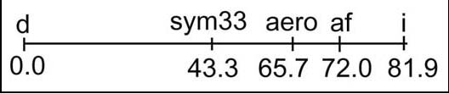 |  | Fig.1. The map of the d—sym33—i region. The distances are given in cM. |  | Table 1. Joint segregation data in the F2 populations of crosses 1) NGB1238 (d) x SGEFix--2 (sym33), 2) SGEFix--2 (sym33) x NGB1515 (d, I), 3) NGB2715 (d, I, af) x SGEFix--2 (sym33), 4) (Wt-10584 (aero, I) x SGEFix--2 (sym33)).
Gene pairs | Phase |  | Number of progeny with |  | designated phenotype* |  | Total |  | Joint χ2 |  | Prob. |  | RCV |  | SE

7

117
000.71

a/b |  |  |  |  |  |  |  |  |  |  |  |  |  |  |  |  |  |  |  |  |  |  |  |  |  |  |  |  |  |  |  |  |  |  |  |  |  |  |  |  |  |  |  | 1 |  |  | d - sym33 |  |  | R
 |  |  |  |  |  |  |  |  |  |  |  | 2 |  |  | 6 |  |  |  | 15 |  |  | 111 |  |  | 08.6 |  |  | <0.025 |  |  | 37.4 |  |  |  | 5.5 |  |  |  |  |  |  |  | 2 |  |  | d - sym33 |  |  | R
7 |  |  |  | 8 |  |  | 17 |  |  | 31 |  |  | 13 |  |  | 4 |  | 9 |  |  | 20 |  |  | 119 |  |  | 18.2 |  |  | <0.005 |  |  | 35.5 |  |  | 4.1 |  |  |  |  |  |  |  |  |  |  | I - sym33 |  |  | C
39 |  |  |  | 23 |  |  |  |  |  |  |  |  |  |  |  | 3 |  | 8 |  |  | 18 |  |  | 119 |  |  | 13.5 |  |  | <0.005 |  |  | 31.9 |  |  | 5.0 |  |  |  |  |  |  |  | 3 |  |  | d - sym33 |  |  | R
 |  |  | 8 |  | 20 |  |  | 66 |  |  | 21 |  |  | 12 |  |  | 14 |  |  | 18 |  |  | 195 |  |  | 16.6 |  |  | <0.005 |  |  | 39.8 |  | 3.4 |  |  |  |  |  |  |  |  |  |  | I - sym33 |  |  | C
79 |  |  |  | 22 |  |  |  |  |  |  |  |  |  |  |  | 3 |  | 21 |  |  | 25 |  |  | 195 |  |  | 29.7 |  |  | <0.0001 |  |  | 27.0 |  |  | 3.6 |  |  |  |  |  |  |  |  |  |  | af - sym33 |  |  | R
 |  |  | 1 |  | 26 |  |  | 57 |  |  | 14 |  |  | 4 |  |  | 26 |  |  | 32 |  |  | 195 |  |  | 50.2 |  |  | <0.0001 |  |  | 27.5 |  | 2.8 |  |  |  |  |  |  |  | 4 |  |  | d - sym33 |  |  | R
 |  |  | 4 |  | 8 |  |  | 24 |  |  | 7 |  |  | 5 |  |  | 7 |  |  | 14 |  |  | 100 |  |  | 27.4 |  |  | <0.0001 |  |  | 28.9 |  | 4.0 |  |  |  |  |  |  |  |  |  |  | I - sym33 |  |  | C
60 |  |  |  | 19 |  |  |  |  |  |  |  |  |  |  |  | 8 |  | 7 |  |  | 20 |  |  | 154 |  |  | 24.9 |  |  | <0.0001 |  |  | 30.9 |  |  | 4.3 |  |  |  |  |  |  |  |  |  |  | aero - sym33 |  |  | R
 |  |  | 1 |  | 10 |  |  | 36 |  |  | 8 |  |  | 9 |  |  | 16 |  |  | 29 |  |  | 144 |  |  | 60.6 |  |  | <0.0001 |  |  | 24.6 |  | 3.0 |  |  |  |  |  |  |  | 1A/a first gene; B/b second gene; h, heterozygous. When both genes are dominant, the capital letter stands for the dominant allele. When the second gene is codominant, the capital A stands for the dominant allele of the first gene and capital B for an allele of the second gene in coupling with A. When both genes are codominant, the capital letter stands for an allele of the first parent. |  |  | The calculations were made using S.M. Rozov’s programs PLANT and CROSS and Piet Stam’s program JoinMap (10). |  |  | 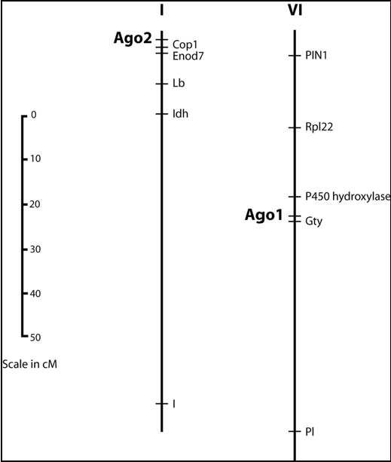
 |  |  | A |  |  |  |  | 5’ segment of PIWI domain |  |  |  |  |  | PsAGO1-1 LLIVILPDNN GSLYGDLKRI CETDLGVVSQ CCLTKHVFKM SKQYLANVSL KINVKVGGRN ..... |  |  | PsAGO1-2 LLIVILPDNN GSLYGDLKRI CETDLGVVSQ CCLTKHVFKM NKQYLANVSL KINVKVGGRN ..... |  |  | OsAGO1 LLIVILPDNN GSLYGDLKRI CETDLGLVSQ CCLTKHVFKM SKQYLANVAL KINVKVGGRN ..... |  |  | NbAGO1-1 LLIVILPDNN GSLYGDLKRI CETELGIVSQ CCLTKHVFKM SKQYLANVSL KINVKVGGRN ..... |  |  | NbAGO1-2 LLVVILPDNN GSLYGDLKRI CETELGVVSQ CCLTKHVFKM SKQYLANVAL KINVKVGGRN ..... |  |  | AtAGO1 LLIVILPDNN GSLYGDLKRI CETELGIVSQ CCLTKHVFKM SKQYMANVAL KINVKVGGRN ..... |  |  | AtZLL LLLAILPDNN GSLYGDLKRI CETELGLISQ CCLTKHVFKI SKQYLANVSL KINVKMGGRN ..... |  | Consensus LLivILPDNN GSLYGDLKRI CET#LG.!SQ CCLTKHVFKm sKQY$ANVsL KINVKvGGRN ..... |  |  |  |  |  |  |  |  |  |  | B

5’ ……GGTGTCTCCTCCACCTGCACCAAGTGAGGCAAG…… 3’

a/h

A mitochondrial DNA marker frequently found in wild peas

Bogdanova, V.S., and Kosterin, O.E. Inst. of Cytol. and Genet. of the Siberian Dept.
Russian Acad. of Sci., Novosibirsk, Russia

Earlier we reported on a chloroplast DNA marker polymorphic in wild peas (1). In the present work a mitochondrial DNA marker is characterized in a set of accessions which includes 31 wild and 18 cultivated samples (see Appendix). The list of accessions tested is extended compared to that reported in (1). The primers were designed 5'-TGGTAATTGGTCTGTTCCGATTCT-3' and 5'-CCACTGCTTGAAGTGATTGTTACG-3' to match the nucleotide sequence of the EMBL X14409 accession (pea mitochondrial coxI gene for cytochrome oxidase subunit I). A fragment of 1200 bp was amplified using the following cycling parameters: initial denaturation at 95oC for 1 min followed by 38 cycles including denaturation at 94oC 59 sec, annealing at 56oC 45 sec, elongation at 72oC 1 min. Five microliters of the reaction were treated with one 1 unit of PsiI endonuclease for 2 hours at 37oC in a volume of 12 μl and electrophoresed in 1.5% agarose gel in TAE buffer. We found a polymorphism for the presence/absence of the PsiI recognition site, so that PCR products obtained from some accessions were digested into two fragments of 260 and 940 bp, while other samples produced a single band of 1200 bp.
We assayed 49 specimens of wild and cultivated peas, which represent most of the presently recognised taxa. The digestion profiles of PCR products amplified from the cox1 gene of some pea accessions are shown in Fig. 1.
We found that the restriction site for PsiI in the mitochondrial gene cox1 is present in all eight accessions of Pisum fulvum Sibth et Smith and in all four accessions of P. sativum ssp. abyssinicum. Following Townsend (2) and Davis (3), we consider all wild representatives of Pisum sativum L. (except for P. sativum ssp. abyssinicum (A. Br.) Berger) within the same subspecies P. sativum ssp. elatius (Bieb.) Schmahl. sensu lato. In total we analysed 23 accessions of this subspecies and found that 11 of them have the restriction site while 12 do not (see Appendix). The restriction site was found in neither accession of P. s. ssp. transcaucasicum Govorov examined nor in any of 12 accessions of P. s. ssp. sativum. Noteworthy, in 44 of 49 accessions analyzed, the presence of the recognition site for PsiI in the mitochondrial coxI gene coincided with the presence of the recognition site for AspLEI endonuclease in the plastid gene rbcL (1, and unpublished), the studied fragments being amplified from the same samples of genomic DNA extracted from a single plant for each accession. The five exceptions were VIR320*, VIR2123, L90, Ps008-120689-0202 (which had the restriction site in the mitochondrial coxI but not the restriction site in the plastid rbcL), and accession VIR1975 in which the situation was opposite. We conclude that the restriction site in the coxI gene, as well as that in the plastic gene rbcL, were both present in the closest common ancestor of the genus Pisum. Both have been lost in at least one lineage of P. sativum ssp. elatius, and this lineage gave rise to the cultivated P. sativum ssp. sativum.

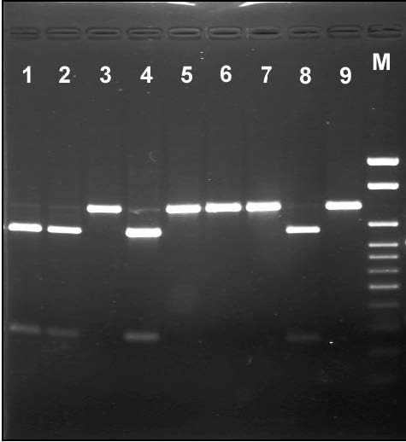 pDrive Cloning Vector

3.85 kb

Fig. 1. Restriction fragments formed after PsiI digestion of PCR-amplified
cox
1 gene from some pea samples. Lanes: 1—VIR2759,
P.s.
ssp.
abyssinicum
; 2—WL1446,
P.s.
ssp.
abyssinicum
; 3—VIR4871,
P.s.
ssp.
transcaucasicum
; 4—WT6, P.s. ssp. abyssinicum; 5—VIR3954,
P.s.
ssp.
sativum
; 6—VIR2593,
P.s.
ssp.
sativum
; 7—VIR3429,
P.s.
ssp.
sativum
(“
Pisum jomardi
”?); 8—VIR320*,
P.s.
ssp.
elatius
; 9—VIR1975,
P.s.
ssp.
sativum
; M—molecular weight marker 100-1000 bp + 1.5 kb + 2 kb.

Fig. 3. Sequence comparisons. A. Alignment of predicted PsAGO1 and PsAGO2 amino acid sequences with some similar plant AGO1-like genes. B. Nucleotide sequences of PsAGO1 and PsAGO2 and match-up with that of Arabidopsis miR168.

Acknowledgement:

This work was supported by the "Biosphere origin and evolution" project of the Russian Academy of Sciences.

1. Bogdanova, V.S. and Kosterin, O.E. 2005. Pisum Genetics 37: 40-42.
2. Townsend, C. 1968. Kew Bull. Roy. Bot. Gard. 21: 435-358.
3. Davis, H. 1970. Flora of Turkey and the East Aegean Islands. Edinburgh, v. 3.
Appendix: List of accessions analysed for the presence of PsiI site in cox1 mitochondrial DNA marker:

Pisum fulvum Sibth et Smith: L93, VIR6070, VIR6071, WL2140, JI2203, WT301, WT303, L96

P. sativum ssp. abyssinicum: VIR2759, WL1446, WT6, JI1876

P. sativum ssp. elatius (Bieb.) Schmahl. with the restriction site: VIR320, VIR320*, VIR2521, VIR2524, WL2123, Ps008-120689-0202, Pe013-190785-0105, JI261, L90, L100, L101

P. sativum ssp. elatius (Bieb.) Schmahl.without the restriction site: VIR1851, VIR4014, VIR7327, VIR7328, VIR7329, JI1794, CE1, CE2, Ps002-050689-0302; P012-050785-0102, P016-290685-01, P017-270685-0105

P. s. ssp. transcaucasicum Govorov: VIR3249, VIR4871

P. s. ssp. sativum: VIR1975, VIR2516, VIR2172, VIR2593, VIR3424, VIR3429, VIR3439, VIR3913, VIR3954, VIR7006, VIR7163, Sprint-1

Two Argonaute

1

genes from pea

DeMason, D.A. and Bot. and Plant Sci., Univ. of California, Riverside, CA, USA
Weeden, N.F. Plant Sci. and Plant Path., Montana State Univ., Bozeman, MT, USA

Introduction
The Argonaute/PIWI family of proteins was founded by the Argonaute genes in Arabidopsis and PIWI in Drosophila. These proteins have now been found in many species of plants, invertebrates and vertebrates, including humans. These proteins are known to function in RNA silencing and contain two conserved domains known as PAZ and PIWI (4). The AGO protein is a component of the RNA-induced silencing complex (RISC), which targets specific mRNAs for destruction using a microRNA (miRNA) as a guide. Recent 3-D analysis of the PAZ and PIWI domains has provided data to explain their functions. The PAZ domain binds to nucleic acids, with a preference for RNA over DNA (18). The 3-D structure of the PIWI domain is similar to that of the RNase H family of enzymes, and it is thought to function as the catalytic site for target mRNA cleavage (15).
There are 10 members of the Argonaute gene family in Arabidopsis. Some of these genes are known to play roles in development because mutants have dramatic developmental phenotypes. AGO7/ZIPPY controls early shoot ontogeny, and AGO10/PINHEAD/ZWILLE plays several roles in shoot meristem identity and maintenance (8, 11, 12, 14). Mutants of AGO1 show many developmental defects. Vegetative leaves often lack blades, axillary buds are lacking, cauline leaves are filamentous, abnormal inflorescences produce sterile, radial flowers, the stem is fasciated, and plants show defects in auxin responses (3, 10, 16, 19). AGO1 is unusual among Arabidopsis AGO family members in that it possesses a miRNA target site and is apparently regulated itself by miR168 (22).
Our goal was to identify AGO1-like genes from pea, compare their sequences to AtAGO1 and other AGO1-like genes, map them to determine if any known mutants in pea correspond to these genes, and observe expression patterns in parts of pea plants, including shoot tips of the leaf form mutants.

Materials and Methods
Pisum sativum genotypes used for this study were obtained from the Marx collection. The tendrilled acacia (uni-tac) line was W6 15272. The other lines used were from a set of near isogenic lines constructed by G.A. Marx and designated: wildtype (WT) W6 22593, acacia/tendril-less (tl) W6 22594, afila (af) W6 22597, and the double mutant, af tl W6 22598. Plants were grown in a standard greenhouse at 20°C in the day and 15°C at night.
To obtain gene sequences, a WT shoot tip cDNA library was screened as described previously (7) using the AtAGO1 PIWI box sequence as a probe. Positive clones were then sequenced and primers were designed to do both 5’ and 3’ RACE to obtain the full coding sequences (5). Sequence analysis was done using the NCBI website (http://www.ncbi.nlm.gov/) and the MultAlin program (http://prodes.toulouse.inra.fr/multalin.html). The putative miRNA binding sites were identified using the Microinspector website (http://www.imbb.forth.gr/microinspector) (17).
To obtain data on gene-specific expression, plant parts, embryos and shoot tips were obtained, cDNAs prepared and PCR was done in the linear range as described previously (1, 6). Expression was calculated on the basis of control genes, which were DEAD-box or β-actin and PCR was done as described previously (6). The primers for PsAGO1 were F: GCT CTT GGT TGC TTA GGT GA and R: TGC TGT GGA GTA AAA CAT CTC A and for PsAGO2 were F: ATT CCC ACG CAT TAC ACA C and R: CTC GAC AAT TTT GCA GAC C. The PCR products obtained from cDNAs were 1425 bp and 800 bp, respectively.
Mapping of
AGO
sequences was performed on two recombinant inbred (RI) populations derived from the crosses JI 1794 x ‘Slow’ and MN313 x JI 1794. The former population consisted of 53 F
12
lines, and segregation data for over 1000 markers is available for this population (23 and unpublished). The latter population consisted of 50 F
8
lines, and about 300 markers have been mapped on the linkage map developed for this

population. Primers used for mapping the

PsAGO1
sequence were F: GGC GGT GTG GGC CCT GGT and R: GAG CCA AGG CGC AGG AAG. These primers were selected to span introns in the genomic sequence. Primers for mapping the
PsAGO2
gene were F: TGC ATT TAT TGA GCC ACT GC and R: TGC AAG CTC ACA ACA AAA GG. These primers were expected to amplify a 1927 bp region across intron 2. Polymorphism was identified by CAPS analysis (9).
Relationships among the various Argonaute sequences available in the literature were determined using Phylogenic Analysis Using Parsimony (PAUP) version 4.0b10 (20). The sequences compared are listed in Table 1. Complete coding sequences were used for the comparison among the two pea sequences, the AtZWILLE, AtPINHEAD and AtAGO1 sequences from Arabidopsis thaliana, the four sequences from Oryza sativa and the two sequences from Nicotiana bethamiana. Only partial coding sequences (ESTs) were available for the Trifolium pratense, Medicago truncatula, Phaseolus coccineus and Arachis hypogaea genes, and these were compared with the two Pisum sativum sequences and the AtAGO1 and NbAGO1-1 sequences using only approximately 660 bp near the 3’ end of the coding sequence available from each of the EST sequences. For this latter analysis the AtAGO1 and NbAGO1-1 sequences were used as the outgroup.

Table 1. List of Argonaute sequences used in the PAUP analysis

Sequence designation | Source | NCBI accession
PsAGO1 | Pisum sativum | EF108450
PsAGO2 | Pisum sativum | EF108449
T. pratense | Trifolium pratense | AB236789
M. truncatula | Medicago truncatula combined | CB895213 and BM779610
P. cocinneus | Phaseolus coccineus | CA905209
A. hypogaea | Arachis hypogaea | EG029779
AtAGO1 | Arabidopsis thaliana | U91995
NbAGO1-1 | Nicotiana bethamiana | DQ321488
NbAGO1-2 | Nicotiana bethamiana | DQ321489
OsAGO1 | Oryza sativa | NM_001054239
OsAGO4g566500 | Oryza sativa | NM_001060116
OsAGOJO13091 | Oryza sativa | AK111587
OsAGO2g831600 | Oryza sativa | NM_001055156
AtPINHEAD | Arabidopsis thaliana | AF154272
AtZWILLE | Arabidopsis thaliana | NM123748.2

Results and Discussion

Results and Discussion
Complete coding sequences of two pea AGO genes were obtained with our methods. We call these PsAGO1 (EF108450) and PsAGO2 (EF108449). Based on the predicted amino acid sequences, these proteins were of similar lengths (1100 vs 1070 aa). They contained the two domains common to Argonaute genes: PAZ (aa 438 and 436 respectively) and PIWI (aa 726 and 696 respectively). BLAST comparisons of these amino acid sequences with other known AGO proteins revealed that they were most similar to AGO1 (NP_849784) in Arabidopsis, two AGO1-like sequences from Nicotiana benthamiana (ABC61502 and ABC61503) and a putative Argonaute protein from rice (BAD27856). These proteins showed strong sequence conservation in all regions except the N-terminal region, which had considerable gene specific variation (data not shown).
Comparison of the two Pisum sativum DNA sequences with other complete coding sequences (Fig 1A) revealed that the two clearly clustered with other AGO1 sequences and were clearly distinct from ZWILLE

and PINHEAD sequences. The Pisum sequences were most closely related to each other, with the AtAGO1 sequence being the next most similar, confirming the results from the protein sequence analysis. Although two AGO1 genes are also found in Nicotiana benthamiana, the presumed duplication producing those two sequences apparently occurred independently of the duplication forming the two Pisum sequences. PAUP analysis of the partial coding sequences available from other legume species produced a tree that mirrored the established phylogeny of the taxa being compared (Fig. 1B). Two most parsimonious trees were detected. Only the strict consensus tree is shown in Fig. 1B. These results support the hypothesis that only AGO1 members of the Argonaute gene family are being compared in this analysis.
The PsAGO1 primers amplified a product of approximately 1500 bp that displayed polymorphism between JI 1794 and the domesticated lines when cut with the restriction enzyme HaeIII . The position of the locus Ago1 was determined to be on linkage group (LG) VI about 4 cM from Gty (Table 2). In the JI 1794 x ‘Slow’ linkage map, the region around Gty appeared to be compressed, with 10 or more markers within 5 cM of Gty. The order of the markers was ambiguous, and it could not be determined on which side of Gty Ago1 was located. The data from the second RI population indicated Ago1 lay distal to Gty, towards Rpl22 (Fig. 2).
The PsAGO2 primers amplified a fragment of about 2000 bp in the domesticated lines but did not amplify a product in JI 1794. This presence/absence polymorphism could be easily scored without need for CAPS analysis. Ago2 was found to be the most distal marker on the upper arm of LGI in both RI populations (Fig 2). The combined data from both populations placed Ago2 approximately 3 cM from Cop1 (Table 2).

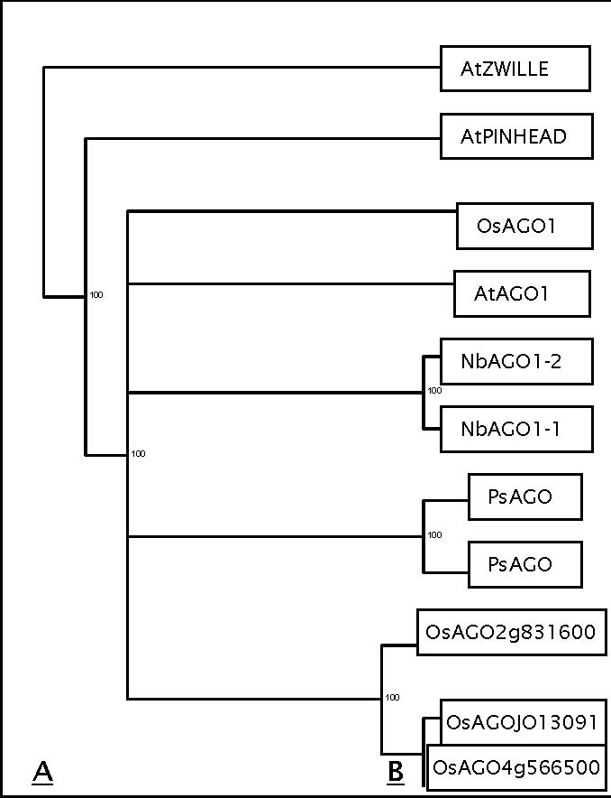

Fig. 1. Phylogenetic relationships among the Argonaute sequences based on PAUP analysis. A) The strict con-sensus tree for the full-length plant Argonaute genes available in the literature and B) the strict consensus tree for the comparison of approximately 600 bp of coding sequence at the 3’ end of an AGO gene from each of the legume species listed. The Arabidopsis and Nicotiana sequences were used as outgroups for the latter analysis.

ATAGO1CODINGAtAGO1
NBAGO1 1CODINGNbAGO1-1
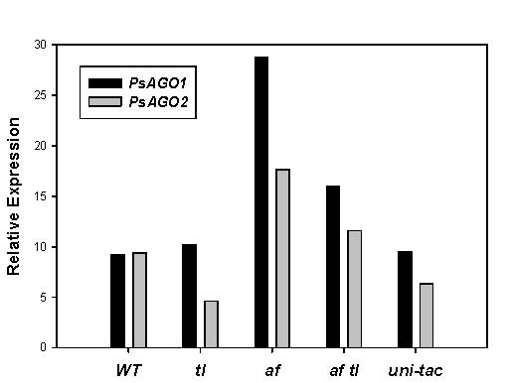

CA905209 SCARL

P. coccineus

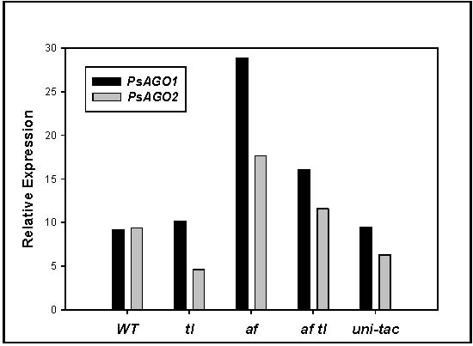

EG029779 PEANU

A. hypogaea

MTRUNCAT COMBIM. truncatula
TRIPRAAGOT. pratense
PSAGO2 ENDPsAGO
PsAGO
B
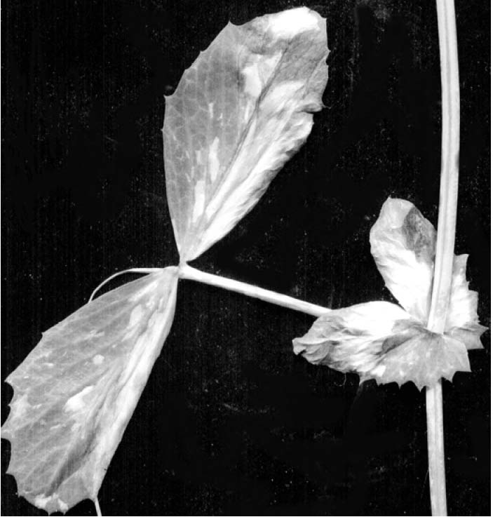

A

B

OSAGO02G067220OsAGO2g831600

Free Energy -34.7

PsAGO2

5’ ……GGTGTCTCCTCCACCTGCACCGAGTGAGGCAAT…… 3’
| | | ||||||||| || ||
mir168a/b 3’aagggcuggacgugguucgcu 5’

Free Energy -34.7

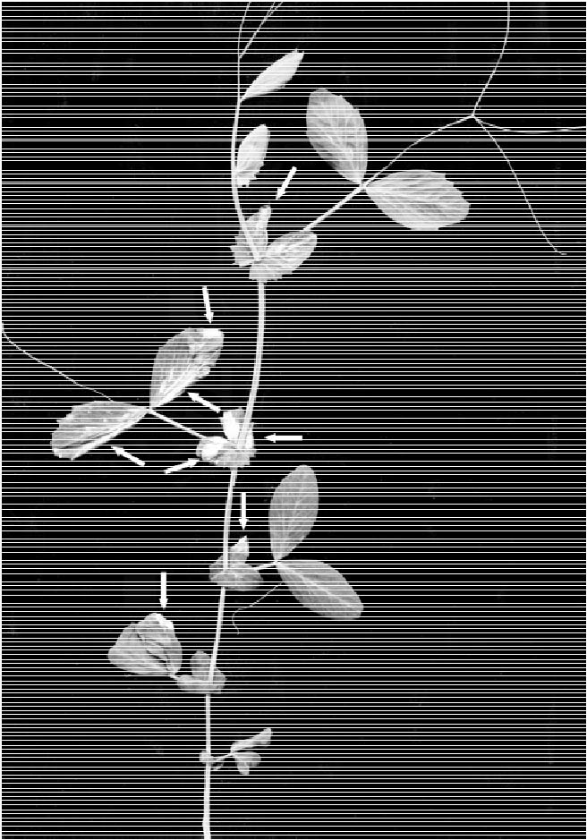

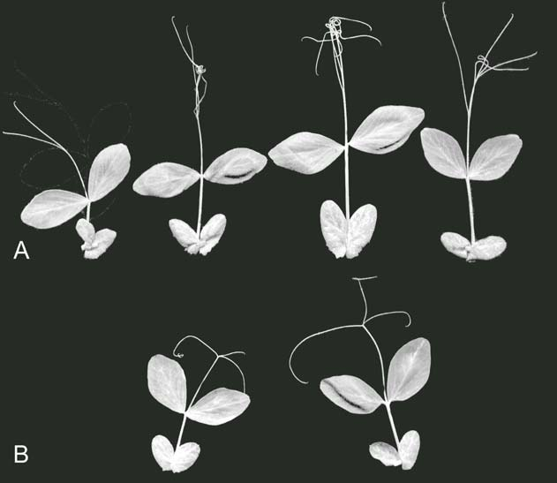
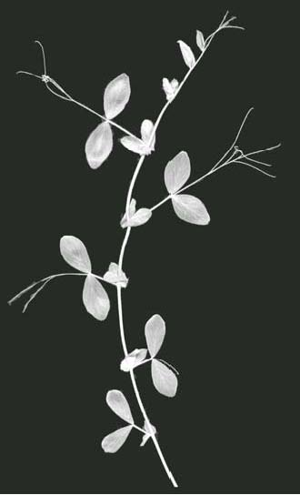

ATZWILLE CODINAtZWILLE

ATPINHEADCODINAtPINHEAD
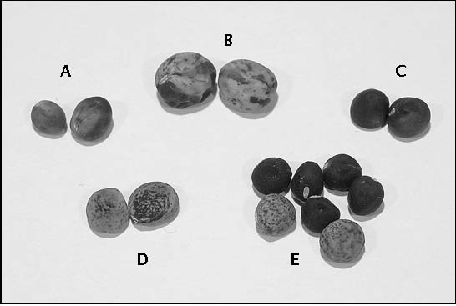

OsAGO1

ATAGO1CODINGAtAGO1
NBAGP1 2NbAGO1-2
NBAGP1 1CODINGNbAGO1-1

PsAGO
PsAGO

OSAGO J01CODINOsAGOJO13091
OsAGO4g566500
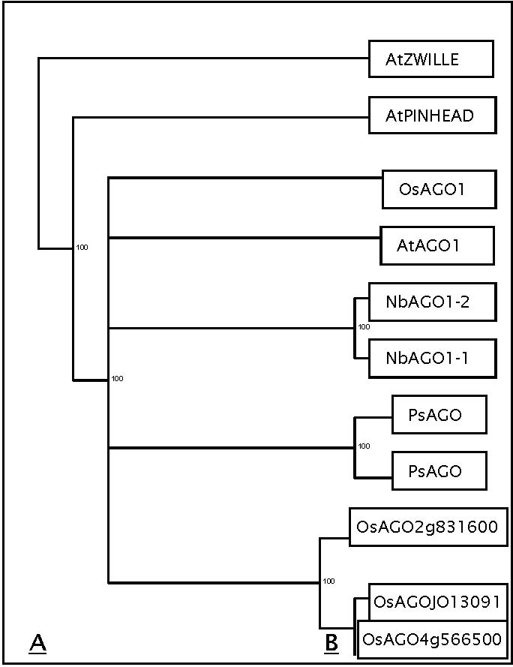

Neither the position of

Ago

1 nor

Ago

2 obviously matched that of known mutations in pea that modify leaf development. There is no known morphological mutation in pea that maps near

Cop

1 (23). Several mutations are located within 15 cM of

Gty

, including

rui

,

p

, and

er

1. Of these, only

rui

has a phenotype that might be expected from a mutation in an

Argonaute

gene (21, 24). Neither the roughened testa characteristic of

Gty

nor the loss of sclerenchyma in the pod walls displayed by plants homozygous for

p

are expected phenotypes for a mutation at

Ago

1. Nor would a mutation of this gene be expected to confer resistance to powdery mildew. Hence, we are investigating only the possibility of a relationship between

rui

and

Ago

1. At present the relative position of

Rui

to

Gty

is uncertain.

Four amino acids (Y, K, Q and K) present near the 5’ end of the conserved PIWI domain have been shown to be important for RNA binding affinity of the Archeoglobus fulgidus Piwi protein and three of these (K, Q, K) have also been shown to be important in cleavage of the target mRNA by the human AGO2 protein (13). These amino acids are also conserved in PsAGO1 and PsAGO2, as well as in the other AGO1-like proteins from the other plant species we examined (Fig.3A). Conservation of these four amino acids extends to the Arabidopsis AGO10/PNH/ZLL protein. Because of this conservation, it is likely that all of these proteins are active in RNAi regulation of gene expression. AtAGO1 mRNA is known to be regulated by a miRNA (miR168), the Microinspector program was used to evaluate the pea nucleotide sequences for potential miRNA binding sites using sequences of Arabidopsis thaliana miRNAs and -27 as the free energy (ΔG) limit for both PsAGO1 and PsAGO2. Both pea sequences possessed a potential miR168 binding site in approximately the same position as the one identified in AtAGO1 (Fig. 3B). In fact, the target sequences from pea are better matches to the Arabidopsis miR168 sequence than the target in AtAGO1 (ΔG of -34.7 vs. -21). The two AGO1 genes from

Table 2. Joint segregation analysis of PsAGO genes and closely linked standard markers

 |  |  | No. of lines with designated genotype1 | Recombination
RI population | N | P1 P1 |  | P1P2 | P2P1 | P2P2 | Fraction + SE
Ago1/Gty
JI 1794 x ‘Slow’ | 43 | 22 |  | 1 | 1 | 29 | 3 + 1
MN313 x JI | 46 | 24 |  | 5 | 0 | 17 | 5 + 1
Ago2/Cop1
JI 1794 x ‘Slow’ | 49 | 14 |  | 4 | 2 | 29 | 6 + 1
MN313 x JI 1794 | 48 | 22 |  | 0 | 1 | 25 | 5 + 1

1Genotype designations: P1 = Maternal parent, P2 = Paternal parent. All genotypes were homozygous.

tobacco and the putative Argonaute sequence from rice lack this target site (data not shown). From these data we would predict that PsAGO1 and PsAGO2 are both regulated by a single miRNA.
Both PsAGO1 and PsAGO2 were expressed in all growing plant parts and showed very similar expression patterns (Fig 4A). mRNA levels of both genes were abundant in developing and mature embryos as well (Fig. 4B). mRNA levels of PsAGO1 appeared to be more abundant in young embryos and the embryonic axis of mature embryos than PsAGO2. Bohmert et al. (3) found that AtAGO1 was expressed in all plant parts and at all stages of development in Arabidopsis. The two pea genes have overlapping and redundant expression patterns in all part of pea tested.
As
AtAGO
1 was originally described as a leaf development gene, we looked at mRNA level of
PsAGO
1 and
PsAGO
2 in the shoot tips of the leaf form mutants. mRNA levels of both genes were higher in the
af
genotypes (
af
and
af tl
) than in
WT
(Fig. 5). The mRNA levels of
PsAGO
1 were similar in
tl
,
uni-tac
and
WT
, whereas those of
PsAGO2
were lower in the
tl
and
uni-tac
genotypes than in
WT
. This pattern of differential expression was not what we had expected from the phenotype of
AGO
1 mutants in
Arabidopsis
, which have peg-shaped leaves lacking a lamina. The radial symmetry of peg-shaped leaves and of tendrils suggested that mRNA levels of these genes might be lower in
af
and higher in
tl
and
uni-tac
. Instead, the pattern of mRNA expression of these

two genes is similar to that of

Uni
,
PsPIN
1 and
PsPK
2, which are all GA and auxin regulated (1, 2, 6), suggesting that these two genes play a role in auxin signaling. Sorin, et al. (19) have shown that in
Arabidopsis AGO
1 plays a role in two auxin responses: auxin-mediated hypocotyle elongation and adventitious root formation.

PsAGO1

| | | |||||||||||| ||
mir168a/b 3’aagggcuggacgugguucgcu 5’

In conclusion, we have identified two pea genes similar in sequence to

AtAGO

1

which we call

PsAGO

1 and

PsAGO

2. They map to LGVI near

Gty

and on the upper arm of LGI near

Cop

1, respectively. The position of the

Ago

1 locus in pea encourages further examination of its relationship to the mutant

ruinous

. Sequence analysis suggests that both

PsAGO

1 and

PsAGO

2 function in RNAi and are themselves regulated by a miRNA, just as

AtAGO

1 is. These genes have overlapping and redundant expression patterns in developing pea and are differentially expressed in shoot tips of the classic pea leaf mutants.

Acknowledgements: The authors thank Matt Lavin for assistance with the PAUP analysis and Janet Giles for her technical support.

1. Bai, F. and DeMason, D.A. 2006. Plant Cell Physiol. 47: 935-948.
2. Bai, F., Watson, J.C., Walling, J., Weeden, N., Santner, A.A. and DeMason, D.A. 2005. Plant Sci. 168: 1281-1291.
3. Bohmert, K., Camus, I., Bellini, C., Bouchez, D., Caboche, M. and Benning, C. 1998. EMBO J. 17: 170-180.
4. Cerutti, L., Mian, N. and Bateman, A. 2000. Trends Biochem. Sci. 25: 481-482.
5. Chawla, R. and DeMason, D. 2003. Pisum Genet. 35: 3-5.
6. Chawla, R. and DeMason, D.A. 2004. Plant Growth Reg. 44: 1-14.
7. Giles, J.E., Villani, P.J. and DeMason, D.A. 1998. Plant Physiol. 117: 1125.
8. Hunter, C., Sun, H. and Poethig, R.S. 2003. Curr. Biol. 13: 1734-1749.

Fig. 4. PsAGO1 and PsAGO2 expression. A. Expression in various plant parts. B. Expression in different stages of developing embryos. DEAD-box was used as a control for equal cDNA used for RT-PCR and equal loading.

Fig. 1. SGE-0812 mutant line. This plant has two well developed lateral branches and many short lateral branches, while the parental SGE line usually forms only a single main stem.

Figure 5. PsAGO1 and PsAGO2 expression shoot tips. Expression is expressed relative to mRNA of actin which was used for equal cDNA for RT-PCR and equal loading.

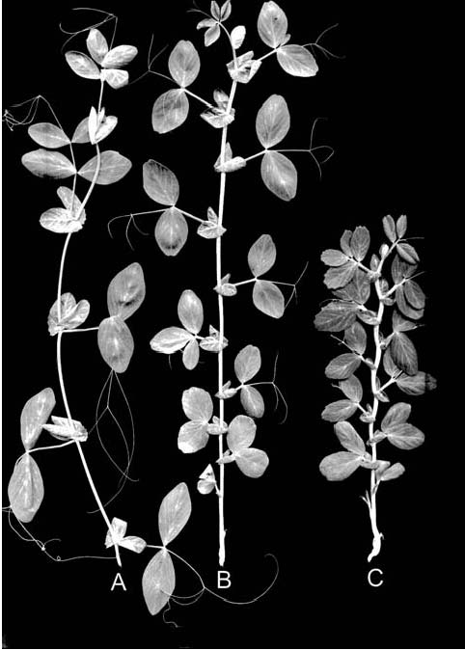

9. Jarvis, P., Lister, C., Szabo, V., Dean, C., Konieczny A. and Ausubel, F.M. 1994. Plant Mol. Biol. 24: 685-687.

10. Kidner, C.A. and Martienssen, R.A. 2004. Nature 428: 81-84.
11. Lynn, K., Fernandez, A., Aida, M., Sedbrook, J., Tasaka, M., Masson, P. and Barton, M.K. 1999. Development 126: 469-491.
12. McConnell, J.R. and Barton, M.K. 1995. Dev. Genet. 16: 358-366.
13. Ma, J-B., Yuan, Y-R., Meister, G., Pei, Y., Tuschl, T. and Patel, D.J. 2005. Nature 434: 666-670.
14. Moussian, B., Schoof, H., Haecker, A., Jürgens, G.. and Laux, T. 1998. EMBO J. 17: 1799-1809.
15. Parker, J.S., Roe, S.M., and Barford, D. 2004. EMBO J. 23: 4727-4737.
16. Ronemus, M., Vaugh, M.W.and Martienssen, R.A.. 2006. Plant Cell 81: 1559-1574.
17. Rusinov, V., Baev, V., Minkov, I. and Tabler, M. 2005. Nuc. Acid Res. 33: W696-W700.
18. Song, J.-J. and J.-T. Leemor. 2006. Cur. Opin. Structural Biol. 16:5-11.
19. Sorin, C., Bussell, J.D., Camus, I., Ljung, K., Kowalczyk, M., Geiss,G., McKhann, H., Garcion, C., Vaucheret, H., Sandberg, G. and Bellini, C. 2005. Plant Cell 17: 1343-1359.
20. Swofford, D. 1998. PAUP*: phylogenetic analysis using parsimony (*and other methods), Version 4.0b10a. Sinauer Associates, Sunderland, MA, USA.
21, Święcicki, W.K. 1988. Pisum Genetics 20: 38.
22. Vaucheret, H., Vazques, F., Crété, P, and Bartel, D.P. 2004. Genes and Dev. 18: 1187-1197.
23. Weeden, N.F., Ellis, T.H.N., Timmerman-Vaughan, G.M., Święcicki, W.K., Rozov, S.M. and Berdnikov, V.A. 1998. Pisum Genetics 30: 1-4.
24. Wolko B. 1989. Pisum Genetics 21: 80-81.

Development and characterization of microsatellite loci in pea

Moreno, R.R. and Polans, N.O. Dept. of Biol. Sci. and Plant Mol. Biol. Center
Northern Illinois Univ., DeKalb, IL, USA

Microsatellite DNA is comprised of rapidly evolving tandem arrays of 1-6 nucleotides in head-to-tail repeat motifs commonly including fewer than 60 units (5-6). Most microsatellite sequences are located in untranslated DNA between genes and, therefore, are unlikely to be affected directly by natural selection (5-6). For this reason, microsatellite loci can serve as highly informative neutral molecular markers in a variety of applications. In previous studies involving pea, microsatellite-based molecular markers have been used to determine inter-genera transferability of primers (7), to analyze diversity within the genus Pisum (3) and to estimate the level of microsatellite polymorphism in Pisum sativum L. (2). Sequence Tagged Microsatellite Sites (STMS) primarily are used to determine sequence length polymorphism; STMS sequence length variations typically arise from the loss or gain of microsatellite repeat units via polymerase slippage. RAMS (Randomly Amplified MicroSatellites), a novel molecular marker technique (3), extends the application of STMS by employing microsatellite-specific primer sets at lower PCR annealing temperatures to produce less-specific multi-banded DNA profiles. It is assumed that the STMS locus is amplified along with these less-specific loci during the RAMS procedure. In the present study we: 1) develop and characterize novel pea microsatellite loci (STMS) and then 2) evaluate RAMS profiles for pea accessions representing the range of the genus using primer sets developed for the STMS loci.

Materials and Methods
Total genomic DNA was extracted from P. sativum ssp. sativum accession PI179449, using 100 mg of fresh tissue. Approximately 4 μg of genomic DNA was digested with Rsa I, BstU I and Alu I restriction enzymes in separate reactions overnight at 37oC (4), after which double-stranded SNX adaptors were ligated to the resulting pea DNA fragments. Ligated DNA fragments from each of the restriction digests were hybridized with microsatellite complementary sequences using step-down programming (4) in a MJ Research PTC-100 thermal cycler. Four different biotinylated microsatellite probe mixtures acquired from the Savannah River Ecology Laboratory were used in separate hybridization reactions (Mixture #1: AACC5, AACG5, AAGC5, AAGG5, ATCC5, AC13; Mixture #2: TG12, AG12, AAG8, ATC8, AAC8, AAT12, ACT12; Mixture #3: AAAC6, AAAG6, AATC6, AATG6, ACCT6, ACAG6, ACTC6, ACTG6; Mixture #4: AAAT8, AACT8, AAGT8, ACAT8, AGAT8). The hybridized solutions were mixed with washed Dynabeads® M-280 Streptavidin magnetic beads. The reactions subsequently were washed six times to remove un-hybridized DNA fragments. After each wash the Dynabeads®, with hybridized DNA attached, were captured using a Magnetic Particle Collector (MPC). This method retained the microsatellite-containing pea DNA fragments bound to complementary probes while eliminating any unbound pea DNA strands. Each enriched pea DNA combination (e.g., Rsa I-cut DNA enriched with oligonucleotide mixture #3) was amplified by PCR, after which aliquots were separated on an agarose gel to ensure the successful recovery of appropriately sized (approximately 500 bp) DNA fragments. Prior to DNA cloning, the remaining PCR products were purified using a QIAquick® PCR purification kit. The linear pDrive cloning vector supplied in the QIAGEN® PCR Cloningplus Kit (see Fig. 1) has a uracil “overhang” that provides efficient U-A base ligation with purified PCR products. Ligation of enriched pea DNA with the pDrive cloning vector resulted in “nested” primer sites in which pea DNA fragments flanked by SNX sequences were inserted into a vector containing M13 universal primer sequences flanking the insertion site. Once the vector-ligation reaction was complete, bacterial transformation of QIAGEN® EZ Competent Cells was conducted using 2 μl of the ligation reaction mixture according to manufacturer specifications. Transformed bacteria were grown at 37oC for 24 hours on LB agar plates containing X-gal, IPTG and ampicillin. The plasmid vector contained in positive colonies then was amplified via PCR using M13 forward (-20) and M13 reverse primers. PCR products were separated on an agarose gel to ensure that the insert was an appropriate size (<600 bp) for sequencing reactions. Bacterial colonies containing an appropriately sized insert were placed in culture tubes containing 3 ml LB broth plus ampicillin and incubated at 37oC in an

Fig. 1 Graphical representation of the pDrive Cloning Vector. Pea DNA was amplified using the SNX sequence in a PCR reaction. The Taq polymerase leaves a deoxyadenosine base to which the uracil overhang at the vector insertion sites attaches. Pea DNA is nested between SNX primer sites which are nested in turn between M13 universal primer binding sites. SNX primers were used to verify pea DNA insertion, while M13 primers were used to check insert size and in subsequent DNA sequencing reactions. Sequence shown between the M13 and SNX primer binding sites is a portion of the plasmid vector sequence at the site of PCR product insertion (8).

incubator shaker at 200 rpm overnight. Plasmid DNA was recovered from the bacteria using a QIAprep® spin miniprep kit and eluted in ddH2O.
Sequencing reactions were conducted in the Core DNA Facility at Northern Illinois University using M13 forward (-20) and M13 reverse primers. SNX and microsatellite DNA sequences were detected as text-format sequencing data using a word processing program and the “Find” command. Text-format sequence data that contained microsatellite DNA sequences were imported into the Primer3 program (9) used to design microsatellite-specific primers. Optimal primer length was set at 20 bp, optimal Tm was set at 60oC and primer GC content was adjusted to a minimum of 20% and maximum of 80%. Resulting primer sets were ordered from either MWG Biotech (High Point, NC) or Sigma Genosys (The Woodlands, TX).
Pea DNA accessions representing the range of the genus
Pisum
were amplified with each primer set to evaluate detectable differences using the RAMS method [PCR: 15.65
μ
l ddH
2
O, 2.5
μ
l 10x PCR buffer, 2.5
μ
l MgCl
2
(25mM), 1.25
μ
l dNTPs (2.5 mM), 1
μ
l each forward and reverse primer (100 pmol/
μ
l) and 1 U
Taq
polymerase; cycle conditions: 95
o
C for 5 min, then 45 cycles of 95
o
C for 30 sec, 35
o
C for 30 sec and 72
o
C for 2 min)]. PCR products (5-6
μ
l) from all primer sets and a single-stranded 10 bp molecular marker were separated on 20 cm x 0.75 mm 6% polyacrylamide denaturing gels run under constant voltage (800 V) for

approximately 2 hours. Gels were stained using a Bio-Rad Silver Stain plus kit and preserved in cellophane. Clearly discernable polymorphic and monomorphic bands between 90-300 bp in size were scored as

“

present

”

,

“

absent

”

or

“

uncertain

”

for all accessions. Additionally, STMS loci were identified using

P.s
. ssp.
sativum
PI179449 DNA in a series of PCR reactions with increasing primer annealing temperatures to isolate a single DNA band in the RAMS profile. Preserved gels were photographed using a Nikon CoolPix 950 digital camera mounted above a white light box. The digital gel images were cropped and labeled using Adobe Photoshop v. 6.0 (see,
e.g.
, Fig. 2).
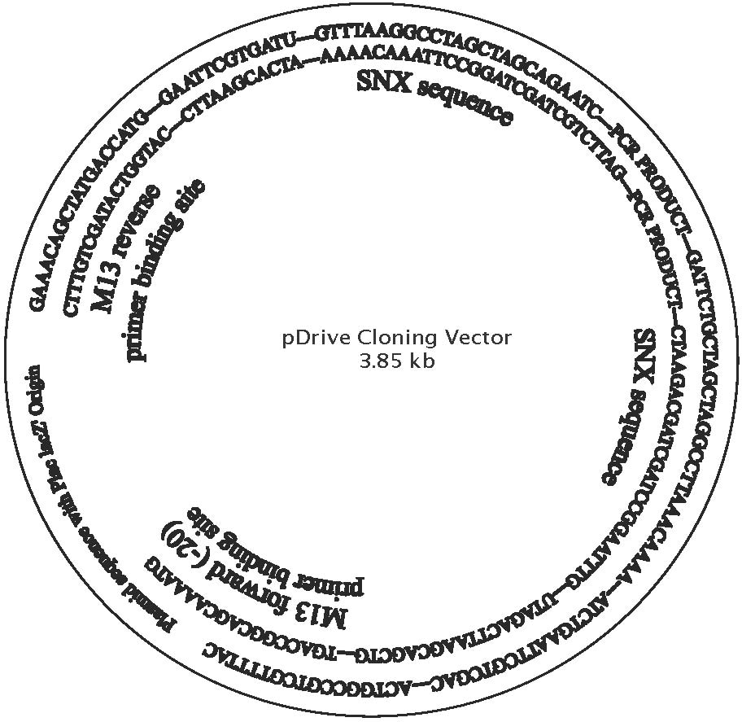
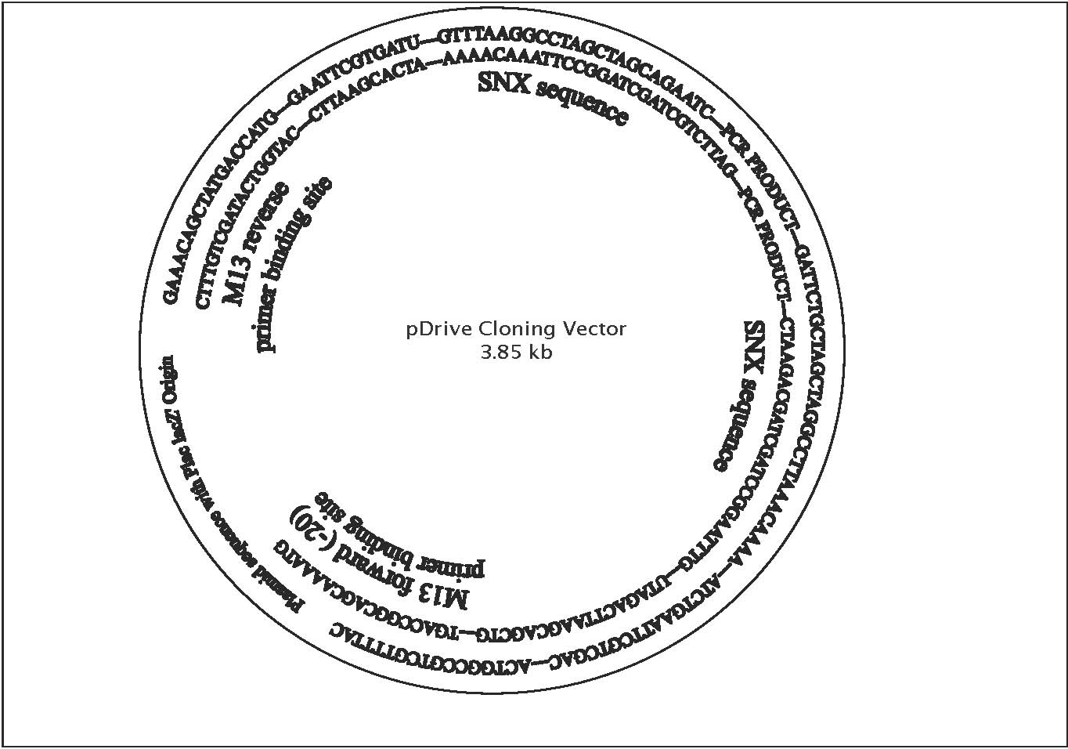

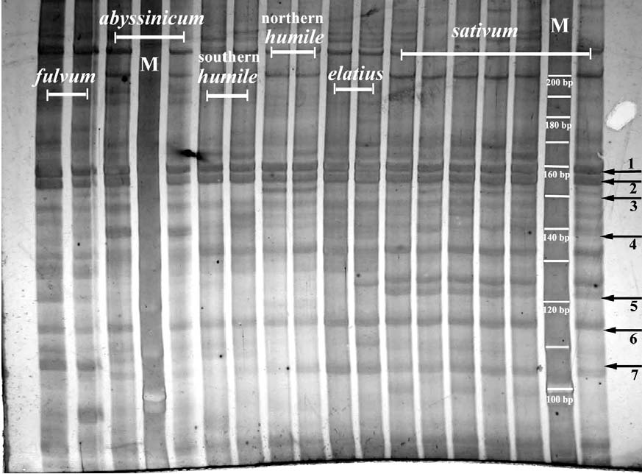

Fig 2. RAMS bands produced using primer set #14 on pea DNA representing the range of the genus Pisum. From left to right: fulvum (703 and 707), abyssinicum (JI2 and JI225), southern humile (713 and 714), northern humile (716 and JI1794), elatius (721 and 722) and sativum (JI228, JI264, JI787, JI1035, JI1372 and cv. Alaska). JI denotes accessions from the John Innes collection, population isolates 703-722 are from the Ben Ze’ev and Zohary (1) collection and cv. Alaska is from J. Mollema and Son, Inc. (Grand Rapids, MI). Both monomorphic bands (1, 2 and 6) and polymorphic bands (3, 4, 5 and 7) are observed. Band #3 is evident only in northern humile, while band #4 is evident only in abyssinicum. Band #5 is present in sativum and band #7 is present only in fulvum. Two lanes, denoted by “M” contain a 10-bp molecular size standard; the brightest band towards the bottom of the gel represents 100 bp. The 6% polyacrylamide gel was treated with silver stain and preserved in cellophane. Digital image was captured using a Nikon CoolPix 950 digital camera mounted above a white light box. Molecular marker sizes (bp), arrows and accessions were added using Adobe PhotoShop v. 6.0.

Results and Discussion
Two hundred twenty-seven plasmid vectors were recovered from the cloning exercises describe in Materials and Methods and then were quantified for DNA concentration. Forty-four of the plasmid DNA samples displayed suitable concentrations (~100 ng/
μ
l) for immediate DNA sequencing. The remaining 183

samples required either dilution with ddH

2
O or concentration with 3M NaOAc in order to be sequenced. These samples were stored at -20
o
C for future use. Twenty-one of the 44 sequenced samples (47%) did not contain microsatellite DNA even though the hybridized solutions were washed six times to remove non-specific fragments. Seven sequences that contained mono-nucleotide sequences (poly A and poly G) also were not included in our analyses because they are difficult to use when estimating length polymorphisms. Finally, two sequences that contained fewer than four repeat units of TG were not used because microsatellite DNA usually is defined by six or more repeat units. The mono-nucleotide microsatellites and short TG repeat microsatellites likely hybridized weakly with complementary microsatellite probes among the 26 different Savannah Laboratory sequences. The remaining 14 samples sequenced (32%) contained 18 microsatellite DNA sequences. Four of these DNA samples contained two unique microsatellite loci; however, reverse primers could not be designed for either locus contained in one of the samples because the microsatellites were located too close to the sequence terminus. The remaining 13 microsatellite-containing sequences contained 16 microsatellites that were flanked by unique DNA from which primers could be developed (Table 1).

Table 1. Pea microsatellite DNA primer set sequences and characteristics.

Primer |  | Sequence 5’ -> 3’ |  |  |  | Length (bp) |  |  | Micro-satellite Motif |  |  | Estimated PCR product size (bp)
1 |  | F:TAGTTCGGTACCGCATGTGT |  |  |  | 20 bp |  |  | TG10 |  |  | 136
 |  | R:ATGTATAATCTCAAACCATACTCAACA |  |  | 24 bp
2 |  | F:TTGATTGATTCCATACAAGCCT |  |  |  | 22 bp |  |  | TG8 |  |  | 297
 |  | R:ACCATGATTACGCCAAGCTC |  |  | 20 bp
3 |  | F:CGCATGCATGGAGTCTCATT |  |  |  | 20 bp |  |  | TG8 |  |  | 274
 |  | R:TGTGGAATTGTGAGCGGATA |  |  | 20 bp
4 |  | F:CACGAACGGATTCCTTCAAT |  |  |  | 20 bp |  |  | AG12 |  |  | 155
 |  | R:CAGAAGCATTTAATGGCGGT |  |  | 20 bp
5 |  | F:CACGAACGGATTCCTTCAAT |  |  |  | 20 bp |  |  | TG21 |  |  | 156
 |  | R:AGAAGCATTTAATGGCGGG |  |  | 20 bp
6 |  | F:AAGCTTGTCGACGAATTCAGA |  |  |  | 21 bp |  |  | TC8 |  |  | 135
 |  | R:GTTGAGTGGGGACGAAGAGG |  |  | 20 bp
7 |  | F:ACGCACAAAAGGAAGGAAAA |  |  |  | 20 bp |  |  | AC5 |  |  | 102
 |  | R:CCGGATAGATATCCTGCGAG |  |  | 20 bp
8 |  | F:CAACCCACACAAATGGTTCTT |  |  |  | 21 bp |  |  | AC7 |  |  | 151
 |  | R:AGCTGCTACGAATGAAGGCT |  |  | 20 bp
9 |  |  | F:GCAACCCACACAAATGGTTC |  |  | 20 bp |  |  | TC22 |  |  | 151
 | R:AGCTGCTACGAATGAAGGCT |  |  | 20 bp
10 |  |  | F:AGCTGCTACCAATGAAGGCT |  |  | 20 bp |  |  | TGAG5 |  |  | 124
 | R:AAAACCCTTGTCCAAAAGCA |  |  | 20 bp
11 |  |  | F:ACGAATGAAGGCTTGGAGTG |  |  | 20 bp |  |  | AG21 |  |  | 117
 | R:AAAACCCTTGTCCAAAAGCA |  |  | 20 bp
12 |  |  | F:CGATATCCTGCCGAGTCAGT |  |  | 20 bp |  |  | TG7 |  |  | 112
 | R:CACGCACACTAGAAATGGGA |  |  | 20 bp
13 |  |  | F:ACGAACAAGAACCAAAGGCA |  |  | 20 bp |  |  | TGA4 |  |  | 290
 | R:TGTGGAATTGTGAGCGGATA |  |  | 20 bp
14 |  |  | F:AAGCTTGTCGACGAATTCAGA |  |  | 21 bp |  |  | TCTA11 |  |  | 149
 | R:TTGAAAACCAAAGCAAGCAA |  |  | 20 bp
15 |  |  | F:AGCTGGTACGAATGAAGGCT |  |  | 20 bp |  |  | AG18 |  |  | 137
 | R:AATCTGAAGCCCACACAAGG |  |  | 20 bp
16 |  |  | F:AAGGGCAAAGACTCTCTCTCG |  |  | 21 bp |  |  | CAA7 |  |  | 268
 | R:TGTGGAATTGTGAGCGGATA |  |  | 20 bp

Twelve of the 16 microsatellite loci detected contained dinucleotide motifs, while two possessed trinucleotide motifs and another two contained tetranucleotide motifs. Seven of the 12 dinucleotide microsatellite loci were perfect arrays of which the shortest locus (detectable with primer set #7) consisted of 5 AC units and the longest locus (detectable with primer set #11) consisted of 21 AG units. The longest dinucleotide micro-satellite locus (detectable with primer set #9) consisted of 22 imperfect repeat units of TC with two transi-tion (C

→

A) mutations. One of the two trinucleotide microsatellite loci we discovered consisted of 4 units of TGA. Ordinarily only DNA segments with 5 or more repeat units are employed as microsatellites (5); how-ever, because the repeats were perfect in this case, we have retained them in our study. The other trinucleo-tide microsatellite locus contained 7 imperfect units of CAA (with one A

→

G transition mutation). Both tetranucleotide microsatellite loci consisted of imperfect repeat units. One contained 5 TGAG units with 1 G insertion and 1 AG insertion, while the other contained 11 TCTA units with 3 transition mutations (all A

→

G).

Eight of the 16 primer sets (#1, #2, #4, #7, #9, #12, #13 and #15) produced only monomorphic bands on 6% polyacrylamide gels when applied to 17 pea accessions representing taxa similar to those depicted in Fig. 2. Four of the 16 primer sets (#6, #8, #10 and #11) produced 18 scoreable bands on 6% polyacrylamide gels using the same 17 accessions. Fourteen of the 18 DNA bands were polymorphic, ranging in size from 110-270 bp. Two of the four monomorphic bands were 135 bp in length, and the other two monomorphic bands both were 150 bp in length. The remaining four of the 16 primer sets (#3, #5, #14 and #16) produced 19 scoreable bands on 6% polyacrylamide gels when applied to a much larger sample of 64 pea accessions. Fifteen of these 19 DNA bands were polymorphic and ranged in size from 105-240 bp. The four monomorphic bands detected ranged in size from 122 bp to 220 bp. On average, each polymorphic primer set generated nearly five DNA bands, with an average fragment length of 165 bp. Primer set #10 yielded three DNA bands, the fewest of the 8 poly-morphic primer sets, while primer set #6 produced 6 DNA bands, the most of the 8 polymorphic primer sets.
STMS loci were localized within the RAMS banding profiles using PI179449 DNA in combination with primer sets #3 (230 bp), #14 (158 bp) and #16 (255 bp), and are consistent with the putative PCR product size determined during primer set design (see Table 1). The STMS locus amplified by primer set #5 could not be localized unambiguously.
Using the RAMS method some general patterns of association among pea taxa can be detected on the preserved gels. In Fig. 2, for example, bands #1 (~160 bp), #2 (~155 bp) and #6 (~115 bp) are monomorphic across all accessions. Band #3 (~150 bp) is present in northern P.s. ssp. humile only. Band #4 (~140 bp) is present in only the P.s. ssp. abyssinicum accessions. Band #5 (~125 bp) is present in the six P.s. ssp. sativum accessions, and band #7 (~105 bp) is present only in the two P. fulvum accessions. These novel microsatellite molecular markers should be useful in a number of applications, including an examination of the relationships among the cultivated peas and their wild relatives.

Acknowledgement: This work was supported by funds from the Department of Biological Sciences and the Plant Molecular Biology Center, Northern Illinois University.

1. Ben Ze’ev, N. and Zohary, D. 1973. Israel J. Bot. 22: 73-91.
2. Burstin, J., Deniot, G., Potier, J., Weinachter, C., Aubert G. and Baranger A. 2001. Plant Breed. 120: 311-317.
3. Ford, R., Le Roux, K., Itman, C., Brouwer, J.B. and Taylor, P.W.J. 2002. Euphytica 124: 397-405.
4. Glenn, T.C. 2001. Savannah River Ecol. Lab publication.
5. Goldstein, D.B. and Pollock, D.D. 1997. J. of Hered. 88: 335-345.
6. Jarne, P and Lagoda, P.J.L.. 1996. Tree 11: 424-429.
7. Pandian, A., Ford, R. and Taylor, P.W.J. 2000. Plant Mol. Bio. Rep. 18: 395a-395h.
8. QIAGEN® PCR Cloning Handbook for QIAGEN PCR Cloning Kit and QIAGEN PCR Cloning plus Kit. 2001. In-house publication
9. Rozen, S. and Skaletsky, H.J. 2000. In: Krawetz, S and Misener, S. (eds.) Bioinformatics Methods and Protocols: Methods in Molecular Biology. Humana Press, Inc., Totowa, NJ, U.S.A., pp. 365-386.

A new allele at the Tl

locus

—

tl

na

Rozov, S.M. Inst. of Cytol. and Genet.
Siberian Branch of Russ. Acad. of Sci., Novosibirsk, Russia

A mutant line SGE-0812 with a clavicula (1, 2) (tendrilless) phenotype was isolated from the M2 progeny of EMS-treated pea line SGE. In addition to the classical acacia-like leaf appearance, line SGE-0812 carries some other striking features. The whole plant of SGE-0812 is one-half to one-third the size of the SGE parental line. All parts and organs of plant are diminished proportionally. We denote this phenotype as nana. In addition, the SGE-0812 line has a strong ramosus tendency, forming lateral branches of different length at almost every node (figs. 1 and 2). It should be noted that the plants of the parental line SGE have only the main stem and very rarely form short lateral branches.

Allelism test in the cross of SGE-0812 with the tester line WL1238 carrying the
clavicula
gene
tl
w
revealed that all F
1
progeny had an obvious
tl
(
clavicula
) phenotype. Thus, the SGE-0812 mutant evidently carries a new allele of the well-known
tl
gene. There remained the question whether the other phenotypic features of SGE-0812, such as size reduction (
nana
) and abundant branching (
ramosus
) result from an activity of the new
tl
allele or are independent mutation events. To clarify this uncertainty, I crossed the SGE-0812 line with the parental SGE line. In this cross all F
1
plants were of normal length, typical of the SGE line. The hybrid plants

also lacked any additional lateral branches but did show flattened tendrils, characteristic of

Tl/tl
heterozygotes. Only three phenotypic classes could be distinguished in the F
2
progeny of this cross, and their segregation ratio is given in Table 1.

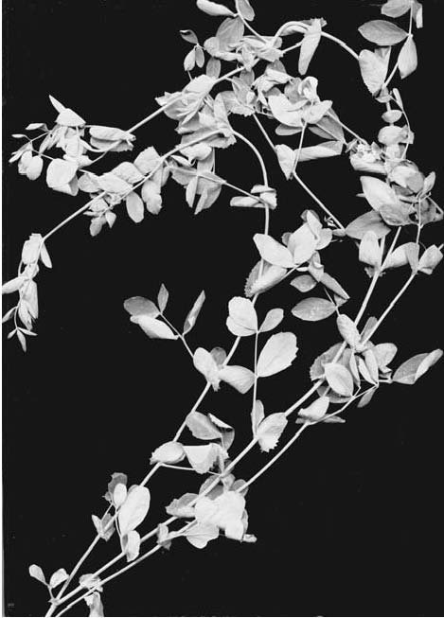

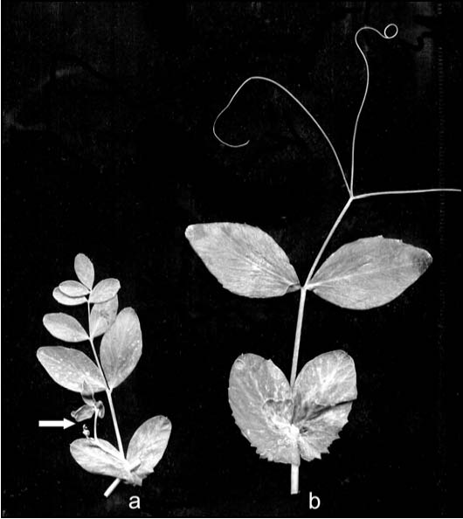

Fig. 1 Different expressions of the

‘

obscura

’

phenotype (A, B, D) compared with a

U
phenotype (C). The seeds shown in E are from a single plant grown from a seed with an
Fs
testa phenotype. The obscura seeds in E are virtually indistinguishable from true-breeding
‘U’
seeds.

A

Fig. 2. Leaf of the SGE-0812 mutant (a) and the parental line SGE (b). Arrow indicates a lateral branch typical of the mutant line but rarely observed in the SGE parent.

B

C

Table 1. Analysis of segregation at single loci in an F

2
population. A – homozygote as the first parental line (‘Shtambovy’), B – homozygote as the second parental line (WL1238), H – heterozygote, N – total number of plants analyzed.

Table 1. Phenotypic segregation in an F2 progeny from the cross between lines SGE-0812 and its parent (SGE)

Phenotype | Tl/Tl, no nana, no ramosus | Tl/tlna (flat tendrils), no nana, no ramosus | tlna/tlna, nana, ramosus
SGE-0812 X SGE | 67 | 135 | 59
χ2 for 1:2:1 = 0.8008, 0.3 < P < 0.4

The results from the segregation of phenotypes in the F2 indicate that both the nana and ramosus features co-segregate with the clavicula type. Thus, it is highly probable that the new allele of the Tl locus (designated tlna) affects not only the leaf structure, but the constitution of the entire plant. Tl has usually been considered a homeotic gene, active primarily in the development of leaf structures (3, 4). My results indicate that Tl can affect a broader range of organogenic processes.

Acknowledgement: The author is grateful to Vera S. Bogdanova for her discussion of this work and support in preparing the publication.

- Blixt, S. 1972. Agri Hort. Genet. 30: 1–293.
- Pisum Genetics Association Gene List. Pgene. http://www.jic.ac.uk/GERMPLAS/pisum/Zgc4g.htm
- Gourlay, C.W., Hofer, J.M. and Ellis, T.H.N. 2000. Plant Cell 12: 1279–1294.
- Yaxley, J.L., Jablonsky, W. and Reid, J.B. 2001. Ann. Bot. 88: 225–234.

Two new pea mutations simultaneously affecting tendril

and leaflet shape and plant internode length.

S. M. Rozov Inst. of Cytol. and Genet.
Siberian Branch of Russ. Acad. of Sci., Novosibirsk, Russia

During the screening of the EMS-treated pea line SGE, M2 progeny, the two new mutants SGE–0284 and SGE–1003 were isolated, characterized with the effect on tendrils and leaflet shape and also the internode length. These mutants are shown at Fig. 1.

The leaflets of the SGE–0284 and SGE–1003 mutants are also altered in shape: both of them have blunt tips, sometimes with a slight notch at the edge of a tip. Moreover, the SGE–1003 mutant has slightly raised veins on the leaflets, and the leaflets are somewhat insecatus. Fig. 2 presents the view of the mutants leaves.
However, the most striking changes in phenotype of the mutants plants concerned the shape of the tendrils. SGE–0284 possesses the deformed tendril tip—it looks like a hook or a chrochet needle (Fig. 3C), so I propose the symbol
htl
(hooked tendril) for this mutation. SGE–1003 mutant has an incrassate tendril base with the tendrils being strongly reduced in length. Lateral tendrils are incrassate, strongly hooked, and

declinated (Fig.3A). To the naked eye the tendrils look singed, suggesting analogy with the

Bristle
gene in Drosophila. Thus, I propose
Bristle
as the name for this pea mutation with the gene symbol
brtl
—
Bristle tendrils
.

Fig. 1. SGE-0284 and SGE-1003 plants: A – normal SGE plant; B – SGE-0284 mutant; C – SGE-1003 mutant.

Note: the internode length of the mutants is slightly (SGE-0284) and strictly (SGE-1003) diminished com
p
ared to the
p
arental normal line, SGE.

Fig.2. A leaf of the SGE

–

1002 mutant. The dry necrotic sectors are clearly visible as the light areas.

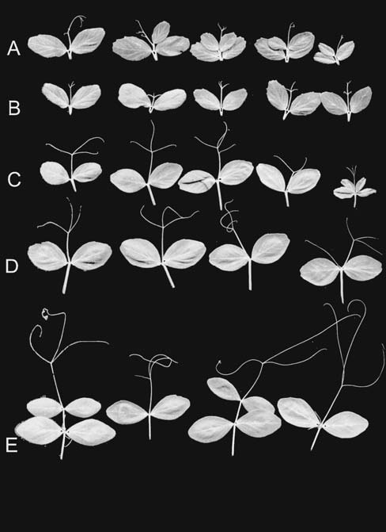

Fig. 1. (left) SGE-0274 plant.

Fig. 2 (right) Leaves of the SGE-0274 mutant (A) and the leaves of the parental line SGE (B).

Fig 2. Leaves of the SGE-1003 mutant (

brtl
) —A, B; leaves of the 0284 mutant (
htl
) —C, D; and the leaves of the normal SGE parental plant — E.

In F

2

progeny derived from crosses between the mutant line and line SGE, a segegation ratio not signifantly different from 3:1 was observed for both mutations, indicating a recessive monogenic basis for each mutation (Table 1).

Only a few genes affecting tendril shape have been described in Pisum sativum (1,2). None of these has the same phenotype as SGE–0284 or SGE–1003 mutant. The mutation bulf (3), is similar in that it affects only leaflets and tendrils. However, bulf produces necrotic areas on leaflet and tendril tips, while the described SGE mutants do not cause necrosis at all.
The allelic test between lines SGE–0284 and SGE–1003 has shown that the mutations affect different loci – all five of the F1 hybrid plants examined were of the wild (normal) phenotype, as the parental pea line SGE.
Hence I must conclude that all phenotypic effects visible in the mutants SGE-0284 and SGE-1003 are produced by the action of one gene—htl in the case of SGE–0284 and brtl in the case of SGE–1003.

Table 1. Segregation in F2 progenies after the crosses between mutant lines SGE-0284 (htl) and SGE-1003 (brtl) with the parental line SGE.
Cross | Parental line phenotype(normal) | Mutant phenotype | χ23:1 | probability
SGE-0284 X SGE | 86 | 22 (htl) | 1.2346 | 0.2 < p < 0.3*
SGE-1003 X SGE | 103 | 28 (brtl) | 0.9186 | 0.3 < p < 0.4*

- Blixt S. 1972. Agri Hort. Genetica 30: 1–293.
- Pisum Genetics Association Gene List. Pgene. http://www.jic.ac.uk/GERMPLAS/pisum/Zgc4g.htm
- Sharma B. 1973. PNL 5: 46.

A gene for stem fasciation is localized on linkage group III

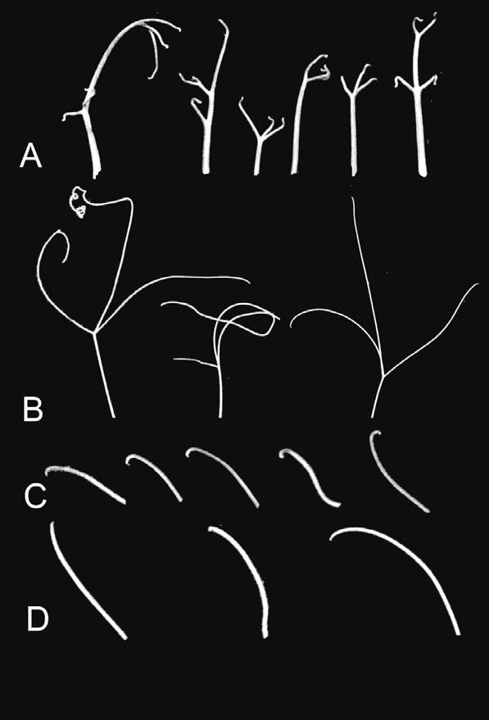

Fig. 1. A plant of SGE–1002 line, showing the dry necrosis phenotype. Arrows point to the dry pale-yellowish sectors of the naturally senesced tissues.

Fig. 3. Tendrils of the SGE-1003 mutant — A; Tendrils of the normal parental line SGE — B; Tendril tips of the SGE-0284 mutant —C; tendril tips of the normal parental line SGE.

Sinjushin, A.A., Konovalov, F.A. and Genetics Dept.

Gostimskii, S.A. Biolog. Faculty of Moscow State Univ., Moscow, Russia

Fasciation is one of the most widespread abnormalities of higher plant development. An understanding of the inheritance of the trait is very important, not only for theoretical purposes dealing with genetic control of meristem activity but also for practical use. Stem and fruit fasciation is used as an agriculturally valuable trait in selection of many species including pea (Pisum sativum L). The peculiarities of genetic control of fasciation in pea are still being discussed. There are few genes responsible for fasciation development; these genes form the fasciata family although little is known about their structure, protein products and even localization on the genetic map. The gene Fa (or Fa1 as was proposed by Święcicki and Gawłowska (8)) is localized in linkage group IV (4), Fa2 is in LG V (8) and Fas is supposed to be associated with LG III (1).
The fasciated mutant ‘Shtambovy’ was produced by induced chemical mutagenesis (ethylmethane sulfonate) from the cultivar ‘Nemchinovsky’ (6). This mutant exhibits strong features of fasciation such as stem flattening, phyllotaxis abnormalities, clustering of axillary racemes on top of the stem, etc. (Fig. 1a). Such phenotype is connected with stem apical meristem enlargement which can be seen with usage of scanning electron microscopy. The apex of mutants becomes ridge-like (Fig. 1b) instead of hemispheric in wild-type plants (Fig. 1c) thus producing ribbon-like stem with multiple bundles and a striated surface. The morphology, anatomy and growth characteristics of fasciated plants compared with normal ones have been previously described (7).
The fasciation in a new mutant line is caused by a recessive mutation in a single gene (see Table 1). Allelism tests revealed that the gene responsible for fasciation in ‘Shtambovy’ is not allelic to gene Fa from JI 5 (‘Mummy Pea’): all F1 plants from cross ‘Shtambovy’ x JI 5 were non-fasciated.
In order to determine the possible relationship between ‘Shtambovy’ mutation and genes
Fas
and
Fa2
, an effort was made to localize the new
fasciata
locus on the pea linkage map. The F
1
and F
2
progeny of a cross ‘Shtambovy’
x
WL

1238 were planted in the field. All F

1
hybrids were monomorphic and exhibited a non-fasciated phenotype. In the second filial generation the genetic analysis was performed involving the trait of interest and morphological markers carried by parental lines. According to some previous data (not shown) the gene of interest appeared to be associated with linkage group III. In order to check this hypothesis PCR-based CAPS markers (
C
leaved
A
mplified
P
olymorphic
S
equences) distributed across LG III were tested for linkage with the gene of interest. Primer sequences and reaction conditions were as described earlier (2, 3). The polymorphism was revealed by digestion of PCR products with restriction endonucleases
Tru
9I (for
PK4
),
Rsa
I (for
Pepcn
) and
Alu
I (for
Egl1
). F
2
segregation data was processed using the program Mapmaker/EXP 3.0 (5). The logarithm of odds (LOD) threshold for the linkage estimation was set at 3.0; the recombination frequencies were converted to map distances in cM using the Kosambi mapping function. The chi-square values for all marker pairs are presented in Table 2.

D

Loci

E

A

Pisum Genetics Association

H

Membership List

B
N
χ2 (P>0.05)
Egl1

27
58
29
114

0.11
PK4
25

32
25
82
3.95
Le
90

We found significant linkage between the gene responsible for

fasciata

phenotype in

‘

Shtambovy

’

and CAPS markers from the bottom part of linkage group III. According to results the map of region containing this gene was constructed with morphological marker

Le

included (although the latter shows no linkage with

fasciata

gene in this cross).

As Fas is the only known fasciata gene associated with LG III, we propose that the gene causing fasciation in the ‘Shtambovy’ mutant is identical to Fas. More investigations on this point are needed including additional allelism tests. Regardless of the outcome of these tests, the new mutation can be used as an additional morphological marker in LG III and may provide new information concerning genetic control of stem development in pea.

Acknowledgement: The authors would like to express their gratitude to Prof. Noel Ellis and Dr. Mike Ambrose (John Innes Centre) for kindly providing them with the seeds of JI 5. The work was supported by Russian Foundation for Basic Research.

- Blixt, S. 1976. Agri Hort. Genet. 34: 83–87.
- Brauner S., Murphy, R.L., Walling, J.G., Przyborowski, J. and Weeden, N.F. 2002. J. Amer. Soc. Hort. Sci. 127: 612–622.
- Konovalov, F.A., Toshchakova, E.A. and Gostimsky, S.A. 2005. Cell. Mol. Biol. Lett. 10: 163–172.
- Lamprecht, H. 1952. Agri Hort. Genet. 10: 158–167.
- Lander, E.S., Green, P., Abrahamson, J., Barlow, A., Daly, M.J., Lincoln, S.E. and Newburg, L. 1987. Genomics 1: 174–181.
- Rehmatulla A., Gostimskii S.A. 1976. Biologicheskie nauki. 5: 107–112. In Russian.
- Sinjushin A.A., Gostimsky S.A. 2006. Russ. J. Dev. Biol. 37. In press.
- Święcicki, W.K. and Gawłowska, M. 2004. Pisum Genetics 36: 22–23.

2A – homozygote as the first parental line (‘Shtambovy’), B – homozygote as the second parental line (WL1238), H – heterozygote, C – dominant phenotype like in the second parental line, N – total number of plants analyzed.
AB
19
24
17
23

Symbiotic gene Sym33 is located on linkage group I

Tsyganov, V.E.1*, Rozov, S.M.2, 1Dept. of Biotech., All–Russia Res. Inst. for Agric. Microbiol.
Borisov, A.Y.1 and Tikhonovich, I.A.1 St. Petersburg,. Russia
*corresponding author 2Inst. of Cytol. and Genet., Novosibirsk, Russia

In pea 40 genes controlling pea-Rhizobium symbiosis have been identified up to now using genetical approaches (1). Nineteen of these have been localized on the genetic map (2, 7, 9, 14). Most of these genes control early nodule developmental stages (6, 12). Only three symbiotic genes controlling late nodule developmental stages, sym13, sym27 and sym31, have been mapped to date (5, 8, 9). In addition, the late symbiotic gene sym26 was linked with a DNA marker found in an unclassified linkage group (13). Some of these genes are also involved in the interaction of the pea host with arbuscular mycorrhizal fungi (1).
In this study we localized late symbiotic gene sym33, which have been identified in mutant SGEFix--2. It has been shown that gene sym33 controls the endocytosis of bacteria into host-cell cytoplasm from infection droplets and differentiation of infection threads in young nodule tissue (11). Mutation in the gene sym33 also influences mycorrhiza development, decreasing mycorrhizal colonization of roots and delaying arbuscule development at low temperature (3, 4).
For the mapping of
Sym
33 we first crossed the mutant SGEFix
-
-2 with the line NGB1238. Segregation at locus
Sym
33 was analyzed in F
3
plants to identify F
2
plants homozygous and heterozygous by wild type and mutant alleles of
Sym
33. Joint segregation analysis showed barely significant linkage between
Sym
33 and

marker

d
(linkage group I) (Table 1). In order to confirm the position of
Sym
33 on linkage group I mutant SGEFix
-
-2 was crossed with lines NGB1515, NGB2715 and Wt10584. In the cross with line NGB1515, linkage between
Sym
33 and both markers
d
and
I
was found (Table 1). In the cross with line NGB2715, linkage between
Sym
33 and three markers
d
,
i
and
af
was also shown (Table 1). The cross with the line Wt10584 showed linkage between
sym
33 and markers
d
,
i
and
aero
. A map of this region was constructed based on our data (Fig. 1). Previously, symbiotic mutations
nod
3,
sym
2,
sym
5,
sym
10,
sym
19,
Enod
7,
Enod
40,
Lb
(14) and
sym
35 (2) have been mapped to linkage group I.
Sym
33 appears to be localized near the symbiotic loci
Sym
5,
Sym
19 and
Enod
40. Currently, linkage group I contains a greater number of genes involved with symbiotic associations than any other linkage group in pea. This prevalence of symbiotic loci may indicate a special role in the establishment of pea-
Rhizobium
symbiosis for this chromosome.

Cross

A/B
A/h

A/b
h/B
h/h

h/b
a/B
13
10
28
16
45
18
20
40
25

Acknowledgements: This work was financially supported by Russian Federal Agency for Science (state contract no. 02.445.11.7492), grant of the President of Russia (НШ-9744.2006.4), Russian Fund for Basic Research (04-04-48457; 06-04-89000-НВОЦ_а).

1. Borisov, A.Y., Danilova, T.N., Koroleva, T.A., Naumkina, T.S., Pavlova, Z.B., Pinaev, A.G., Shtark, O.Y., Tsyganov, V.E., Voroshilova, V.A., Zhernakov, A.I., Zhukov, V.A. and Tikhonovich, I.A. 2004. Biologia. 59 Suppl: 137–144.
2. Borisov, A.Y., Madsen, L.H., Tsyganov, V.E., Umehara, Y., Voroshilova, V.A., Batagov, A.O., Sandal, N., Frederiksen, A., Schauser, L., Ellis, N., Tikhonovich, I.A. and Stougaard, J. 2003. Plant Physiol. 131: 1009–1017.
3. Jacobi ,L.M., Petrova, O.S., Tsyganov, V.E., Borisov, A.Y. and Tikhonovich, I.A. 2003a. Mycorrhiza. 13: 3–7.
4. Jacobi, L.M., Zubkova, L.A., Barmicheva, E.M., Tsyganov, V.E., Borisov, A.Y. and Tikhonovich,I.A. 2003b. Mycorrhiza. 13: 9–16.
5. Kneen, B.E., LaRue, T.A., Hirsch, A.M., Smith, C.A. and Weeden, N.F. 1990. Plant Physiol. 94: 899–905.
6. Kneen, B.E., Weeden, N.F. and LaRue, T.A. 1994. J. Heredity. 85: 129–133.
7. Koroleva, T.A., Voroshilova, V.A., Tsyganov, V.E., Borisov, A.Y. and Tikhonovich, I.A. 2001 Pisum Genet. 33: 30–31.
8. Rozov, S.M., Borisov, A.Y. and Tsyganov, V.E. 1994. Pisum Genet. 26: 24–25.
9. Rozov, S.M., Borisov, A.Y., Tsyganov, V.E. and Kosterin, O.E. 1999. Pisum Genet. 31: 55–57.
10. Stam, P. 1993. Plant J. 3: 739–744.
11. Tsyganov, V.E., Morzhina, E.V., Stefanov, S.Y., Borisov, A.Y., Lebsky, V.K. and Tikhonovich, I.A. 1998. Mol. Gen. Genet. 256: 491–503
12. Tsyganov, V.E., Voroshilova, V.A., Priefer, U.B., Borisov, A.Y. and Tikhonovich, I.A. 2002. Ann. Bot. 89: 357–366.
13. Ul-Hasan, M., Weeden, N.F., Temnykh, S.V. and LaRue, T.A. 1996. Pisum Genet. 28: 29–30.
14. Weeden, N.F., Ellis, T.H.N., Timmerman–Vaughan, G.M., Święcicki, W.K., Rozov, S.M. and Berdnikov, V.A. 1998. Pisum Genet. 30: 1–4.

Fs and U

appear to be alleles of a

locus near the end of linkage group V

Weeden, N.F. Montana State Univ., Bozeman, MT, USA

Both Fs (violaceopunctata) and U (violet testa) are described loci that have been placed on the lower half of linkage group (LG) V as that linkage group is traditionally depicted (1, 8). Phenotypes produced by alleles at Fs and U have an interesting interrelationship because both produce anthocyanin pigmentation in the testa. Dominant alleles at Fs generally produce more or less intense spots of anthocyanin (usually 20 to 100) on the testa, whereas the U allele causes anthocyanin to be produced uniformly throughout the testa, resulting in a dark violet or ‘black’ seed. However, occasionally in an Fs line seeds will be formed in which the spotted phenotype is replaced by a solid pigmentation that covers much or all the testa. This phenotype is referred to as ‘obscura’ (Fig. 1). The cause of the obscura phenotype is unclear because the next generation nearly always displays the spotted testa phenotype (1). Furthermore, a second allele of U, designated Ust, produces stripes or streaks of anthocyanin pigmentation on the testa, differing from a typical Fs pattern primarily by the streaks being larger and more irregular than the spots produced by Fs alleles, as well as by their fewer number (0-5) on the testa.
Lamprecht (6) reported a recombination value between Fs and U of 23%, and this arrangement is reflected in Blixt’s classical linkage map (1). However, in two other experiments he reported less than 1% recombination (4, 5) between the two phenotypes. Linkage analysis between Fs and U is complicated because the Fs phenotype is hypostatic to U and thus cannot be observed in seeds with the typical U phenotype. Furthermore, in lines homozygous Ust, not every seed displays the streaks characteristic of this allele. Thus, if relatively few seeds are collected from a plant possessing the Ust allele, it is possible to incorrectly score the plant as u/u. Finally, the obscura phenotype can complicate the scoring of phenotypes when both Fs and U are segregating in a population.
In order to determine the actual linkage intensity between
Fs
and
U
, I mapped both
Fs
and
U
relative to the isozyme locus
Pgdc
. Upon finding that both genes mapped to the same location within the error of the analysis, I attempted to reject the hypothesis that
Fs
,
U
and
U
st

are all alleles at the same locus, both by reviewing the literature and by performing the analyses described below. I am unable to reject the hypothesis and, indeed, developed evidence that neither
U
nor
U
st
are 100% penetrant when involved in crosses. Thus, the “recombination” observed between
Fs
and
U
st
by myself and other pea geneticists could merely reflect incomplete expression of the
U
or
U
st
phenotype. Although the history of the nomenclature for
U
and
Fs
is complicated, both genes being initially given different symbols [
Ast
for
U
(9) and
P
for
Fs
(3)], it appears
U
has precedence over
Fs
, and at this point it seems appropriate to retire the symbol
Fs
and identify the
violaceopunctata
phenotype in JI 261, A578-238 and many other lines as being produced by an allele of
U
, namely
U
fs
. This allele is dominant relative to absence of spotting (
u
) and codominant with
U
st
. A second locus (
F
)

ostensibly able to produce the

violaceopunctata
phenotype, has been described previously (7,9) and has been assigned to LG III (6). The elimination of
Fs
should have no effect on the validity of
F
, although I have not been able to verify the existence of this latter gene.

Material and Methods
Several crosses, involving different sources of the alleles U, Ust or Fs were used in this analysis (Table 1). Each of the parents had been inbred several generations and consistently displayed the same testa phenotype in each generation. In two cases (WL1414 and WL1018), the line is homozygous a, and thus does not express Fs or U alleles. However, when crossed to a line that is homozygous A, the testa pattern can be observed in seed from the hybrid plant and in subsequent generations in seed of plants expressing the A allele.

Table 1. Populations used to examine the joint segregation of U, Fs and Pgdc
Cross designation Parents of cross Genotype of parents Source of U
1 B77-257 x A578-238 fs, u x Fs, u U not present
2 WL1238 x ‘Sparkle’ fs, Ust x [a] (fs, u)1 S. Blixt
3 WL1414 x WL808 [a] (Fs, u) x fs, U P. s. ssp. abyssinicum
4 WL1018 x 87-19i-a [a] (U) x Fs, u S. Blixt
5 87-19I-a x WL1018 Fs, u x [a] (U) S. Blixt
6 C98-54 x C98-1-12 U x Fs N.F. Weeden
7 WL1238 x JI 261 fs, Ust x Fs, Ust S. Blixt and P. s. ssp humile
8 Marx 15241 x Marx 15098 fs, oh x (Fs), U G.A. Marx
9 C01-1b x A03-123 (Fs?), u/U x Fs, u N.F. Weeden
1Parentheses indicate hidden phenotype of Fs, U or both that is not directly observable due to hypostatic interactions with other genes.

Plants were grown in the glasshouse under 16 hr daylength or for a relatively few populations, in the field at Bozeman, Montana, USA. Pods were allowed to dry on the plant to allow full development of testa pattern.

Results and Discussion
As testa pattern is determined by the maternal genotype, the seed produced from a cross should display the same phenotype as the maternal parent. Furthermore, seed produced on all F1 plants from either U x Fs or Fs x U crosses, should have the U phenotype. The former prediction was confirmed in all crosses. The phenotypes observed on seeds from the hybrid in each cross are presented in Table 2.

Table 2. Phenotype of seeds obtained from the hybrid plants in each of the crosses studied

Cross | Phenotype of Parents | Phenotype on seeds from hybrid | Phenotypes observed on seeds from F2
1 | fs, u x Fs, u | all seeds Fs | 29 Fs, 10 fs
2 | fs, Ust x a | all seeds Ust | 53 Ust, 18 u, 29 a
3 | a x fs, U | 7 U, 3 Ust, 25 u, (Fs or fs) | 0 U, 0 Ust, 9 Fs, 6 fs
4 | a x Fs, u | all seeds U | 4 U, 4 Fs, 7 a
5 | Fs, u x a | U or U*1 | 37 U or U*, 10 Fs, 13 a
6 | U x Fs | 20 U and 14 Fs | 4 U, 9 U*, 11 Fs
7 | fs, Ust x Fs, Ust | all seeds Fs and Ust | Not tested
8 | fs x U | 3 U, 2 Fs | 1 U, 1 U*, 2 fs, v. faint U
9 | u/U x Fs, u | both seeds U* | U and Fs (backcross)

1 Asterisk indicates that the U phenotype only partially covered testa

Cross

1

(B77

‐

257

x

B578

‐

238)

This cross was used primarily to confirm normal segregation of Fs and to determine recombination distance between Pgdc and Fs. The original two seeds produced from the cross both were fs, u, the same phenotype as the maternal parent. The hybrid plants generated from these two seeds produced only Fs seed (24 seed from one plant and 15 from the other). Of the 39 F2 plants grown, 29 produced only Fs seeds and 10 produced only fs seed. Joint segregation analysis of Fs and Pgdc gave a recombination distance between the two loci of 6 cM. Thus, this cross and F1 and F2 generations indicated that Fs was behaving as a single Mendelian factor, closely linked to Pgdc. Other crosses placed Fs distal to Pgdc relative to Acp1 (Weeden, unpublished).

Cross 2 (WL 1238 x ‘Sparkle’)
This cross was used primarily to confirm normal segregation of Ust and to determine recombination distance between Pgdc and Ust. Four seeds were produced from the original cross, and each had the maternal fs, Ust testa phenotype. The seed from the hybrid plant also displayed this same phenotype. If the white-flowered plants are excluded from consideration, the F2 population segregated approximately 3 Ust : 1 u (Table 2), and the calculated recombination distance between Pgdc and U was 7 cM. The locus Gp was also segregating in this population, and it mapped on the opposite side of Pgdc from U in agreement with (2). These results place U at approximately the same position as Fs, within the precision of the data from crosses 1 and 2.

Cross 3 (WL1414 x WL808)
This cross contained the violet testa (U allele) observed in many P. s. ssp. abyssinicum lines. The initial cross gave seeds lacking anthocyanin because the maternal parent was white-flowered. The F1 generation surprisingly produced mostly seeds lacking a solid violet testa, indeed most lacked any evidence of U expression with seven showing the solid violet pattern, three a partial violet testa, and 25 being either Fs or fs (a careful examination of the Fs phenotype was unfortunately not performed on this generation). When the F2 generation was grown, only 25 of the 35 lines produced seed and 10 of these were white-flowered, precluding the scoring of Fs or U. Of the colored-flowered plants producing seed, none were U or Ust, nine were Fs and six were fs. One of the Fs and two of the fs plants were from seeds with a U or partial U phenotype. The fs phenotype came from the P. s. ssp. abyssinicum parent, indicating that either all six of the fs F2 plants reflected recombination between Fs and U or that the U phenotype had been suppressed in these plants. The 9:6 ratio does not differ significantly from the expected 3:1 ratio (assuming lack of U expression), suggesting that segregation is not strongly distorted in this region of the genome.

Cross 4 (WL1018 x 87‐19i‐a)
The seed produced from the cross displayed the expected solid violet testa, as did the seed produced from the F1. Nearly half the F2 plants were homozygous for a, so that U and Fs could not be scored. Four of the F2 plants produced at least some seed with solid violet testa, whereas four F2 plants produced only Fs seed. However, two of the F2 plants scored as U produced some seed on which only part of the testa was solid violet, the remaining being violet spotted. Here again it appears that U is often incompletely dominant in segregating populations.

Cross 5 (87‐19I‐a x WL1018)
The hybrid seed possessed the
Fs
phenotype characteristic of the maternal parent. The seed from the F
1
was a mixture of
U
and
U
plus
Fs
phenotypes. The
U
:
Fs
segregation ratio in the F
2
did not differ significantly from the expected 3:1 ratio. However nine of the plants scored as
U
gave seed that only displayed partial fusion of the anthocyanin pigmentation into a solid pattern. Some of the seed collected

from these plants displayed only the spotted pattern typical of

Fs
genotypes. One plant gave three pods, one in which all seeds were
U
, one in which all seeds were
Fs
, and one in which the seeds were
Fs
but some had a partial fusion of the spots. These results mimic the spectrum of patterns observed in some
Fs
genotypes in which the obscura phenomenon is common. In addition, several of the plants scored
Fs
had slightly larger spots on the testa of some seeds, suggestive of a
U
st
pattern in combination with
Fs
. All of the F
2
plants with an incomplete
U
pattern showed violet spots in the open regions. The lack of a double recessive phenotype can be explained by either WL1018 being
Fs, U
or with
Fs
and
U
being allelic.

Cross 6 (C98‐54 x C98‐1‐12)
This cross used a line expressing the U phenotype (C98-54) that had produced solid violet seed coats for several generations, although the pedigree could not be traced back to either P. sativum ssp. abyssinicum or Lamprecht’s type line for U. The hybrid seed had the expected solid violet testa. However, the seed from the F1 was a mixture of phenotypes with some of the U seeds displaying only a partially violet testa and a significant proportion of the seeds exhibiting an Fs phenotype. Not all the F2 plants produced seed, but of those that did, 4 produced only seeds with solid violet testa, 9 produced seeds displaying various mixtures of partially solid violet testa and 11 produced only seeds with the Fs phenotype, which was sometimes very faint. In order to confirm the F2 seed testa phenotype, two seeds were taken from each F2 and grown to produce seed from the F3. In most cases the testa phenotype from F3 plants corroborated that from the F2. However, there were some notable exceptions. In two cases seed from the F2 that possessed an Fs phenotype gave seed with a U phenotype in the next generation. In another three cases, seed from the F2 that had barely discernable violet spots (although two had obscura markings) produced seed from the F3 that had clear Fs markings. In summary, this cross gave a slight but significant (χ2 = 5.5, 1 d.f.) deficiency in the dominant (U) phenotype in the F2 even after correcting for the two lines that displayed U in the F3 but not in the F2 (Table 2), and there were a number of cases in which the expression of a dominant character (U or Fs) was observed in seed from F3 plants, when it had been lacking in the previous generation.

Cross 7 (WL 1238 x JI 261)
This cross gave the expected Ust, fs phenotype on the one seed produced. The hybrid plant was semi sterile, and only four seeds were obtained. All these seeds displayed both the typical Ust streaks in a background of small violet spots, indicating that both Ust and Fs were expressed. I was not able to detect on the seed from the F1 generation the small streaks that characterize the Ust phenotype of JI 261. Rather all four seeds had the large blotches characteristic of WL 1238 together with many round spots attributable to Fs from JI 261.

Cross 8 (Marx 15241 x Marx 15098)
This cross was complicated slightly by the presence of recessive alleles at
Oh
(testa reddish-brown) and
B
(petals pink) segregating in the population. However, the critical finding for the purposes of this paper was that both seeds with the
U
phenotype and seeds with the
Fs
phenotype were produced from the hybrid plant. The known genotype of the hybrid was
u/U
,
b/B, oh/Oh
. I am uncertain whether Marx 15098 has violet spots obscured by the solid violet color of the testa. However, the seeds from the hybrid would all be expected to display the
U
phenotype. The presence of seeds with only violet spots further indicate that
U
is not 100% penetrant in some crosses. Seeds collected from two F
2
plants derived from seeds with
U
phenotype and two F
2
plants derived from seeds with
Fs
phenotype were, respectively, U, pale U (with no violet spots),
fs
with a faint obscura, and
fs
with a faint pinkish hue. All four F
2
had wildtype (
B
) flowers. Finally, when a typical
U
phenotype seed from the first of the F
2
plants mentioned was used to produce F
3
seed, this seed was uniformly
Fs
. Thus, in this cross the
U
phenotype was lost by the third filial generation, appearing to transform into an
Fs
pattern despite the
U
allele having been

derived from a line that stably expressed the

U
phenotype for several generations. The loss of the
Fs
phenotype in some lines when going from the F
2
to the F
3
generation is also interesting, although it could be explained by simple segregation, or interactions with
b
or
oh
.

Cross 9 (C01‐1b x A03‐123)
C01-1b was an F1 plant produced from the cross B5 (U) x B77-257 (fs, u). The line B5 shared the same U allele as C98-54 in cross 6. The cross of this hybrid with A03-123 (Fs) gave two seeds both of which display a testa that was partially solid violet and partially violet spots. Selfed seed from C01-1b was typical U (completely solid violet). The two hybrid seeds were planted, and one produced all U seeds, whereas the other produced all Fs seed. This last results can be interpreted as being consistent with the segregation at U from C01-1b. However, because the original hybrid seeds were produced on a plant that was heterozygous at U, both of these seeds should have been uniformly solid violet. It again appears that U is not completely penetrant in some genetic backgrounds.

The results from the above crosses clearly demonstrate that the solid violet testa phenotype described for the U allele is not completely penetrant in many crosses. This behavior does not appear to be dependent on the source of the U allele, for lines from the Weibullsholm collection, the Marx genetic stocks collection, my own collection and the taxon P. s. ssp. abyssinicum all showed incomplete expression in at least one cross. At present, the specific genetic background (if any) that produces the incomplete expression is not obvious.
Joint segregation analysis between the locus Pgdc and either Fs or U revealed nearly identical recombination frequencies between the isozyme marker and each of the seed testa phenotypes, placing both Fs and U distal to Pgdc (in agreement with previous studies) and within 1 to 2 cM of each other. This result is in disagreement with the position of U on LG V on certain linkage maps for pea (1) but agrees well with some of Lamprecht’s data (3, 4). When the two markers are separated on LG V, U is always placed distal to Fs, and usually forms the most distal marker on that arm of the linkage group. I suggest that most recombinants identified between Fs and U in earlier studies are a result of incomplete expression of the U phenotype and are apparent recombinants rather than real. The only evidence for a significant recombination frequency between Fs and U is the appearance of the fs phenotype on seeds in the F2 of cross 3. Such seed could be interpreted as being produced from a plant that was recombinant between Fs and U on both homologous chromosomes. However, the F1 of cross 3 already displayed significant loss of U expression, suggesting that a general loss or suppression of U expression might be a more conservative explanation for the fs phenotype. Indeed, a study of a large population produced from backcrossing a P. sativum ssp abyssinicum x ‘Sparkle’ hybrid (U/u, fs/fs) to other white-flowered cultivars (u/u) revealed a complete absence of U phenotypes in the seed from 26 BC1F3 plants that displayed violet flowers (data not presented). The only anthocyanin markings on testa of seed from this generation were very faint obscura patterns in some lines. This result suggests that the solid violet testa in P. s. ssp. abyssinicum is not particularly stable in crosses and possibly can be transformed to obscura, a phenotype associated with the Fs locus.
As heterozygotes from all sources of
U
can show incomplete penetrance, the mapping of
U
and the use of
U
as an anchor marker become problematic. If
U
maps near
Fs
, an allelism test is called for, yet with
Fs
being hypostatic to
U
, with the capability of
Fs
converting to an obscura phenotype very similar to an incomplete expression of
U
, and with the expression of
U
being erratic in many crosses, it becomes difficult perform such a test. To my knowledge, the only lines used in the above experiments that are definitely
fs, U
are the violet testa
P. s
. ssp.
abyssinicum
accessions, and this taxon displays the greatest loss of penetrance of the
U
phenotype in seed from F
1
plants. In all other crosses between a line with an
Fs
phenotype and a line with a
U
phenotype I have yet to isolate a derivative with an
fs
phenotype lacking

some type of obscura pattern. My review of the literature also fails to identify an allelism test in which the problems of incomplete penetrance and the obscura phenomenon have been clearly overcome.

It has always been the responsibility of the investigator, when describing a new gene, to perform the necessary allelism tests. In the case of Fs and U, both symbols are already accepted in the literature despite an apparent absence of a rigorous allelism tests, due to the complications described above. Again because of these complications, I have been unable to provide clear evidence that the two phenotypes represent alleles at the same locus. However, given the facts that (1) the phenotypic expression of both Fs and U is unstable and produces similar ‘off types’ and (2) in independent crosses phenotypic segregation places Fs and U within the same 1-3 cM region on LG V, the most conservative alternative at present is to treat Fs and U as the same locus. Hence, I recommend that Fs be referred to as Ufs until a clear demonstration is available that it represents a distinct locus.

- Blixt, S. 1972. Agri Hort. Genet. 30: 1–293.
- Irzykowska, L., Wolko, B. and Święcicki, W.K. 2001. Pisum Genetics 33: 13-18.
- Kajanus, B. and Berg, S.O.. 1919. Ark. f. Botanik 15: 1–18.
- Lamprecht, H. 1942a. Hereditas 28: 143–156.
- Lamprecht, H. 1942b. Hereditas 28: 157–164.
- Lamprecht, H. 1961. Agri Hort. Genet. 19: 360–401.
- Tschermak, E. von. 1912. Z. ind. Abst. u. Vererbungsl. 7: 81–234.
- Weeden, N.F., Ellis, T.H.N., Timmerman-Vaughan, G.M., Święcicki, W.K., Rozov, S.M. and Berdnikov, V.A. 1998. Pisum Genetics 30: 1–4.
- White, O.E. 1917. Proc. Amer. Phil Soc. 56: 487–588.

A new dominant-acting necrosis mutation in pea

S. M. Rozov Inst. of Cytol. and Genet.
Siberian Branch of Russ. Acad. of Sci., Novosibirsk, Russia

The necrosis phenotype in pea consists of a relatively small class of mutations. The majority of these mutations produce small necrotic spots or marginal stripes on leaves and stipules. The spots and stripes may be of different color — from yellow to orange or dark brown. In some mutants the spots can enlarge and form necrotic sectors on the leaves. The well-known necrosis mutations are: nec (6), necrosis of leaf and stipule margins, that covers the intervenial area as well as the veins; len (4), leaf-edge necrosis, that forms a necrotic spots or areas at the leaflet margins; gn (7), gold necrosis, which forms the gold orange spots and areas on underside of the leaflets; brz or dgl (2,3), bronze or degenerating leaves, which forms deep-yellow to dark-brown growing necrotic spots or areas on older leaves and stipules, caused by the excessive iron accumulation in some cells of pea shoot tissues (1); and bulf (5), burnt leaf, that causes brown necrotic stripes on the periphery of leaflets and stipules. All of these mutations are recessive in nature. In the present work I describe a dominant EMS-induced mutation associated with leaf necrosis. During the screening of an M2 progeny of the EMS-treated line SGE, the SGE–1002 mutant was isolated. This mutation is characterized by the presence of dry, pale-yellow sectors on leaflets and stipules. Tissues in these areas look like leaf lamina of the mature pea plants that have naturally senesced (Fig. 1, 2).
The dry necrotic lesions on leaflets and stipules in the SGE–1002 mutant line appear very quickly and spontaneously: one day the leaflets or stipules are normal and green, without any visible defects, the next day the almost dry pale-yellowish sectors are present. Dry necrotic sectors in the SGE–1002 mutants can

cover from about

1
/
10
to about
1
/
5
of the leaf area. I have not observed this type of lesion on stems, inflorescences, flowers or pods. Fertility of the SGE-1002 mutant is nearly the same as that of the parental SGE line; no aborted embryos are observed in the pods.
The SGE–1002 mutant line was crossed with its parental line SGE. All 11 F1 plants obtained in this cross had similar easily visible dry necrotic sectors, like the SGE–1002 mutant. The following segregation was observed in F2: 189 plants with dry necrotic sectors: 58 normal plants. This ratio does not deviate significantly from 3:1 (χ23:1 = 0.487, 0.5 < p < 0.6).
Thus, we have a case of a dominant mutation affecting only the lamina photosynthetic structures of pea (leaflets and stipules). Dominant alleles very rarely occur in artificial mutagenesis, such as EMS or X-ray treatment, making the SGE–1002 dry necrosis mutant of special interest. This type of necrosis has not been previously described in pea. Although allelism tests have yet to be performed with nec, len, gn, bulf, brz, and dgl, I am suggesting that the mutation probably affects a new locus. Unfortunately, the location of this mutation on the pea genetic map is still unknown, but this work is in progress.

Acknowledgement: The author is very grateful to Vera S. Bogdanova, for her discussion on this work and support in preparing the publication.

1. Becker, R., Manteuffel, R., Neumann, D. and Scholz, G. 1998. Planta 207: 217–223.
2. Gottschalk, W. 1964. Botanishe Sudien 14: 1-359.
3. Kneen, B.E., La Rue, T.A., Welch, R.M. and Weeden, N.F. 1990. Plant Physiol. 93: 717–722
4. Marx, G.A. 1980. Pisum Newslett. 12: 52–53.
5. Sharma, B., 1973. Pisum Newslett. 5: 46.
6. Święcicki, W.K. 1985. Pisum Newslett. 17: 68–69.
7. Sweicicki, W.K. 1987. Pisum Newslett. 19: 74–75.

A new mutation in pea affecting tendrils (taa): lateral tendrils grow at an acute angle

S. M. Rozov Inst. of Cytol. and Genet.
Siberian Branch of Russ. Acad. of Sci., Novosibirsk, Russia

Several mutations in pea affecting tendril development have been described previously. These include the dominant gene Twt, that curls tendrils into compact glomerules (1,2); bulf, which causes the ends of tendrils to dry out (3); and two well-known homeiotic mutants, tl and af, which, respectively, transform tendrils to leaflets or vice versa (4,5).
During the screening of an M
2
progeny of the EMS-treated SGE line a new mutant SGE-0274 was isolated, characterized by an unusual form of tendrils (Fig. 1). The lateral tendril branches of this mutant

intersect the primary rachis at an angle of about 20 to 45 degrees, while the parent line SGE forms lateral tendril branches at a nearly right angle (Fig. 2).

As far as I know, a similar phenotype has not been described before. I suggest that a new, previously unknown locus is involved in SGE-0274 tendril formation. SGE-0274 tendrils never form a compact glomerule such as is characteristic of Twt plants; moreover, Twt is a dominant gene. The only known gene that forces lateral tendrils to grow at the angle less then 90 degrees is af. However, the allelic test of SGE-0274 and WL-1746 line (af) suggest that they are not allelic: all F1 plants were of normal phenotype — no afila, and lateral tendrils were arranged at the right angle.
The SGE-0274 mutant phenotype was designated as the tendrils at acute angle, and I propose the gene symbol taa for it.

Acknowledgement: The author gratefully acknowledges Vera S. Bogdanova for her discussion of this work and support in preparing the publication.

- Gorel, F.L., Temnykh, S.V., Lebedeva, I.P. and Berdnikov, V.A. 1992. Pisum Genetics 24: 48-49.
- Berdnikov V.A., Gorel F.L. and Temnykh S.V. 1994. Pisum Genetics 26: 9-10.
- Sharma, B. 1973. PNL 5: 46.
- Blixt S. 1972. Agri Hortique Genetica 30: 1–293.
- Pisum Genetics Association Gene List. Pgene, http://www.jic.ac.uk/GERMPLAS/pisum/Zgc4g.htm

Formation of PeaGRIC: An international consortium
to co-ordinate and utilize the genetic diversity and
agro ecological distribution of major collections of Pisum

Furman, B.J.1, 1International Center for Agriculture in the Dry Areas, Aleppo, Syria
Ambrose, M. 2, 2John Innes Centre, Norwich, UK
Coyne, C.J.3 and 3USDA-ARS, WRPIS, Pullman, WA, USA
Redden, B.4 4Department of Primary Industries, Horsham, Victoria, Australia

Pisum ranks fourth among the grain legumes worldwide with a total dry pea production of over 11 million tons and green pea production of over 9 M tons (1). In spite of its global importance, there is no CGIAR mandate for Pisum improvement and conservation, although the International Center for Agricultural Research in Dry Areas (ICARDA), Syria houses a major collection of field pea (Pisum sativum) and contains a number of accessions from its center of origin and domestication. Important collections are also housed at the Western Regional Plant Introduction Station, Pullman, WA, USA (USDA/ARS); the N.I. Vavilov Research Institute of Plant Research (VIR), Russia; the International Pisum Genetic Stock collection located at the John Innes Centre (JIC), UK; the Australian Temperate Field Crops Collection (ATFCC), Department of Primary Industries (DPI-Victoria), Australia; the Nordic Gene Bank (NGB), Sweden; the Crop Genetic Resources Institute (CGR) within the Institute of Crop Sciences CAAS, Beijing, China; the Institute of Plant Genetics and Crop Plant Research (IPK), Gatersleben, Germany; and the Germplasm Institute (GIBARI) at Bari, Italy. Together, these collections provide a wealth of exploitable genetic diversity, much of which has yet to be discovered.
In addition, a number of bilateral and multilateral initiatives in Pisum genetic resources conservation, utilization and improvement are underway. These include:
- The European Cooperative Program for Crop Genetic Resources (ECP/GR) includes a working group for grain legumes (http://www.ecpgr.cgiar.org/)
- GLIP (Grain Legumes Integrated Project (EU FP6; http://www.eugrainlegumes.org/)
- GERMINATE (Generic database for plant genetic resources) (http://www.germinate@scri.sari.ac.uk)
- IPIS (International Pea Information System based on ICIS - based at ATFCC)
- GRIN (Germplasm Research Information Network; USDA/ARS; http://www.ars-grin.gov/npgs/index.html)

Here we propose to develop a multi-institute genebank consortium to facilitate international collaboration and utilization of Pisum genetic resources

• to elucidate and utilize the existing genetic potential in the major Pisum collections available to the scientific community,

• to develop commonality and shared genetic resources objectives,

• to promote, deliver, and exchange resources and expertise to the Pisum research, breeding and conservation communities, including
  - Pisum germplasm resources
  - wild and weedy relatives
  - landraces
  - cultivars
  - cultivar reference collections
  - breeding lines
  - mutant collections
  - mapping populations

• standardization of molecular marker technology and expertise

•

potential for marker-association for traits of interest

• eco-geographical referencing
• computational resources
• a global pea genetic resources portal for phenotypic characterization and evaluation, and for molecular characterization.
To ensure utilization of these invaluable genetic resources, a thorough investigation into the genetic structure of individual collections is required. The strength of the consortium will be the complementation and synergy of expertise and resources and their links to ongoing research and breeding initiatives. With accessions and markers in common across various research initiatives, a basis for comparability will enable leverage of research into a wider context, add value to both past and current research across organizations, and add to the totality of information on pea germplasm world wide
The objectives of this project include:
- To create a portal for the Pisum research community with a database of Pisum genetic resources and links between Pisum databases by participating with and delivering into on-going database initiatives
- To develop an international reference collection of Pisum to help elucidate the genetic and agronomic diversity available to the scientific research, conservation and breeding community
- To facilitate agronomic and molecular characterization of the reference collection
- To study genetic diversity in relation to ecological diversity and land use in order to predict future diversity and selection of sites for collections, target the mining of current diversity, in-situ conservation, and crop improvement emphasis utilizing GIS technology

Methodology:
Objective 1:
All available reference collection data will be fed into existing database initiatives (e.g., GERMINATE, IPIS, GRIN, etc.). The combined data will result in a virtual global collection and provide a portal for the international Pisum research community to interactively search and query germplasm as desired by the breeder/researcher with a) required expressions across multiple traits, b) specified countries of origin, c) choice as per distribution maps of climate/abiotic stresses corresponding with GIS data of collection sites.
Objective 2:
A dispersed international reference collection will be developed by consortium genebanks based on single plant selections from accessions. Each individual reference subcollection will be determined based on taxonomic, passport and characterization data, ecological and geographical representation, and special interest accessions and will include where available, valuable trait data such as resistance to lodging, abiotic and biotic stresses (e.g., 2,3,4).
Objective 3:
Agronomic and morphological characterization of accessions will be carried out on individual reference sub-collections at the participating institutes to obtain data on important agronomic traits, pest and disease resistances, tolerances of abiotic stresses and adaptation traits, nitrogen fixation, seed quality, food and nutritional properties. Molecular characterization will be carried out using mapped, polymorphic and transferable genic SSR-based neutral molecular markers already available in the public domain to provide a comprehensive genetic diversity analysis of accessions. This will be undertaken in partnership with other groups within member institutions (eg. ICARDA, JIC, DPI, ICGR, IPK and NGB) and with other interested organizations who have sufficient expertise, marker resources and facilities and the results made available in the public domain.
Objective 4:
Appropriate GIS software will be utilized to study the collections on an eco-geographic level. This will enable i. study of the structure and patterns of genetic diversity within the wider ex-situ
Pisum
germplasm resources, ii. help to establish the distribution of specific agronomically important traits, and iii. identify important gaps in the collection by eco-geographic area. This information will also be

used, in partnership with others, to help define areas for in-situ conservation of landraces and wild relatives, as well as predict the affects of climate change on future diversity in order to identify areas of focus for crop improvement of the species.

Potential outcomes
The development of an international reference collection for Pisum will fill a gap and addresses a need by the research and breeding communities for a coordinated and structured germplasm resource for Pisum at the international level. The associated DNA stocks and data sets derived from the work will become key reference sources for future investigations. Information obtained above will be utilized to study and compare the development of gene pools in very different agro-climatic zones, land use and crop production systems as well as to develop a more detailed understanding of any resulting changes in genetic structure. One important outcome will be to identify and address gaps in information (morphological, agronomical, eco-geographical, molecular, passport, etc.). The utilization of common SSR markers in addition to agronomic characterization will allow the creation of a virtual characterized global germplasm collection. Molecular characterization based on single plants will provide added value to breeders for potential association studies. Such information will enable a world database to be assembled, with increments from each successive study. The database and the information it will hold will provide a portal for the global Pisum research community. A world database can facilitate; improved utilisation of pea germplasm at a global level, more strategic targeting of accessions for breeding / germplasm enhancement programs, sharing of germplasm maintenance, identification of unique germplasm - a priority of the Global Crop Diversity Trust associated with the PGRFA treaty, and increased synergies with the sharing of evaluation data.
The Executive Committee will organize a PeaGRIC workshop at the 6th AEP meeting (Lisbon, Portugal November 2007) and invite all interested in joining the consortium to participate.

Executive Committee:
Mr. Mike Ambrose, JIC (mike.ambrose@bbsrc.ac.uk)
Dr. Clarice Coyne, USDA/ARS (coynec@wsu.edu)
Dr. Bonnie J. Furman, ICARDA (b.furman@cgiar.org)
Dr. Bob Redden, DPI (bob.redden@dpi.vic.gov.au)

1. FAO. 2006. Food and Agriculture Organization Statistical Databases (FAOSTAT). Rome: Food and Agricul. Org. of the United Nations, 14 July 2006, <http://faostat.fao.org/>.
2. Upadhyaya, H.D., Bramel, P.J. and Singh, S. 2001. Crop Sci. 41: 206-210.
3. Furman, B.J. 2006. Plant Genet. Res: Conserv. and Util. 4(1): 2-12.
4. Upadhyaya, H.D., Furman, B.J., Dwivedi, S.L., Udupa, S.M., Gowda, C.L.L., Baum, M., Crouch, J.H., Buhariwala, H.K. and Singh, S. 2006. Plant Gene. Res: Conserv. and Util. 4(1): 13-19.

M. Ambrose
Dept. of Crop Genetics
John Innes Centre
Colney Lane
Norwich NR4 7UH, UK
mike.ambrose@bbsrc.ac.uk

Amelioration des Plantes &
Biotechnologies Vegetales
Domaine de La Motte
BP 35327
35653 Le Rheu CEDEX, France

Dr. Steven Antonius
Del Monte Foods
Agriculture Research-Central
Plant No. 204
600 N. 15th St.
Rochelle, IL 61068-1002, USA
Tel: 815-562-1345

Robert Arthur
Crites-Moscow Growers, Inc.
P.O.Box 8912
Moscow, ID 83843-1412, USA
Tel: 208-882-5519

Dr. Stig Blixt
Angahusvagen 154
261 76 Asmundtorp, Sweden
Tel: (0) 418-432284

Dr. V.S. Bogdanova
Inst. of Cytology and Genetics
Lavrentiev Ave. 10
Novosibirsk 630090, Russia
vera@bionet.nsc.ru

Dr. Alex Y. Borisov
Res. Inst. for Agric. Microbiology
Podbelsky Shosse 3
St.Petersburg–Pushkin 8, 189 620 Russia
rifam@mail.rcom.ru

Abel J. Bouwman
Innoseeds, BV
PO Box 139
8200 AC Lelystad, Netherlands
abeljan.bouwman@innoseeds.nl

British Library
Acquistions Unit
Boston Spa
Wetherby, West Yorks, LS23 78Q England

Bulgarian Academy of Sciences
Central Library
1, 7 Noemvri Street
1040 Sofia, Bulgaria

Dr. Izumi Bunkan
80932868
Tohoku Gakuin-21 1 Tenjinsawa
IZUMI Ku
Sendai 981-3193 MZ, Japan

Dr. Rod Casey
Department of Metabolic Biology
John Innes Centre
Colney Lane
Norwich NR4 7UH, UK
rod.casey@bbsrc.ac.uk

Cornell University
Acquisitions Division
Albert Mann Library
Ithaca, NY 14853-4301

Dr. Clarice J. Coyne
USDA-ARS, WRPIS
59 Johnson Hall
Washington State University
Pullman, WA 99164-6402, USA
Tel: 509-334-3227
coynec@wsu.edu

CSIRO Librarian
Black Mountain Library
GPO Box 109
Canberra, ACT 2601, Australia

Dr. Darleen A. De Mason
Dept. of Botany & Plant Sciences
University of California
Riverside, CA 92521, USA
demason@ucrac1.ucr.edu

Dr. Claire Domoney
Department of Metabolic Biology
John Innes Centre
Colney Lane
Norwich NR47UH, UK
claire.domoney@bbsrc.ac.uk

Dr. T.H.N. Ellis
Department of Crop Genetics
John Innes Centre
Colney Lane
Norwich NR4 7UH, UK
noel.ellis@bbsrc.ac.uk

Dr. Keith Fox
Advanta Holdings (UK) Ltd.
Boothby Graffoe
Lincoln LN5 OLF, UK
yr95@dial.pipex.com

Dr. Sergei Gostimskii
D-mitziya Ul’yanova St. 12/2
S.Q. 24
Moscow, 117292, Russia

Dr. Niall Green
Herbage & Vegetable Section
Scottish Agricultural Sci. Agency
82 Craigs Road
Edinburgh EH12 8NJ, UK
niall.green@sasa.gov.uk

Dr. Jan Grant
Crop & Food Research
Private Bag 4704
Christchurch, New Zealand
grantj@crop.cri.nz

Dr. Michael A. Grusak
USDA/ARS, CNRC
1100 Bates Street
Houston, TX 77030, USA
mgrusak@bcm.tmc.edu

Dr. Lee A. Hadwiger
Department of Plant Pathology
P.O.Box 646430
Washington State University
Pullman, WA 99164-6430, USA
chitosan@wsu.edu

Dr. C. Hedley
Department of Metabolic Biology
John Innes Centre
Colney Lane
Norwich NR4 7UH, UK
cliff.hedley@bbsrc.ac.uk

Dr. Julie Hofer
Department of Crop Genetics
John Innes Centre
Colney Lane
Norwich NR4 7UH, UK
julie.hofer@bbsrc.ac.uk

Prof. H.J. Jacobsen
Lehrgebiet Molekulargenetik
Universität Hannover
Herrenhäuser Strasse 2
D-30419 Hannover, Germany
jacobsen@mbox.lgm.uni-hannover.de

John Innes Operations Center
Library & Information Service
Colney Lane
Norwich NR4 7UH, UK

Dr. Alan Jones
Department of Metabolic Biology
John Innes Centre
Colney Lane
Norwich NR4 7UH, UK
alan.jones@bbsrc.ac.uk

Mrs. Slavka Kalupchiev
The Maritsa Veg. Crops Res. Inst.
ul Brezovsko strosse No. 32, PK20
4003 Plovdiv, Bulgaria

Eric P. Klassen
Johnson Seeds
12 Garnet Bay
Winnipeg, MB R3T 0L5, Canada
eklassen@johnsonseeds.com

Dr. Oleg E. Kosterin
Institute of Cytology and Genetics
Lavrentiev Ave. 10
Novosibirsk 630090, Russia
kosterin@bionet.nsc.ru

Tony Leonforte
Agriculture Victoria Horsham
Private Bag 260
Natimuk Rd., Horsham
Victoria 3401, Australia
tony.leonforte@nre.vic.gov.au

Richard S. Lowe
Pureline Seeds Inc.
Box 8866
Moscow ID 83843-1366, USA

Ted Lund
W. Brotherton Seed Co
P.O. Box 1136
Moses Lake, WA 98837, USA

Dr. Roxanne Mainz
Syngenta Seeds
Research Center, 317-330th St,
Stanton, MN 55018, USA

Dr. Kevin McPhee
USDA, Department of Agronomy
303 Johnson Hall
Washington State University
Pullman, WA 99164-6434, USA

Dr. Vojislav Mihailovic
Inst. of Field and Vegetable Crops
Forage Crops Department
Makisima Gorkog 30
21000 Novi Sad
Serbia and Montenegro

Alex Mikac
Inst. of Field and Vegetable Crops
Forage Crops Department
Makisima Gorkog 30
21000 Novi Sad
Serbia and Montenegro

Dr. Fred J. Muehlbauer
USDA, Dept. Agronomy
Washington State Univ.
Pullman, WA 99164, USA
muehlbau@wsu.edu

Prof. I.C. Murfet
School of Plant Science
University of Tasmania
GPO Box 252-55
Hobart, Tas. 7001, Australia
ian.murfet@utas.edu.au

Dr. Jim Myers
Department of Horticulture
Oregon State University
Corvallis, OR 97331-7304, USA
myersja@bcc.orst.edu

Dr. Constance G. Nozzolillo
Department of Biology
University of Ottawa
Ottawa K1N 6N5, Canada
cxnsb@acadvm1.uottawa.ca

Nunhem’s Netherland BV
Attn: Library
PO Box 4005
6080 AA Haelen
The Netherlands

Dr. Florence Picard
VILMORIN
Service Documentation
49250 La Menitre, France
florence.picard@vilmoria.com

Dr. Neil O. Polans
Department of Biological Sciences
Northern Illinois University
DeKalb, IL 60115, USA
npolans@niu.edu

Polish Academy of Sciences
Mrs. B. Sadowska, Head of Library
Institute of Plant Genetics
ul. Strzeszynska 34
60-479 Poznan, Poland

Dr. Lyndon Porter
USDA ARS
Veg, and Forage Crops Res. Unit
24106 N Bunn Road
Prosser, WA 99350, USA
Tel: (509) 786-9237
Email: lporter@pars.ars.usda.gov

Professor J.B. Reid
School of Plant Science
University of Tasmania
GPO Box 252-55
Hobart, Tas. 7001, Australia
jim.reid@utas.edu.au

Dr. Peter Römer
Südwestsaat GBR
Im Rheinfeld 1-13
D-76437 Rastatt, Germany

Dr. J. J. Ross
Departmen of Plant Science
University of Tasmania
GPO Box 252-55
Hobart, Tas. 7001, Australia
john.ross@utas.edu.au

Dr. Serge M. Rozov

Institute of Cytology & Genetics
Russian Academy of Sciences
Lavrentjev Ave. 10
Novosibirsk 630090, Russia
rozov@bionet.nsc.ru

Serasem
Centre Agronomique
Z.A. du Port
77940 La Brosse Montceaux, France

Dr. B. Sharma
16/10 East Patel Nagar
Delhi 110008, India

Dr. K. K. Sidorova
Institute of Cytology & Genetics
Russian Academy of Sciences
Lavrentjev Ave. 10
Novosibirsk 630090, Russia
sidorova@bionet.nsc.ru

Dr. Susan R. Singer
Department of Biology
Carleton College
Northfield, MN 55057, USA
ssinger@carleton.edu

Dr. Olga G. Smirnova
Institute of Cytology & Genetics
Russian Academy of Sciences
Lavrentjev Ave. 10
Novosibirsk 630090, Russia

Dr. Ingrid Sterner de Renzone
Salta 545, 2107
Alvarex (SF), Argentina
msterner@agatha.unr.edu.ar

Prof. W.K. Święcicki
Institute of Plant Genetics
Polish Academy of Sciences
ul. Strzeszynska 30/36
60-479 Poznan, Poland
wswi@igr.poznan.pl

Scott Taylor
Department of Crop Genetics
John Innes Center
Colney Lane
Norwich NR4 7UH, UK
scott.taylor@bbsrc.ac.uk

University of Tasmania
Library - Serials Section
GPO Box 252-25
Hobart, Tas. 7001, Australia

Prof. Igor A. Tikhonovich
Res. Inst. for Agric. Microbiology
Podbelsky Shosse 3
St. Petersburg-Pushkin 8, 189 620 Russia
rifam@mail.rcom.ru

Dr. Gail Timmerman-Vaughan
Crop and Food Research/CRI
Private Bag 4704
Christchurch, New Zealand
timmermang@crop.cri.nz

Victor E. Tsyganov
Department of Biotechnology
Res. Inst. for Agric. Microbiology
Podbelsky Shosse 3
St. Petersburg-Pushkin 8, 189 620 Russia
viktor_tsyganov@arriam.spb.ru

Dr. Trevor Wang
Department of Metabolic Biology
John Innes Centre
Colney Lane
Norwich NR4 7UH, UK
trevor.wang@bbsrc.ac.uk

Dr. Thomas D. Warkentin
Crop Development Centre
University of Saskatchewan
51 Campus Dr.
Saskatoon, SK S7N 5A8, Canada
warkentin@sask.usask.ca

Dr. David Webster
21120 Highway 30
Filer, ID 83328, USA
Tel: 208 326 6136
david.webster@seminis.com

Dr. Norman Weeden
Dept. of Plant Science & Plant Path.
Montana State University
Bozeman, MT 59717, USA
nweeden@montana.edu

Dr. Jim L. Weller
School of Plant Sciences
University of Tasmania
GPO Box 252-55
Hobart, Tasmania 7001
Australia

University of Wisconsin-Madison
Steenbock Memorial Library
550 Babcock Drive
Madison, WI 53706-1293, USA

Dr. Ulrich Wobus
Institut fur Pflanzengenetik
und Kulturpflanzenforschung
Corrensstrasse 3
06466 Gatersleben, Germany

