Pisum Genetics Volume 28 1996 Contents
TABLE OF CONTENTS
Page
Preface
Pea Map
The current pea linkage map.
N. F. Weeden, W. K. Swiecicki, G. M. Timmerman-Vaughan, T. H. N. Ellis
and M. Ambrose 1
Review
Breeding field peas for Western Australia: progress and problems.
T. N. Khan, R. J. French and D. C. Hardie 5
Research Reports
Confirmation that the sn locus is between Aldo and Gal2 in linkage group VII of pea.
I. C. Murfet and L. J. Sherriff . 13
A more severe mutant allele at the ls locus.
J. B. Reid, J. L. Weller and L. J. Sherriff 15
The problem of leaflet dentation inheritance in pea.
O. G. Smirnova 18
The effect of Uni on leaf shape.
J. M. I. Hofer and T. H. N. Ellis 21
A novel viviparous mutant (vip).
J. L. Yaxley, J. L. Weller and J. B. Reid 24
Identification of a DNA marker closely linked to the nitrogen fixation mutant sym26 and its assignment to an unclassified linkage group.
M. Ul-Hasan, N. F. Weeden, S. V. Temnykh and T. A. LaRue 29
Development of an ASAP marker for bean yellow mosaic virus in Pisum sativum.
J. Yu, W. K. Gu, N. F. Weeden and R. Provvidenti 31

Pisum Genetics Volume 28 (1996)
ISSN 1320-2510
Editor: I.C. Murfet; Associate Editor: N.F. Weeden
Published by the Pisum Genetics Association.
Printed at the University of Tasmania, Hobart, Australia.
Cover. Top: dry seeds of the precociously germinating vip mutant (right) and its initial line cv. Torsdag (left). Bottom: seeds of the vip mutant germinate precociously in the pod shortly after contact point is reached. See Yaxley et al. pages 24-28.

Pisum Genetics Volume 28 1996 Preface
i

PGA The Pisum Genetics Association (PGA) is a non-profit,
unincorporated organization established to foster genetic study of the pea, to facilitate the exchange of information and to ensure preservation of valuable genetic stocks. Pisum Genetics (formerly The Pisum Newsletter = PNL) is the principal means of meeting these aims.
"Pisum Genetics" Published annually in one issue, Pisum Genetics contains reports of research findings and other information relating to genetic variation in Pisum. The PGA currently has 160 members from 28 countries.
Membership Membership of the PGA is open to all interested persons and
organizations. Dues are $15 U.S. or $20 Australian per annum. Cheques for an equivalent sum are acceptable in any other major currency, e.g. Danish kronar, English pounds, French francs or Japanese yen. Please do not send Money Orders. Dues are used to help defray the costs of publishing and mailing Pisum Genetics. Members are encouraged to
Payment of dues pay dues for two or more years to simplify bookkeeping and to reduce losses through bank charges which are Aust $2.50 per cheque regardless of the size of the cheque. Please make cheques payable to Pisum Genetics Association and send to Prof I.C. Murfet, Dept. of Plant Science, University of Tasmania, GPO Box 252-55, Hobart, Tasmania 7001, Australia. Pisum Genetics will be sent on receipt of dues.
Editor The Editor, Prof I.C. Murfet, may be contacted at the above address
by phone 61 3 62262605, fax 61 3 62262698 or e-mail (Ian.Murfet@plant.utas.edu.au).
Manuscripts Please submit manuscripts double-spaced. Figures should be ready to
print and of good quality. Tables should be set out in accordance with established format. References should be listed in alphabetical then chronological order and full details supplied for papers in monographs, e.g. give details of editors, publisher and city, page numbers and list all authors; Smith et al. is not sufficient. Research papers should be organised concisely in the format of a short introduction outlining the background to and aim of the study, a materials and methods section with essential details and references to techniques, a results section and a discussion section interpreting the results and integrating findings with those of other workers. Section headings are not obligatory. Conclusions should be justified, where applicable, by appropriate statistical analysis. Length should generally be kept within the range of 1-4 journal pages but longer papers will be considered on their merits. Research papers and reviews are subjected to peer review and revision if necessary. Research papers should contain original work not currently submitted to any other journal. Review articles are obtained by invitation. However, the Editor would welcome enquiries or suggestions regarding possible review topics. Papers will not be rejected because the English is not fluent. However, the intended meaning must be clear, the scientific content sound and appropriate, the conclusions justified and the organisation logical. Abstracts may be submitted of work to be published elsewhere or conference papers. Issues of interest to members may be discussed in the forum section or raised as letters to the editor.

ii
Pisum Genetics
Volume 28 1996
Preface

Electronic mail and WWW
Novosibirsk sites
Gene Symbols
Pea Genetic Stocks Centres
Linkage map
Contributors are encouraged to send in correspondence by e-mail with
articles as attachments. We use a Eudora e-mail system, Mac computers
and Microsoft Word 5 or 6 for processing. To retain format, attachments
from PCs should be uuencoded. Photographs can be sent by JPEG.
These methods have proved useful for regions where mail and fax delivery
have proved uncertain. Perhaps in the not too distant future Pisum
Genetics can be placed on the Internet. Already the Institute of Cytology
and Genetics at Novosibirsk, a major centre for pea research, has three
internet sites of interest to pea researchers: a home site
(http://pisum.bionet.nsc.ru), a pea linkage map
(http://pisum.bionet.nsc.ru/peamap/index.htm) and papers submitted to
Pisum Genetics from Novosibirsk
(http://pisum.bionet.nsc.ru/PG/index.htm). The latter site provides an opportunity to preview a number of articles from Novosibirsk which could not be processed in time for Volume 28.
Mr Mike Ambrose (John Innes Centre, Norwich NR4 7UH, UK; phone 44 1603 452571, fax 44 1603 456844, e-mail mike.ambrose@bbsrc.ac.uk) continues as Co-ordinator of Gene Symbols. If you are proposing a new gene symbol please check with Mike that the symbol is free and appropriate. In most cases not more than three letters are necessary to symbolise a locus. Again if you are proposing a new gene please make a reasonable effort to check for allelism with established genes of similar type. (Reports where allelism tests have not been done risk rejection). This saves the literature being cluttered with confusing synonyms. PGA rules for gene symbols are under review. The current rules are given in Pisum Newsletter 9 Supplement: 61 -64 (1977). In due course, please send type lines for new genes and relevant reprints to Mike Ambrose as the John Innes Centre has now taken on responsibility in regard to the maintenance and supply of pea type lines and representative lines. A JI Pisum Genetic Stocks catalogue is now available from Mike. Members are reminded that the USA national Pisum collection and the G.A. Marx Pisum Genetics Stocks Collection have been transferred from Geneva, NY to Pullman, WA and enquiries concerning this material should be addressed to Dr R.M. Hannan, USDA-ARS, Western Regional Plant Introduction Station, Washington State University, Pullman, WA 99164.
The Linkage Map Co-ordinator is Dr Norman F. Weeden (Dept. of Hort. Sci., Cornell Univ./ NYSAES, Geneva, NY 14456, USA; phone 1 315 787 2245, fax 1 315 787 2320, e-mail nfwl@nysaes.cornell.edu). The most recent map update provided by the Linkage Committee appears in this issue (Pisum Genetics 28:1-4). While the foundations of genetics were laid by work on the pea, it is a matter of concern to all of us that we still do not have a stable pea linkage map. Nor do we know for certain all the linkage group/chromosome relationships. The pea is an important model species not only for genetics but also for work on the physiological, biochemical and molecular control of plant development. All members are strongly encouraged to help fill in the gaps in our knowledge and to send

Pisum Genetics Volume 28 1996 Preface
iii

Meetings in 1997 and 1998
Retirements
Thanks
send relevant results to Norm Weeden as soon as possible. Adherence to the proposed Mapping Guidelines (Pisum Genetics 25:13-14) will improve the rigour of the work and hopefully avoid some of the pitfalls of the past. The following planned or proposed meetings are of interest:
- International Food Legume Research Conference III at Adelaide,
Australia, 22-26 Sep 1997. Contact: Sapro Marketing, PO Box 8253,
Hindley St, Adelaide SA 5000, Australia; e-mail
(allsapro@camtech.net.au).
- NPIA meeting at Annapolis, Maryland, 3-4 Nov 1997. Contact: Ted Lund, Brotherton Seed Co., PO Box 1136, Moses Lake, WA 98837, USA; fax 1 (509) 765 1817.
- The All-Russia Res. Inst, for Agricultural Microbiology at St. Petersburg is seeking to organise a workshop entitled "Pisum sativum L. - a tool for studying plant-microbe interactions". To support this initiative contact Dr A. Y. Borisov, ARRIAM, Podbelsky Shosse 3, St Petersburg-Pushkin 8, 189620, Russia; e-mail (biotec@riam.spb.su).
- The 3rd European Conference on Grain Legumes will be held at
Valladolid, Spain on 14-19 Nov 1998. Contact: AEP 1998 Conference,
12 avenue George V, 75008 Paris, France; fax 31 1 47 23 58 72.
In July 1997, Ian Murfet will retire from his post as Professor in Plant Science at the University of Tasmania, Hobart, after 37 years on faculty. After entering the University of Tasmania in 1953, he was soon convinced by the enlightened advocacy of Newton Barber FRS, then Professor of Botany, that an understanding of the control of plant development could best be achieved by a genetic approach and that peas were an excellent model species for that purpose. His work on pea commenced in 1956 with a project involving application of gibberellic acid to dwarf genotypes. His association with the PGA dates from 1974 following a fascinating visit with Stig Blixt at the wonderful world of Weibullsholm and a year working at Geneva, NY, with PGA founder and pea advocate extraordinaire, Jerry Marx. Retirement from teaching will allow more time for research, writing and PGA matters, and hopefully a chance for a little more free time than recent years have permitted.
Thanks to all members (and non-members) who assisted with the refereeing and in other ways helped with the work of the PGA. Special thanks to Norm Weeden (Map Co-ordinator/Associate Editor); Mike Ambrose (Gene Symbols Co-ordinator); Oleg Kosterin, Alexey Borisov and Serge Rozov for their help with PGA matters in Russia; Shona Batge, Mary Connors and Gaye Johnson for Stirling work on correspondence and preparation of Volume 28; and Kit Williams for his cheerful, patient and skillful resolution of computing problems. Thanks also to Norm Weeden who has taken over the role of sending out back issues (Volumes 4, 6 and 11 are now out of print) from Geneva, NY. Lastly, thanks to the crew in the Printing Section for their prompt and efficient printing and binding of Pisum Genetics.

iv Pisum Genetics Volume 28 1996 Preface
Financial Financial Report for the period Oct 1 1995 to Sep 30 1996. This
Report period includes the production and mailing of Pisum Genetics Volume 27.
All sums are in Australian dollars except funds in Geneva, NY, which are in US dollars. Our balance of funds increased by $1046.32. Printing and mailing costs were kept down by the below average size of Volume 27. We are now in a sound position to cover the costs of mailing to some deserving members who have difficulty paying, to cover future issues to members who have paid well in advance, and to cover the cost of a large issue above the 250 gram mailing threshold. It already seems likely that Volume 29 will be larger than Volumes 27 or 28.
Hobart balance brought forward (AUD) 5996.14
Income Subscriptions 1708.27
Bank interest 142.26
Total income 1850.53
Expenditure Printing 625.40
Postage 177.40
Govt duties 1.41
Total expenditure 804.21
Hobart balance as at September 30 1996.
Commonwealth Bank a/c 767102.5002314 2027.76
Commonwealth Bank a/c 7104 5001 6807 5000.00
Cash on hand 14.70
Total 7042.46
Geneva, NY balance (USD)
Sav. Bank Finger Lakes a/c 01-11030029 240.08
I.C. Murfet
for the Co-ordinating Committee:
S. Blixt F. Muehlbauer W.K. Swiecicki
E. Gritton I. Murfet N. Weeden
C. Hedley J. Reid
L.Monti B. Sharma

Pisum Genetics Volume 28 1996 Pea Map l
The current pea linkage map
Assembled by the Linkage Committee, November, 1996
(N.F. Weeden, W.K. Swiecicki, G.M. Timmerman-Vaughan, T.H.N. Ellis, and M. Ambrose)
In this version of the pea linkage map we have started with the 'classical' map of Blixt (1) as revised by the Linkage Committee (5) and attempted to locate as many as possible of the DNA markers used in the maps of Ellis et al. (3, 4), Dirlewanger et al. (2) and Timmerman-Vaughan et al., unpublished. Our main problem in combining these maps has been the dearth of 'anchor' loci located on more than one of the maps, most particularly those loci listed in the guidelines for mapping studies in Pisum (6). However, progress is being made towards mapping many of the reference genes in several of the mapping populations, permitting the various maps to be more specifically integrated. It should be noted that not all DNA markers mapped by the various research groups have been located on the current combined map, nor was a computer algorithm (e.g. JOINMAP) used to generate this map. Rather, the map was assembled in sections, with the most complete data set (regardless of which laboratory produced it) being used to form the outline of that section and other loci/markers added as possible. This approach had the unfortunate consequence of causing the position a few of the standard markers (e.g. Pur, Tra, creep, cp, etc.) to become ambiguous relative to those markers forming the outline of the map, and forcing us to place the standard markers in parentheses to the side of the linkage group.
The primary changes in the pea linkage map made in the last three years are the combining of linkage groups IA and II into a single linkage group (tentatively labeled II and IA on the diagram of the map) and the extension of IVA to include a number of additional markers including chitinase and sym9. We have moved IVB underneath IB for two reasons: 1) cytogenetic evidence indicates that le (and therefore IVB) is not on a chromosome containing a satellite region (IVA or VII) and 2) IB and IVB are the two shortest linkage groups and 'fit' best together on the page and possibly also as two halves of an, as yet, unsubstantiated linkage group.
Some of the symbols used on the map will be new to the reader. The solid circles to the left of each linkage group represent RAPD markers mapped in either the JI1794 x Slow recombinant inbred lines (RILs) or the Sparkle x JI73 RILs. RAPDs generally are not transferable between different crosses, particularly among the wide crosses used in most of the mapping populations, so we did not attempt to identify each of the RAPDs uniquely. Such data are available upon request from the senior author. AFLP markers are indicated by 'afp...' and presently have all been mapped by G.M. Timmerman-Vaughan. PCR markers that have been coverted to sequence tagged sites (e.g. SCARs and ASAPs) are indicated by a "Z" followed by a number representing the original primer which generated the polymorphism. Further information on these can be obtained from the senior author. DNA sequences mapped by RFLP techniques are designated in various ways; however, the laboratory from which the mapping data were derived is usually indicated as follows:
* = N.F. Weeden, Cornell University, USA
§ = T.H.N. Ellis, John Innes Institute, UK
† = G.M. Timmerman-Vaughan, Institute for Crop & Food Research, NZ
‡ = E. Dirlewanger, FNRA, France

2 Pisum Genetics Volume 28 1996 Pea Map
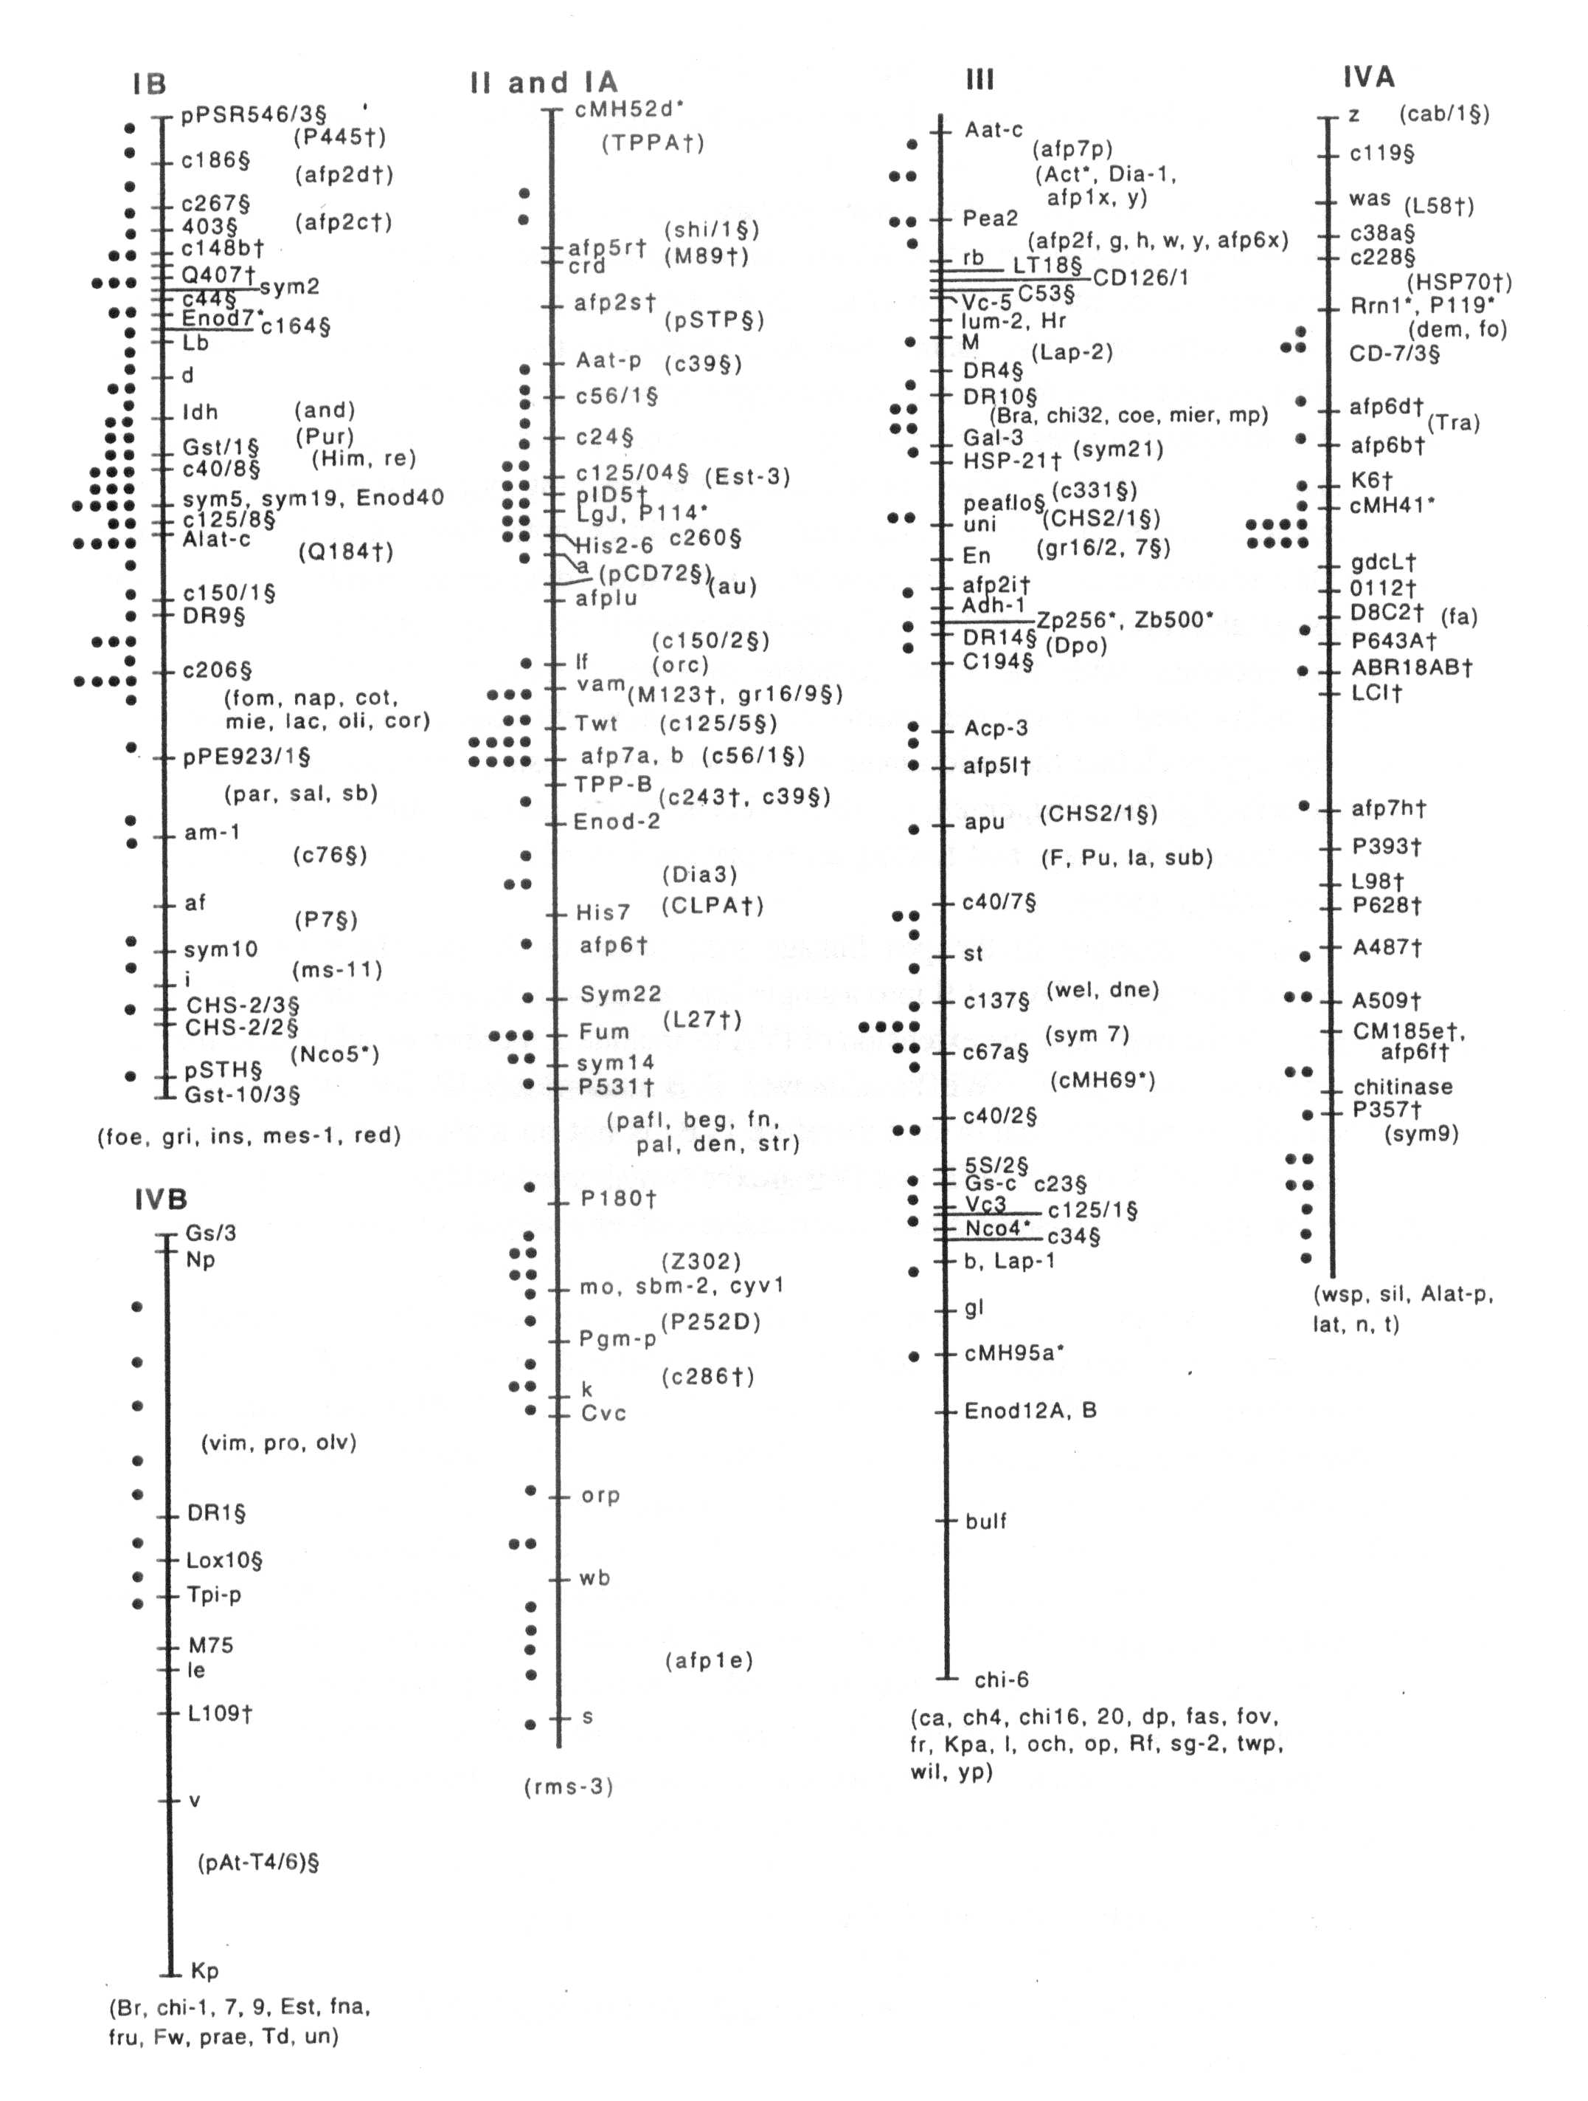
Pisum Genetics Volume 28 1996 Pea Map 3

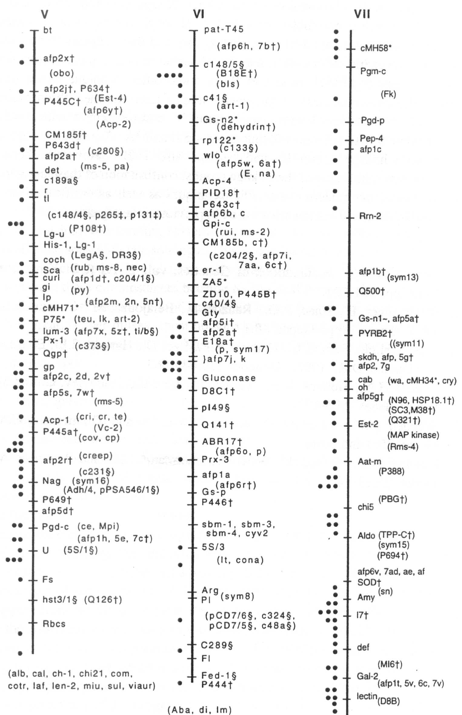
4 Pisum Genetics Volume 28 1996 Pea Map

The assignment of linkage groups and chromosomes appears to be nearly complete. The presence of the ribosomal genes on linkage groups IVA and VII indicate that these groups must correspond' to chromosomes 4 and 7, although not necessarily respectively. The two satellite chromosomes are difficult to distinguish, and there appears to be some confusion even with the cytogenetic stocks, so it may be advisable to define these chromosomes based on the linkage groups (by FISH, in situ PCR, or some other technique where markers are used to identify the chromosomes). Cytogenetic studies have matched chromosome 2 with linkage group VI, chromosome 3 with linkage group V, chromosome 5 with linkage group III, and chromosome 6 with what now is linkage group II and IA. By default, chromosome 1 must be paired with linkage group IB and perhaps also IVB. However, before we commit to chromosomal numbering of the linkage groups, confirmation of these assignments is needed by at least one of the modern cytogenetic techniques as well as verification of the chromosomes involved in the translocation stocks used in previous investigations.

- Blixt, S. 1974. In:Handbook of Genetics, vol. 2, Ed R.C. King, Plenum Press, New York, pp. 181-221.
- Dirlewanger, E., Isaac, P.G., Ranade, S., Belajouza, M., Cousin, R. and de Vienne, D. 1994. Theor. Appl. Genet. 88:17-27.
- Ellis, T.H.N., Turner, L., Hellens, R.P., Lee, D., Harker, C.L., Enard, C, Domoney, C. and Davies, D.R. 1992. Genetics 130:649-663.
- Ellis, T.H.N., Hellens, R.P., Turner, L., Lee, C, Domoney, C. and Welham, T. 1993. Pisum Genet. 25:5-12.
- Weeden, N.F., Swiecicki, W.K., Ambrose, M. and Timmerman, G.M. 1993. Pisum Genet. 25:4 and cover.
- Weeden, N.F., Swiecicki, W.K., Timmerman, G.M. and Ambrose, M. 1993. Pisum
Genet. 25:13-14.

Pisum Genetics Volume 28 1996 Review
5

Breeding field peas for Western Australia: progress and problems
Khan, T. N., French, R. J. Agriculture Western Australia
and Hardie D. C. 3 Baron-Hay Court
South Perth, WA 6151, Australia
Field pea has been grown in Western Australia (WA) since the beginning of this century but it was not until the middle of the 1980s that a major expansion in the area began to occur. The area peaked in 1988/89 at about 50,000 ha but it declined sharply in response to adverse publicity generated due to severe epidemics of black spot disease caused by Mycosphaerella pinodes in early sown crops and due to difficulties in harvesting. The black spot problem is now managed by delayed sowing but the pea area has remained static at around 35,000 ha.
Field pea fits best into WA farming systems in medium to low rainfall areas on fine-textured neutral to alkaline soils with late sowings. This is despite field pea often yielding well on coarser-textured and acid soils (7) and from early plantings (6) in WA. They have not become more important in these circumstances because narrow-leaf lupin has been spectacularly successful on acid sandy soils, and the risk of large yield losses from black spot disease with early sowings is too great. Other pulses, most notably faba bean and chickpea, are preferred for early sowings (21), but field pea will consistently out-yield these from late sowings when there is little risk of black spot.
The field pea industry of the 1980s began with the adoption of the cvs Derrimut and Dundale, both producing greenish brown (dun type) seed. Dundale was encouraged due to it's suitability for milling. Later, a South Australian white-flowered cultivar, Wirrega, was introduced but its inconsistent performance lead to a return of Dundale as the most popular variety. More recently, another white-flowered and earlier flowering South Australian cultivar, Laura, has been released to replace Wirrega. Another cultivar with varying success is a late flowering South Australian cultivar, Alma.
The breeding program
With the emergence of field peas as a significant crop in the 1980s, breeding lines from the South Australian and Victorian Pea Breeding Programs were imported for trials in WA. Three years of evaluation work concluded that a majority of lines were too late flowering for the short season environment of the wheatbelt. A local breeding program was therefore started in 1988 with the support from the Grain Legume Research Council. In 1993, the program was incorporated into the Australian Coordinated Pea Improvement Program (ACPIP) funded by the Grain Research and Development Corporation (GRDC). The WA program was delegated to focus on breeding for the short season environment. The longer growing seasons were to be largely catered for by importing breeding lines from South Australia and Victoria.
The breeding objectives of the program may best be viewed against the two phases of the program. The pre-1996 phase saw a response to low and inconsistent yields as the first priority, and therefore yield, adaptation to the short season environment, and milling quality were the primary objectives, with standing ability and less susceptibility to black spot as the secondary objectives. The post-1996 objectives include resistance to black spot and harvestibility amongst the primary objectives in recognition of these factors as major hurdles in the field pea development in WA. The GRDC is also encouraging a major effort in breeding for

6 Pisum Genetics Volume 28 1996 Review
the black spot resistance. Pea weevil resistance is also desired as it is one of the most wide spread insect pests affecting both yield and quality, but this work is currently at an investigation stage.
Methodology
The breeding material is channeled in two streams. The larger stream is that for the low rainfall areas representing the short season environment and a smaller stream for the high rainfall areas of the South. The low rainfall material is tested at Latham (300 mm annual rainfall), Merredin (310 mm) and Konnongorring (350 mm) and the high rainfall material is tested at Katanning (474 mm) and Tunney (500 mm). Medina (800 mm), on the outskirts of Perth, is used for the black spot resistance screening. Most of the trial seed production is carried out at Avondale (400 mm). The length of the growing season varies from about 21-22 weeks at the northernmost site Latham (latitude 29° 45' S) to about 25-26 weeks at the southernmost site Tunney (latitude 34° 07' S).
The breeding method used in the beginning was based on early generation testing where F₂ derived lines were bulked and yield tested until F₅ when re-selection of single plants was done in the targeted lines. Due to the problem of recognizing potential lines in early generations (17, 22) and the masking effect of heterosis (19), crosses are now bulked-raised and bulks are compared in replicated trials at the F₄ stage. Single plants are then selected at the F₅ stage from the selected crosses.
The F₅/F₆ lines are bulked and selected for agronomic characters before selection for yield at the F₅/F₇ and F₅/F₈ stages. A limited number of lines are then promoted to about 15 regional trial sites in the first year and about 35 sites in the subsequent years. With a greater emphasis now on black spot resistance, two recurrent selection procedures are being considered. The first option is to select for resistance in the F₂/F₃ and then intercross resistant lines. The second option involves following single seed descent to F₅ and then selection for resistance in F₅/F₆ lines before intercrossing.
Selection for yield and adaptation
The typical field pea crop in WA is planted in the last week of May or the first half of June. It will receive 200 to 250 mm of rainfall throughout the growing season, but usually very little falls after mid September. The crop will be ready for harvest in late October. Field pea performs well under these conditions by exhibiting a drought escape mechanism. This means that the crop flowers early, then sets and fills pods while plant water status is adequate. To achieve this early flowering and vigorous early growth are necessary, as well as reliable early pod set and pod retention. Osmotic adjustment could also be a useful trait by extending the period of favourable water relations during pod fill. One of the objectives of the WA program has been earlier flowering. Much of the locally bred material flowers earlier than the most commonly grown commercial cultivar, Dundale (Fig. 1). However, earlier flowering does not necessarily result in higher yields. From a 23 May sowing in 1995, for example, best yields were actually obtained from the later flowering lines (Fig. 1). However, there were quite a few lines flowering up to a week earlier than Dundale that yielded very well. These lines should perform better with late sowings than the later flowering lines, and so should be more adaptable in WA. Fig. 1 shows trend lines for yield with flowering date for locally bred lines and for controls derived from elsewhere. The offset between these two lines shows that the local breeding program has made a yield improvement that is independent of flowering date. This could be related to improvements in flower and pod retention and in seed filling. This possibility has not been investigated thoroughly with locally bred material, but detailed

Pisum Genetics Volume 28 1996 Review
7

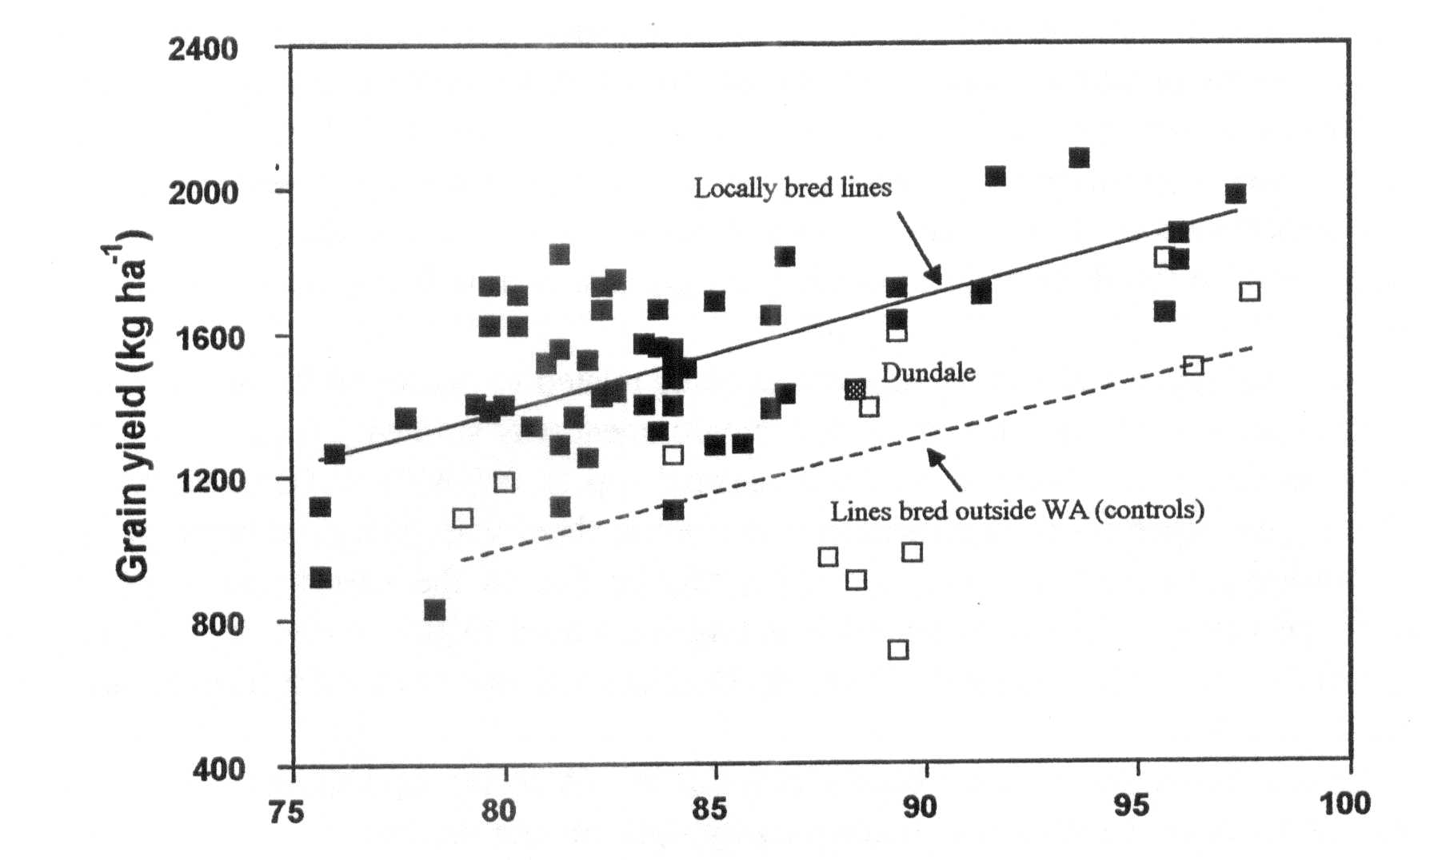
Flowering date (days after sowing)
Fig. 1. Relationships between flowering date and grain yield of pea lines grown at Merredin, WA in 1995. The solid symbols represent locally bred lines (crosses made in 1988 and 1989) and the open symbols represent existing cultivars or breeding lines derived from Victoria or South Australia. The two regression lines show separate yield trends with flowering date for local lines (r²=0.404) and other lines (r²=O.273).

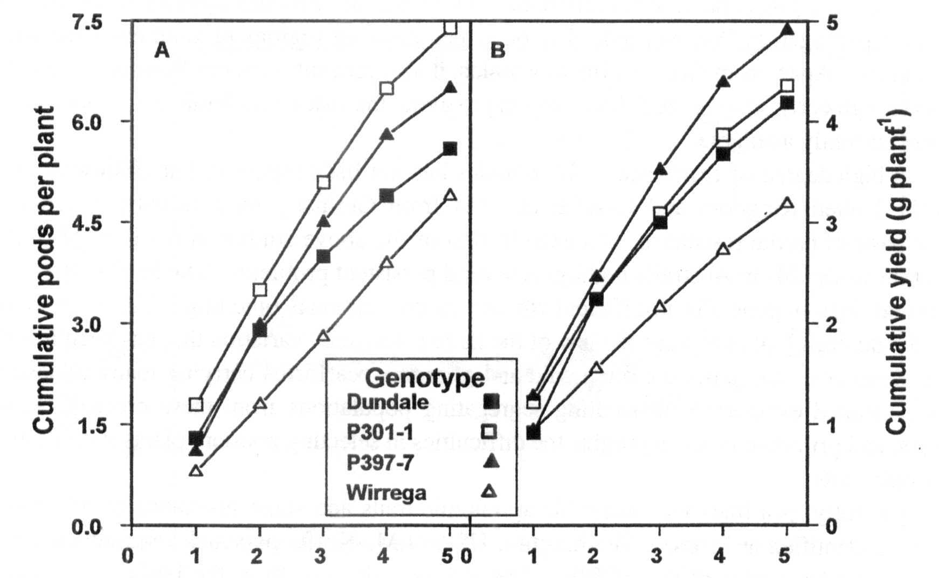
Reproductive node number
Fig. 2. Cumulative pod number (A) and cumulative seed yield (B) on the first five reproductive nodes of four genotypes of field pea grown at Merredin, WA in 1995, showing differences in the ability of different genotypes to set, retain, and fill pods in this environment. The lines shown here were all derived from South Australia.

8 Pisum Genetics Volume 28 1996 Review
physiological studies have been made locally with material derived mainly from the South Australian breeding program. These show that although nearly all pea genotypes can potentially produce two pods per reproductive node, few do so consistently, and there are considerable differences between genotypes in how many pods are set and retained (Fig. 2a). Seed set and filling are important too, as Fig. 2b shows that the genotypes setting the most pods do not necessarily produce the most yield. Locally bred material is now being examined for pod set and seed set.
Following reports of osmotic adjustment being related to higher yields in pea under dry conditions in Spain (18), its value in the WA environment was studied. Appreciable levels of osmotic adjustment were found in the local material (up to 0.7 MPa at 100% relative water content) and genotypes varied significantly. However, there was little correlation with yield under water-limited conditions (Fig. 3). This may be due to the narrow range of genetic breadth in the highly selected, advanced breeding lines used in this study. It is significant, though, that the successful commercial cultivar, Dundale, was one of the best osmotic adjusters in the material tested.
Direct selection for yield has been successful in WA so far, and should continue to be. It seems that we have the flowering times roughly right for our environment, but further yield testing with later planting is required to establish the value of flowering earlier than Dundale in our farming system. More attention to improving pod and seed set is likely to lead to further yield improvement.
Disease resistance
A number of bacterial and fungal diseases have been identified but none produces any threat to the field pea crop with the major exception of black spot. Black spot disease in pea is caused by three fungi Ascochyta pisi Lib., Mycosphaerella pinodes Berk. & Blox. and Phoma medicaginis var. pinodella (Jones) Boerema. Of these, M. pinodes appears to be the most significant pathogen in WA and indeed in other pea-growing regions of southern Australia on the mainland. Apart from directly affecting yields, it also prevents farmers from achieving high yields through early sowing, as delayed sowing to avoid the risk of epidemic is the only control measure currently available.
A high degree of resistance to M. pinodes has not been reported, but Clulow et al. (4) from the United Kingdom and Nasir et al. (15) from Germany have recently reported the genetic basis of partial resistance. An examination of the above studies in the light of past (1) and recent work (24) in Australia highlights several persistent problems. The level of resistance in parental lines is generally insufficient for use in conventional breeding. There are doubts about the durability of resistance in view of the large pathogenic variation that has been found to occur. Sources of resistance are often wild and primitive pea forms carrying many undesirable genes. Limited experience in handling segregating populations from these crosses between domestic and primitive types highlights the difficulties in selecting resistant plants with desirable agronomic traits.
Recently, pea lines with desirable agronomic traits and some resistance to M. pinodes have been identified at Prosser, Washington, USA (J.M. Kraft, personal communication), in WA, and in other nodes of the ACPIP. These lines will now form the basis of a recurrent selection program to improve the level of resistance in commercial pea cultivars and also to improve the level of resistance in resistant × resistant crosses.

Pisum Genetics Volume 28 1996 Review
9

Table 1: Yield (expressed as percentage of Wirrega's yield) and other characteristics of the crossbred lines selected for the Crop Variety Testing Stage 3 trials at Konnongorring and Perenjori.

Entry | Pedigree | Konn-ongorr ing% yield | Peron-jori % yield | Flower colour | Days  to  flower | 100 seed weight (g) | Seed colour/shape
Wirrega | Control | 100 | 100 | W | 96 | 18.27 | white round
Dundale | Control | 96 | 108 | P | 88 | 23.64 | dun
Laura | Control | 107 | 113 | W | 89 | 16.82 | white round
Pennant | Control | 73 | 89 | W | 79 | 16.54 | white round
88P077-2-8 | WA1/COLLEGIAN | 114 | 114 | P | 91 | 20.56 | speckled dun
88P077-3-8 | WA1/COLLEGIAN | 93 | 117 | W | 86 | 17.80 | white round
88P084-4-1 | DUNDALE/WA1 | 113 | 114 | P | 85 | 20.02 | dun
88P084-5-4 | DUNDALE/WA1 | 111 | 109 | P | 82 | 19.08 | greenish dun
88P084-5-15 | DUNDALE/WA1 | 115 | 108 | P | 82 | 19.20 | greenish dun
88P084-5-22 | DUNDALE/WA1 | 135 | 124 | P | 92 | 17.30 | dun
88P084-5-25 | DUNDALE/WA1 | 114 | 120 | P | 91 | 19.52 | greenish dun
89P123-2-4 | DERRIMUT/P94-2 | 116 | 115 | P | 80 | 19.90 | greenish dun
89P123-2-30 | DERRIMUT/P94-2 | 108 | 110 | P | 80 | 17.63 | greenish dun
89P123-2-39 | DERRIMUT/P94-2 | 108 | 124 | P | 80 | 17.99 | greenish dun
89P133-4-9 | DERPJMUT/WA724 | 121 | 117 | P | 87 | 19.30 | speckled dun
89P134-1-2 | DERRIMUT/SOLARA | 117 | 115 | W | 83 | 23.84 | white round
89P150-15-8 | WIRREGA/P94-1 | 110 | 106 | P | 96 | 16.14 | dun
89P150-15-15 | WKREGA/P94-1 | 120 | 115 | W | 96 | 17.66 | white round
89P150-15-19 | WIRREGA/P94-1 | 125 | 122 | W | 96 | 16.26 | white round
Wirrega | (yeld kg per ha) | 1498 | 1796
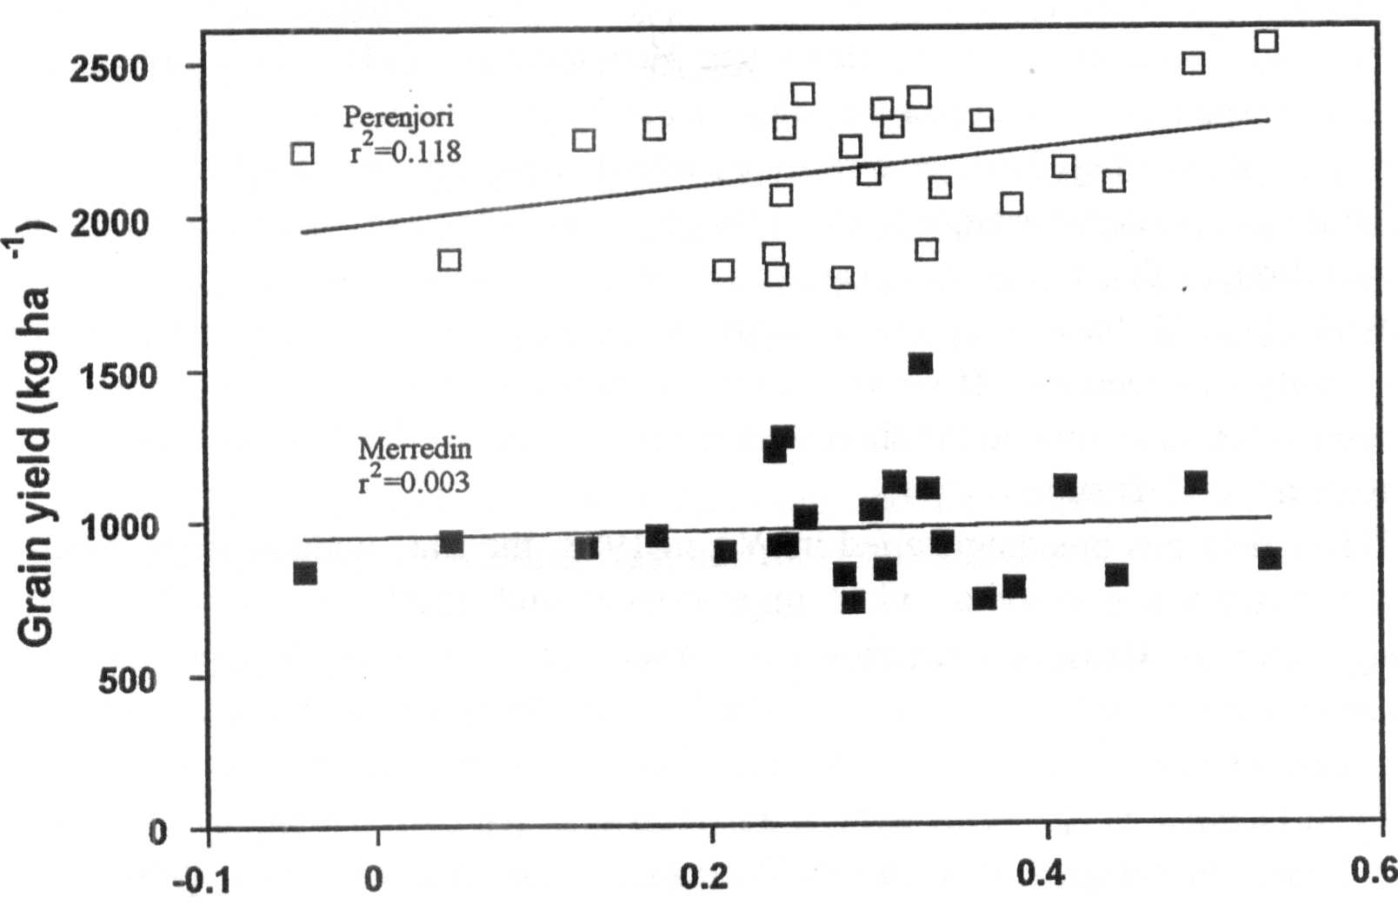
Osmotic adjustment (MPa)
Fig. 3. Relationship between maximum osmotic adjustment (screened in pots) and grain yield at two locations in the WA wheatbelt in 1994, of 24 locally bred field pea lines derived from 1988 crosses.

10 Pisum Genetics Volume 28 1996 Review
Insect pest resistance
The redlegged earth mite (Halotydeus destructor Tucker), the pea weevil (Bruchus pisorum L.) and the native budworm {Helicoverpa punctigera Wallengren) are the three important insect pests in WA. All could potentially be controlled with the use of resistant cultivars. However, currently only pea weevil is being addressed.
As early as 1938, Newman and Elliot (16) in WA found that Lathyrus species were resistant to the weevil (2). Unsuccessful attempts were made to cross peas with several species of Lathyrus to incorporate its' resistance (5). More recently, the neoplastic pod allele (Np) has been implicated with resistance to the pea weevil through a pod epidermal outgrowth in response to oviposition (3, 8, 9). However, it seems the impact of the Np gene response may be of limited value as the majority of neonate larvae will crawl off the neoplastic growths and penetrate the pod through unaffected tissue (9). New findings in Australia demonstrate resistance to the pea weevil in another pea species, P.fulvum Sibth. & Sm. (9, 10), which can be crossed with P. sativum, and in transgenic pea seeds (CSIRO, Canberra) expressing the a-amylase inhibitor from Phaseolus vulgaris L. (20). Studies in the USA (S.L. Clement, personal communication) and Chile (H. Norambuena, personal communication) confirm the presence of high levels of resistance to the pea weevil in the P. fulvum material.
The P. fulvum resistance research, which began in South Australia and has continued in WA, indicates more than one resistance mechanism to the pea weevil in the P. fulvum material screened to date. Some of the P. fulvum accessions appear immune to the pea weevil, due mainly to the presence of an antibiosis factor in the seed cotyledons and our investigations into this factor suggest that it is controlled by several genes. Chemical analysis of the cotyledons has not revealed the source of the resistance, but research to identify the resistance factor is continuing.
The afila gene and its application
Applications of the afila gene (af), which confers semi-leaflessness by changing leaflets into tendrils, has been advocated by Heath and Hebblethwaite (11). This gene has radically affected the appearance of new pea varieties in the North America and Europe. Apart from greatly improved standing ability as a result of inter-locking amongst tendrils, it has also been claimed to impart greater resistance to water logging (14) and greater tolerance to drought (13). It was also thought that the more open canopy will discourage disease epidemics. Although recent studies (12, 23) have cast doubt on many of these claims, use of the af gene in improving standing ability will continue. However, a greatly increased biomass in the semi-leafless lines will be needed for adaptation to the short season environment of the WA wheatbelt.
Past, present and future
When field pea breeding started in WA in 1988, the state-wide average yield of about 800 kg/ha dictated a priority on yield improvement and emphasis on milling quality for marketing reasons. Crosses were aimed at earlier flowering and tall types which showed greatest adaptation to the local conditions. The lines originating from these crosses entered the regional variety trials in 1995 for the first time (Table 1). Whereas yield improvement over cvs Wirrega and Dundale is clearly evident, improvement in seed size of the white, round-seeded cross-bred lines in comparison with cvs Wirrega and Laura is of added interest. It is also notable that although flowering date did not form the basis of selection, most of the lines which reached the regional trial stage flower earlier, suggesting a flowering window of about 80 to 90 days. It is expected that one of these lines will be released before the end of this century. In the meantime, two selections from segregating material received from New Zealand are now

Pisum Genetics Volume 28 1996 Review
11

being bulked for possible release in 1997/98. One of these two lines is a stiff-stem dwarf and the other a semi-leafless semi-dwarf; both these lines represent a radical departure from the plant type traditionally grown in WA.
After the first two seasons of crossing, greater attention has gone into choosing parents with bold and round white seed, stiff stem, semi-leafless character, growth vigour and cold tolerance. Re-selected genetically stable lines from these crosses should enter the yield trials shortly.
The pea breeding program has started a new round of industry funding and resistance to black spot caused by M. pinodes is now a priority objective. The breeding program will take a recurrent selection approach with agronomically suitable types with a degree of improvement in resistance being channeled to yield evaluation in date-of-sowing experiments as soon as possible; early sowing encourages black spot epidemics. However, disease assessment in pea plants, more particularly single plants, poses a formidable challenge and the success or failure of this program is likely to depend on innovations to successfully score for disease reaction. Molecular markers will also be sought in cooperation with an overseas research institution.
Just under a decade of breeding peas has made us appreciate that the pea plant presents many technical problems. This may explain why success stories in pea breeding have been few and far between despite pea being one of the most studied plants from the genetic point of view. Its trailing growth habit, poor anchorage at the soil level when the crop dries, and lodging make it difficult to estimate yield accurately. Single plant selection is difficult because isolated pea plants grow and yield poorly and are often uprooted by the wind. In addition, large inter-plant spaces pose associated weed problems. Inter-plot spaces of about 1 m are necessary to avoid plots merging into each other, but this presents problems in obtaining realistic yield estimates. The co-efficient of variation in pea trials is generally very high. The only practical solution is to increase plot size which increases demand for resources, and in earlier generations, this is just not possible. Studies on field plot techniques in pea breeding, an area sadly neglected in pea studies, needs urgent attention. The resurgence of the pea industry in WA will require high yielding and milling type cultivars which have a level of black spot resistance that will allow them to be sown earlier. In addition, stiff stem and semi-leaflessness will be needed for improved harvesting, and pea weevil resistance to minimize inputs. The outcome of the current work on black spot and pea weevil resistance, and physiological work on defining plant type for yield and drought resistance, will determine the success of future pea breeding in Western Australia.
Acknowledgments. We thank the Grains Research and Development Corporation and the Grains Research Committee of Western Australia for financial support.
__________________________
- Ali, S. M., Nitschke, L. F., Dube, A. J., Krause, M. R. and Cameron, B. 1978. Aust. J. Agric. Res. 29: 841-849.
- Anon. 1947. Resistance of strains of Vicia and Lathyrus to pea weevil. Australian Council of Scientific and Industrial Research Annual Report 21: 14.
- Berdnikov, V. A., Trusov, Y. A., Bogdanova, V. S., Kosterin, O. E., Rozov, S. M.. Nedel'kina, S. V. and Nikulina, Y. N. 1992. Pisum Genetics 24: 37-39.
- Clulow, S. A., Matthews, P. and Lewis, B. G. 1991. Euphytica 58:183-189.
- Fisher, H. M. 1953. Pisum-Lathyrus cross. The A.P.G Newsletter 3: 14.

12 Pisum Genetics Volume 28 1996 Review
- French, R. J. 1990. Aust. J. Agric. Res. 41: 853-862.
- French, R. J. and M. A. Ewing. 1989. Aust. J. Exp. Agric. 29: 829-835.
- Hardie, D. C. 1990. Pea weevil, Bruchus pisorum L., resistance in peas. In: Proc. Nat. Pea Weevil Workshop, Ed. Smith, M. A. Dept. Agric. and Rural Affairs, Melbourne, Australia.
- Hardie, D. C. 1992. Resistance to the pea weevil in Pisum species. PhD thesis, Univ. Adelaide, Australia.
- Hardie, D. C., Baker, G. J. and Marshall, D. R. 1995. Euphytica 84: 155-161.
- Heath, M. C., Hebblethwaite, P. D. 1984. Outlook on Agriculture 13:195-202.
- Heath, M. C. and Hebblethwaite, P. D. 1992. In: Proc. 1st European Conf. Grain Legumes, Angers, France, pp. 215-216.
- Heath, M. C. and Hebblethwaite, P. D. 1992. In: Proc. 1st European Conf. Grain Legumes, Angers, France, pp. 225-226.
- Jackson, M. B. 1985. In : The Pea Crop. A basis for Improvement, Eds Hebblethwaite, P. D., Heath, M. C. and Dawkins, T. C. K., Butterworths, London, pp. 163-172.
- Nasir, M., Hoppe, H. H., Ebrahim-Nesbat, F. 1992. Plant Path. 41:187-194.
- Newman, L. J. and Elliott, H. G. 1938. J. Agric. Western Australia 15:156-158.
- Ranalli, P. and Fantino, M. G. 1992. In: Proc. 1st European Conf. Grain Legumes, Angers, France, pp. 61-62.
- Rodriguez-Maribona, B., Tenorio, J. L., Conde, J. R. and Ayerbe. L. 1992. Field Crops Res. 29: 15-22.
- Sarawat, P., Stoddard, F. L., Marshall, D. R. and Ali, S. M. 1994. Euphytica 80:39-48.
- Schroeder, H. E, Gollasch, S., Moore, A., Tabe, L. M., Craig, S., Hardie, D. C. Crispfield, M. J., Spencer, D. and Higgins, T. J. 1995. Plant Physiol. 107: 1233-1239.
- Siddique, K. H. M., Walton, G. H., and Seymour, M. 1993. Aust. J. Exp. Agric. 33: 915-922.
- Stelling, D. and Ebmeyer, E. 1990. Plant Breeding 105: 169-179.
- Tenario, M. L. and Ayerbe, L. 1992. In: Proc. 1st European Conf. Grain Legumes, Angers, France, pp. 211-212.
- Wroth, M. 1996. Host-pathogen relationship of the ascochyta blight {Mycosphaerella pinodes (Berk. & Blox.) Vestergr.) disease of pea {Pisum sativum L.). PhD thesis, Univ. Western Australia, Perth.
Pisum Genetics Volume 28 1996 Research Reports 13
Confirmation that the sn locus is between Aldo and Gal2 in linkage group VII of pea
Murfet, I.C. Department of Plant Science, University of Tasmania
and Sherriff, L.J. Hobart, Tas 7001, Australia
Sn is one of three complementary dominant genes Sn, Dne and Ppd which together confer the ability to respond to photoperiod and a late flowering habit in pea (1-4). The recessive mutant allele sn causes a loss of the photoperiod response, and common early flowering, day neutral cultivars such as Sparkle, Massey, Alaska and Progress #9 are homozygous for this allele (2, 5, 7). Weeden et al. (7) reported very close linkage between sn and the amylase locus Amyl leading to placement of the sn locus between isozyme loci Aldo and Gal2 in the lower section of linkage group VII in recent maps (e.g. 8).

We have recently obtained data from cross HL249 (Aldo^{s} Sn Gal2^{s}) x Sparkle (Aldo^{F}sn Gal2^{F}) which confirm that location. Monohybrid segregation for Aldo and sn was in good accordance with expectation (P>0.5), but segregation for Gal2 was mildly disturbed (P<0.01). The dihybrid segregation data (Table 1) indicate linkage between all markers and generate the following map:
These results are in reasonable accordance with, and thus support, the 1993 (8) and current (9) maps for this section of the pea genome. Whether sn is located above or below Amyl remains undetermined.
Table 1. Dihybrid segregation data from the F₂ of the cross HL249 (Aldo^{s} Sn Gal2^{s}) x Sparkle (Aldo^{F}sn Gal2^{F}). The plants were grown under an 8-h photoperiod to allow unequivocal recognition of Sn and sn segregants. The data were analysed using the program LINKAGE1 (6).
Gene pair |  |  |  | Phenotype¹ |  |  |  |  |  | Total | Linkage | Recomb
 |  |  |  |  |  |  |  |  |  |  | Chi-square | Fract. SE
 | DF | DH | DS | RF | RH | RS
Sn - Aldo | 6 | 33 | 17 | 16 | 4 | 0 |  |  |  | 76 | 35.10** | 13 4
Sn-Gal2 | 3 | 24 | 29 | 8 | 10 | 2 |  |  |  | 76 | 18.70** | 25 6
 | FF | FH | FS | HF | HH | HS | SF | SH | SS
Aldo – Gal2 | 5 | 13 | 4 | 6 | 15 | 16 | 0 | 6 | 11 | 76 | 10.27* | 37 3
¹D = dominant, R = recessive, F = homozygous fast, H = heterozygous, and S = homozygous slow. The first named
locus is shown first.
*, ** P<0.05 and 0.0001, respectively.
__________________________________________
- Arumingtyas, E.L. and Murfet, I.C. 1994. J. Hered. 85:12-17.
- Barber, H.N. 1959. Heredity 13:33-60.
- King, W.M. and Murfet, I.C. 1985. Ann. Bot. 56:835-846.
14 Pisum Genetics Volume 28 1996 Research Reports

- Murfet, I.C. 1971. Heredity 27:93-110.

- Murfet, I.C. 1990. Pisum Genetics 22:78-86.
- Suiter, K.A., Wendel, J.F. and Case, J.S. 1983. J. Hered. 74:203-204.
- Weeden, N.F., Kneen, B.E. and Murfet, I.C. 1988. Pisum Newsletter 20:49-51.
- Weeden, N.F., Swiecicki, W.K., Ambrose, M. and Timmerman, G.M. 1993. Pisum Genetics 25: cover.
- Weeden, N.F., Swiecicki, WK., Timmerman-Vaughan, G.M., Ellis, T.H.N, and Ambrose, M. 1996. Pisum Genetics 28: cover.

Pisum Genetics

Volume 28 1996 Research Reports
15

A more severe mutant allele at the ls locus
Reid, J.B., Weller, J.L. and Sherriff, L.J. Department of Plant Science
University of Tasmania, GPO Box 252-55 Hobart, Tasmania 7001, Australia
During our ethylmethane sulphonate (1%) mutagenesis program (7), a severely dwarfed (nana) mutant, AF51, was isolated. The parental cultivar was Torsdag, a tall, quantitative long day pea. The AF51 mutant responded well to applied gibberellin A₃ (GA₃), and indeed treatment of young seedlings with GA₃ was required in order to obtain a reasonable seed yield (5 - 10 seeds per plant). This suggested the mutant might be deficient in GA₁, the biologically active gibberellin in peas (5). Currently, there are mutations at four described loci that block various steps in GA₁ biosynthesis (Fig. 1) and lead to a dwarf GA-responsive phenotype in peas; le which blocks 3P-hydroxylation of GA₂₀ to GA₁ (3), na which appears to block the conversion of 7α-hydroxy-kaurenoic acid to GA₁₂ - aldehyde (2), lh which blocks the oxidation steps from ent-kaurene to ent-karenoic acid (6) and ls which blocks the conversion of geranyl-geranyl pyrophosphate (GGPP) to copalyl pyrophosphate (CPP) by reducing kaurene synthetase A activity (1).
The cross Torsdag x AF51 produced a wild type tall F₁. The F₂ segregated to give 27 tall : 8 nana progeny, in good accordance with a 3 : 1 segregation (χ²₁ = 0.09) (Fig. 2). This indicates that a single gene recessive mutation caused the mutant AF51 phenotype.
Allelism tests were conducted between the new mutant, AF51, and standard lines possessing four known GA-synthesis mutations (NGB5839, allele le-3; NGB1766, allele na-1; K511, allele lh-1, HL181, allele ls-1). All mutations were on a Torsdag genetic background except na. The F₁ plants of all crosses were wild type (tall) in phenotype except for the F₁ plants of cross AF51 (nana) x HL181 (dwarf), which were dwarf in stature. The F₂ of cross AF51 x HL181 segregated to give 41 dwarf: 19 nana progeny, again in agreement with a 3 : 1 segregation (χ²₁ = 1.4) (Fig. 3).
The results indicate that the AF51 mutant possesses a mutation at the ls locus. Because two mutations at this locus have previously been described, ls-1 (formerly known as ls^{K202}) from cv. Torsdag by Dr K. Sidorova (4), and ls-2 (formerly known as ls^{M26}) from cv. Dippes Gelbe Viktoria by Professor W. Gottschalk (4), the mutant ls allele in AF51 has been designated ls-3. The ls-1 and ls-2 mutations are not markedly different in severity because no clear segregation in the F₂ was observable when the two mutants were crossed. In the present cross, ls-1 x ls-3 (HL181 x AF51; Fig. 3), the clear segregation in the F₂ indicates that ls-3 is a more severe allele than ls-1. Previous genetic analyses had suggested that the ls-1 allele was leaky (i.e. that it did not completely block GA biosynthesis) because the double mutant, ls-1 lh-1, was shorter than either single mutant (4). However, existance of an alternative synthesis pathway or another gene coding for kaurene synthetase A activity could not be ruled out. The discovery of a more severe mutation at the ls locus confirms the suggestion that ls-1 is a leaky mutation. The ls-3 allele is also recessive to both the wild type Ls allele and the less severe ls-1 allele. The new ls-3 allele should prove useful in analysing the molecular action of this gene, a question already under active examination (1).
_________________________
- Ait-Ali, T., Swain, S.M., Reid, J.B, Sun, T. and Kamiya, Y. 1997. Plant J. (in press).
- Ingram, TJ. and Reid, J.B. 1987. Plant Physiol. 83:1048-1053.

16
Pisum Genetics
Volume 28 1996
Research Reports

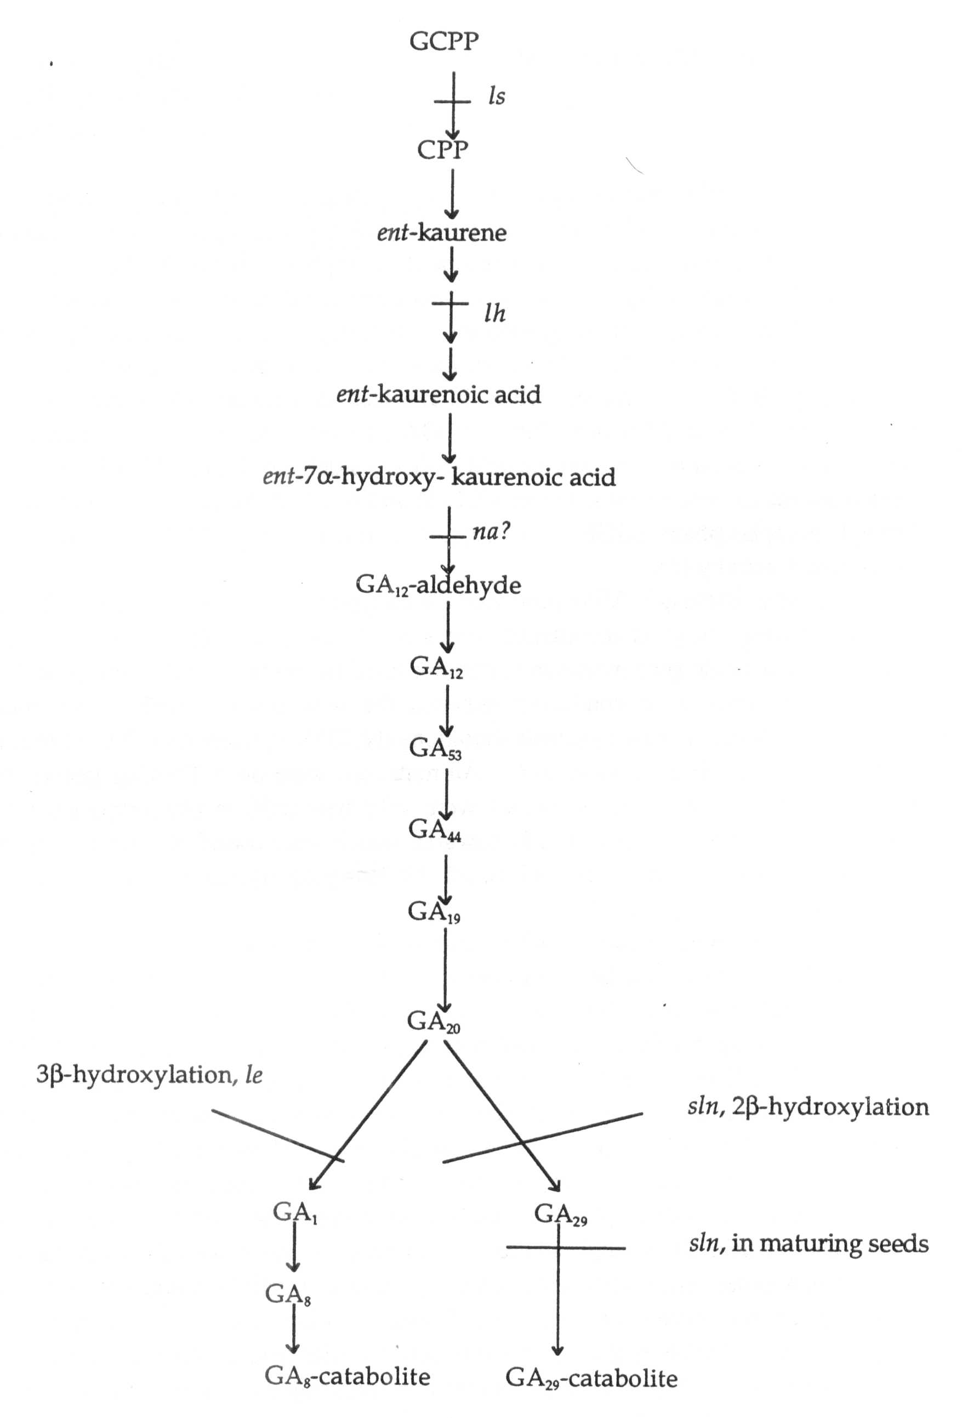
Fig. 1. The dominant GA biosynthetic pathway in the shoots of peas and the sites of action of the GA-biosynthesis mutations (1, 2, 3, 4, 6).
Pisum Genetics Volume 28 1996 Research Reports 17
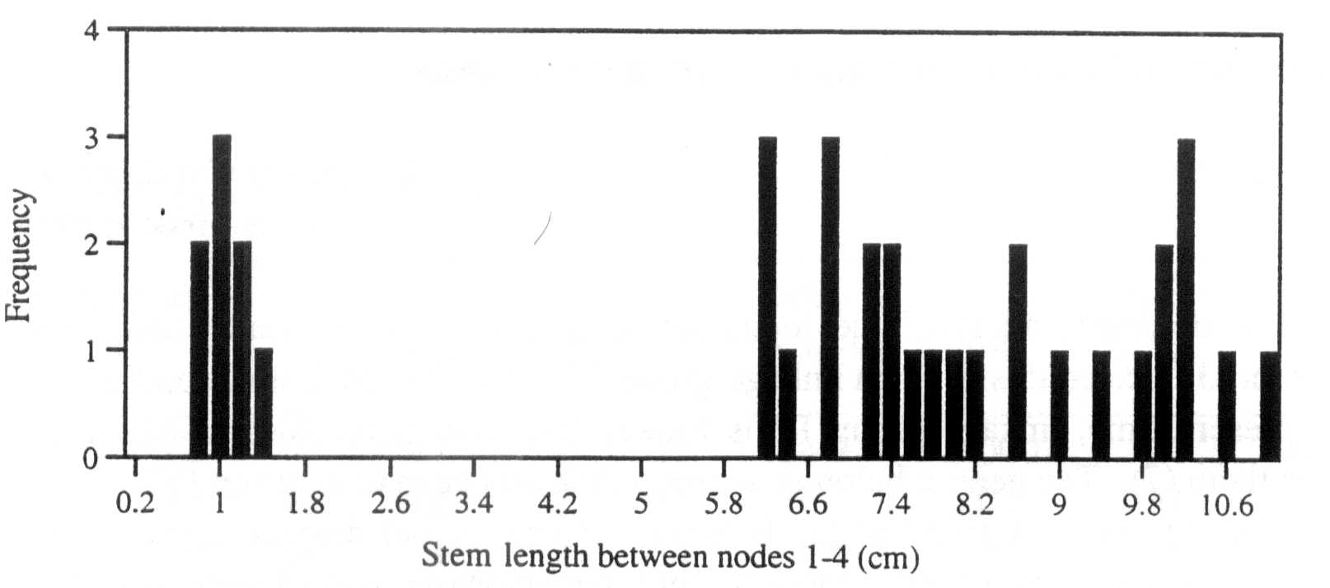

Fig. 2. Distribution of stem lengths between nodes 1 and 4 (to the nearest 2 mm) for the F₂ of the cross Torsdag x AF51. All plants were grown in a glasshouse under an 18 h photoperiod.

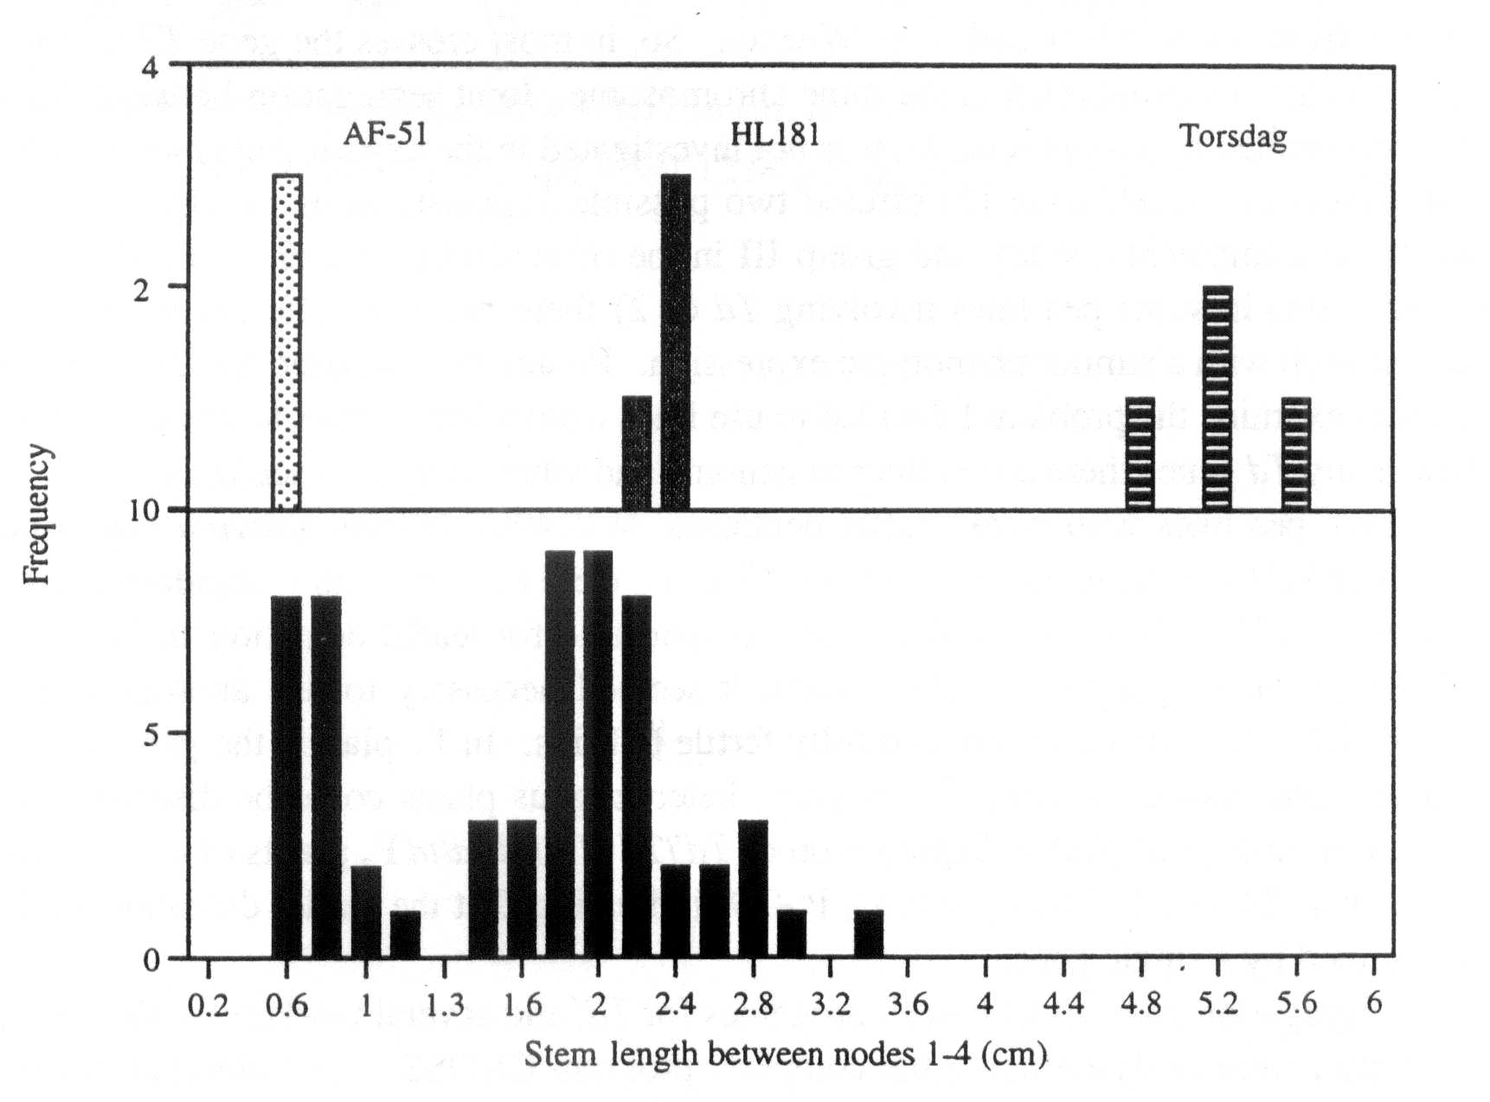
Fig. 3. Distribution of stem lengths between nodes 1 and 4 (to the nearest 2 mm) for parental lines HL181 (dwarf) and AF51 (nana) and the F₂ of the cross HL181 x AF51. As a control, Torsdag (tall) stem lengths are also shown. All plants were grown in a glasshouse under an 18 h photoperiod.
- Ingram, T.J., Reid, J.B., Murfet, I.C., Gaskin, P., Willis, C.L. and MacMillan, J. 1984. Planta 160:455-463.
- Reid, J.B. 1986. Ann. Bot. 57:577-592.
- Reid, J.B. and Ross, J J. 1993. Int. J. Plant. Sci. 154:22-34.
- Swain, S.M., Ross, J.J., Reid, J.B. and Kamiya, Y. 1995. 15th Int. Conf. Plant Growth Substances, Minneapolis, USA. Abstract 115.
- Weller, J.L., Terry, M.J., Reid, J.B. and Kendrick, R.E. 1997. The phytochrome-deficient pcd2 mutant of pea is unable to convert biliverdin IXα to 3Z-phytochromobilin. Plant J. (in press).

18 Pisum Genetics Volume 28 1996 Research Reports
The problem of leaflet dentation inheritance in peas
Smirnova, O. G. Institute of Cytology and Genetics
Novosibirsk 630090, Russia
The dominant allele of the locus Td determines a weak leaflet dentation in peas. Lamprecht (3) located this gene on linkage group IV about 33 cM from le and 36 cM from z. At the present time, linkage group IV is broken into two parts without observable linkage between them (7). The gene z belongs to group IVA and gene le to group IVB.
Marx (5) did not find linkage between Td and z, but demonstrated linkage (15 cM) between Td and b of group III. More recently Grajal-Martin and Muehlbauer (2) and Polans (6) obtained additional evidence that Td is in linkage group III between genes st and Lap-1 (the latter is close to b). The plant materials used in the two latter studies (2, 6) were obtained originally from G. A. Marx and N. F. Weeden. So, in most crosses the gene Td was the same and, as a result, it was mapped in the same chromosome. Joint segregation between Td and le, which was studied by Lamprecht (3), was not investigated in the experiments mentioned above. Grajal-Martin and Muehlbauer (2) offered two possible explanations as to why Td mapped to group IV in Lamprecht's study and group III in the other studies: either 1) there are genomic rearrangements in some pea lines involving Td or 2) there are two different genes for leaflet dentation each with a similar phenotypic expression. Polans (6) favoured the first explanation. To further examine the problem I decided to use lines from other sources to answer the question of how many Td genes there are in the pea genome and where they are localized.
Two pea lines with weak leaflet dentation, WIR4907 (Pisum sativum ssp. asiaticum) and WIR319 (Pisum sativum ssp. sativum) (Fig. 1), were crossed with a standard marker line, WL1238 (= JI73). To distinguish the gene responsible for leaflet dentation in lines WIR319 and WIR4907 from the gene used by Marx, it seemed necessary to use another symbol, for example, Td'. Both crosses produced fully fertile hybrids. In F, plants, the gene Td' showed incomplete dominance. Among F₂ progeny, heterozygous plants could be distinguished from dominant homozygous plants. Segregation of Td'/Td':Td'/td:td/td F₂ plants of cross WIR319 x WL1238 was 24:48:25 (Chi-sq. = 0.03, P>0.9) indicating that the leaflet dentation in WIR319 is determined by a single gene.
Segregation analysis of two F₂ progenies for Td' and several markers is shown in Table 1. The data were analysed using the computer program CROSS. All individual segregations were in accordance with a 3:1 ratio (P>0.05). In the cross WIR4907 x WL1238, Td' was estimated to be located about 20 map units from le and, at the same time, 32 map units from gene b. The linkage Td'-le is highly significant (P<0.0001) while the Td'-b linkage is scarcely significant (P<0.01). It is difficult to explain the linkage with b confidently. One can only assume that an unknown gene near b has an influence on the expression of gene Td' from linkage group IVB. The F₂ data from the cross WIR319 x WL1238 clearly indicate that Td' is associated with le but not with b. As can be inferred from the segregation of Td', le and Np, these genes are be arranged in the following order: Np — 23 — le — 17 — Td'.
Thus, in lines WIR319 and WIR4907 Td' is located on the linkage group IVB. The gene Td' of these lines seems to be not the same as in line A886-193 used by Marx (5). The line A886-193 is derived from Pisum abyssinicum where the stipules and leaflets become dentate at node 6 or 7 and in all succeeding leaves. The lines WIR4907 and WIR319 have

Pisum Genetics

Volume 28 1996
Research Reports
19

Table 1. Joint segregation analysis for Td' and le, b and Np.

Gene | pair | Phenotypic |  | classes |  | Joint |  | Recomb.
Cross* X | Y | XY | Xy | xY | xy | Chi-sq | Prob. | fract. | SE
A Le | Td' | 74 | 17 | 4 | 19 | 34.7 | <0.0001 | 20.2 | 4.3
B | Td' | 62 | 18 | 16 | 18 | 10.2 | <0.01 | 31.7 | 5.5
B Le | Td' | 69 | 11 | 3 | 14 | 26.8 | <0.0001 | 16.7 | 4.2
B | Td' | 53 | 21 | 19 | 4 | 1.1 | >0.05 | - | -
Np | Td' | 58 | 16 | 14 | 9 | 2.8 | >0.05 | - | -
Le | Np | 68 | 12 | 6 | 11 | 19.1 | <0.0001 | 22.8 | 5.0
*A. Cross WIR4907 {Td', Le, B) x WL1238 {td, le, b); n = 114
B. Cross WIR319 {Td', Le, B, Np) x WL1238 {td, le, b, np); n = 97
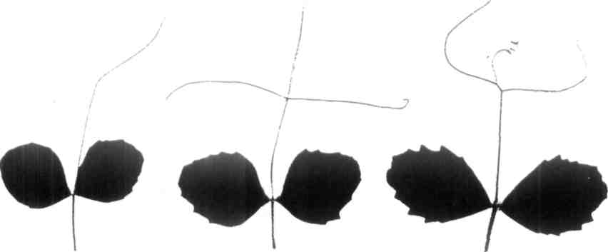
Fig. 1. Left to right: toothed leaves from the 6th node of pea lines WIR4907 and WIR319 (gene Td'), WL6 (gene Td) and WL1325 (gene Ser).

20 Pisum Genetics Volume 28 1996 Research Reports

dentate leaflets only at nodes 6, 7, 8 and sometimes an occasional separate tooth on upper nodes.
The line WL6 from the Nordic Gene Bank has a classic Td phenotype. Its leaflets are toothed at nodes' 6 to 9 and leaflet dentation is a little deeper than in lines WIR319 and WIR4907 (Fig. 1). A test cross WTR319 x WL6 was made to verify if the leaflet dentation genes of these lines are the same or not. Under field conditions among 176 F₂ plants, 13 plants were without leaflet dentation (Chi-sq. (15:1) = 0.39, P>0.5). The remaining 163 plants differed as to the tooth intensity. One could see plants with weak, normal, strong and very strong leaflet dentation. The experiment was repeated in the greenhouse. 113 F₂ plants of the same cross were examined with respect to the degree of leaflet dentation at nodes 5 to 9. The F₂ plants were confidently divided into 5 phenotypic classes with very strong, strong, normal, weak, and without dentation, respectively. The numbers in the classes were 14:29:40:21:9. These numbers are in reasonable agreement with the theoretically expected ratio 1:4:6:4:1 (Chi-sq. = 8.7, P>0.05) for leaflet dentation being controlled by two independently segregating genes with partial dominance and additive effects.
Support for this result was found in the review by Blixt (1). He reported that besides the gene Td in the pea genome there is a semi-dominant gene, Int (incrementum), which determines, together with Td, leaflet dentation of the scalaris forma type. This gene was described by Lamprecht (4). Its location is unknown.
Another gene coding for a saw-toothed leaflet dentation is the semi-dominant gene Ser. Its map location is also unknown. The serratus dentation was first described by Sutton in 1914 in Pisum abyssinicum. The line WL1325 from the Nordic Gene Bank expresses the classic Ser phenotype (Fig. l), with leaflets dentate at nodes 5 to 9 and weak teeth on the following leaves.
The crosses WL6 x WL1325 and WIR319 x WL1325 were made. The resulting hybrid
plants were fully fertile. Plants without toothed leaflets appeared in both F₂ populations. The
toothed/without teeth plant ratio was 125:10 (Chi-sq. = 0.31, P>0.5) in the former cross and
209:18 (Chi-sq. = 1.1, P>0.2) in the latter cross. Judging from the number of plants with
untoothed leaflets, which constituted about 1/16 part of analysed F₂ plants, these genes
segregate independently. Thus, two different genes for "Td-phenotype" are present in the pea genome. They segregate independently from each other and from gene Ser. Both these genes, Td' of WIR319 and Td of WL6, have phenotype expression differing from the expression of Td reported by Marx. Perhaps Td of WL6 is not the same as Td of line A886-193 of Marx. Further genetic experiments are necessary to make clear the genetics of leaflet dentation in pea.
_________________________________________
- Blixt, S. 1977. Pisum Newsl. 9, Supplement
- Grajal-Martin, M. J. and Muehlbauer, F. J. 1992. Pisum Genet. 24:54-55.
- Lamprecht, H. 1961. Agri Hort. Genet. 19:360-401.
- Lamprecht, H. 1962. Agri Hort. Genet. 20:63-74.
- Marx, G. A. 1987. Pisum Newsl. 19:38-39.
- Polans, N. O. 1993. Pisum Genet. 25:36-39.
- Weeden, N. F., Swiecicki, W. K., Timmerman-Vaughan, G. M., Ellis, T. H. N. and
Ambrose, M. 1996. Pisum Genet. 28:1-4.

Pisum Genetics Volume 28 1996 Research Reports 21
The effect of Uni on leaf shape
Hofer, J.M.I, and Ellis, T.H.N. Department of Applied Genetics
John Innes Centre, Colney Lane Norwich NR4 7UH, England, U.K.
The pleiotropic unifoliata (uni; 2,6) mutation reduces the complexity of the compound leaf. Leaves are tendril-less, ranging from unifoliate at lower nodes (including the scale leaves) to trifoliate at higher nodes prior to flowering. The uni^{tac} allele (7,8,10) has a similar, but weaker effect; the number of pairs of tendrils is reduced. Like uni, uni^{tac} mutants develop a leaflet at the terminal position. Both alleles are recessive, suggesting they may be loss-of-function variants. This implies that Uni functions to increase the complexity of the compound leaf.
Triple mutant combinations of the genes afila (af; 3,5), tendril-less (tl;1) and uni, were generated to test this inference and examine the effects of Uni on compound leaf structure. The leaves in Fig. 1 are from equivalent nodes and are homozygous for af, tl and uni, uni^{tac} or Uni from left to middle and right, respectively. Their arrangement shows the effect of incrementally adding Uni function to a pleiofila (af/af, tl/tl) leaf.
Two gradients of change are obvious. Firstly, the amount of branching increases from left to right, resulting in an increased number of leaflets. This demonstrates that Uni function does increase leaf complexity, as inferred from the uni mutant alleles. How does it do so? The adult leaves shown in Fig. 1 are the outcomes of earlier developmental events in the leaf primordia (4,9). The relative structural complexity of the af/af, tl/tl, Uni/Uni leaf (right) may be the passive result of Uni functioning in the leaf rachis meristem to maintain it in an indeterminate state (of unlimited growth potential; 11). Alternatively, Uni may have an active role, whereby its presence promotes the production of lateral primordia. Detection of the Uni transcript in developing leaf, rachide and leaflet primordia supports both these possibilities (J.Hofer, unpublished results).
Secondly, leaflet size decreases from left to right (Fig. 1). The surface area of individual laminae reflects the circumference of the rachis meristems from which they emerge. This gradient in leaflet size mimics, in an exaggerated way, the gradient in leaflet size from base to distal tip (left to right) of a single, homozygous tl leaf (Fig. 2). As it is known that the only changing factor in Fig. 1 is an increment in Uni function (from left to right), it is tempting to consider that the form of the leaf in Fig. 2 resulted from a temporal or physical gradient in Uni function that existed in the leaf rachis primordium.
Young (12) presented a model for pea leaf morphogenesis in which there were three possible meristem fates: rachis, leaflet or tendril, and the fate of a meristem was determined by its "size". In the model, "size" was an abstract notion, although it was clearly considered to be connected to physical dimension. The leaves shown here suggest that Uni function is somehow correlated with, or could substitute for, Young's "size".
Af, like Uni, regulates the complexity of the leaf, but is opposite in effect. Leaflets of the af mutant are replaced by branching rachides (Fig. 3; 3,5,12) indicating that Af functions to increase determinacy, or suppress the production of lateral primordia. Uni and Af can be likened to counterbalancing "accelerator" and "brake" signals in pea leaf development, uni leaves lack "acceleration", are unifoliate and resemble simple leaves, whereas af leaves lack
22 Pisum Genetics Volume 28 1996 Research Reports

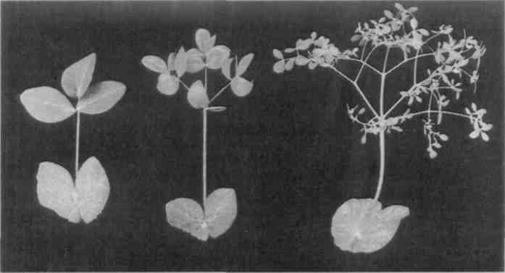
Fig. 1. Adult pea leaves from equivalent nodes: af/af, tl/tl, uni/uni (left), af/af, tl/tl, uni^{tac}/uni^{tac} (middle) and af/af, tl/tl, Uni/Uni (right).

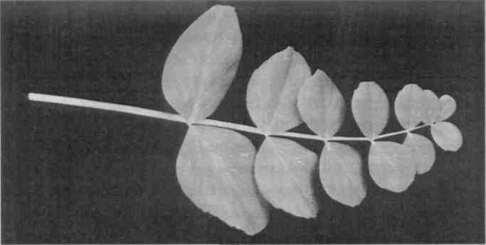
Fig. 2. Adult homozygous tl/tl leaf with stipules removed.
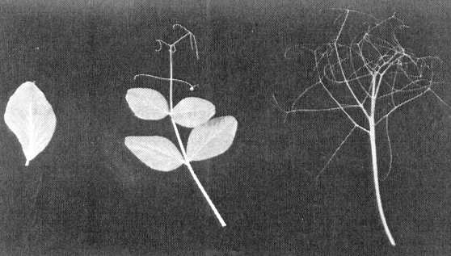
Fig. 3. Adult leaves with stipules removed: uni/uni (left), wild type (middle) and af/af (right).

Pisum Genetics Volume 28 1996 Research Reports 23
"brakes" and appear supercompound, with multiple dividing rachides. The wild-type compound leaf results from a balance between these two opposing signals (Fig. 3).
_____________________________________
- De Vilmorin, P. and Bateson, W. 1911. Proc. Royal Soc. B. 84:9-11.
- Eriksson, G. 1929. Zeitschr. Pflanzenzuchtung 14:445-475.
- Goldenberg, J.B. 1965. Boletin Genetico 1:27-28.
- Gould, K.S., Cutter, E.G. and Young, J.P.W. 1994. Am. J. Bot. 81:352-360.
- Kujala,V. 1953. Arch. Soc. Zool. Bot. Fenn. "Vanamo" 8:44-45.
- Lamprecht, H. 1933. Hereditas 18:56-64.
- Marx, G.A. 1986. Pisum Newsletter 18:49-53.
- Marx, G.A. 1987. Plant Mol. Biol. Rep. 5:311-335.
- Sachs, T. 1969. Isr. J. Bot. 18:21-30.

- Sharma, B. 1972. Pisum Newsletter 4:50.
- Smith, L.G. and Hake, S. 1992. Plant Cell 4:1017-1027.
- Young, J.P.W. 1983. Ann. Bot. 52:311-316.

24 Pisum Genetics Volume 28 1996 Research Reports
A novel viviparous mutant (vip)
Yaxley, J.L., Weller, J.L. Department of Plant Science, University of Tasmania
and Reid, J.B. , GPO Box 252-55, Hobart, Tasmania 7001, Australia
We have isolated two allelic viviparous mutants of Pisum sativum L. Mutant seeds germinate precociously in the pod (Figs 1 and 2). These are the first mutants of this type described in the garden pea and the gene symbol vip has been assigned to the locus.
Abscisic acid (ABA) plays an important role in the prevention of precocious germination in many species. There are well known viviparous mutants of maize (7), caused by either impaired ABA biosynthesis (6), or decreased ABA sensitivity (8). In Arabidopsis, the double mutant (aba-1 abi3) of the ABA synthesis mutant aba-1 and the ABA insensitive mutant abi3, shows viviparous germination inside the siliques (5). In species which exhibit vivipary as part of their normal development, ABA responses have also been shown to be affected. In the case of the mangrove Rhizophora mangle L., unusually high concentrations of ABA are required to inhibit the growth of excised embryo-seedlings (9). Embryos of most species display the ability to germinate precociously on culture media when removed from the ovule after pattern formation is complete. Such precocious germination can be prevented in many cases by adding ABA to the culture media (2,4). However, ABA may not have this role in pea. The pea ABA synthesis mutant wil does not exhibit vivipary, despite having one fifth the ABA level of wildtype seeds (3). In addition, the precocious germination of pea embryos in culture cannot be fully inhibited by ABA (1). Thus, this new viviparous mutant represents an important tool for greater understanding of the involvement of ABA in the precocious germination of peas, in particular, and of the switch between the seed maturation and germination programmes in general.
In a mutagenesis programme, cv. Torsdag (Hobart line 107) was treated with the alkylating agent EMS (ethylmethanesulphonate) at 1% for 6 h at 18°C. Among 1100 M₂ families screened, two showed segregation for viviparous seed. Dry vip seeds are not viable, so the two mutants were recovered via M₂ heterozygous siblings, as these selfed heterozygous siblings again produced viviparous seeds in the M₃. The two original mutant lines were designated as A303 and A353. These lines were crossed to each other and the F₁ seeds were viviparous, indicating that both mutations are at the same locus. We named these mutant alleles vip-1 (A303) and vip-2 (A353), respectively.
The vip-1 and vip-2 mutant seeds germinated precociously in the pod on the mother plant 20 to 25 days after opening of the flower, depending on the season (Fig. 2). This is shortly after the seed reached contact point (the point at which all liquid endosperm has been absorbed). At first, the radicle emerged and the testa split. As growth continued, the radicle extended and in the most pronounced examples (approximately 10% of a vip seed population) the plumule and first scale leaves also emerged from the cotyledons. Typically, the radicle reached 10 to 20 mm in length before dehydration, while the plumule and hypocotyl, if emergent, typically extended 5 to 7 mm. The morphology of the vip seeds did not appear to be affected by temperature or photoperiod on this background (cv. Torsdag).
__________________________
Correspondence to: Jenny Yaxley Fax: 61 (03) 62 26 2698 Email: jennyy@plant.utas.edu.au
Pisum Genetics Volume 28 1996 Research Reports 25

Fig. 1. Dry seeds of the precociously germinating vip-1 mutant (right) and its wildtype progenitor cv.Torsdag (left). The viviparous seeds do not tolerate desiccation and dry vip seed is not viable.
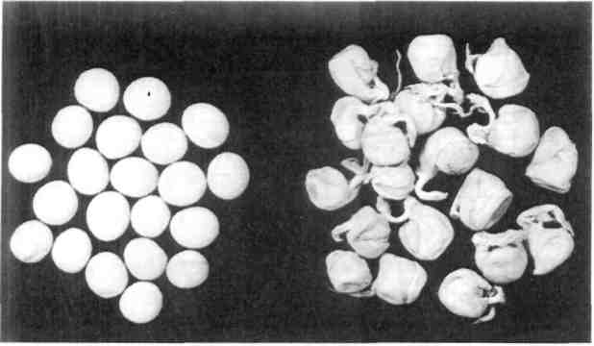

Fig. 2. Seeds of the vip-1 mutant germinate precociously in the pod shortly after contact point is reached.
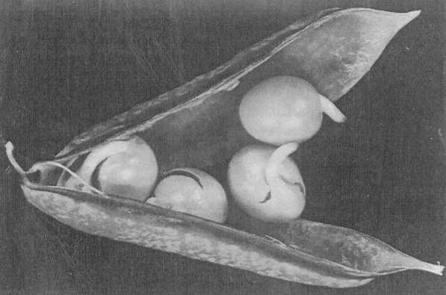

The vip mutant seeds remain green as maturation progresses, while the wildtype seeds turn yellow [Torsdag has yellow (I) cotyledons] and dehydrate. If vip seeds remain in the pod on the mother plant, they die through desiccation as the plant senesces. Yet, if they are removed from the pod and planted before they dry out, they will continue to grow and will generate a normal healthy plant (Fig. 3). However, vip seedlings have reduced early growth and survival. When they emerge from the soil they are somewhat weak and slow-growing compared with wildtype seedlings, and the axillary buds in the cotyledons and first nodes often grow out (Fig. 4). In our studies 10 to 25% of vip seedlings failed to survive. Nonetheless, surviving vip seedlings gradually regained vigour until their appearance was equivalent to that of the wildtype plants. Thus, it seems that the vip mutation is entirely seed specific, although the disraption of seed metabolism that occurs during precocious germination does have a detrimental effect on early seedling growth. The extent of seedling mortality varied with the time at which the seeds were removed from the pod, and with the growing conditions. Survival was highest when vip seeds were removed from a pod which was dehydrating; that is, the pod was mostly brown, but retained some green colouring, particularly along the suture. Growth and survival of the planted germinating vip seeds is promoted by keeping them moist, as they are sensitive to dehydration, but not too wet, as they are also prone to rotting.

26
Pisum Genetics
Volume 28 1996
Research Reports

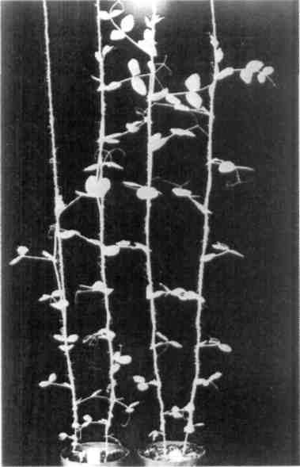
Fig. 3. Six-week-old plants of the vip-1 mutant (left pot) and its wildtype progenitor cv. Torsdag (right pot). After an initial lag period, vip mutant plants have normal wildtype growth.
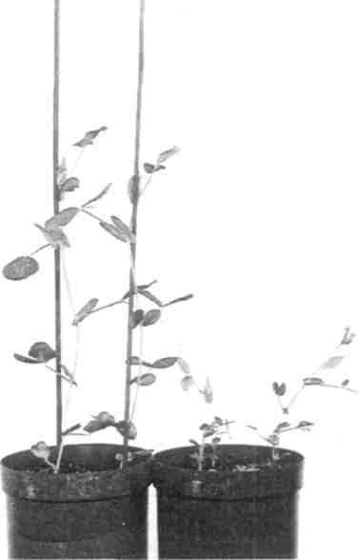
Fig. 4. Two-week-old seedlings of vip-1 (right pot) and its wildtype progenitor cv. Torsdag (left pot). The vip seedlings have reduced early growth and survival.

There is little difference in the morphology of the vip-1 and vip-2 mutants. The vip-2 mutant has better early seedling survival and growth. In some cases the vip-1 mutant showed up to 25% seedling mortality, compared with an average of 10% for the vip-2 mutant. For this reason, we suggest that vip-1 is the more severe allele, causing a greater disruption of seed metabolism. In some crosses, segregation for wildtype and vip seeds was in accordance with a 3:1 ratio, but the combined data from several crosses indicated a significant and consistent deficiency of vip segregants (Table 1). There was no evidence of heterogeneity among the crosses and both alleles gave similar results with an average of 15 to 16% of vip seeds instead of the expected 25% (Table 1). There did not appear to be an increased number of aborted seeds in these F₂ populations, which suggests that vip gametes may have reduced viability. In crossing the vip mutants with wildtype lines, it was also determined that it is the genotype of the embryo, independent of that of the seed coat and pod, that determines the expression of vivipary. Mutant vip seeds showed vivipary even when contained in heterozygous Vip vip pods, while heterozygous seeds showed no evidence of vivipary within homozygous vip mutant pods. Therefore, the vip mutants must be deficient in a single embryo-specific factor that acts, in the wildtype, to prevent precocious germination.
Seed fresh weight, dry weight and water content for the vip-2 mutant and wildtype were compared (Fig. 5). Seed weights were measured at the time of harvest, and then again after freeze-drying to obtain dry weight and hence water content values. The fresh weight of wildtype and vip-2 mutant seed was similar. However, the dry weight of the vip-2 seeds was approximately 50 mg (about 20%) less than the wildtype seeds from 15 days after flowering. In this experiment, vivipary occurred at around 20 days, so apparently the vip-2 mutation has

Pisum Genetics
Volume 28 1996
Research Reports
27

Table 1. Combined data from the F₂ of several crosses for segregation of wildtype and vip seeds.
Segregating alleles | Phenotype  Vip vip |  | Total Percentage of mutant seeds | Segregation Prob. χ²(3:l) |  | Hetero- Prob.  geneity  χ²(df=12)
Vip/vip-1 Vip/vip-2 | 253 231 | 46 43 | 299 15.4 274 15.7 | 14.74 12.66 | <0.001 <0.001 | 2.82 >0.9 4.88 >0.9
an effect on seed metabolism before the onset of vivipary, and before contact point is reached. The water content of the seed was concomitantly increased in the vip-2 mutant, in particular at 15 days after anthesis, when the vip-2 mutant seeds had a 13% greater water content than the wildtype seeds.
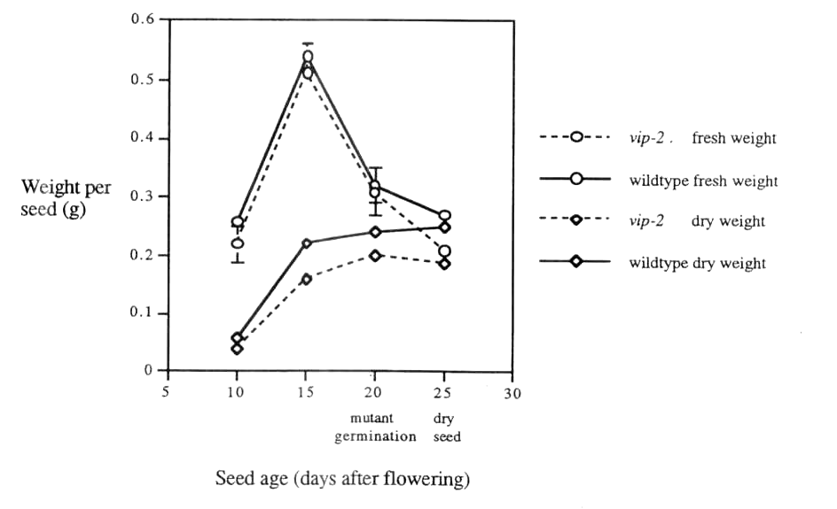
Although the appearance of vivipary is the first readily visible aspect of the vip mutant phenotype, it is apparent that the vip mutation also alters seed metabolism during earlier seed development as the seed matures and accumulates storage products. Thus, if vip is deficient in a factor responsible for the prevention of precocious germination, then this factor must become active during early maturation of the seed. It cannot be ruled out that the vip mutation affects an earlier seed-specific step which is necessary for the production of such a factor. However, as the viviparously germinating seed is still able to survive if planted out, the disruption of other aspects of seed metabolism must not be profound. An analysis of ABA metabolism and the expression of seed storage genes in the vip mutant will be reported elsewhere, and a linkage analysis is in progress. Pea is an excellent model species in which to examine seed development, and the isolation of this new type of maturation-germination mutant in pea will facilitate a greater understanding of these processes.

Fig. 5. Changes in fresh weight and dry weight during development of seeds of the vip-2 mutant and its wildtype progenitor cv. Torsdag.

28 Pisum Genetics Volume 28 1996 Research Reports
Acknowledgments: We thank Robert Warren, Ian Cummings and Tracey Jackson for technical assistance, and the Australian Research Council and the Grains Research and Development Corporation for financial support.
_________________________
- Barratt, D.H.P., Whitford, P.N., Cook, S.K., Butcher, G. and Wang T.L. 1989. J. Exp. Bot. 218:1009-1014.
- Black, M. 1991. In: Abscisic Acid Physiology and Biochemistry, Eds. Davies, W.J. and Jones, H.G., BIOS Scientific Publishers, Oxford, pp. 99-124.
- DeBruijn, S.M., Buddendorf, CH.J.J. and Vreugdenhil, D. 1993. Acta. Bot. Neerl. 42:491-503.
- Kermode, A.R. 1995. In: Seed Development and Germination, Eds. Kigel, J. and Galili, G., Marcel Dekker Inc., N.Y., pp 273-332.
- Koornneef, M., Hanhart, C.J., Hilhorst, H.W.M. and Karssen, CM. 1989. Plant Physiol. 90:463-469.
- Neill, S.J., Horgan, R. and Parry, A.D. 1986. Planta 169:87-96.
- Robertson, D.S. 1955. Genetics 40:745-760.
- Robichaud, C.S., Wong, J. and Sussex, I.M. 1980. Dev. Genet. 1:325-330.
- Sussex, I. 1975. Am. J. Bot. 62:948-953.

Pisum Genetics Volume 28 1996 Research Reports 29
Identification of a DNA marker closely linked to the nitrogen fixation mutant sym26 and its assignment to an unclassified linkage group.
Ul-Hasan, M.* and Weeden, N. F., Department of Horticultural Sciences
NYSAES, Cornell University Geneva, NY 14456, USA
Temnykh, S. V. and LaRue, T. A. Boyce Thompson Institute for Plant Research
Ithaca, NY 14853-1801, USA
The non-fixing mutant line P63 was initially isolated and described by Duc et al. (1) along with several other mutants that produced the same white-nodule phenotype when exposed to Rhizobium leguminosarum strain 128C53. Complementation analysis suggests that this mutant is not allelic with other non-fixing mutations [(1) and G. Duc, pers. comm.] and has been assigned the gene symbol sym26. We have been attempting to map each of these mutants by crossing with the line JI73 (= NGB1238), performing bulked segregant analysis on segregating F₂ or F₃ populations derived from these crosses, and mapping the markers identified in a standard recombinant inbred population derived from the cross Sparkle x JI73. Although Due's mutants were produced in cv. Frisson, the same DNA markers generally segregate in both crosses.
The initial P63 x JI73 F₂ population consisted of 53 plants which were scored for nodulation phenotype as described previously (2). The mutant phenotype was clearly expressed, with 12 of the 53 plants displaying the mutant phenotype. Progeny from 14 of the F₂ plants with normal phenotype were further examined for incidence of the mutation. Ten of these progenies segregated for the mutation. The F3 results confirmed the recessive nature of the mutation and identified four progenies which were apparently homozygous wild type. DNA was extracted from a single individual from each of these four F₃ populations and from five F₃ plants derived from five different non-fixing F₂ plants. These DNA samples were combined into two bulks (wild type and non-fixing) and used for bulked segregant analysis (BSA) (3).
Approximately 100 10-base oligonucleotides were tested using BSA. The primers were selected to cover all linkage groups developed in the Sparkle x JI73 recombinant inbred lines described in (4). One 425-bp fragment produced by primer OPA09 was present in JI73 and the wild type bulk but not in P63 or the mutant bulk. Further analysis of 21 F₄ plants derived from 19 different F₂ plants by single seed descent gave no recombinants between the marker and the gene. The OPA09425 marker belongs to a linkage group (linkage group 11) that has yet to be matched with any of classical linkage groups in pea. However, it is likely to be part of linkage group IVA or VI because most of the remaining known linkage map has already been paired with other linkage groups identified in this population. None of the markers on the remaining linkage groups gave rise to clear differences between the fix- and wild type bulks. The position of the mutant was further confirmed by testing markers adjacent to OPA09425 on linkage group 11, as developed for the Sparkle x JI73 RILs (Fig. 1). One of these markers, BC213a, segregated in the P63 x JI73 F₃ population and displayed close linkage with the wild type phenotype.
____________________________
* Current address: Nuclear Institute for Agriculture & Biology, Jhang Road, P.O. Box 128, Faisalabad. Pakistan.
30 Pisum Genetics Volume 28 1996 Research Reports
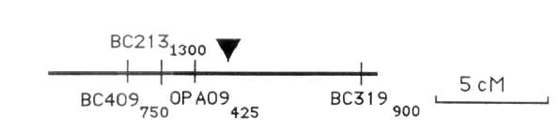

Fig. 1. Linkage group 11 of the Sparkle x JI73 RIL map. The approximate position of sym26 is identified by the triangle. The scale is given on the right.
Acknowledgements. This research was funded in part by USDA-NRI and The International Atomic Energy Agency.
________________________________
l. Duc, G. and Messager, A. 1989. Plant Sci. 60:207-213.
- Kneen, B.E., LaRue, T.A., Hirsch, A.M., Smith, C.A., and Weeden, N.F. 1990. Plant Physiol. 94:899-905.
- Michelmore, R.W., Paran, I., and Kesseli, R.V. 1991. Proc. Natl. Acad. Sci. USA 88:9828-9832.
- Weeden, N. F., Swiecicki, W. K., Timmerman, G. M. and Ambrose, M. 1993. Pisum Genetics 25:13-14.

Pisum Genetics Volume 28 1996 Research Reports 31
Development of an ASAP marker for resistance to bean yellow mosaic virus in Pisum sativum.
Yu, J., Gu, W. K. and Weeden, N. F. Department of Horticultural Sciences
Cornell University, Geneva, NY 14456. USA
Provvidenti, R Department of Plant Pathology
Cornell University, Geneva, NY 14456, USA
Pea mosaic, caused by bean yellow mosaic virus (BYMV), is a disease of economic importance in many pea growing areas of the world. Resistance to this virus is conferred by a single recessive gene, mo (6), located on linkage group II about 5 cM from K (3). The relatively close linkage between K and Mo has permitted the use of the mutant k as a marker for mo in a segregating progeny. However, several disadvantages are associated with it as a marker. The mutant phenotype is fully recessive, allowing only two progeny classes to be distinguished, and the phenotype is expressed in the flower, delaying selection for resistance until the plants bloom. More recently an isozyme marker (Pgm-p), mapping between k and mo, has been identified (5). However, isozyme analysis is cumbersome for large-scale screening, whereas PCR-based DNA markers offer many advantages in marker-assisted selection programs. Here we describe two DNA fragments linked to Mo, the conversion of one of these fragments into an allele-specific marker, and determine the linkage intensity between this latter marker and Mo.
Four F₂ families from the cross 'Ranger' (susceptible) x 'Bonneville' (resistant) were used for linkage analysis. In addition, a set of 19 F₅ plants derived by single seed descent from the same cross and 50 F₈ recombinant inbred lines from the cross JI1794 (susceptible) x Slow (resistant) were included to confirm the linkage. DNA was extracted by the method of Torres et al. (4). Approximately 300 different 10-base oligonucleotide primers were screened using a polymerase chain reaction (PCR) procedure described previously (7). Two of the primers. BC302 (sequence 5'-CGGCCCACGT) and BC355 (sequence 5'-GTATGGGGCT), gave fragments closely linked to Mo. The 1300-bp fragment from BC302 (BC302₁₃₀₀) was linked in coupling with the susceptible allele, while another 1300-bp fragment generated by BC355 (BC355₁₃₀₀) was linked in coupling with the resistant allele. Both of these fragments were cut from the gel, reamplified, and ligated into the vector pCRII using the TA Cloning® Kit (Invitrogen Corp., San Diego). The clone containing BC3021300 was sequenced by the dideoxy chain termination method using M13 sequences as primers. Allele-specific associated primers (ASAPs) were designed with the sequences: 5'-CGGCCCACGTCACTAGTGA and 5'-CGGCCCACGTCGGGGTATC. This pair of primers produced a single band in susceptible plants but no conspicuous product in resistant plants. The BC355 fragment was also sequenced, but in this case the longer primers that we had synthesized generated the marker in both resistant and susceptible individuals.
Analysis of 100 F₂ individuals gave only three recombinants between BC302₁₃₀₀ and Mo (Table 1). Heterogeneity tests among the F₂ families indicated the data were homogenous and could be combined, generating an overall recombination frequency of 3%. Similar analysis of the 50 RILs gave 3 recombinants. Using the equation r = R/(2-2R), where R is fraction of lines displaying a recombinant phenotype, for calculation of linkage intensity (1), we obtained a linkage value of 3.2%, very similar to that obtained for the F₂ population (Table 1). In the F₅
32 Pisum Genetics Volume 28 1996 Research Reports
plants, no recombinants were found between BC302₁₃₀₀ and Mo, but two recombinants were
identified between BC355₁₃₀₀ and the virus resistance gene. From these results we conclude
that the latter marker is further from Mo than BC302₁₃₀₀ although we do not know whether the
two markers are on the same side of or flank the gene.
Table 1. Joint segregation analysis of mo and BC302₁₃₀₀ in F₂ and F₈ populations.

 | Phenotype designation¹ |  |  |  |  | Joint seg. | Recombinant
Family | S/+ | S/- | R/+ | R/- | Total | Chi-sq. | fraction ± SE
F₂ families
A185-46 | 48 | 1 | 0 | 26 | 75 | 70.7 | 1 + 11
A185-36 | 5 | 0 | 0 | 2 | 7 | 7.0 | <10
A185-39 | 4 | 1 | 0 | 4 | 9 | 5.8 | 8 ±33
A185-38 | 3 | 1 | 0 | 5 | 9 | 5.6 | 8 + 33

Total F₂ 60 3 0 37 100 88.1 3±10
F₈ recombinant inbred lines
87-18,19 23 1 2 24 50 38.8 3±5
__________________________________________________________________
¹ R = resistant, S = susceptible, + = present, - = absent.
The use of DNA markers simplifies the process of mapping major genes and provides the opportunity for 'tagging' disease resistance genes with genetic markers that are suitable for marker-assisted selection in plant breeding programs. Marker-assisted selection using ASAPs appears to offer a very efficient and cost-effective approach for screening large numbers of samples (2). Our dominant ASAP marker is linked in coupling with the susceptible allele, Mo. Having the dominant alleles in coupling permits selection for the resistant phenotype (absence of marker) but does not permit unambiguous identification of heterozygous individuals. The BC355₁₃₀₀ marker is at least 10 cM from mo and thus is probably not an improvement over the isozyme marker, being both further away and requiring electrophoresis to separate the various products produced by amplification with the short primers.
__________________________________________
- Burr, B., Burr, A.F., Thompson, K.H., Albertson, M.C., and Stuber, C.W. 1988. Genetics 118:519-526.
- Gu, W-K., Weeden, N.F, Yu, J. and Wallace, D.H. 1995. Theor. Appl. Genet.
91:465-470.
- Marx, G. A. and Provvidenti, R. 1979. Pisum Newsletter 11:28-29.
- Torres, A., Weeden, N.F., and Martin, A. 1993. Theor. Appl. Genet. 85:937-945.
- Weeden, N.F., Provvidenti R., and Marx, G.A. 1984. J. Hered. 75:411-412.
- Yen, D.E., and Fry, P.R. 1956. Aust. J. Agric. Res. 7:272-281.
- Yu, J., Gu, W-K., Provvidenti, R. and Weeden, N.F. 1995. J. Am. Soc. Hortic. Sci. 120: 730-733.
*****

