Pisum Genetics Volume 28 1996 Review
5

Breeding field peas for Western Australia: progress and problems
Khan, T. N., French, R. J. Agriculture Western Australia
and Hardie D. C. 3 Baron-Hay Court
South Perth, WA 6151, Australia
Field pea has been grown in Western Australia (WA) since the beginning of this century but it was not until the middle of the 1980s that a major expansion in the area began to occur. The area peaked in 1988/89 at about 50,000 ha but it declined sharply in response to adverse publicity generated due to severe epidemics of black spot disease caused by Mycosphaerella pinodes in early sown crops and due to difficulties in harvesting. The black spot problem is now managed by delayed sowing but the pea area has remained static at around 35,000 ha.
Field pea fits best into WA farming systems in medium to low rainfall areas on fine-textured neutral to alkaline soils with late sowings. This is despite field pea often yielding well on coarser-textured and acid soils (7) and from early plantings (6) in WA. They have not become more important in these circumstances because narrow-leaf lupin has been spectacularly successful on acid sandy soils, and the risk of large yield losses from black spot disease with early sowings is too great. Other pulses, most notably faba bean and chickpea, are preferred for early sowings (21), but field pea will consistently out-yield these from late sowings when there is little risk of black spot.
The field pea industry of the 1980s began with the adoption of the cvs Derrimut and Dundale, both producing greenish brown (dun type) seed. Dundale was encouraged due to it's suitability for milling. Later, a South Australian white-flowered cultivar, Wirrega, was introduced but its inconsistent performance lead to a return of Dundale as the most popular variety. More recently, another white-flowered and earlier flowering South Australian cultivar, Laura, has been released to replace Wirrega. Another cultivar with varying success is a late flowering South Australian cultivar, Alma.
The breeding program
With the emergence of field peas as a significant crop in the 1980s, breeding lines from the South Australian and Victorian Pea Breeding Programs were imported for trials in WA. Three years of evaluation work concluded that a majority of lines were too late flowering for the short season environment of the wheatbelt. A local breeding program was therefore started in 1988 with the support from the Grain Legume Research Council. In 1993, the program was incorporated into the Australian Coordinated Pea Improvement Program (ACPIP) funded by the Grain Research and Development Corporation (GRDC). The WA program was delegated to focus on breeding for the short season environment. The longer growing seasons were to be largely catered for by importing breeding lines from South Australia and Victoria.
The breeding objectives of the program may best be viewed against the two phases of the program. The pre-1996 phase saw a response to low and inconsistent yields as the first priority, and therefore yield, adaptation to the short season environment, and milling quality were the primary objectives, with standing ability and less susceptibility to black spot as the secondary objectives. The post-1996 objectives include resistance to black spot and harvestibility amongst the primary objectives in recognition of these factors as major hurdles in the field pea development in WA. The GRDC is also encouraging a major effort in breeding for

6 Pisum Genetics Volume 28 1996 Review
the black spot resistance. Pea weevil resistance is also desired as it is one of the most wide spread insect pests affecting both yield and quality, but this work is currently at an investigation stage.
Methodology
The breeding material is channeled in two streams. The larger stream is that for the low rainfall areas representing the short season environment and a smaller stream for the high rainfall areas of the South. The low rainfall material is tested at Latham (300 mm annual rainfall), Merredin (310 mm) and Konnongorring (350 mm) and the high rainfall material is tested at Katanning (474 mm) and Tunney (500 mm). Medina (800 mm), on the outskirts of Perth, is used for the black spot resistance screening. Most of the trial seed production is carried out at Avondale (400 mm). The length of the growing season varies from about 21-22 weeks at the northernmost site Latham (latitude 29° 45' S) to about 25-26 weeks at the southernmost site Tunney (latitude 34° 07' S).
The breeding method used in the beginning was based on early generation testing where F₂ derived lines were bulked and yield tested until F₅ when re-selection of single plants was done in the targeted lines. Due to the problem of recognizing potential lines in early generations (17, 22) and the masking effect of heterosis (19), crosses are now bulked-raised and bulks are compared in replicated trials at the F₄ stage. Single plants are then selected at the F₅ stage from the selected crosses.
The F₅/F₆ lines are bulked and selected for agronomic characters before selection for yield at the F₅/F₇ and F₅/F₈ stages. A limited number of lines are then promoted to about 15 regional trial sites in the first year and about 35 sites in the subsequent years. With a greater emphasis now on black spot resistance, two recurrent selection procedures are being considered. The first option is to select for resistance in the F₂/F₃ and then intercross resistant lines. The second option involves following single seed descent to F₅ and then selection for resistance in F₅/F₆ lines before intercrossing.
Selection for yield and adaptation
The typical field pea crop in WA is planted in the last week of May or the first half of June. It will receive 200 to 250 mm of rainfall throughout the growing season, but usually very little falls after mid September. The crop will be ready for harvest in late October. Field pea performs well under these conditions by exhibiting a drought escape mechanism. This means that the crop flowers early, then sets and fills pods while plant water status is adequate. To achieve this early flowering and vigorous early growth are necessary, as well as reliable early pod set and pod retention. Osmotic adjustment could also be a useful trait by extending the period of favourable water relations during pod fill. One of the objectives of the WA program has been earlier flowering. Much of the locally bred material flowers earlier than the most commonly grown commercial cultivar, Dundale (Fig. 1). However, earlier flowering does not necessarily result in higher yields. From a 23 May sowing in 1995, for example, best yields were actually obtained from the later flowering lines (Fig. 1). However, there were quite a few lines flowering up to a week earlier than Dundale that yielded very well. These lines should perform better with late sowings than the later flowering lines, and so should be more adaptable in WA. Fig. 1 shows trend lines for yield with flowering date for locally bred lines and for controls derived from elsewhere. The offset between these two lines shows that the local breeding program has made a yield improvement that is independent of flowering date. This could be related to improvements in flower and pod retention and in seed filling. This possibility has not been investigated thoroughly with locally bred material, but detailed

Pisum Genetics Volume 28 1996 Review
7

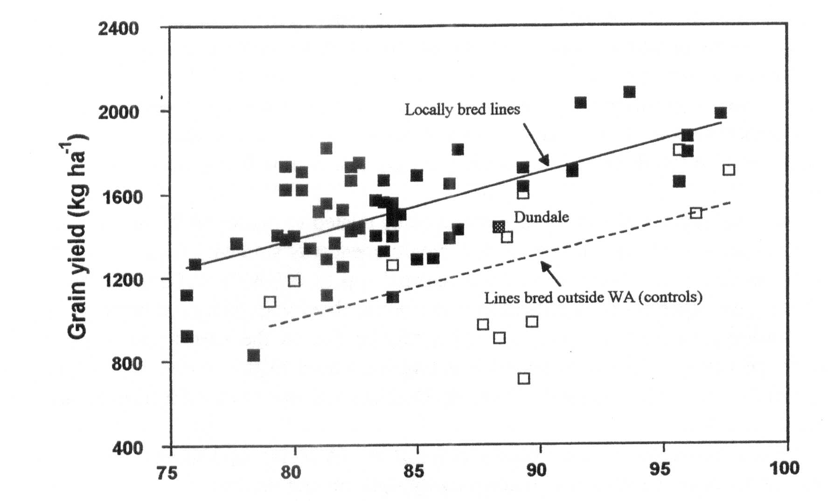
Flowering date (days after sowing)
Fig. 1. Relationships between flowering date and grain yield of pea lines grown at Merredin, WA in 1995. The solid symbols represent locally bred lines (crosses made in 1988 and 1989) and the open symbols represent existing cultivars or breeding lines derived from Victoria or South Australia. The two regression lines show separate yield trends with flowering date for local lines (r²=0.404) and other lines (r²=O.273).

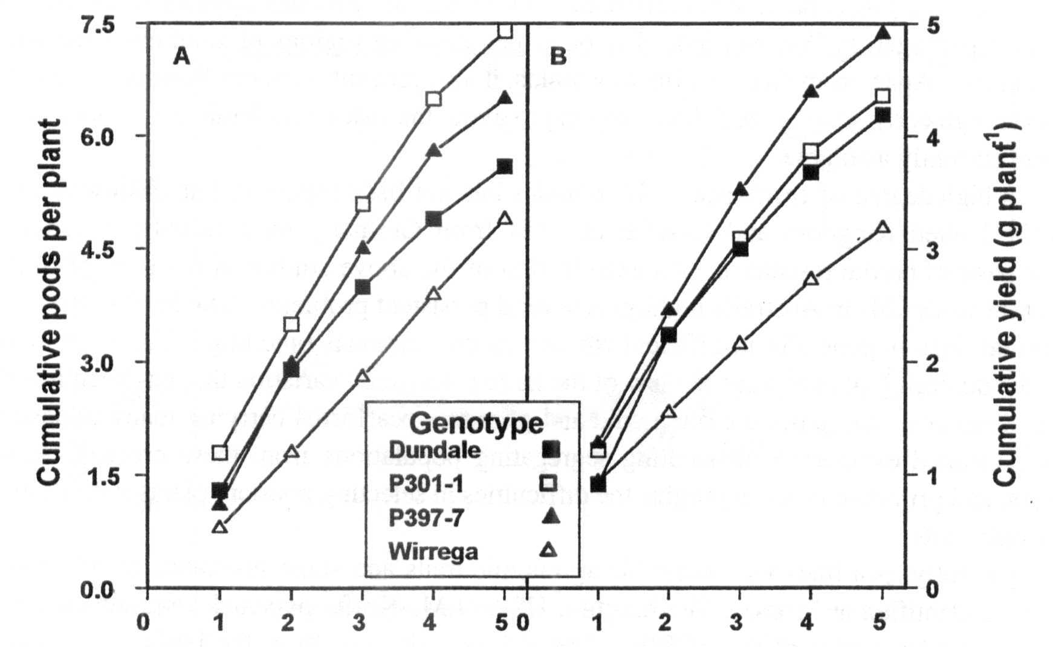
Reproductive node number
Fig. 2. Cumulative pod number (A) and cumulative seed yield (B) on the first five reproductive nodes of four genotypes of field pea grown at Merredin, WA in 1995, showing differences in the ability of different genotypes to set, retain, and fill pods in this environment. The lines shown here were all derived from South Australia.

8 Pisum Genetics Volume 28 1996 Review
physiological studies have been made locally with material derived mainly from the South Australian breeding program. These show that although nearly all pea genotypes can potentially produce two pods per reproductive node, few do so consistently, and there are considerable differences between genotypes in how many pods are set and retained (Fig. 2a). Seed set and filling are important too, as Fig. 2b shows that the genotypes setting the most pods do not necessarily produce the most yield. Locally bred material is now being examined for pod set and seed set.
Following reports of osmotic adjustment being related to higher yields in pea under dry conditions in Spain (18), its value in the WA environment was studied. Appreciable levels of osmotic adjustment were found in the local material (up to 0.7 MPa at 100% relative water content) and genotypes varied significantly. However, there was little correlation with yield under water-limited conditions (Fig. 3). This may be due to the narrow range of genetic breadth in the highly selected, advanced breeding lines used in this study. It is significant, though, that the successful commercial cultivar, Dundale, was one of the best osmotic adjusters in the material tested.
Direct selection for yield has been successful in WA so far, and should continue to be. It seems that we have the flowering times roughly right for our environment, but further yield testing with later planting is required to establish the value of flowering earlier than Dundale in our farming system. More attention to improving pod and seed set is likely to lead to further yield improvement.
Disease resistance
A number of bacterial and fungal diseases have been identified but none produces any threat to the field pea crop with the major exception of black spot. Black spot disease in pea is caused by three fungi Ascochyta pisi Lib., Mycosphaerella pinodes Berk. & Blox. and Phoma medicaginis var. pinodella (Jones) Boerema. Of these, M. pinodes appears to be the most significant pathogen in WA and indeed in other pea-growing regions of southern Australia on the mainland. Apart from directly affecting yields, it also prevents farmers from achieving high yields through early sowing, as delayed sowing to avoid the risk of epidemic is the only control measure currently available.
A high degree of resistance to M. pinodes has not been reported, but Clulow et al. (4) from the United Kingdom and Nasir et al. (15) from Germany have recently reported the genetic basis of partial resistance. An examination of the above studies in the light of past (1) and recent work (24) in Australia highlights several persistent problems. The level of resistance in parental lines is generally insufficient for use in conventional breeding. There are doubts about the durability of resistance in view of the large pathogenic variation that has been found to occur. Sources of resistance are often wild and primitive pea forms carrying many undesirable genes. Limited experience in handling segregating populations from these crosses between domestic and primitive types highlights the difficulties in selecting resistant plants with desirable agronomic traits.
Recently, pea lines with desirable agronomic traits and some resistance to M. pinodes have been identified at Prosser, Washington, USA (J.M. Kraft, personal communication), in WA, and in other nodes of the ACPIP. These lines will now form the basis of a recurrent selection program to improve the level of resistance in commercial pea cultivars and also to improve the level of resistance in resistant × resistant crosses.

Pisum Genetics Volume 28 1996 Review
9

Table 1: Yield (expressed as percentage of Wirrega's yield) and other characteristics of the crossbred lines selected for the Crop Variety Testing Stage 3 trials at Konnongorring and Perenjori.

Entry | Pedigree | Konn-ongorr ing% yield | Peron-jori % yield | Flower colour | Days  to  flower | 100 seed weight (g) | Seed colour/shape
Wirrega | Control | 100 | 100 | W | 96 | 18.27 | white round
Dundale | Control | 96 | 108 | P | 88 | 23.64 | dun
Laura | Control | 107 | 113 | W | 89 | 16.82 | white round
Pennant | Control | 73 | 89 | W | 79 | 16.54 | white round
88P077-2-8 | WA1/COLLEGIAN | 114 | 114 | P | 91 | 20.56 | speckled dun
88P077-3-8 | WA1/COLLEGIAN | 93 | 117 | W | 86 | 17.80 | white round
88P084-4-1 | DUNDALE/WA1 | 113 | 114 | P | 85 | 20.02 | dun
88P084-5-4 | DUNDALE/WA1 | 111 | 109 | P | 82 | 19.08 | greenish dun
88P084-5-15 | DUNDALE/WA1 | 115 | 108 | P | 82 | 19.20 | greenish dun
88P084-5-22 | DUNDALE/WA1 | 135 | 124 | P | 92 | 17.30 | dun
88P084-5-25 | DUNDALE/WA1 | 114 | 120 | P | 91 | 19.52 | greenish dun
89P123-2-4 | DERRIMUT/P94-2 | 116 | 115 | P | 80 | 19.90 | greenish dun
89P123-2-30 | DERRIMUT/P94-2 | 108 | 110 | P | 80 | 17.63 | greenish dun
89P123-2-39 | DERRIMUT/P94-2 | 108 | 124 | P | 80 | 17.99 | greenish dun
89P133-4-9 | DERPJMUT/WA724 | 121 | 117 | P | 87 | 19.30 | speckled dun
89P134-1-2 | DERRIMUT/SOLARA | 117 | 115 | W | 83 | 23.84 | white round
89P150-15-8 | WIRREGA/P94-1 | 110 | 106 | P | 96 | 16.14 | dun
89P150-15-15 | WKREGA/P94-1 | 120 | 115 | W | 96 | 17.66 | white round
89P150-15-19 | WIRREGA/P94-1 | 125 | 122 | W | 96 | 16.26 | white round
Wirrega | (yeld kg per ha) | 1498 | 1796
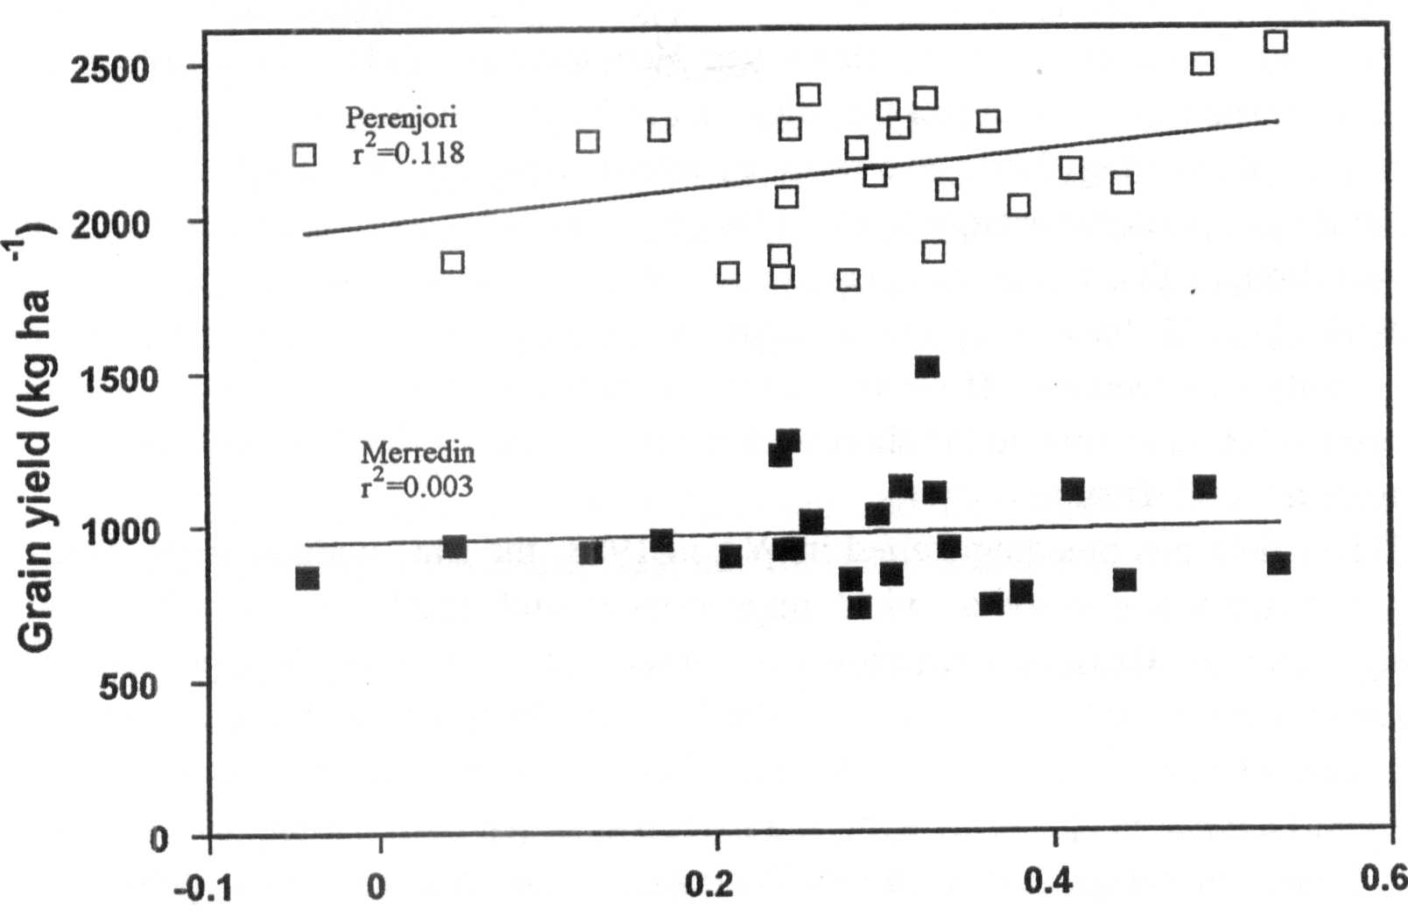
Osmotic adjustment (MPa)
Fig. 3. Relationship between maximum osmotic adjustment (screened in pots) and grain yield at two locations in the WA wheatbelt in 1994, of 24 locally bred field pea lines derived from 1988 crosses.

10 Pisum Genetics Volume 28 1996 Review
Insect pest resistance
The redlegged earth mite (Halotydeus destructor Tucker), the pea weevil (Bruchus pisorum L.) and the native budworm {Helicoverpa punctigera Wallengren) are the three important insect pests in WA. All could potentially be controlled with the use of resistant cultivars. However, currently only pea weevil is being addressed.
As early as 1938, Newman and Elliot (16) in WA found that Lathyrus species were resistant to the weevil (2). Unsuccessful attempts were made to cross peas with several species of Lathyrus to incorporate its' resistance (5). More recently, the neoplastic pod allele (Np) has been implicated with resistance to the pea weevil through a pod epidermal outgrowth in response to oviposition (3, 8, 9). However, it seems the impact of the Np gene response may be of limited value as the majority of neonate larvae will crawl off the neoplastic growths and penetrate the pod through unaffected tissue (9). New findings in Australia demonstrate resistance to the pea weevil in another pea species, P.fulvum Sibth. & Sm. (9, 10), which can be crossed with P. sativum, and in transgenic pea seeds (CSIRO, Canberra) expressing the a-amylase inhibitor from Phaseolus vulgaris L. (20). Studies in the USA (S.L. Clement, personal communication) and Chile (H. Norambuena, personal communication) confirm the presence of high levels of resistance to the pea weevil in the P. fulvum material.
The P. fulvum resistance research, which began in South Australia and has continued in WA, indicates more than one resistance mechanism to the pea weevil in the P. fulvum material screened to date. Some of the P. fulvum accessions appear immune to the pea weevil, due mainly to the presence of an antibiosis factor in the seed cotyledons and our investigations into this factor suggest that it is controlled by several genes. Chemical analysis of the cotyledons has not revealed the source of the resistance, but research to identify the resistance factor is continuing.
The afila gene and its application
Applications of the afila gene (af), which confers semi-leaflessness by changing leaflets into tendrils, has been advocated by Heath and Hebblethwaite (11). This gene has radically affected the appearance of new pea varieties in the North America and Europe. Apart from greatly improved standing ability as a result of inter-locking amongst tendrils, it has also been claimed to impart greater resistance to water logging (14) and greater tolerance to drought (13). It was also thought that the more open canopy will discourage disease epidemics. Although recent studies (12, 23) have cast doubt on many of these claims, use of the af gene in improving standing ability will continue. However, a greatly increased biomass in the semi-leafless lines will be needed for adaptation to the short season environment of the WA wheatbelt.
Past, present and future
When field pea breeding started in WA in 1988, the state-wide average yield of about 800 kg/ha dictated a priority on yield improvement and emphasis on milling quality for marketing reasons. Crosses were aimed at earlier flowering and tall types which showed greatest adaptation to the local conditions. The lines originating from these crosses entered the regional variety trials in 1995 for the first time (Table 1). Whereas yield improvement over cvs Wirrega and Dundale is clearly evident, improvement in seed size of the white, round-seeded cross-bred lines in comparison with cvs Wirrega and Laura is of added interest. It is also notable that although flowering date did not form the basis of selection, most of the lines which reached the regional trial stage flower earlier, suggesting a flowering window of about 80 to 90 days. It is expected that one of these lines will be released before the end of this century. In the meantime, two selections from segregating material received from New Zealand are now

Pisum Genetics Volume 28 1996 Review
11

being bulked for possible release in 1997/98. One of these two lines is a stiff-stem dwarf and the other a semi-leafless semi-dwarf; both these lines represent a radical departure from the plant type traditionally grown in WA.
After the first two seasons of crossing, greater attention has gone into choosing parents with bold and round white seed, stiff stem, semi-leafless character, growth vigour and cold tolerance. Re-selected genetically stable lines from these crosses should enter the yield trials shortly.
The pea breeding program has started a new round of industry funding and resistance to black spot caused by M. pinodes is now a priority objective. The breeding program will take a recurrent selection approach with agronomically suitable types with a degree of improvement in resistance being channeled to yield evaluation in date-of-sowing experiments as soon as possible; early sowing encourages black spot epidemics. However, disease assessment in pea plants, more particularly single plants, poses a formidable challenge and the success or failure of this program is likely to depend on innovations to successfully score for disease reaction. Molecular markers will also be sought in cooperation with an overseas research institution.
Just under a decade of breeding peas has made us appreciate that the pea plant presents many technical problems. This may explain why success stories in pea breeding have been few and far between despite pea being one of the most studied plants from the genetic point of view. Its trailing growth habit, poor anchorage at the soil level when the crop dries, and lodging make it difficult to estimate yield accurately. Single plant selection is difficult because isolated pea plants grow and yield poorly and are often uprooted by the wind. In addition, large inter-plant spaces pose associated weed problems. Inter-plot spaces of about 1 m are necessary to avoid plots merging into each other, but this presents problems in obtaining realistic yield estimates. The co-efficient of variation in pea trials is generally very high. The only practical solution is to increase plot size which increases demand for resources, and in earlier generations, this is just not possible. Studies on field plot techniques in pea breeding, an area sadly neglected in pea studies, needs urgent attention. The resurgence of the pea industry in WA will require high yielding and milling type cultivars which have a level of black spot resistance that will allow them to be sown earlier. In addition, stiff stem and semi-leaflessness will be needed for improved harvesting, and pea weevil resistance to minimize inputs. The outcome of the current work on black spot and pea weevil resistance, and physiological work on defining plant type for yield and drought resistance, will determine the success of future pea breeding in Western Australia.
Acknowledgments. We thank the Grains Research and Development Corporation and the Grains Research Committee of Western Australia for financial support.
__________________________
- Ali, S. M., Nitschke, L. F., Dube, A. J., Krause, M. R. and Cameron, B. 1978. Aust. J. Agric. Res. 29: 841-849.
- Anon. 1947. Resistance of strains of Vicia and Lathyrus to pea weevil. Australian Council of Scientific and Industrial Research Annual Report 21: 14.
- Berdnikov, V. A., Trusov, Y. A., Bogdanova, V. S., Kosterin, O. E., Rozov, S. M.. Nedel'kina, S. V. and Nikulina, Y. N. 1992. Pisum Genetics 24: 37-39.
- Clulow, S. A., Matthews, P. and Lewis, B. G. 1991. Euphytica 58:183-189.
- Fisher, H. M. 1953. Pisum-Lathyrus cross. The A.P.G Newsletter 3: 14.

12 Pisum Genetics Volume 28 1996 Review
- French, R. J. 1990. Aust. J. Agric. Res. 41: 853-862.
- French, R. J. and M. A. Ewing. 1989. Aust. J. Exp. Agric. 29: 829-835.
- Hardie, D. C. 1990. Pea weevil, Bruchus pisorum L., resistance in peas. In: Proc. Nat. Pea Weevil Workshop, Ed. Smith, M. A. Dept. Agric. and Rural Affairs, Melbourne, Australia.
- Hardie, D. C. 1992. Resistance to the pea weevil in Pisum species. PhD thesis, Univ. Adelaide, Australia.
- Hardie, D. C., Baker, G. J. and Marshall, D. R. 1995. Euphytica 84: 155-161.
- Heath, M. C., Hebblethwaite, P. D. 1984. Outlook on Agriculture 13:195-202.
- Heath, M. C. and Hebblethwaite, P. D. 1992. In: Proc. 1st European Conf. Grain Legumes, Angers, France, pp. 215-216.
- Heath, M. C. and Hebblethwaite, P. D. 1992. In: Proc. 1st European Conf. Grain Legumes, Angers, France, pp. 225-226.
- Jackson, M. B. 1985. In : The Pea Crop. A basis for Improvement, Eds Hebblethwaite, P. D., Heath, M. C. and Dawkins, T. C. K., Butterworths, London, pp. 163-172.
- Nasir, M., Hoppe, H. H., Ebrahim-Nesbat, F. 1992. Plant Path. 41:187-194.
- Newman, L. J. and Elliott, H. G. 1938. J. Agric. Western Australia 15:156-158.
- Ranalli, P. and Fantino, M. G. 1992. In: Proc. 1st European Conf. Grain Legumes, Angers, France, pp. 61-62.
- Rodriguez-Maribona, B., Tenorio, J. L., Conde, J. R. and Ayerbe. L. 1992. Field Crops Res. 29: 15-22.
- Sarawat, P., Stoddard, F. L., Marshall, D. R. and Ali, S. M. 1994. Euphytica 80:39-48.
- Schroeder, H. E, Gollasch, S., Moore, A., Tabe, L. M., Craig, S., Hardie, D. C. Crispfield, M. J., Spencer, D. and Higgins, T. J. 1995. Plant Physiol. 107: 1233-1239.
- Siddique, K. H. M., Walton, G. H., and Seymour, M. 1993. Aust. J. Exp. Agric. 33: 915-922.
- Stelling, D. and Ebmeyer, E. 1990. Plant Breeding 105: 169-179.
- Tenario, M. L. and Ayerbe, L. 1992. In: Proc. 1st European Conf. Grain Legumes, Angers, France, pp. 211-212.
- Wroth, M. 1996. Host-pathogen relationship of the ascochyta blight {Mycosphaerella pinodes (Berk. & Blox.) Vestergr.) disease of pea {Pisum sativum L.). PhD thesis, Univ. Western Australia, Perth.

