24 Pisum Genetics Volume 28 1996 Research Reports
A novel viviparous mutant (vip)
Yaxley, J.L., Weller, J.L. Department of Plant Science, University of Tasmania
and Reid, J.B. , GPO Box 252-55, Hobart, Tasmania 7001, Australia
We have isolated two allelic viviparous mutants of Pisum sativum L. Mutant seeds germinate precociously in the pod (Figs 1 and 2). These are the first mutants of this type described in the garden pea and the gene symbol vip has been assigned to the locus.
Abscisic acid (ABA) plays an important role in the prevention of precocious germination in many species. There are well known viviparous mutants of maize (7), caused by either impaired ABA biosynthesis (6), or decreased ABA sensitivity (8). In Arabidopsis, the double mutant (aba-1 abi3) of the ABA synthesis mutant aba-1 and the ABA insensitive mutant abi3, shows viviparous germination inside the siliques (5). In species which exhibit vivipary as part of their normal development, ABA responses have also been shown to be affected. In the case of the mangrove Rhizophora mangle L., unusually high concentrations of ABA are required to inhibit the growth of excised embryo-seedlings (9). Embryos of most species display the ability to germinate precociously on culture media when removed from the ovule after pattern formation is complete. Such precocious germination can be prevented in many cases by adding ABA to the culture media (2,4). However, ABA may not have this role in pea. The pea ABA synthesis mutant wil does not exhibit vivipary, despite having one fifth the ABA level of wildtype seeds (3). In addition, the precocious germination of pea embryos in culture cannot be fully inhibited by ABA (1). Thus, this new viviparous mutant represents an important tool for greater understanding of the involvement of ABA in the precocious germination of peas, in particular, and of the switch between the seed maturation and germination programmes in general.
In a mutagenesis programme, cv. Torsdag (Hobart line 107) was treated with the alkylating agent EMS (ethylmethanesulphonate) at 1% for 6 h at 18°C. Among 1100 M₂ families screened, two showed segregation for viviparous seed. Dry vip seeds are not viable, so the two mutants were recovered via M₂ heterozygous siblings, as these selfed heterozygous siblings again produced viviparous seeds in the M₃. The two original mutant lines were designated as A303 and A353. These lines were crossed to each other and the F₁ seeds were viviparous, indicating that both mutations are at the same locus. We named these mutant alleles vip-1 (A303) and vip-2 (A353), respectively.
The vip-1 and vip-2 mutant seeds germinated precociously in the pod on the mother plant 20 to 25 days after opening of the flower, depending on the season (Fig. 2). This is shortly after the seed reached contact point (the point at which all liquid endosperm has been absorbed). At first, the radicle emerged and the testa split. As growth continued, the radicle extended and in the most pronounced examples (approximately 10% of a vip seed population) the plumule and first scale leaves also emerged from the cotyledons. Typically, the radicle reached 10 to 20 mm in length before dehydration, while the plumule and hypocotyl, if emergent, typically extended 5 to 7 mm. The morphology of the vip seeds did not appear to be affected by temperature or photoperiod on this background (cv. Torsdag).
__________________________
Correspondence to: Jenny Yaxley Fax: 61 (03) 62 26 2698 Email: jennyy@plant.utas.edu.au
Pisum Genetics Volume 28 1996 Research Reports 25

Fig. 1. Dry seeds of the precociously germinating vip-1 mutant (right) and its wildtype progenitor cv.Torsdag (left). The viviparous seeds do not tolerate desiccation and dry vip seed is not viable.
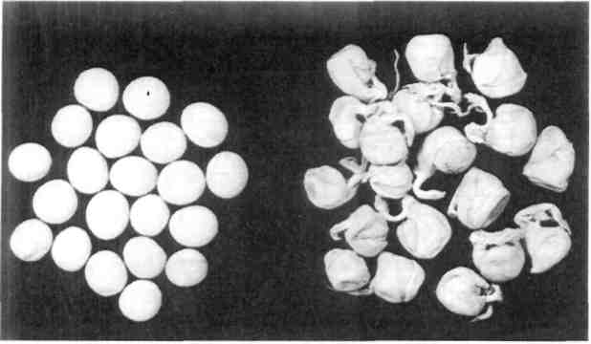

Fig. 2. Seeds of the vip-1 mutant germinate precociously in the pod shortly after contact point is reached.
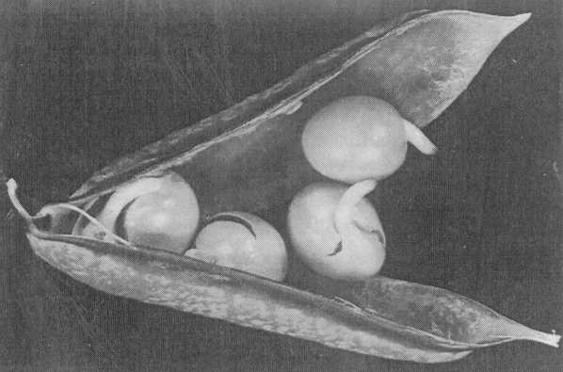

The vip mutant seeds remain green as maturation progresses, while the wildtype seeds turn yellow [Torsdag has yellow (I) cotyledons] and dehydrate. If vip seeds remain in the pod on the mother plant, they die through desiccation as the plant senesces. Yet, if they are removed from the pod and planted before they dry out, they will continue to grow and will generate a normal healthy plant (Fig. 3). However, vip seedlings have reduced early growth and survival. When they emerge from the soil they are somewhat weak and slow-growing compared with wildtype seedlings, and the axillary buds in the cotyledons and first nodes often grow out (Fig. 4). In our studies 10 to 25% of vip seedlings failed to survive. Nonetheless, surviving vip seedlings gradually regained vigour until their appearance was equivalent to that of the wildtype plants. Thus, it seems that the vip mutation is entirely seed specific, although the disraption of seed metabolism that occurs during precocious germination does have a detrimental effect on early seedling growth. The extent of seedling mortality varied with the time at which the seeds were removed from the pod, and with the growing conditions. Survival was highest when vip seeds were removed from a pod which was dehydrating; that is, the pod was mostly brown, but retained some green colouring, particularly along the suture. Growth and survival of the planted germinating vip seeds is promoted by keeping them moist, as they are sensitive to dehydration, but not too wet, as they are also prone to rotting.

26
Pisum Genetics
Volume 28 1996
Research Reports

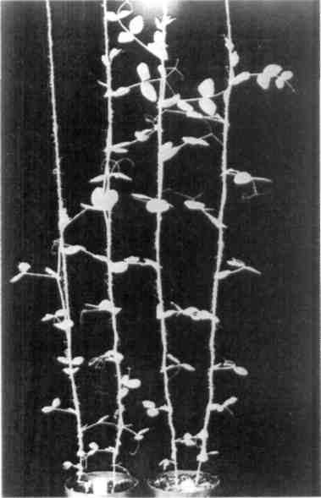
Fig. 3. Six-week-old plants of the vip-1 mutant (left pot) and its wildtype progenitor cv. Torsdag (right pot). After an initial lag period, vip mutant plants have normal wildtype growth.
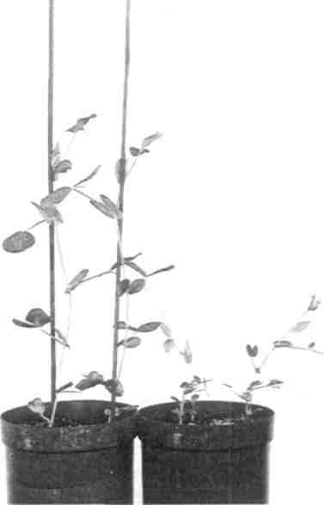
Fig. 4. Two-week-old seedlings of vip-1 (right pot) and its wildtype progenitor cv. Torsdag (left pot). The vip seedlings have reduced early growth and survival.

There is little difference in the morphology of the vip-1 and vip-2 mutants. The vip-2 mutant has better early seedling survival and growth. In some cases the vip-1 mutant showed up to 25% seedling mortality, compared with an average of 10% for the vip-2 mutant. For this reason, we suggest that vip-1 is the more severe allele, causing a greater disruption of seed metabolism. In some crosses, segregation for wildtype and vip seeds was in accordance with a 3:1 ratio, but the combined data from several crosses indicated a significant and consistent deficiency of vip segregants (Table 1). There was no evidence of heterogeneity among the crosses and both alleles gave similar results with an average of 15 to 16% of vip seeds instead of the expected 25% (Table 1). There did not appear to be an increased number of aborted seeds in these F₂ populations, which suggests that vip gametes may have reduced viability. In crossing the vip mutants with wildtype lines, it was also determined that it is the genotype of the embryo, independent of that of the seed coat and pod, that determines the expression of vivipary. Mutant vip seeds showed vivipary even when contained in heterozygous Vip vip pods, while heterozygous seeds showed no evidence of vivipary within homozygous vip mutant pods. Therefore, the vip mutants must be deficient in a single embryo-specific factor that acts, in the wildtype, to prevent precocious germination.
Seed fresh weight, dry weight and water content for the vip-2 mutant and wildtype were compared (Fig. 5). Seed weights were measured at the time of harvest, and then again after freeze-drying to obtain dry weight and hence water content values. The fresh weight of wildtype and vip-2 mutant seed was similar. However, the dry weight of the vip-2 seeds was approximately 50 mg (about 20%) less than the wildtype seeds from 15 days after flowering. In this experiment, vivipary occurred at around 20 days, so apparently the vip-2 mutation has

Pisum Genetics
Volume 28 1996
Research Reports
27

Table 1. Combined data from the F₂ of several crosses for segregation of wildtype and vip seeds.
Segregating alleles | Phenotype  Vip vip |  | Total Percentage of mutant seeds | Segregation Prob. χ²(3:l) |  | Hetero- Prob.  geneity  χ²(df=12)
Vip/vip-1 Vip/vip-2 | 253 231 | 46 43 | 299 15.4 274 15.7 | 14.74 12.66 | <0.001 <0.001 | 2.82 >0.9 4.88 >0.9
an effect on seed metabolism before the onset of vivipary, and before contact point is reached. The water content of the seed was concomitantly increased in the vip-2 mutant, in particular at 15 days after anthesis, when the vip-2 mutant seeds had a 13% greater water content than the wildtype seeds.
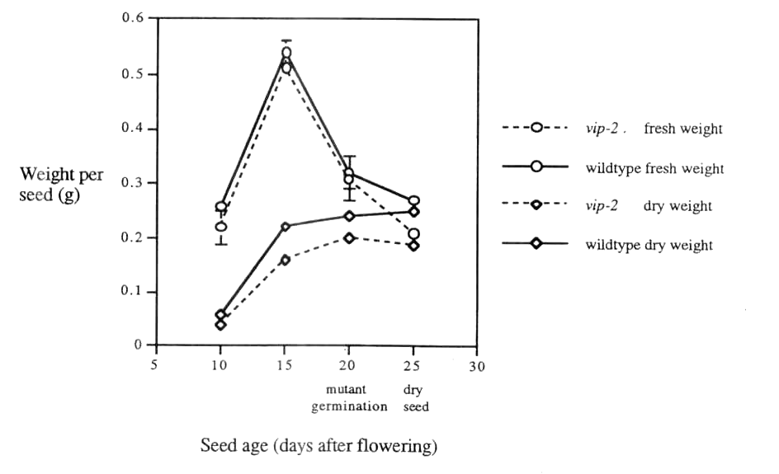
Although the appearance of vivipary is the first readily visible aspect of the vip mutant phenotype, it is apparent that the vip mutation also alters seed metabolism during earlier seed development as the seed matures and accumulates storage products. Thus, if vip is deficient in a factor responsible for the prevention of precocious germination, then this factor must become active during early maturation of the seed. It cannot be ruled out that the vip mutation affects an earlier seed-specific step which is necessary for the production of such a factor. However, as the viviparously germinating seed is still able to survive if planted out, the disruption of other aspects of seed metabolism must not be profound. An analysis of ABA metabolism and the expression of seed storage genes in the vip mutant will be reported elsewhere, and a linkage analysis is in progress. Pea is an excellent model species in which to examine seed development, and the isolation of this new type of maturation-germination mutant in pea will facilitate a greater understanding of these processes.

Fig. 5. Changes in fresh weight and dry weight during development of seeds of the vip-2 mutant and its wildtype progenitor cv. Torsdag.

28 Pisum Genetics Volume 28 1996 Research Reports
Acknowledgments: We thank Robert Warren, Ian Cummings and Tracey Jackson for technical assistance, and the Australian Research Council and the Grains Research and Development Corporation for financial support.
_________________________
- Barratt, D.H.P., Whitford, P.N., Cook, S.K., Butcher, G. and Wang T.L. 1989. J. Exp. Bot. 218:1009-1014.
- Black, M. 1991. In: Abscisic Acid Physiology and Biochemistry, Eds. Davies, W.J. and Jones, H.G., BIOS Scientific Publishers, Oxford, pp. 99-124.
- DeBruijn, S.M., Buddendorf, CH.J.J. and Vreugdenhil, D. 1993. Acta. Bot. Neerl. 42:491-503.
- Kermode, A.R. 1995. In: Seed Development and Germination, Eds. Kigel, J. and Galili, G., Marcel Dekker Inc., N.Y., pp 273-332.
- Koornneef, M., Hanhart, C.J., Hilhorst, H.W.M. and Karssen, CM. 1989. Plant Physiol. 90:463-469.
- Neill, S.J., Horgan, R. and Parry, A.D. 1986. Planta 169:87-96.
- Robertson, D.S. 1955. Genetics 40:745-760.
- Robichaud, C.S., Wong, J. and Sussex, I.M. 1980. Dev. Genet. 1:325-330.
- Sussex, I. 1975. Am. J. Bot. 62:948-953.

