Pisum Genetics Volume 28 1996 Research Reports 21
The effect of Uni on leaf shape
Hofer, J.M.I, and Ellis, T.H.N. Department of Applied Genetics
John Innes Centre, Colney Lane Norwich NR4 7UH, England, U.K.
The pleiotropic unifoliata (uni; 2,6) mutation reduces the complexity of the compound leaf. Leaves are tendril-less, ranging from unifoliate at lower nodes (including the scale leaves) to trifoliate at higher nodes prior to flowering. The uni^{tac} allele (7,8,10) has a similar, but weaker effect; the number of pairs of tendrils is reduced. Like uni, uni^{tac} mutants develop a leaflet at the terminal position. Both alleles are recessive, suggesting they may be loss-of-function variants. This implies that Uni functions to increase the complexity of the compound leaf.
Triple mutant combinations of the genes afila (af; 3,5), tendril-less (tl;1) and uni, were generated to test this inference and examine the effects of Uni on compound leaf structure. The leaves in Fig. 1 are from equivalent nodes and are homozygous for af, tl and uni, uni^{tac} or Uni from left to middle and right, respectively. Their arrangement shows the effect of incrementally adding Uni function to a pleiofila (af/af, tl/tl) leaf.
Two gradients of change are obvious. Firstly, the amount of branching increases from left to right, resulting in an increased number of leaflets. This demonstrates that Uni function does increase leaf complexity, as inferred from the uni mutant alleles. How does it do so? The adult leaves shown in Fig. 1 are the outcomes of earlier developmental events in the leaf primordia (4,9). The relative structural complexity of the af/af, tl/tl, Uni/Uni leaf (right) may be the passive result of Uni functioning in the leaf rachis meristem to maintain it in an indeterminate state (of unlimited growth potential; 11). Alternatively, Uni may have an active role, whereby its presence promotes the production of lateral primordia. Detection of the Uni transcript in developing leaf, rachide and leaflet primordia supports both these possibilities (J.Hofer, unpublished results).
Secondly, leaflet size decreases from left to right (Fig. 1). The surface area of individual laminae reflects the circumference of the rachis meristems from which they emerge. This gradient in leaflet size mimics, in an exaggerated way, the gradient in leaflet size from base to distal tip (left to right) of a single, homozygous tl leaf (Fig. 2). As it is known that the only changing factor in Fig. 1 is an increment in Uni function (from left to right), it is tempting to consider that the form of the leaf in Fig. 2 resulted from a temporal or physical gradient in Uni function that existed in the leaf rachis primordium.
Young (12) presented a model for pea leaf morphogenesis in which there were three possible meristem fates: rachis, leaflet or tendril, and the fate of a meristem was determined by its "size". In the model, "size" was an abstract notion, although it was clearly considered to be connected to physical dimension. The leaves shown here suggest that Uni function is somehow correlated with, or could substitute for, Young's "size".
Af, like Uni, regulates the complexity of the leaf, but is opposite in effect. Leaflets of the af mutant are replaced by branching rachides (Fig. 3; 3,5,12) indicating that Af functions to increase determinacy, or suppress the production of lateral primordia. Uni and Af can be likened to counterbalancing "accelerator" and "brake" signals in pea leaf development, uni leaves lack "acceleration", are unifoliate and resemble simple leaves, whereas af leaves lack
22 Pisum Genetics Volume 28 1996 Research Reports

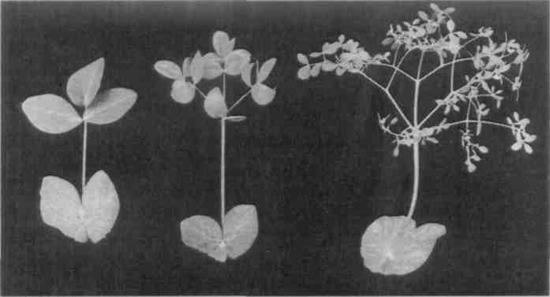
Fig. 1. Adult pea leaves from equivalent nodes: af/af, tl/tl, uni/uni (left), af/af, tl/tl, uni^{tac}/uni^{tac} (middle) and af/af, tl/tl, Uni/Uni (right).

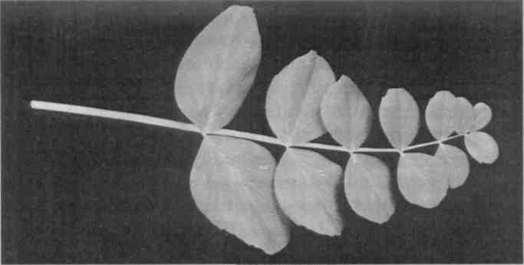
Fig. 2. Adult homozygous tl/tl leaf with stipules removed.
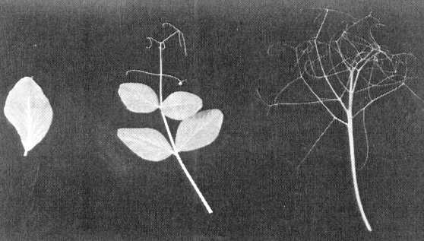
Fig. 3. Adult leaves with stipules removed: uni/uni (left), wild type (middle) and af/af (right).

Pisum Genetics Volume 28 1996 Research Reports 23
"brakes" and appear supercompound, with multiple dividing rachides. The wild-type compound leaf results from a balance between these two opposing signals (Fig. 3).
_____________________________________
- De Vilmorin, P. and Bateson, W. 1911. Proc. Royal Soc. B. 84:9-11.
- Eriksson, G. 1929. Zeitschr. Pflanzenzuchtung 14:445-475.
- Goldenberg, J.B. 1965. Boletin Genetico 1:27-28.
- Gould, K.S., Cutter, E.G. and Young, J.P.W. 1994. Am. J. Bot. 81:352-360.
- Kujala,V. 1953. Arch. Soc. Zool. Bot. Fenn. "Vanamo" 8:44-45.
- Lamprecht, H. 1933. Hereditas 18:56-64.
- Marx, G.A. 1986. Pisum Newsletter 18:49-53.
- Marx, G.A. 1987. Plant Mol. Biol. Rep. 5:311-335.
- Sachs, T. 1969. Isr. J. Bot. 18:21-30.

- Sharma, B. 1972. Pisum Newsletter 4:50.
- Smith, L.G. and Hake, S. 1992. Plant Cell 4:1017-1027.
- Young, J.P.W. 1983. Ann. Bot. 52:311-316.

