18 Pisum Genetics Volume 28 1996 Research Reports
The problem of leaflet dentation inheritance in peas
Smirnova, O. G. Institute of Cytology and Genetics
Novosibirsk 630090, Russia
The dominant allele of the locus Td determines a weak leaflet dentation in peas. Lamprecht (3) located this gene on linkage group IV about 33 cM from le and 36 cM from z. At the present time, linkage group IV is broken into two parts without observable linkage between them (7). The gene z belongs to group IVA and gene le to group IVB.
Marx (5) did not find linkage between Td and z, but demonstrated linkage (15 cM) between Td and b of group III. More recently Grajal-Martin and Muehlbauer (2) and Polans (6) obtained additional evidence that Td is in linkage group III between genes st and Lap-1 (the latter is close to b). The plant materials used in the two latter studies (2, 6) were obtained originally from G. A. Marx and N. F. Weeden. So, in most crosses the gene Td was the same and, as a result, it was mapped in the same chromosome. Joint segregation between Td and le, which was studied by Lamprecht (3), was not investigated in the experiments mentioned above. Grajal-Martin and Muehlbauer (2) offered two possible explanations as to why Td mapped to group IV in Lamprecht's study and group III in the other studies: either 1) there are genomic rearrangements in some pea lines involving Td or 2) there are two different genes for leaflet dentation each with a similar phenotypic expression. Polans (6) favoured the first explanation. To further examine the problem I decided to use lines from other sources to answer the question of how many Td genes there are in the pea genome and where they are localized.
Two pea lines with weak leaflet dentation, WIR4907 (Pisum sativum ssp. asiaticum) and WIR319 (Pisum sativum ssp. sativum) (Fig. 1), were crossed with a standard marker line, WL1238 (= JI73). To distinguish the gene responsible for leaflet dentation in lines WIR319 and WIR4907 from the gene used by Marx, it seemed necessary to use another symbol, for example, Td'. Both crosses produced fully fertile hybrids. In F, plants, the gene Td' showed incomplete dominance. Among F₂ progeny, heterozygous plants could be distinguished from dominant homozygous plants. Segregation of Td'/Td':Td'/td:td/td F₂ plants of cross WIR319 x WL1238 was 24:48:25 (Chi-sq. = 0.03, P>0.9) indicating that the leaflet dentation in WIR319 is determined by a single gene.
Segregation analysis of two F₂ progenies for Td' and several markers is shown in Table 1. The data were analysed using the computer program CROSS. All individual segregations were in accordance with a 3:1 ratio (P>0.05). In the cross WIR4907 x WL1238, Td' was estimated to be located about 20 map units from le and, at the same time, 32 map units from gene b. The linkage Td'-le is highly significant (P<0.0001) while the Td'-b linkage is scarcely significant (P<0.01). It is difficult to explain the linkage with b confidently. One can only assume that an unknown gene near b has an influence on the expression of gene Td' from linkage group IVB. The F₂ data from the cross WIR319 x WL1238 clearly indicate that Td' is associated with le but not with b. As can be inferred from the segregation of Td', le and Np, these genes are be arranged in the following order: Np — 23 — le — 17 — Td'.
Thus, in lines WIR319 and WIR4907 Td' is located on the linkage group IVB. The gene Td' of these lines seems to be not the same as in line A886-193 used by Marx (5). The line A886-193 is derived from Pisum abyssinicum where the stipules and leaflets become dentate at node 6 or 7 and in all succeeding leaves. The lines WIR4907 and WIR319 have

Pisum Genetics

Volume 28 1996
Research Reports
19

Table 1. Joint segregation analysis for Td' and le, b and Np.

Gene | pair | Phenotypic |  | classes |  | Joint |  | Recomb.
Cross* X | Y | XY | Xy | xY | xy | Chi-sq | Prob. | fract. | SE
A Le | Td' | 74 | 17 | 4 | 19 | 34.7 | <0.0001 | 20.2 | 4.3
B | Td' | 62 | 18 | 16 | 18 | 10.2 | <0.01 | 31.7 | 5.5
B Le | Td' | 69 | 11 | 3 | 14 | 26.8 | <0.0001 | 16.7 | 4.2
B | Td' | 53 | 21 | 19 | 4 | 1.1 | >0.05 | - | -
Np | Td' | 58 | 16 | 14 | 9 | 2.8 | >0.05 | - | -
Le | Np | 68 | 12 | 6 | 11 | 19.1 | <0.0001 | 22.8 | 5.0
*A. Cross WIR4907 {Td', Le, B) x WL1238 {td, le, b); n = 114
B. Cross WIR319 {Td', Le, B, Np) x WL1238 {td, le, b, np); n = 97
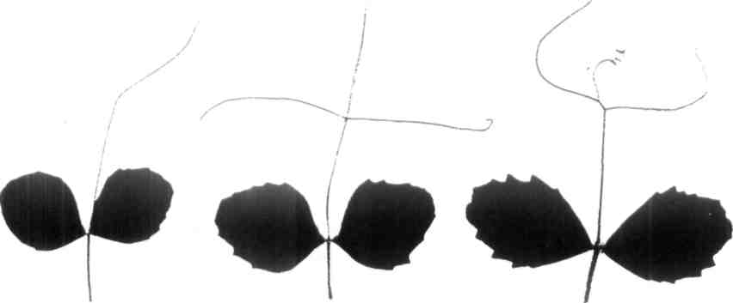
Fig. 1. Left to right: toothed leaves from the 6th node of pea lines WIR4907 and WIR319 (gene Td'), WL6 (gene Td) and WL1325 (gene Ser).

20 Pisum Genetics Volume 28 1996 Research Reports

dentate leaflets only at nodes 6, 7, 8 and sometimes an occasional separate tooth on upper nodes.
The line WL6 from the Nordic Gene Bank has a classic Td phenotype. Its leaflets are toothed at nodes' 6 to 9 and leaflet dentation is a little deeper than in lines WIR319 and WIR4907 (Fig. 1). A test cross WTR319 x WL6 was made to verify if the leaflet dentation genes of these lines are the same or not. Under field conditions among 176 F₂ plants, 13 plants were without leaflet dentation (Chi-sq. (15:1) = 0.39, P>0.5). The remaining 163 plants differed as to the tooth intensity. One could see plants with weak, normal, strong and very strong leaflet dentation. The experiment was repeated in the greenhouse. 113 F₂ plants of the same cross were examined with respect to the degree of leaflet dentation at nodes 5 to 9. The F₂ plants were confidently divided into 5 phenotypic classes with very strong, strong, normal, weak, and without dentation, respectively. The numbers in the classes were 14:29:40:21:9. These numbers are in reasonable agreement with the theoretically expected ratio 1:4:6:4:1 (Chi-sq. = 8.7, P>0.05) for leaflet dentation being controlled by two independently segregating genes with partial dominance and additive effects.
Support for this result was found in the review by Blixt (1). He reported that besides the gene Td in the pea genome there is a semi-dominant gene, Int (incrementum), which determines, together with Td, leaflet dentation of the scalaris forma type. This gene was described by Lamprecht (4). Its location is unknown.
Another gene coding for a saw-toothed leaflet dentation is the semi-dominant gene Ser. Its map location is also unknown. The serratus dentation was first described by Sutton in 1914 in Pisum abyssinicum. The line WL1325 from the Nordic Gene Bank expresses the classic Ser phenotype (Fig. l), with leaflets dentate at nodes 5 to 9 and weak teeth on the following leaves.
The crosses WL6 x WL1325 and WIR319 x WL1325 were made. The resulting hybrid
plants were fully fertile. Plants without toothed leaflets appeared in both F₂ populations. The
toothed/without teeth plant ratio was 125:10 (Chi-sq. = 0.31, P>0.5) in the former cross and
209:18 (Chi-sq. = 1.1, P>0.2) in the latter cross. Judging from the number of plants with
untoothed leaflets, which constituted about 1/16 part of analysed F₂ plants, these genes
segregate independently. Thus, two different genes for "Td-phenotype" are present in the pea genome. They segregate independently from each other and from gene Ser. Both these genes, Td' of WIR319 and Td of WL6, have phenotype expression differing from the expression of Td reported by Marx. Perhaps Td of WL6 is not the same as Td of line A886-193 of Marx. Further genetic experiments are necessary to make clear the genetics of leaflet dentation in pea.
_________________________________________
- Blixt, S. 1977. Pisum Newsl. 9, Supplement
- Grajal-Martin, M. J. and Muehlbauer, F. J. 1992. Pisum Genet. 24:54-55.
- Lamprecht, H. 1961. Agri Hort. Genet. 19:360-401.
- Lamprecht, H. 1962. Agri Hort. Genet. 20:63-74.
- Marx, G. A. 1987. Pisum Newsl. 19:38-39.
- Polans, N. O. 1993. Pisum Genet. 25:36-39.
- Weeden, N. F., Swiecicki, W. K., Timmerman-Vaughan, G. M., Ellis, T. H. N. and
Ambrose, M. 1996. Pisum Genet. 28:1-4.

