Pisum Genetics
Volume 28 1996 Research Reports
15

A more severe mutant allele at the ls locus
Reid, J.B., Weller, J.L. and Sherriff, L.J. Department of Plant Science
University of Tasmania, GPO Box 252-55 Hobart, Tasmania 7001, Australia
During our ethylmethane sulphonate (1%) mutagenesis program (7), a severely dwarfed (nana) mutant, AF51, was isolated. The parental cultivar was Torsdag, a tall, quantitative long day pea. The AF51 mutant responded well to applied gibberellin A₃ (GA₃), and indeed treatment of young seedlings with GA₃ was required in order to obtain a reasonable seed yield (5 - 10 seeds per plant). This suggested the mutant might be deficient in GA₁, the biologically active gibberellin in peas (5). Currently, there are mutations at four described loci that block various steps in GA₁ biosynthesis (Fig. 1) and lead to a dwarf GA-responsive phenotype in peas; le which blocks 3P-hydroxylation of GA₂₀ to GA₁ (3), na which appears to block the conversion of 7α-hydroxy-kaurenoic acid to GA₁₂ - aldehyde (2), lh which blocks the oxidation steps from ent-kaurene to ent-karenoic acid (6) and ls which blocks the conversion of geranyl-geranyl pyrophosphate (GGPP) to copalyl pyrophosphate (CPP) by reducing kaurene synthetase A activity (1).
The cross Torsdag x AF51 produced a wild type tall F₁. The F₂ segregated to give 27 tall : 8 nana progeny, in good accordance with a 3 : 1 segregation (χ²₁ = 0.09) (Fig. 2). This indicates that a single gene recessive mutation caused the mutant AF51 phenotype.
Allelism tests were conducted between the new mutant, AF51, and standard lines possessing four known GA-synthesis mutations (NGB5839, allele le-3; NGB1766, allele na-1; K511, allele lh-1, HL181, allele ls-1). All mutations were on a Torsdag genetic background except na. The F₁ plants of all crosses were wild type (tall) in phenotype except for the F₁ plants of cross AF51 (nana) x HL181 (dwarf), which were dwarf in stature. The F₂ of cross AF51 x HL181 segregated to give 41 dwarf: 19 nana progeny, again in agreement with a 3 : 1 segregation (χ²₁ = 1.4) (Fig. 3).
The results indicate that the AF51 mutant possesses a mutation at the ls locus. Because two mutations at this locus have previously been described, ls-1 (formerly known as ls^{K202}) from cv. Torsdag by Dr K. Sidorova (4), and ls-2 (formerly known as ls^{M26}) from cv. Dippes Gelbe Viktoria by Professor W. Gottschalk (4), the mutant ls allele in AF51 has been designated ls-3. The ls-1 and ls-2 mutations are not markedly different in severity because no clear segregation in the F₂ was observable when the two mutants were crossed. In the present cross, ls-1 x ls-3 (HL181 x AF51; Fig. 3), the clear segregation in the F₂ indicates that ls-3 is a more severe allele than ls-1. Previous genetic analyses had suggested that the ls-1 allele was leaky (i.e. that it did not completely block GA biosynthesis) because the double mutant, ls-1 lh-1, was shorter than either single mutant (4). However, existance of an alternative synthesis pathway or another gene coding for kaurene synthetase A activity could not be ruled out. The discovery of a more severe mutation at the ls locus confirms the suggestion that ls-1 is a leaky mutation. The ls-3 allele is also recessive to both the wild type Ls allele and the less severe ls-1 allele. The new ls-3 allele should prove useful in analysing the molecular action of this gene, a question already under active examination (1).
_________________________
- Ait-Ali, T., Swain, S.M., Reid, J.B, Sun, T. and Kamiya, Y. 1997. Plant J. (in press).
- Ingram, TJ. and Reid, J.B. 1987. Plant Physiol. 83:1048-1053.

16
Pisum Genetics
Volume 28 1996
Research Reports

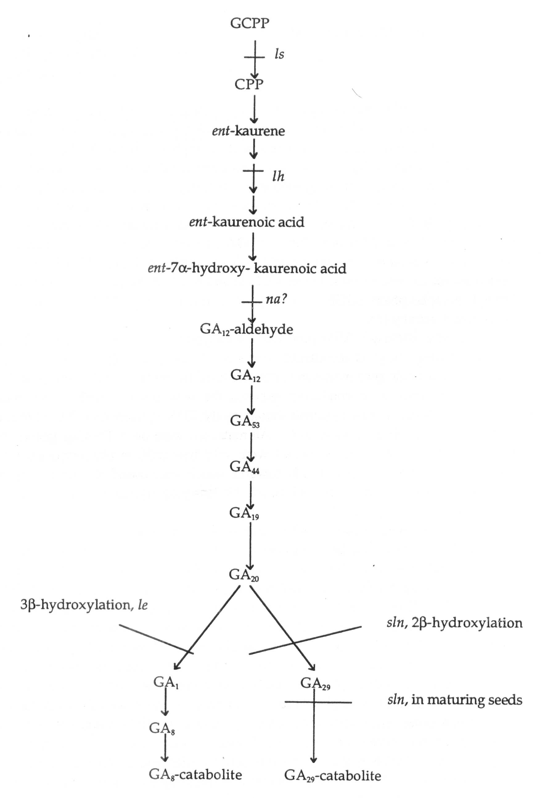
Fig. 1. The dominant GA biosynthetic pathway in the shoots of peas and the sites of action of the GA-biosynthesis mutations (1, 2, 3, 4, 6).
Pisum Genetics Volume 28 1996 Research Reports 17
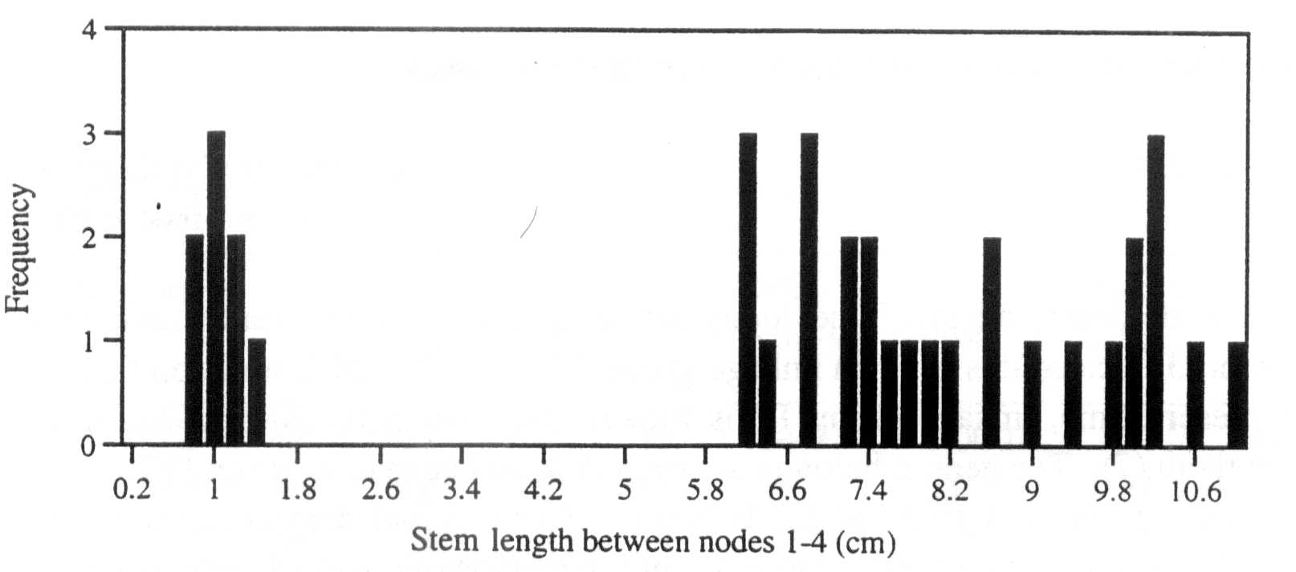

Fig. 2. Distribution of stem lengths between nodes 1 and 4 (to the nearest 2 mm) for the F₂ of the cross Torsdag x AF51. All plants were grown in a glasshouse under an 18 h photoperiod.

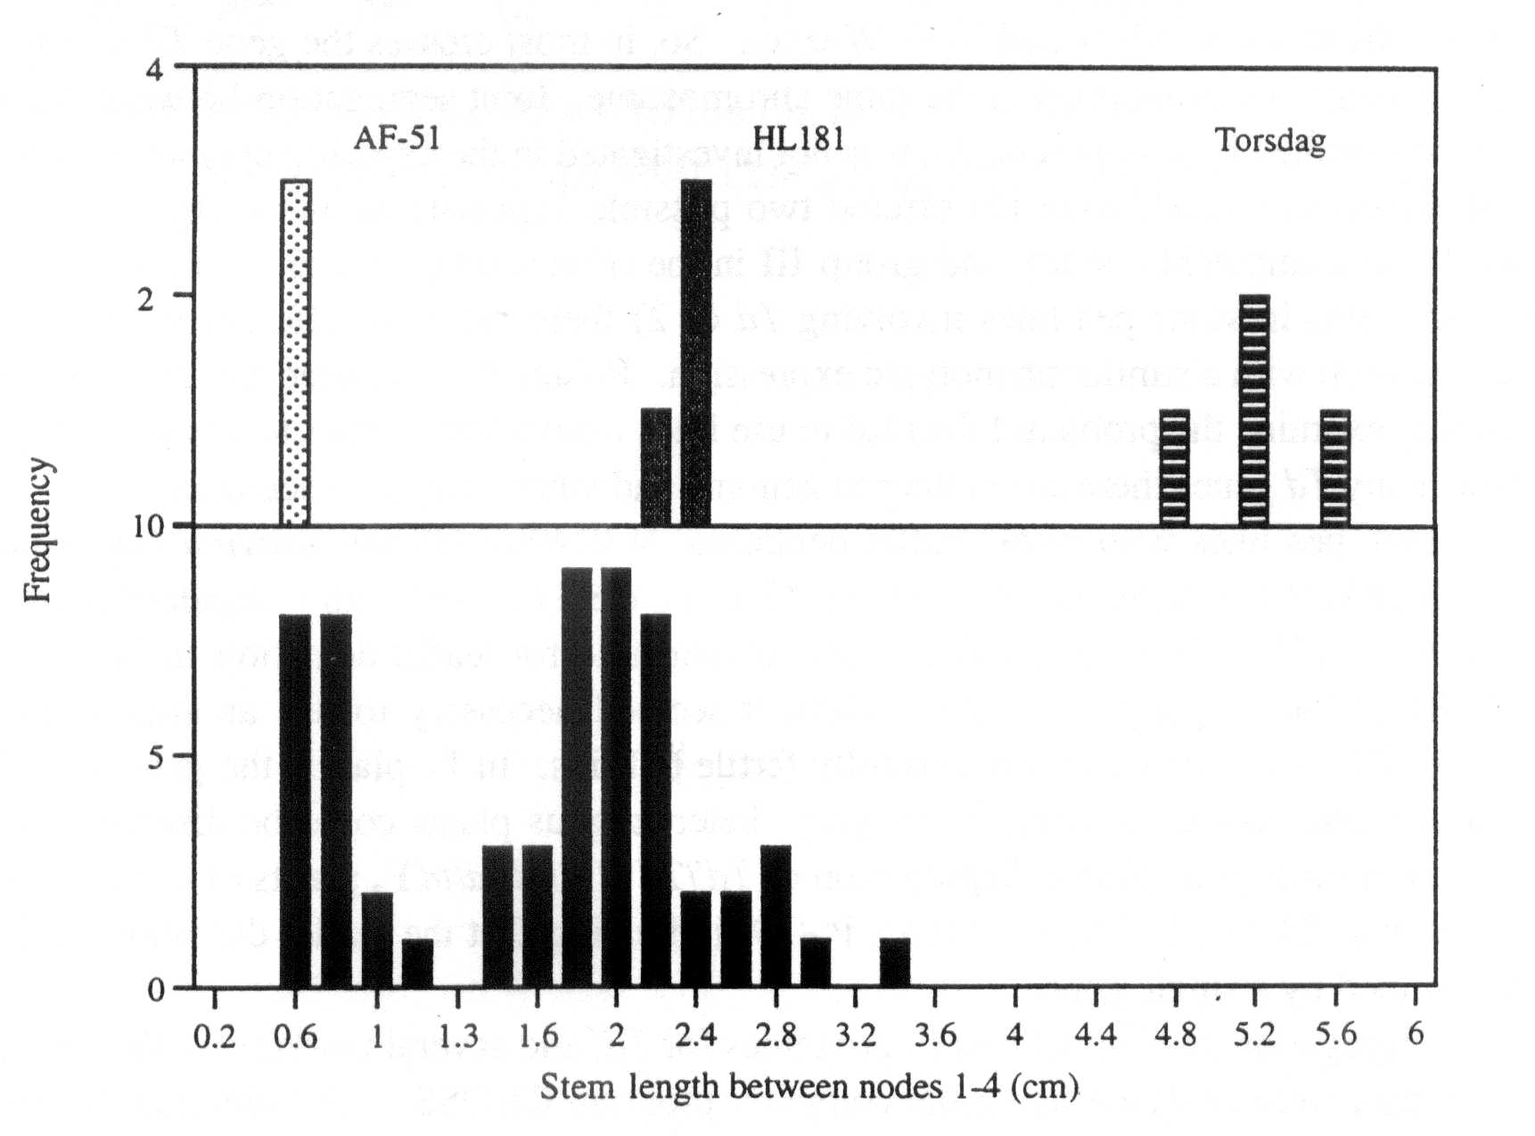
Fig. 3. Distribution of stem lengths between nodes 1 and 4 (to the nearest 2 mm) for parental lines HL181 (dwarf) and AF51 (nana) and the F₂ of the cross HL181 x AF51. As a control, Torsdag (tall) stem lengths are also shown. All plants were grown in a glasshouse under an 18 h photoperiod.
- Ingram, T.J., Reid, J.B., Murfet, I.C., Gaskin, P., Willis, C.L. and MacMillan, J. 1984. Planta 160:455-463.
- Reid, J.B. 1986. Ann. Bot. 57:577-592.
- Reid, J.B. and Ross, J J. 1993. Int. J. Plant. Sci. 154:22-34.
- Swain, S.M., Ross, J.J., Reid, J.B. and Kamiya, Y. 1995. 15th Int. Conf. Plant Growth Substances, Minneapolis, USA. Abstract 115.
- Weller, J.L., Terry, M.J., Reid, J.B. and Kendrick, R.E. 1997. The phytochrome-deficient pcd2 mutant of pea is unable to convert biliverdin IXα to 3Z-phytochromobilin. Plant J. (in press).

