Pisum Genetics Volume 28 1996 Pea Map l
The current pea linkage map
Assembled by the Linkage Committee, November, 1996
(N.F. Weeden, W.K. Swiecicki, G.M. Timmerman-Vaughan, T.H.N. Ellis, and M. Ambrose)
In this version of the pea linkage map we have started with the 'classical' map of Blixt (1) as revised by the Linkage Committee (5) and attempted to locate as many as possible of the DNA markers used in the maps of Ellis et al. (3, 4), Dirlewanger et al. (2) and Timmerman-Vaughan et al., unpublished. Our main problem in combining these maps has been the dearth of 'anchor' loci located on more than one of the maps, most particularly those loci listed in the guidelines for mapping studies in Pisum (6). However, progress is being made towards mapping many of the reference genes in several of the mapping populations, permitting the various maps to be more specifically integrated. It should be noted that not all DNA markers mapped by the various research groups have been located on the current combined map, nor was a computer algorithm (e.g. JOINMAP) used to generate this map. Rather, the map was assembled in sections, with the most complete data set (regardless of which laboratory produced it) being used to form the outline of that section and other loci/markers added as possible. This approach had the unfortunate consequence of causing the position a few of the standard markers (e.g. Pur, Tra, creep, cp, etc.) to become ambiguous relative to those markers forming the outline of the map, and forcing us to place the standard markers in parentheses to the side of the linkage group.
The primary changes in the pea linkage map made in the last three years are the combining of linkage groups IA and II into a single linkage group (tentatively labeled II and IA on the diagram of the map) and the extension of IVA to include a number of additional markers including chitinase and sym9. We have moved IVB underneath IB for two reasons: 1) cytogenetic evidence indicates that le (and therefore IVB) is not on a chromosome containing a satellite region (IVA or VII) and 2) IB and IVB are the two shortest linkage groups and 'fit' best together on the page and possibly also as two halves of an, as yet, unsubstantiated linkage group.
Some of the symbols used on the map will be new to the reader. The solid circles to the left of each linkage group represent RAPD markers mapped in either the JI1794 x Slow recombinant inbred lines (RILs) or the Sparkle x JI73 RILs. RAPDs generally are not transferable between different crosses, particularly among the wide crosses used in most of the mapping populations, so we did not attempt to identify each of the RAPDs uniquely. Such data are available upon request from the senior author. AFLP markers are indicated by 'afp...' and presently have all been mapped by G.M. Timmerman-Vaughan. PCR markers that have been coverted to sequence tagged sites (e.g. SCARs and ASAPs) are indicated by a "Z" followed by a number representing the original primer which generated the polymorphism. Further information on these can be obtained from the senior author. DNA sequences mapped by RFLP techniques are designated in various ways; however, the laboratory from which the mapping data were derived is usually indicated as follows:
* = N.F. Weeden, Cornell University, USA
§ = T.H.N. Ellis, John Innes Institute, UK
† = G.M. Timmerman-Vaughan, Institute for Crop & Food Research, NZ
‡ = E. Dirlewanger, FNRA, France

2 Pisum Genetics Volume 28 1996 Pea Map
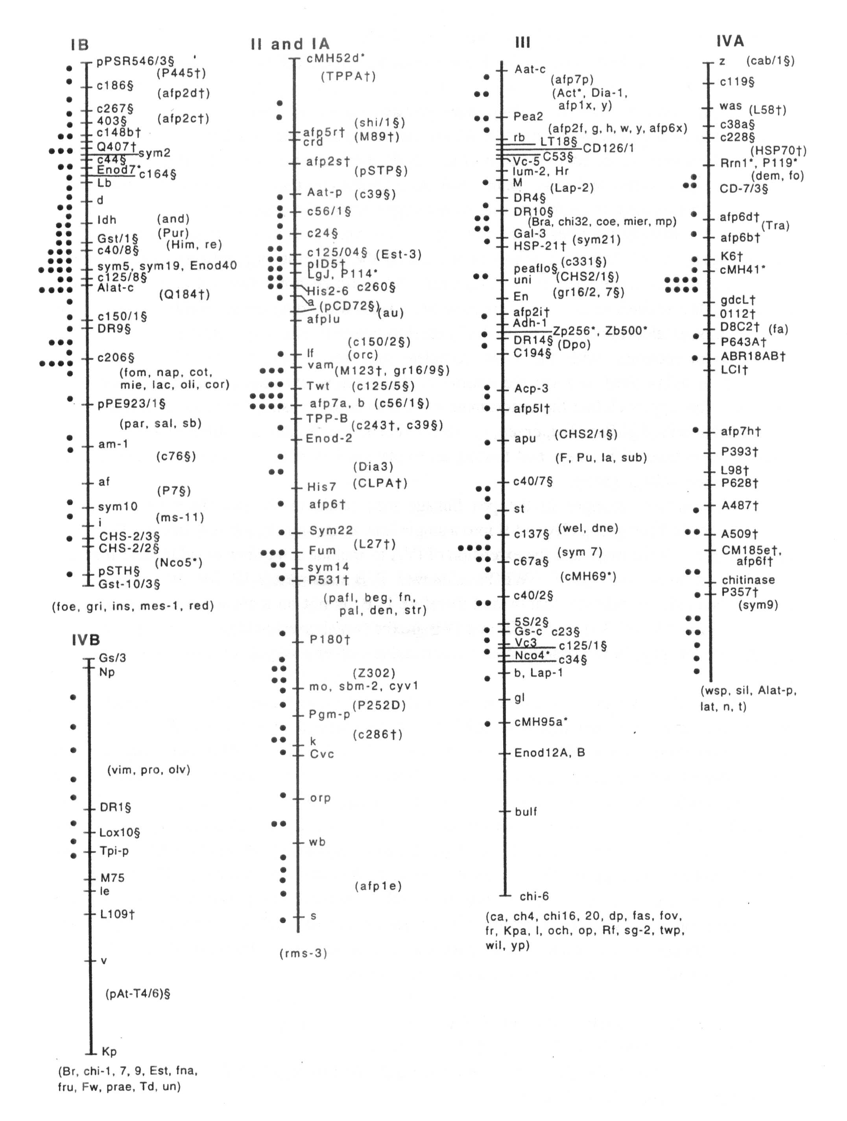
Pisum Genetics Volume 28 1996 Pea Map 3

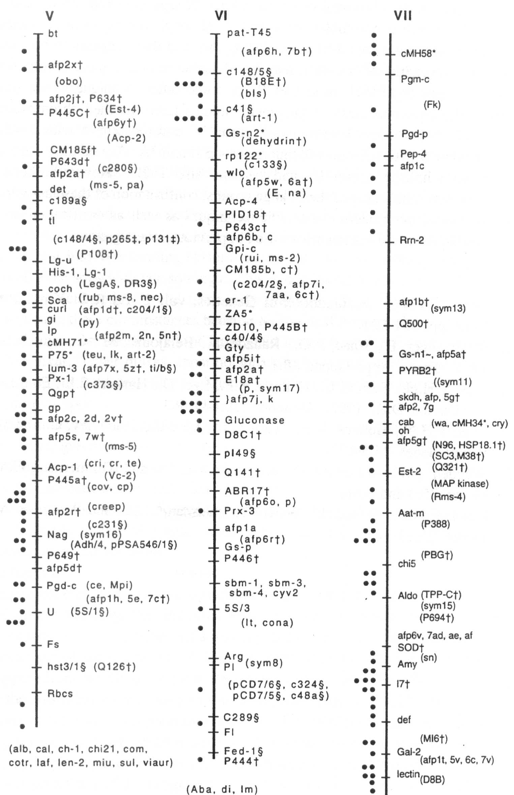
4 Pisum Genetics Volume 28 1996 Pea Map

The assignment of linkage groups and chromosomes appears to be nearly complete. The presence of the ribosomal genes on linkage groups IVA and VII indicate that these groups must correspond' to chromosomes 4 and 7, although not necessarily respectively. The two satellite chromosomes are difficult to distinguish, and there appears to be some confusion even with the cytogenetic stocks, so it may be advisable to define these chromosomes based on the linkage groups (by FISH, in situ PCR, or some other technique where markers are used to identify the chromosomes). Cytogenetic studies have matched chromosome 2 with linkage group VI, chromosome 3 with linkage group V, chromosome 5 with linkage group III, and chromosome 6 with what now is linkage group II and IA. By default, chromosome 1 must be paired with linkage group IB and perhaps also IVB. However, before we commit to chromosomal numbering of the linkage groups, confirmation of these assignments is needed by at least one of the modern cytogenetic techniques as well as verification of the chromosomes involved in the translocation stocks used in previous investigations.

- Blixt, S. 1974. In:Handbook of Genetics, vol. 2, Ed R.C. King, Plenum Press, New York, pp. 181-221.
- Dirlewanger, E., Isaac, P.G., Ranade, S., Belajouza, M., Cousin, R. and de Vienne, D. 1994. Theor. Appl. Genet. 88:17-27.
- Ellis, T.H.N., Turner, L., Hellens, R.P., Lee, D., Harker, C.L., Enard, C, Domoney, C. and Davies, D.R. 1992. Genetics 130:649-663.
- Ellis, T.H.N., Hellens, R.P., Turner, L., Lee, C, Domoney, C. and Welham, T. 1993. Pisum Genet. 25:5-12.
- Weeden, N.F., Swiecicki, W.K., Ambrose, M. and Timmerman, G.M. 1993. Pisum Genet. 25:4 and cover.
- Weeden, N.F., Swiecicki, W.K., Timmerman, G.M. and Ambrose, M. 1993. Pisum
Genet. 25:13-14.

