PISUM GENETICS
Volume 27 1995
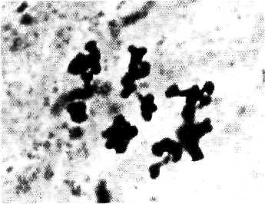
ISSN 1320-2510 The University of Tasmania

