Studies on colchicine induced tetraploids of the pea
Kravchenko, A.Y. Department of Plant Breeding and Genetics
Novosibirsk State Agarian University
Dobrolyubov St 160
Novosibirsk 630039, Russia
Artificial tetraploids of the pea have been obtained by several different authors (1, 4, 7). The aim of our work was to study the pea tetraploids cytomorphologically over a series of five successive generations.
Tetraploids of the pea cultivar SIR-5 were induced by treating the dry seeds in an aqueous solution of colchicine. The best results were obtained by treatment with a low concentration of colchicine (0.0025-0.005%) for 8 h (5).
Morphological and cytological studies were conducted on tetraploids of the C2-C6 generations. Meiotic examinations were performed on ten plants of each generation grown in the greenhouse. The immature anthers were fixed in acetic acid and ethanol (1:3) and squashed in 2% acetocarmine. Pollen viability was estimated by staining pollen grains with a 2% acetocarmine solution.
Tetraploid plants had larger leaves, pollen grains and seeds than diploid plants (Table 1). The predominant shape of diploid pollen grains was triangular (Fig. l). The tetraploids had low fertility (Table 1). Similar observations were made by other authors (1, 3, 7). The meiotic processes in tetraploids were characterised by irregularities. The chromosomes were arranged mainly in quadrivalent configurations in metaphase I (Figs. 2 and 3). Bivalents were the second most common association. The frequency of trivalents and univalents was comparatively small (Table 2). At anaphase I, laggards (Fig. 4) and bridges were observed.
Chromosome behaviour in meiosis underwent some changes during successive generations (Table 2). The number of trivalents and univalents in metaphase I, and the number of cells with lagging chromosomes and bridges in anaphase I, decreased. The frequency of quadrivalent formation remained high. The high frequency of quadrivalents and the decrease in abnormalities in anaphase I indicate that the regularity of quadrivalent disjunction improved in the advanced generations. The increase in regularity of chromosome segregation resulted in improvement of pollen fertility to 85-90%, but the seed productivity of tetraploids remained low. In the C6 generation, the tetraploids produced 7.8 seeds per a plant compared with 20.1 in the diploids. The number of seeds per pod was 1.4 to 2.2 in the tetraploids and 3.6 in the diploid plants. High pollen viability but poor seed setting of artificial tetraploids of the pea was also observed by Kasperek (4). It is worth searching for the cause of this phenomenon in megasporogenesis and embryonic processes. Many authors (2, 3 ,6 ,7, 8) have suggested that some genetic, physiological and environmental factors might play a major role in the reduction of fertility in tetraploids and further studies will be conducted on induced tetraploids to determine the reasons for their low fertility.
Acknowledgements. The author is grateful to Dr.V.A. Berdnikov for the help in conducting the experiments and to Dr. O.E. Kosterin for the help with preparation of this report.
Table 1. Comparison of some characteristics of C2 tetraploids and diploids of the pea cultivar SIR-5.
Characteristics | 4n | 2n
Leaf size:
length (mm) | 54.1 ± 0.9 | 47.0 ± 0.9
width (mm) | 38.1 ± 0.4 | 31.6 ± 0.6
Pollen grain size:
length (μm) | 50.3 ± 0.5 | 45.0 ± 0.2
width (μn) | 41.5 ± 0.5 | 29.8 ± 0.2
Pollen viability (%) | 75.4 ± 1.8 | 99.3 ± 0.6
Pods per plant | 2.8 ± 0.2 | 5.7 ± 0.4
Seeds per plant | 4.4±0.6 | 20.1 ± 1.9
Seeds per pod | 1.5 ±0.1 | 3.6 ± 0.2
10-seed weight (g) | 2.8 ± 0.3 | 1.8 ± 0.2
Table 2. Fertility and chromosome behaviour at metaphase I and anaphase I in tetraploids of different generations.
Characteristics |  | Generations
Characteristics | C2 | C4 | C5 | C6
Pollen viability (%) | 75.4 ± 1.8 | 85.7 ± 1.5 | 91.2 ± 2.8 | 85.9 ± 2.0
Pods per plant | 2.80 ± 0.20 | 3.87 ± 0.46 | 3.24 ± 0.21 | 5.18 ± 0.81
Seeds per plant | 4.40 ± 0.60 | 7.73 ± 1.04 | 6.96 ± 0.46 | 7.82 ± 1.42
Seeds per pod | 1.54 ± 0.13 | 2.00 ± 0.15 | 2.20 ± 0.15 | 1.44 ± 0.08
Mean number of associations at metaphase I (per cell):
Quadrivalents | 5.47 ± 0.24 | 4.98 ± 0.19 | 5.45 ± 0.37 | 5.73 ± 0.27
Trivalents | 0.50 ± 0.14 | 0.04 ± 0.03 | 0.18 ± 0.12 | 0.18 ± 0.12
Bivalents | 2.03 ± 0.41 | 3.96 ± 0.64 | 2.55 ± 0.81 | 2.18 ± 0.63
Univalents | 0.57 ± 0.15 | 0.04 ± 0.03 | 0.18 ± 0.12 | 0.18 ± 0.12
Chromosome behaviour at anaphase I (per cent of cells):
Laggards | 33.60 | 12.0 | 7.3 | 8.2
Bridges | 1.67 | 1.2 | 0 | 0.7

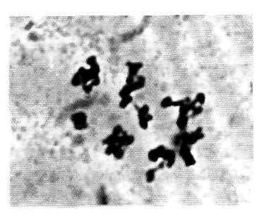
Fig. 1. Diploid pollen of the pea.
Fig. 3. Metaphase I: 6 quadrivalents and 2 bivalents.
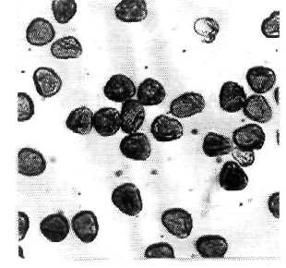
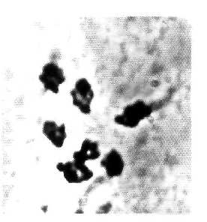
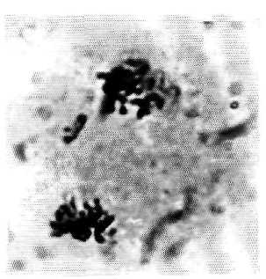
1. Djachuk, P.A. and Cheredeeva, V.S. 1974. In: Teoreticheskie i prakticheskie
problemy poliploidii. Nauka, Moscow, pp. 185-213. (in Russian).

Fig. 2. Metaphase I: 7 quadrivalents.
Fig. 4. Lagging chromosome at anaphase I.
2. Dynansagar, V.R. and Sudhakaran, I.V. 1970. Cytologia 35:227-241.
3. Errico, A., Conicella, C. and Talierico, U. 1991. Plant Breeding 106:141-148.
4. Kasperek, G. 1986. Pisum Newsletter 18:32.
5. Kravchenko, A.Y. 1994. In: Analiz sovremennych agrarnych problem. Novosibirsk
State Agrarian University, Novosibirsk, pp. 28-34. (in Russian).
6. Martin, A., Gonzalez-Garcia, J.A. and Serradilla, J.M. 1986. Biol. Zentralbl. 105:85-
94.
7. Mercy Kutty, V.C. and Kumar, H. 1983. Cytologia 48:51-58.
8. Shambulengappa, K.G., Chennaveeraiah, M.S. and Patel, S.R. 1965. Cytologia
30:205-212.

