Inheritance of a pollen protein and a probable case of inversion in the pea chromosome corresponding to linkage group I
Kosterin O.E., Bogdanova V.S., Institute of Cytology and Genetics
Gorel', F.L., and Berdnikov V.A. Novosibirsk 630090, Russia
Searching for new biochemical markers in the garden pea we paid attention to the pollen. We applied a perchloric acid extraction of proteins (3). The pollen taken from five just opened flowers was suspended in 0.7 ml of 5% perchloric acid for 5 min and centrifuged, the supernatant was added with 6 volumes of cool acetone containing 0.1 M sulphuric acid and incubated at 5°C for 12 h. The precipitated protein was collected by centrifugation and resolved in 8 ml of 0.9 M acetic acid / 4 M urea / 15% sucrose. The preparations were subjected to electrophoresis in 0.1 mm thick 15% polyacrylamide gel containing 4 M urea and 0.9 M acetic acid (the modified Panyim and Chalkley method; see 1, 3). Electrophoresis revealed several protein zones, designated on Fig.1 as PP1, PP2, PP3, and PP4 (PP stands for "pollen protein"). Zone PP1 exhibits a series of diffuse bands, zone PP2 contains several bands of different intensity, zone PP3 is one major band, zone PP4 comprises two or three bands with electrophoretic mobility varying among different pea accessions of VIR collections. The extract from immature anthers provided the same spectrum with some diffuse bands added (as on Fig. 2), originating probably from the anther wall.
The perchloric acid soluble proteins were studied in 37 accessions of the cultivated pea forms. They all had an identical mobility of the band PP3. We tested 31 wild forms of Pisum sativum L.: P. s. elatius (Bieb.) Schmahl., P. s. syriacum (Boiss. et Noe.) Berger, and P. s. humile Boiss. et Noe., the two latter usually being considered as synonyms. In 21 of the wild forms, the band PP3 had the same mobility (this variant was designated as PP3^{f}), but in four accessions, namely: L99, L100, L101 (kindly provided by Dr. N. Weeden), and VIR320 (P. s. syriacum, Palestine) the PP3 band migrated at a slower rate (this variant was designated PP3^{s}, see Fig.l).
We crossed a line VIR320-2 derived from the accession VIR320 with four pea forms possessing the fast variant PP3^{f}. In all the crosses, the F₁ hybrids had both parental variants, while the F₂ plants showed a Mendelian segregation for the PP3 protein phenotypes (Table 1, Fig. 2), in accordance with monogenic inheritance of the variants PP3^{s} and PP3^{f}. We symbolize the corresponding gene as Pp3 with alleles Pp3^{s} and Pp3^{f}.
One of the bands of the zone PP4 (designated PP4-2) also showed a Mendelian segregation (Fig. 2); its variants exhibited no linkage with any involved markers of the linkage groups I and V.
In all the four crosses (with a total of 338 F₂ individuals), no cross-over was observed between the gene Pp3 and the cluster His(2-6) of the histone H1 genes. We observed only heterozygous phenotypes for PP3 and histone H1 or homozygous phenotypes identical to the parental ones. Moreover, it turned out that in the three crosses where gene a was involved (with a total of 294 F₂ plants), the alleles of a, Pp3, and the haplotypes of His(2-6) also cosegregated as a single unit. This was quite unexpected, because we have shown previously in numerous crosses that the loci a and His(2-6) are separated by 2-13 cM (the mean distance is 7.0 ± 0.5 cM). The data from all four crosses are summarized in Table 1. We concluded i) the gene Pp3 resides in linkage group I and ii) the involvement of the corresponding chromosome of line VIR320-2 in a cross supresses recombination between the loci a and His(2-6).
Table 1. Segregations for phenotypes in the F₂ progeny of four crosses in which one parent was line VIR320-2. Because we detected no cross-over events between the loci involved, only three phenotypic classes were observed: those of the parents and the heterozygous one. Line VIR320-2 has the variant PP3^{S}, haplotype 1223 of histone H1 subtypes 3-6 (for designation see ref. l), and allele A. The other parent in each cross has protein PP3^{f}; the H1 haplotype of these lines and the allele of gene a appear in brackets.
Cross | Phenotype of protein PP3 and histone H1 subtypes 3-6 |  |  | n | Chi-square
 |  |  |  |  | (1:2:1)
 | That of | Hetero- | That of the
 | VIR320-2 | zygous | other parent
VIR2524 (P.s syriacum, Pale  stine) (A, 0121) x VIR320-2 | 9 | 26 | 8 | 33 | 1.93  P>0.30
VIR320-2 x VIR1858 (Ethi  opia) (a, 2121) | 29 | 62 | 45* | 136 | 4.82  P>0.05
VIR4340 (Czechoslovakia)  (a, 1121) x VIR320-2 | 25 | 40 | 17* | 82 | 1.61  P>0.40
VIR2222 (Asia Minor)  (a, 1121) x VIR320-2 | 17 | 37 | 22* | 76 | 0.71  P>0.70
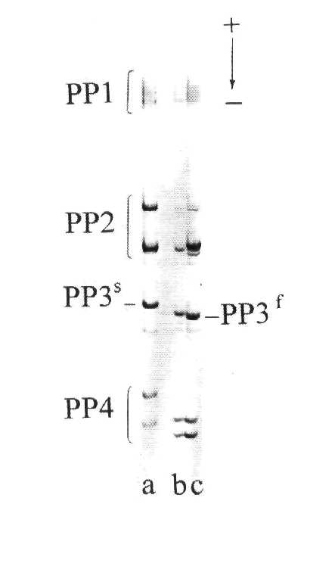
*These plants had white flowers
Fig. 1. Electrophoresis (0.9 M acetic acid / 4 M urea) of the proteins extracted by 5% perchloric acid from the pollen of line VIR320-2 (a), the accession VIR3902 (Pisum sativum asiaticum Govorov, Tadjikistan) (b), and an F₂ plant of the cross SGE80 x VIR3971 (P. s. sativum L.) (c).
To further study the latter effect, we chose a plant homozygous for alleles A, Pp3^{s} and the haplotype 1223 of the cluster His(2-6) (for designation see ref. l) from the F₂ of the cross VIR2222 x VIR320-2 and fertilized it with the pollen of our original line OK14 with the genotype a, Pp3^{f}, His(2-6)¹¹²¹, lfª and blb. The recessive allele blb determines narrow leaflets and a swollen stem base (2). The line OK14 originated from the F₂ of the cross 2 described in (2), in which no chromosomal rearrangements were detected.
Six F₁ plants of the above mentioned cross, as expected, had red flowers appearing from 10th-12th node (counting from the first scale leaf as node 1), and the variants of histone H1 subtypes and PP3 protein coming from both parents. They exhibited full fertility of pollen and ovules. We pollinated them by the line OK14 and obtained from this testcross a progeny of 104 individuals. The latter exhibited only four phenotypic classes (Table 2). White flowers were always accompanied with phenotypes for the histone H1 haplotypes and the protein PP3 variant identical to that of the line OK14. These plants formed the first (sometimes sterile) inflorescence at nodes 6-8, i.e. they were homozygous for lfª. Plants with red flowers had heterozygous phenotypes for histone H1 and PP3 and started flowering from nodes 10-14. Thus, no cross-over recombination was observed between the genes His(2-6), a, lf, and Pp3. As follows from Table 2, recombination between the gene blb and the other considered genes did occur, the distance being calculated as 16.4 ± 3.6%. This result can be presented as the following map segment
{His(2-6), a, lf} blb
16.4 ± 3.6 % rec.
At the same time, according to our earlier bulked data on eighteen crosses treated by the JOINMAP program (4), normal recombination relationships between the loci involved are as follows:
His(2-6) a lf blb
7.0 ± 0.5 9.8 ± 1.1 35.8 ± 7.8 % rec.
Meiosis in the pollen mother cells was studied cytologically in three plants heterozygous for all the markers considered and one plant homozygous for His(2-6), a, lf, and blb. The latter plant showed no abnormalities in metaphase I. In the nuclei of all three heterozygous plants, six normal bivalents and a pair of univalents were observed.
All the data presented show that the region His(2-6)-lf of the line VIR320-2 does not undergo cross-over recombination with its counterparts, and on the neighbouring region lf-blb recombination is partly suppressed. This might result from some chromosomal rearrangement. The progeny of the latter testcross were tested for pollen sterility. Almost all plants had fully fertile pollen. This fact demonstrates that no reciprocal trdnslocation was involved in the cross.
The cytological data also suggest that in heterozygous plants the synapsis of one chromosome pair is disturbed. It is worth mentioning that a similar picture, 5-6 partly decoupled bivalents and 2-4 free univalents, was observed in pollen mother cell metaphase I in F₁ hybrids of cross L101 x OK7, where the first parent was a wild pea form also possessing the slow variant of the PP3 protein. However, in those hybrids no more than 25% of the pollen were fertile, evidence suggesting heterozygosity for multiple chromosome rearrangements.

Table 2. Segregation for phenotypes of the genes His(2-6), a, lf, Pp3, and blb in the testcross (an F₂ plant of the cross VIR2222 x VIR320-2) x OK14 x OK14.
 | Blb | blb | Total
A, Lf, PP3^{f}+PP3^{s}, H1: 1121+1223 | 47 | 7 | 54
a. lfª, PP3^{f}, H1: 1121 | 10 | 40 | 50
Total | 57 | 47 | 104
n=104; Chi-square (1:1) for blb is 0.96 (P>0.3), that for other genes is 0.15 (P>0.6); joint segregation Chi-square is 47.08 (P<0.0001).

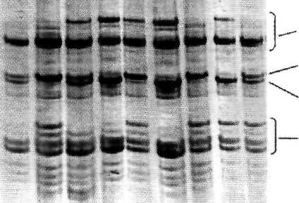

PP2 PP3^{S} PP3^{f} PP4
Fig. 2. Segregation for the pollen protein phenotypes in F₂ plants of the cross VIR320-2 x VIR1858.
The most probable candidate for the recombination-inhibiting factor contained in line VIR320-2 is an inversion. This might be proved by inducing new mutations in genes A, His(2-6), or Lf in this line. Anyway, the chromosome with the listed genes inherited from this line could be used for constructing a balancer system in the pea.
Acknowledgements. This work was partly supported by the Russian State Programs "Frontiers in Genetics" and "Russian Fund for Fundamental Research", and, partially, by the International Science Foundation.
- Kosterin, O.E., Bogdanova, V.S., Gorel, F.L., Rozov, S.M., Trusov, Y.A., Berdnikov,
V.A. 1994. Plant Sci. 101: 189-202.
- Kosterin, O.E., Rozov, S.M. 1993. Pisum Genet 25: 27-31.
- Smirnova, O.G., Rozov, S.M., Kosterin, O.E., Berdnikov V.A. 1992. Plant Sci. 82: 1-
13.
- Stam, P. 1993. Plant J. 5:739-744.

