Linkage of gene chi-33 on linkage group VI
Swiecicki, W.K. Institute of Plant Genetics, Polish Academy of Sciences
and Kruszka, K. Strzeszynska 34, Poznan 60-479, Poland
The spontaneous chlorotica mutation chi-33 (Wt11019) shows clear expression at the seedling stage except under greenhouse conditions (1). A preliminary linkage test (1) indicated significant linkage between chi-33 and linkage group VI marker Pl (29 cM) but linkage with wlo on this chromosome was not significant.
To locate chi-33 more precisely, we crossed Wt11019 with tester line Wt11777 which carries four group VI markers Pl, Arg, wlo and art-1. In the F₂, chi-33 and the four markers all showed normal monohybrid segregation (Table 1). Dihybrid segregation analyses (Table 1) provided strong evidence of linkage between chi-33 and markers Arg (P<0.0001, 13.6 cM) and Pl (P<0.0001, 16.7 cM) but only weak evidence of linkage between chi-33 and markers wlo (P<0.01, cM 25.4) and art-1 (P<0.05, 29.7 cM). Together with the previous data (1), these results indicate chi-33 is located in the linkage group VI and closer to Pl than wlo. The data in Table 1 suggest the following arrangement of loci:
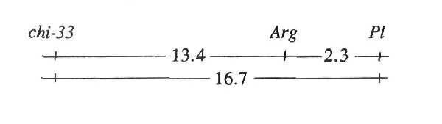
Table 1. Monohybrid (a) and dihybrid (b) segregation in the F₂ population of the cross
K. 1317 = Wt 11019 (chi-33, arg, pl, Art-1, Wlo) x Wt 11777 (Chi-33, Arg, Pl, art-1, wlo).
(a) | Phenotype* |  |  |  |  |  |  | Chi-sq. (3:1)
Locus | D |  | R |  |  | Total
Chi-33 | 100 |  | 30 |  |  | 130 |  | 0.26
Arg | 98 |  | 32 |  |  | 130 |  | 0.01
Pl | 96 |  | 31 |  |  | 127 |  | 0.02
Art-1 | 102 |  | 27 |  |  | 129 |  | 1.14
Wlo | 96 |  | 34 |  |  | 130 |  | 0.09
(b) | Phenotype* |  |  |  |  |  |  | Joint Chi-sq. | Recomb fract. | SE
Loci | DD | DR |  | RD | RR |  | Total | Joint Chi-sq. | Recomb fract. | SE
Chi-33/Arg | 91 | 9 |  | 7 | 23 |  | 130 | 56.9 | 13.6 | 3.2
Chi-33/Pl | 88 | 11 |  | 8 | 20 |  | 127 | 43.0 | 16.7 | 3.7
Arg/Pl | 95 | 2 |  | 1 | 29 |  | 127 | 111.1 | 2.3 | 1.3
Chi-33/Art-1 | 75 | 25 |  | 27 | 2 |  | 129 | 4.4 | 29.7 | 7.9
Chi-33/Wlo | 68 | 32 |  | 28 | 2 |  | 130 | 7.7 | 25.4 | 8.1
*D = homozygous dominant + heterozygous; R = homozygous recessive
1. Apisitwanich, S. and Swiecicki, W.K. 1993. Pisum Genetics 25:17.

