PISUM GENETICS
Volume 26
1994
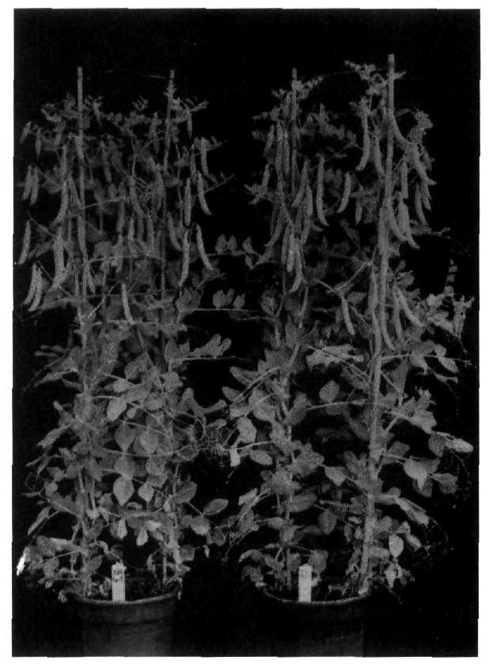
ISSN 1320-2510 | The University of Tasmania

