Location in linkage group III of a gene coding minor vicilin polypeptide
Smirnova, O.G. Institute of Cytology and Genetics
Novosibirsk 630090, Russia
Eggi, E.E. N.I. Vavilov All-Russian Plant Industry Institute
St Petersburg, Russia
The pea seed storage protein vicilin has M_{r} about 150 kD and consists of three primary subunits of M_{r} 50 kD. Sodium dodecylsulphate gel electrophoresis separates vicilin subunits into polypeptides of M_{r} 12.5, 13.5, 16, 19, 33, 35 and 50 kD (4). The initial products of the vicilin structural genes are polypeptides of M_{r} 50 and 47 kD (1). All of the 47 kD and some of the 50 kD precursors are proteolytically cleft yielding vicilin polypeptides of M_{r}<35 kD. There are two potential cleavage sites in vicilin precursors. Processing could take place at one point, at another, at both points or not at all if asparagine residues are absent in required positions (8). Taking into consideration that vicilin is encoded by several gene families (2), the observed variety of vicilin polypeptides should be expected.
It has been shown (5) that one of the genes coding the 50 kD vicilin subunit, Vc-1, is linked to the locus r. It also has been demonstrated that vicilin polypeptides of M_{r} 33 kD are controlled by a pair of co-dominant genes at a single locus (7). Further investigations were carried out using the length polymorphism of DNA sequences homologous to the vicilin messenger RNAs. Gene Vc-2 was mapped on linkage group V and genes Vc-3 and Vc-5 on opposite ends of linkage group III (3, 9).
We have studied one of the minor vicilin polypeptides with an M_{r} about 35 kD which binds the vicilin antibodies in Western blot analysis. This polypeptide was designated by us Vc-mp. In dodecylsulphate gel electrophoresis Vc-mp has at least two allelic variants of M_{r} 35.4 (F) and 35.9 (S) kD (Fig. 1). Among 100 samples of the world pea collection at St Petersburg these variants were found with frequencies 0.58 and 0.38, respectively. Sometimes we encountered varieties lacking polypeptides in the zone of 35.4 or 35.9 kD.
We crossed lines VIR4907 (Pisum sativum ssp. asiaticum, Vc-mp S) and WL1238 (Vc-mp F). Analysis of F₁ seeds from the reciprocal cross VIR4907 x WL1238 showed co-dominant inheritance of the Vc-mp polypeptide patterns. This indicates that the Vc-mp polypeptide variants are due to variation in the nuclear structural genes and that there is no maternal effect on Vc-mp polypeptide inheritance. 156 F₂ seeds were examined. The observed segregation into Vc-mp classes was 37 SS: 81 SF: 38 FF [χ² (1:2:1) = 0.24], indicating monogenic control for the Vc-mp polypeptide synthesis. F₂ segregation data for the Vc-mp polypeptide and various morphological markers revealed significant linkage (P<0.0001) between the gene coding for the Vc-mp polypeptide and gene b in linkage group III (Table 1). The corresponding distance was calculated as 12.3 ± 2.8 map units. There was no evidence of linkage between the vicilin gene and any of the other markers (d, f, gp, i, k, le, m, pi, r, s, tl, u and wb) segregating in this cross. To locate the vicilin gene more accurately, we crossed lines VIR4907 (Vc-mp slow, St, B) and WL1749 (Vc-mp fast, st, b) differing in two marker genes of linkage group III. F₂ segregation data are shown in Table 1. The recombination fractions calculated from the data in Table 1 suggest the following arrangement of the genes:
st | — | 29 | — | 'Vc-mp' | — | 9 | — | b
As was mentioned above, two vicilin loci are already mapped on pea linkage group III. Vc-5 is situated approximately 25 map units from gene st in the opposite direction to gene b (3, 6). Thus Vc-5 is in a different location to the gene coding for the Vc-mp polypeptide. Vc-3 was placed on the "M end" of group III by Weeden et al (9) but it is now accepted that Vc-3 lies below st in the general vicinity of the b locus (3, N.F. Weeden pers. com.). Thus Vc-3 is very likely the gene coding for Vc-mp polypeptide. The map position 9 units above b is consistent with that conclusion but further work is necessary to fully resolve the identity of the vicilin gene mapped in our study.
Table 1. Dihybrid segregation data obtained from F₂ populations of crosses 1) VIR4907 (B Vc-mp slow) x WL1238 (b Vc-mp fast) and 2) VIR4907 (B St Vc-mp slow) x WL1749 (b st Vc-mp fast).
Loci |  | Cross | Phenotype¹ |  |  |  |  |  | Total | Joint χ² | Recomb  frac | SE
 |  | Cross | DS | DH | DF | RS | RH | RF
b | Vc-mp | 1 | 36 | 71 | 7 | 1 | 10 | 31 | 156 | 77.48* | 12.27 | 2.78
b | Vc-mp | 2 | 45 | 87 | 4 | 0 | 8 | 40 | 184 | 127.14* | 6.57 | 1.88
b | Vc-mp | 1+2 | 81 | 158 | 11 | 1 | 18 | 71 | 340 | 202.97* | 9.18 | 1.63
st | Vc-mp | 2 | 41 | 71 | 20 | 4 | 24 | 24 | 184 | 23.74* | 29.38 | 3.88
 |  |  | DD | DR | RD | RR
st | b | 2 | 108 | 24 | 28 | 24 |  |  | 184 | 15.14* | 32.23 | 6.51
¹ D - dominant, R = recessive, S = homozygous slow, H = heterozygous fast/slow, and F = homozygous fast The first named locus is shown first.
* P<0.0001
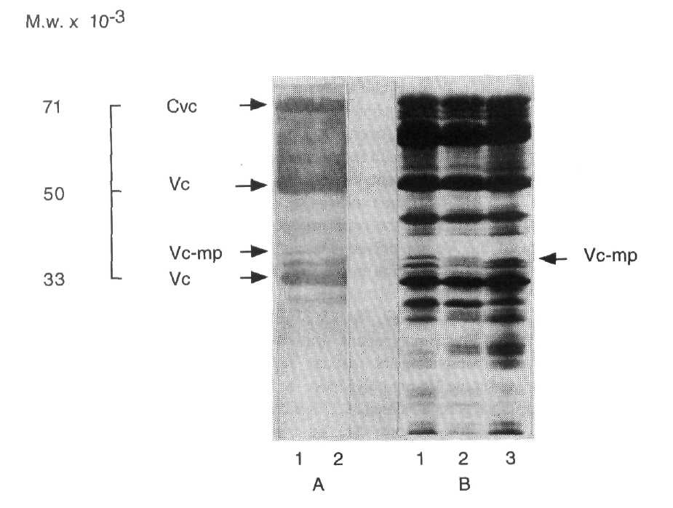
Fig. 1. Sodium dodecylsulphate polyacrylamide gel electrophoresis (non-reducing conditions) of pea seed proteins:
A - vicilin subunits, identified by "Western" blot analysis;
B - total protein extracts of seeds of parental lines VIR4907 (1) and WL1749 (3) and the F₁ (2) from their cross, stained by Coomassie R-250.

- Croy, R.R.D., Gatehouse, J.A., Evans, I.M. and Boulter, D. 1980. Planta 148:57-
63.
- Ellis, T.H.N., Domoney, C., Castleton, J., Cleary, W. and Davies, D.R. 1986. Mol.
Gen. Genet. 205:164-169.
- Ellis, T.H.N., Hellens, R.P., Turner, L., Lee, C., Domoney, C. and Welham, T.
1993. Pisum Genet. 25:5-14.
- Gatehouse, J.A., Croy, R.R.D., Morton, H., Tyler, M. and Boulter, D. 1981. Eur.
J. Biochem. 118:627-633.
- Mahmoud, S.H. and Gatehouse, J.A. 1984. Heredity 53:181-191.
- Polans, N.O. and Folta, K.M. 1992. Pisum Genet. 24:79-81.
- Thomson, J.A., Schroeder, H.E. and Tassie, A.M. 1980. Aust. J. Plant Physiol.
7:271-282.
- Watson, M.D., Lambert, N., Delauney, A., Yarwood, I.N., Croy, R.R.D.,
Gatehouse, J.A., Wright, D.J. and Boulter, D. 1988. Biochem. J. 251:857-864.
- Weeden, N.F., Ambrose, M. and Swiecicki, W.K. 1993. In Genetic Maps, Ed. S.J.
O'Brien, Cold Spring Harbor Laboratory Press, Cold Spring Harbor, N.Y. pp.6.24-
6.34.

