Location of gene lum-3 in relation to tl and gp
Rozov, Serge M. Institute of Cytology and Genetics
Lavrentjev Avenue 10, Novosibirsk, 630090 Russia
A costata-type mutant, lum-3, was isolated and localised in linkage group V about 10 cM from gp by Swiecicki (3). In the crosses analysed, Swiecicki did not find any linkage between lum-3 and the r–tl segment of group V. As the relative linkage intensities among the markers examined (lum-3, te, cp, gp) were slightly contradictory (3), the precise position of lum-3 could not be stated with certainty.
In my cross of testerline RT-2 (det, Tl, Sca ^{f}, Lum-3, Gp) with the Wiatrowo type line for lum-3, WM5309 (Det, tl ^{w}, Sca ^{s}, lum-3, gp), I found a strong linkage between lum-3 and gene Sca, known to be linked to tl (2), and gp. The dihybrid segregation data for this cross are shown in Table 1.
According to the data obtained in this cross and results given in the previous paper (1), the combined r–tl–gp chromosome segment may be drawn as follows:
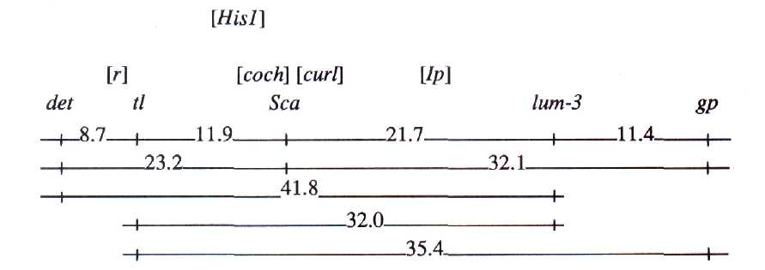
Acknowledgements. I thank Dr W.K. Swiecicki for supplying line Wt-15309. The work was partially funded by the Russian State Foundation "Frontiers in Genetics".
- Rozov, S.M., Temnykh, S.V., Gorel, F.L. and Berdnikov, V.A. 1993. Pisum
Genetics, 25:46-51.
- Smirnova, O.G., Rozov, S.M. and Berdnikov, V.A. 1989. Pisum Newsl.
21:63-65.
- Swiecicki, W.K. 1988. Pisum Newsl. 20:36-37.
Table 1. Joint segregation data obtained from the F₂ of cross RT-2 (det, Tl, Sca ^{f}, Lum-3, Gp) x Wt-15309 (Det, tl ^{w}, Sca ^{s}, lum-3, gp).
Genes |  | Phase | Number of progeny with designated phenotype¹ |  |  |  |  |  |  |  |  | Joint seg. χ² | Recomb. frac. | SE
 |  | Phase | A/B | A/h | A/b | h/B | h/h | h/b | a/B | a/h | a/b | Joint seg. χ² | Recomb. frac. | SE
det | tl | C | 13 | 38 | 3 | -- | -- | -- | 1 | 3 | 23 | 52.4*** | 8.7 | 3.3
det | Sca | C | 18 | 28 | 8 | -- | -- | -- | 2 | 8 | 17 | 20.4*** | 23.2 | 5.2
det | lum-3 | R | 38 | -- | 16 | -- | -- | -- | 22 | -- | 5 | 1.6 | 41.8 | 9.1
det | gp | R | 36 | -- | 18 | -- | -- | -- | 23 | -- | 3 | 4.3* | 32.3 | 9.9
tl | Sca | C | 20 | 6 | 1 | 5 | 43 | 7 | 0 | 4 | 21 | 98.7*** | 11.9 | 2.4
lum-3 | tl | C | 22 | 44 | 11 | -- | -- | -- | 5 | 11 | 14 | 12.7** | 32.0 | 5.3
gp | tl | C | 22 | 37 | 11 | -- | -- | -- | 3 | 12 | 8 | 5.3 | 35.4 | 5.9
lum-3 | Sca | C | 23 | 44 | 10 | -- | -- | -- | 2 | 9 | 19 | 28.4*** | 21.7 | 4.4
gp | Sca | C | 23 | 33 | 14 | -- | -- | -- | 2 | 10 | 11 | 8.8* | 32.2 | 5.7
lum-3 | gp | C | 65 | -- | 5 | -- | -- | -- | 5 | -- | 18 | 47.0*** | 11.5 | 3.5
¹ A,a - first gene; B,b - second gene; h - heterozygous. Where both genes are dominant, the capital letter stands for the dominant allele. Where the second gene is codominant, capital A stands for the dominant allele of the first gene and capital B for an allele of the second gene which is in coupling with A. Where both genes are codominant, the capital letter stands for an allele of the first parent.
*,**,*** P < 0.05,0.01 and 0.001, respectively. Data were analysed by the LINKAGE-1 program.

