Twisted tendrils (Twt) - a phenotype associated with a translocation involving chromosome 1
Gorel, F.L., Temnykh, S.V., Institute of Cytology and Genetics
Lebedeva, I.P., and Berdnikov, V.A. Novosibirsk 630090, Russia
A new mutant displaying altered tendril morphology was found in 1988 after treatment of Sprint-2 seeds with 0.015% EMS. The tendrils of the mutant coil strongly soon after they form, even in the absence of contact with other objects (Fig. 1). Three of four plants in one M₂ family expressed the mutant phenotype, and one of these was used as the pollen parent in crosses with marker line WL1238 and with the initial line Sprint-2. Approximately half of the progeny in both cases had abnormal twisted tendrils and were semisterile; the other half were normal. We initially hypothesised that the pollen parent was heterozygous for a dominant gene that affects tendril morphology and fertility. The symbol Twt (Twisted tendrils) is proposed.
An F₂ population from the cross WL1238 (A, twt, i, s, wb, k, b, le, gp, cp, tl, U^{st}, Bra, fna) x Sprint-2 (a, Twt) was analysed, and a recombination fraction of about 30% was found between genes Twt and a (data not shown). For more accurate localisation of Twt a three-point test cross, involving a, Twt, and His(2-6), was analysed. His(2-6) is a cluster of closely linked genes coding a set of four molecular variants of histone H1 (H1 haplotype) and has previously been shown to be 4 cM from a (1). The histone H1 phenotype is described by a numerical formula of four digits that reflects the electrophoretic mobility of histone H1 variants numbers 3, 4, 5, and 6 (Fig. 2).
A maternal plant taken from VIR accession K-3953 (Tadjikistan) with genotype H1-1133/H1-1133, A/A, twt/twt was crossed with a plant having genotype H1-1021/H1-1021, a/a, Twt/twt produced from the backcross mentioned above. Eight of the 15 F₁ plants had phenotype Twt. The remaining seven plants were normal. This result is consistent with the dominance of the mutant trait. All 8 F₁ plants having supercoiled tendrils were crossed reciprocally with tester line 5-11 (H1-1123/H1-1123 a/a, twt/twt). Progeny analysis of the testcross (Tables 1 and 2) permitted us to localise the genetic factor responsible for phenotype Twt at 8 cM from a and 13 cM from His(2-6). These data suggest the following order of the three genes: His(2-6) -(5.3 cM) - a - (8.0 cM) - Twt.
However, it should be noted that situation is complicated by the presence among the testcross progeny of 28 plants that apparently had all three sets of the histone H1 haplotype (see Fig. 2, lane 4). All of them had phenotype A, Twt, H1-1133/1021/1123, and they could be distinguished from the rest by smaller size, much slower development, and stipules with pointed apexes and undulating margins. These observations, particularly the presence of all three H1 haplotypes, suggested that these exceptional plants were trisomic at least with respect to the segment of chromosome 1 carrying His(2-6). Indeed, the cytological analysis of one of these trisomics revealed the presence of one additional chromosome (Fig. 3a).

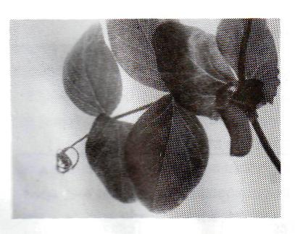 | Fig. 1. The phenotype of the Twt (Twisted tendrils) mutant.
Fig. 2. Segregation of histone H1 phenotypes in testcross progeny. Lanes 1, 2, 3 and 5 show the heterozygous phenotype 1133/1123 and lanes 7 and 8 show the heterozygous phenotype 1021/1123. Lane 6 depicts the 1021 H1 pattern of Sprint-2. The trisomic phenotype 1021/1133/1123 is represented by lane 4. | 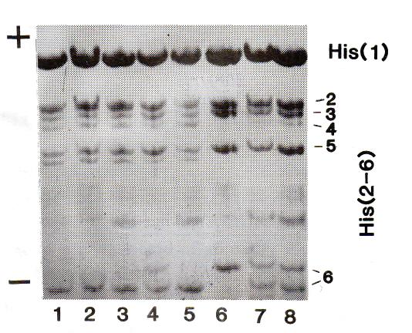
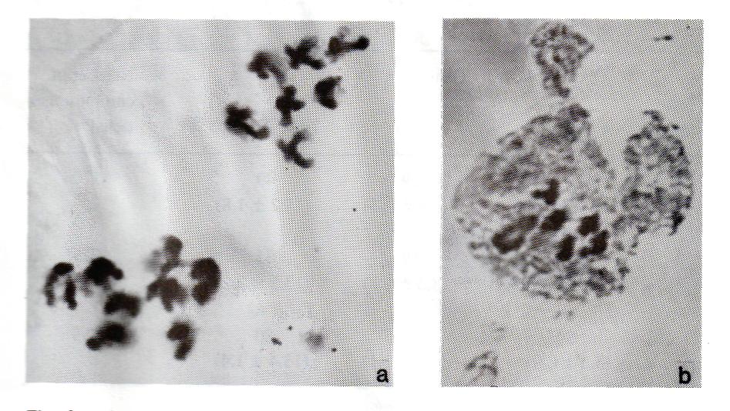
Fig. 3. Acetocarmine staining of different meiotic stages. a) Eight and seven chromosomes at anaphase I in PMC of a trisomic plant having phenotype A, Twt, H1-1133/1021/1123. b) Five bivalents and one ring of four at metaphase I in PMC of a Twt/twt plant from the cross K-3953 x Sprint-2 (Twt).
Table 1. Phenotypic distribution in the progeny from the testcrosses:
- (Twt/twt, A/a, 1021/1133) x (twt/twt, a/a, 1123/1123).
- (twt/twt, a/a, 1123/1123) x (Twt/twt, A/a, 1021/1133).
Phenotype
Morphology | H1 | Testcross 1 | Testcross 2
twt, A | 1133/1123 | 171 | 91
Twt, a | 1021/1123 | 150 | 107
twt, A | 1021/1123 | 13 | 9
Twt, a | 1133/1123 | 7 | 3
twt, a | 1021/1123 | 22 | 6
Twt, A | 1133/1123 | 7 | 13
Twt, A | 1133/1021/1123 | 21 | 7
Table 2. Total number and fraction (in parentheses) of recombinant chromosomes in relation to gene pairs A, His(2-6); A, Twt; and Twt, His(2-6).
Test-cross | Gene pairs |  |  | Number of chromosomes  tested
Test-cross | A-His(2-6) | A-Twt | Twt-His(2-6) | Number of chromosomes  tested
1 | 20 | 29 | 49 | 370
 | (5.4 ± 1.2) | (7.8 ± 1.4) | (13.2 ± 1.8)
2 | 12 | 19 | 31 | 229
 | (5.2 ± 1.5) | (8.3 ± 1.8) | (13.5 ± 2.2)
Σ 1+2 | 32 | 48 | 80 | 599
 | (5.3 ± 0.9) | (8.0 ±1.1) | (13.4 ± 1.4)

The appearance of extra chromosomes may be generated from lines heterozygous for a translocation (2). The trisomy we observed in some of the Twt plants may have arisen as a result of a translocation involving chromosome 1, with Twt residing at the point of the chromosome break. This hypothesis is in agreement with two observations. First, the pollen fertility of the heterozygous Twt/twt plants was approximately 50-70% of that of the homozygous Twt/Twt and twt/twt plants. Second, five bivalents and one ring of four chromosomes were seen at metaphase 1 in pollen mother cells of heterozygous Twt/twt plants (Fig. 3b). The data suggest that EMS can induce structural aberrations in addition to the point mutations. EMS is known to have produced deletions in maize (3). The observations also could be interpreted to indicate that the mutant trait is directly caused by the presence of reciprocal chromosome exchange. At present we cannot determine if Twt is a phenotype produced by the translocation or simply reflects an altered DNA sequence near the breakpoint. In either event, Twt represents a unique case of an easily discernible dominant Mendelian character associated with a translocation.
- Belyaev, A.I. and Berdnikov, V.A. 1981. Genetika (USSR) 17:498-504.
- Sutton, E. 1939. J. Genetics 38:459-476.
- Okagaki, R.E., Neuffer, M.G. and Wessler, S.R. 1991. Genetics 128:425-431.

