A new allele, stbs, at the St locus
Apisitwanich, S. Department of Genetics, Kasetsart University
and Bangkok, Thailand
Swiecicki, W.K. Inst. of Plant Genetics, Polish Academy of Sciences
Poznan, Poland
In 1980 at Wiatrowo, two independently induced mutant lines, Wt11301 and Wt11311, with stipules of reduced size (so called "butterfly stipules") were selected following treatment of cv. Paloma with 200r Nf + 0.014% NEU. Segregation in the M₂ families showed the recessive nature of both mutants. Reciprocal crosses between Wt11311 and Wt11301 showed the two mutations were at the same locus. The F₁ plants from reciprocal crosses between Wt11311 and Wt11288 (st = stipules reduced) had butterfly stipules and the F₂ segregated in accordance with the ratio 3 butterfly stipules : 1 reduced stipules. Thus it appeared that the trait butterfly stipules is controlled by an allele dominant to st but recessive to St (normal, wild-type stipules). We suggest symbol stbs for the intermediate allele conferring butterfly stipules. The three phenotypes are illustrated in Fig. 1.
No significant linkages were detected for chromosome 3 markers st, b and m in the F₂ of cross Wt11311 (stbs B m) x Wt11288 (st b M), but a selection with genotype stbs b M was isolated and included in the Genetics Stock Centre as Wt11323. The larger surface area of stbs stipules (instead of the strongly reduced st stipules) is sometimes useful in cases where other markers influencing stipule traits (e.g. wb, sil) are under study.
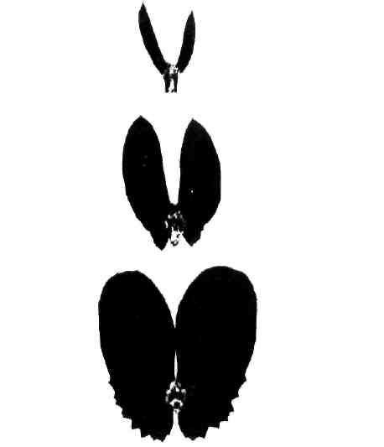
Fig. 1. The stipule phenotype conferred by alleles St (bottom), stbs (middle) and st (top). The dominance order is St > stbs > st.

