Additional mapping data for lum-2 on chromosome 3
Swiecicki, W.K. Plant Experiment Station, Wiatrowo
and B. Wolko 62100 Wagrowiec, Poland
Swiecicki (2) described mutation cases of the costata type obtained at Wiatrowo. One of them was subsequently found (3) to be controlled by a gene, lum-2, which was strongly linked with M on chromosome 3 (Cr-0% = 2). Further linkage data are now available for lum-2 with two genes close to M: uni (Cr-0% = 4; Blixt 1977) and Lap-2 (Cr-0% = 9; Weeden 1985). Unfortunately, there was no suitable tester line available for multipoint analysis and additional difficulty was caused by the sterility of uni flowers (the mutant is maintained through heterozygous lines). In the first F₂ population raised from the cross Wt15299 (lum-2 Lap-2^{s} Uni) x Wt10187 (Lum-2 Lap-2^{f} Uni/uni) segregation data were obtained only for alleles at the Lum-2 and Lap-2 loci. No uni segregates occurred (presumably no uni gametes were provided by the Wt10187 parent). The Cr-0 value for Lum-2 and Lap-2 was 17% in this cross and 15% in the F₂ of cross Wt15299 (lum-2 Lap-2^{s}) x Wt8905 (Lum-2 Lap-2^{f}) (Table 1). In a second F₂ population from cross Wt15299 x Wt10187 some families did segregate for uni. Small disturbances occurred in the monohybrid segregation but a strong deviation from independent assortment occurred for lum-2 and uni (Cr-0% = 12; Table 1). The following map is suggested based on our data and other results in the literature.
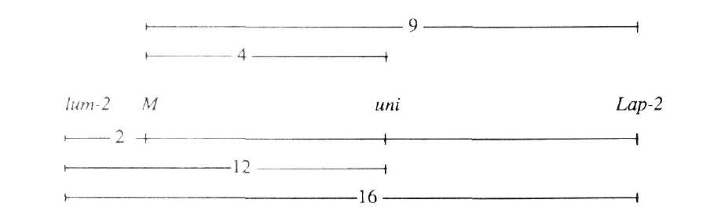
1. Blixt, S. 1977. PNL 9 Suppl.
2. Swiecicki, W.K. 1983. Hod. Rosl., Akl., Nas. 27(4): 221-276.
3. Swiecicki, W.K. 1987. PNL 19:70-71.
4. Weeden, N.F. 1985. In: The Pea Crop: A Basis for Improvement, Eds P.D.
Hebblethwaite, M.C. Heath and T.C.K. Dawkins, Butterworths, Lond. pp 55-66.
Table 1. Phenotypic distribution in an F₂ population from crosses:
1) Wt15299 (lum-2 Lap-2^{s}) x Wt10187 (Lum-2 Lap-2^{f})
2) Wt15299 (lum-2 Uni) x Wt10187 (Lum-2 Uni/uni)
3) Wt15299 (lum-2 Lap-2^{s}) x Wt8905 (Lum-2 Lap-2^{f})
A. Monohybrid segregation
Phenotype |  |  | Total |  | Chi-sq. (3:1)
1) Lum-2 | lum-2
81 | 25 |  | 106 |  | 0.11
Lap-2^{f} | Lap-2^{s}
72 | 24 |  | 96 |  | 0.00
2) Lum-2 | lum-2
244 | 53 |  | 297 |  | 8.11**
Uni | uni
202 | 95 |  | 297 |  | 7.73**
3) Lum-2 | lum-2
110 | 21 |  | 131 |  | 5.62*
Lap-2^{f} | Lap-2^{s}
102 | 28 |  | 130 |  | 0.83
B. Joint segregation of lum-2 with Lap-2 and Uni
Phenotype |  |  |  |  |  |  | Total | Joint chi-sq. | Recomb. fract. | SE | Phase
1)Lum-2 Lap-2^{f} |  | Lum-2 Lap-2^{s} |  | lum-2 Lap-2^{f} |  | lum-2 lap-2^{s}
67 |  | 10 |  | 5 |  | 14 | 96 | 29.94*** | 17.1 | 4.3 | C
2)Lum-2 Uni |  | Lum-2 uni |  | lum-2 Uni |  | lum-2 uni
149 |  | 95 |  | 53 |  | 1 | 297 | 27.84*** | 11.9 | 5.7 | R
3)Lum-2 Lap-2^{f} |  | Lum-2 Lap-2^{s} |  | lum-2 Lap-2^{f} |  | lum-2 Lap-2^{s}
97 |  | 12 |  | 5 |  | 16 | 130 | 44.26*** | 14.9 | 3.4 | C
*,**,*** P < 0.05, 0.01 and 0.001, respectively.
In segregating progenies, the phenotype designated Lap-2^{f} includes both Lap-2^{f}/Lap2^{f} and
Lap-2^{f}/Lap-2^{s} plants.

