pGENE: A PISUM GENE DATABASE
Winfield, P.J. Dept. Agric. & Fisheries, Agricultural Scientific
Services, East Craigs, Edinburgh EH12 8NJ, UK
pGene may be used to examine information on the genes of peas. Genes may be selected by chromosome, gene symbol status or form of inheritance. For each gene, the gene symbol, symbol status, and the chromosome the gene is found on is displayed along with the mode of inheritance, the mutation group and sub-group according to the scheme of Blixt (1, 3), the mutation type and a short description (Fig. 1). A more extensive description of the effect of each gene, the associated bibliography and type-lines for each gene may also be displayed. Finally, a gene list for selected genes may be produced as a text file.
pGene comes as a database and standalone program designed to be used on IBM compatible personal computers. The original database was developed by Blixt on a Wang computer as part of a larger database of the Weibullsholm Pisum collection and at the time the Pisum Gene symbol list (2, 3) was compiled. It was subsequently converted into dBase III format at the John Innes Institute in 1988. I have restructured the database and written the pGene software.
The pGene database has been produced to make the database originally developed by Stig Blixt more widely accessible in electronic form and as the starting point for an up-to-date gene list. It should be of use to anyone with access to a personal computer who is interested in having a convenient reference to the genes of peas. To use pGene an IBM compatible computer with a minimum of 512K RAM and, preferably, a hard disk is required. The database plus software requires approximately 1MB of disk space. No additional software is required to use the database.
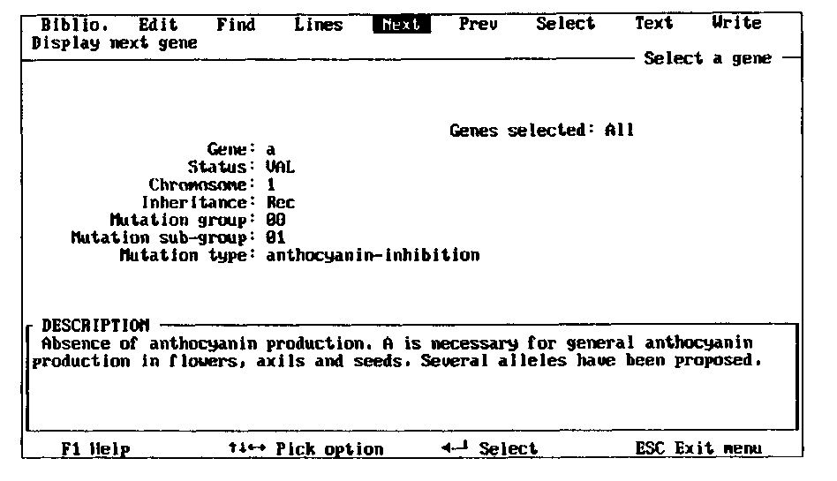
Fig. 1. Main gene interrogation screen of the pGene software.
A revised and updated version of the database is planned for release by the end of 1990.
Anyone who would like a copy of the database or further information should dontact me (see below). I am particularly interested in receiving comments or suggestions concerning the structure and content of the database at this early stage in its development.
Peter Winfield
Agricultural Scientific Services
East Craigs
EDINBURGH EH12 8NJ
Scotland, UK
Telephone 44 31 - 244 8914 (international)
Telephone 031 - 244 8914 (national)
Fax: 44 (0) 31 - 244 8940
Telex 727348 DAFASS G
- Blixt, S. 1972. Agri Hort. Genet. 30:1-293.
- Blixt, S. 1974. In Handbook of Genetics, Ed. R.C. King, Plenum Press, New York. pp. 181-221.
- Blixt, S. 1977. PNL 9 (Supplement) 1-59.

