COLLECTION OF PISUM GERMPLASM IN TURKEY IN 1985 AND 1989
Muehlbauer, F.J., W.J. Kaiser, USDA-ARS, Pullman, Washington
and Ziya Kutlu and C.R. Sperling Aegean Research Institute, Menemen
Izmir, Turkey
Expeditions in collaboration with Turkish scientists were undertaken in 1985 and 1989 to collect wild and indigenous forms of food legumes in Turkey. Major production areas for food legumes were explored in 1985 and mostly cultivated landraces of lentil end chickpea were collected. A major part of the 1985 trip was concentrated in the southeastern production area along the Euphrates River. That area is now in the process of being flooded upon completion of a series of dams on the river. As a result, production areas and villages are in the process of being relocated. Because of these changes, it was considered of primary importance that the landraces and wild species of that area be collected and preserved. The major objective of the 1989 trip was to collect wild species of Pisum, Lens, and Cicer.
While the 1985 trip to southeastern Turkey concentrated on collection of landraces, the 1989 trip concentrated on collection of wild species of Lens, Cicer and Pisum in mostly uncropped, dry and rocky habitats and adjacent small cultivated fields. The combined route taken by the collection team in 1985 and 1989 is shown in Fig. 1. The major part of the 1989 trip was centered in the provinces of Diyarbakir, Mardin and Siirt in the southeastern part of the country.
Both the 1985 and 1989 seasons were extremely dry in Turkey, a situation that made it difficult to find and collect wild species. Germination of seeds of wild species was reduced and the size of the wild plants was quite small. Also, heavy grazing by sheep and goats added to the difficulties in finding wild material. Collection of the cultivated landraces was not affected by the dry conditions. Nearly all of the Pisum collections made were P. sativum ssp elatius in 1985, while most of the collections made in 1989 were P. sativum ssp humile (Table 1).
The wild pea collections were made mostly in fields that were planted to either lentil or chickpea. In those fields, wild pea was a weedy contaminant and they were generally mature and often had dehisced their seeds. Other areas where wild pea was found included the rocky borders of cultivated fields and rocky, noncropped areas. The noncropped areas were generally overgrazed, but often wild material could be found in niches where grazing by animals was difficult, e.g. areas with numerous large rocks and under brushy perennials.
The material is currently being increased and will be added to the National Plant Germplasm Systems Pisum collection maintained at the Regional Plant Introduction Station at Geneva, New York. We plan to evaluate the material for possible use as parents in the dry pea breeding program. According to N.F. Weeden (personal communication), additional accessions from Turkey have consistently yielded previously unavailable isozyme polymorphisms indicating that additional genetic variation can still be found there. We plan to survey the material for previously unavailable isozyme polymorphisms, and to evaluate the material for resistance to disease prevalent in our area including root rot, wilt, powdery mildew and certain viruses. Small samples of the material collected will be available on request after seed increase.
Table 1. Accessions of wild and cultivated Pisum collected in Turkey in 1985 and 1989
Field collection number | Species | Wild/ Cult. | Elevation | Province where collected
1985:
290685-01 | P. sativum ssp. elatius | wild | 430 m | Denizli
270685-0105 | P. sativum ssp. elatius | wild | 790 m | Mersin
010785-01 | P. sativum ssp. humile | wild | 800 m | Gaziantys
240785-13 | P. sativum ssp. elatius | wild | 930 m | Denizli
230785-07 | P. sativum ssp. elatius | wild | 1100 m | Afyon
190785-0105 | P. sativum ssp. elatius | wild | 750 m | Tokat
Qf0785-03 | P. sativum ssp. humile | wild | 1250 m | Diyarbakir
050785-0109 | P. sativum ssp. elatius | wild | 380 m | lldiyaman
190785-02 | P. sativum ssp. arvense | cult. | 900 m | Tokat
040785-0302 | P. sativum ssp. arvense | cult. | 540 m | Urfa
1989:
010689-0201 | P. sativum ssp. elatius | wild | 1270 m | Elazig
050689-0302 | P. sativum ssp. humile | wild | 1050 m | Mardin
060689-0107 | P. sativum ssp. humile | wild | 1060 m | Mardin
070689-0202 | P. sativum ssp. humile | wild | 770 m | Mardin
080689-0403 | P. sativum ssp. humile | wild | 1050 m | Mardin
11068S-0105 | P. sativum ssp. humile | wild | 1100 m | Siirt
110689-0302 | P. sativum ssp. humile | wild | 1040 m | Siirt
120689-0202 | P. sativum ssp. humile | wild | 630 m | Siirt
140689-0102 | P. sativum ssp. humile | wild | 920 m | Diyarbakir

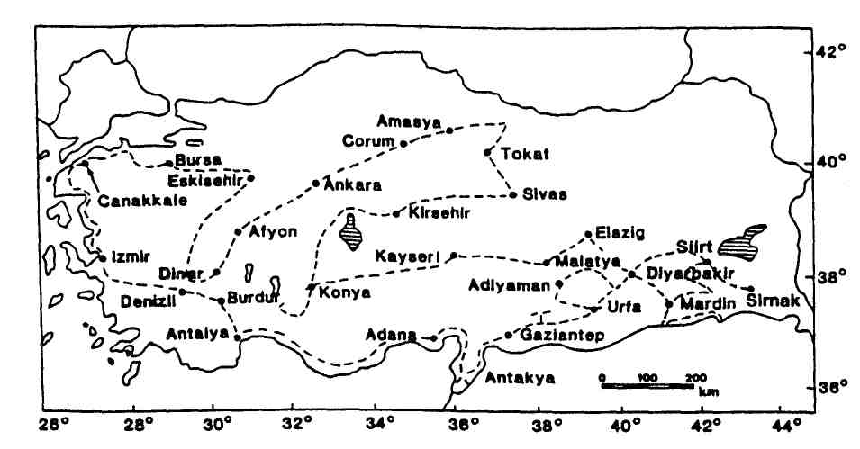
Fig. 1. Route taken by the collection team in Turkey (1985 and 1989 routes combined).

