FLOWERING GENES IN PEA AND THEIR USE IN BREEDING
Murfet, Ian C. Department of Plant Science, University of Tasmania
Hobart, Tasmania 7001 , Australia
At least eight major flowering genes have now been identified in pea which influence the onset of flowering while a nineth gene causes rapid termination of flowering. Some of these genes also influence other aspects of growth and development. In addition, several quantitative systems are known to influence flowering. What follows is a brief description of these flowering genes and their relevance to breeding strategies.
The Lf locus
Lf, (late flowering) was the first major flowering locus identified in pea (7, 45) and the first reported case of a clear segregation for flowering node (41) was almost certainly attributable to segregation at this locus (23). The Lf locus is on chromosome 1 about 10 units from A, the basic locus for anthocyanin production (7, 16, 19). Four naturally occurring alleles have been identified and symbolized Lf^{d}, Lf, lf and lfª (16,1 9; see cover photo). The Lf locus is relatively susceptible to mutation and the great majority of induced flowering mutants in pea, including those symbolised efr, no and pra, have been traced to this locus (21, 23). The Lf alleles appear to operate in the shoot apex where they confer different degrees of sensitivity to the flowering signal (17). An Lf^{d} apex requires the strongest signal with descending order through Lf and lf to lfª. The Lf locus is of great practical significance because the alleles at this locus determine the minimum length of the vegetative period; the minimum node of flower initiation (counting from the first scale leaf as node 1) ranges from 15 for Lf^{d}, through 11 for Lf, 8 for lf to 5 for lfª (21, 23).
The Sn Dne system
The loci Sn (sterile nodes; 1,16) and Dne (day neutral; 8) should be considered together because the two dominant alleles Sn and Dne act in a complementary manner to confer the ability to respond to photoperiod (Figs 1, 3). [Note. The symbol Sn was introduced by Tedin and Tedin (41) but the segregation they described is now attributed to the Lf locus (23)]. These two genes operate in the shoot and cotyledons, and they are believed to control steps in the biosynthesis of a substance which functions as a graft-transmissible flower inhibitor (8, 17, 30, 34). The respective mutant alleles, sn and dne, confer day neutrality by blocking synthesis of inhibitor but dne is undoubtedly leaky since genotype Lf^{d} Sn dne Hr is now known to be very late flowering and strongly photoperiodic (27). The Sn locus is on chromosome 2 close to the amylase locus Amy-1 (44) while Dne is located 5 units from st (reduced stipules) on chromosome 3 (8, 24). Activity of the Sn Dne system is reduced by long days and low temperatures (1, 31). The Sn Dne product is proposed to direct assimilate flow (23, 38) and Sn Dne activity has widespread effects on basal branching (increased), number of flowers per inflorescence (increased), peduncle length (increased), flower life span (increased), flower and fruit development (slowed), duration of the reproductive period (increased), maturity date (delayed) and yield (increased) (3, 15, 22, 23, 29, 32). The loci Sn and Dne are of major practical importance.
Loci E and Hr
The genes E (early; 15) and Hr (high response; 18) both modify activity of the Sn Dne system but at different stages of ontogeny. Gene E operates in the cotyledons to reduce Sn Dne activity in the early stages of seedling growth (17). Thus genotype lf E Sn Dne may initiate flower buds as early as node 9 or 10 although in short days subsequent development of these buds may be retarded or suppressed due to Sn Dne activity in the shoot (15, 23). Gene Hr acts later in the life cycle to prolong Sn Dne activity and genotypes with the combination Sn Dne Hr show a very large response to photoperiod which is manifest in short days either as a very prolonged reproductive phase in early photoperiodic types [e.g. Marx G2 response type (10, 29; Fig. 2)] or a very prolonged vegetative phase in late photoperiodic types (18, 29). Hr is located about 7 units from M (marbled testa) on chromosome 3 (18, 25) and E_ is on chromosome 6 (16). Gene E is difficult to work with since it is hypostatic to Lf^{d}, Lf, sn and dne, and dominance of E can be reversed in some backgrounds (21). E and Hr are of practical value.
The Veg locus
Plants homozygous for the mutant allele veg (vegetative; 4) do not flower under any environmental or genetic circumstances (38). The veg mutation appears to act in the shoot apex to block some step in the process leading to flower initiation (38). veg has no practical value.
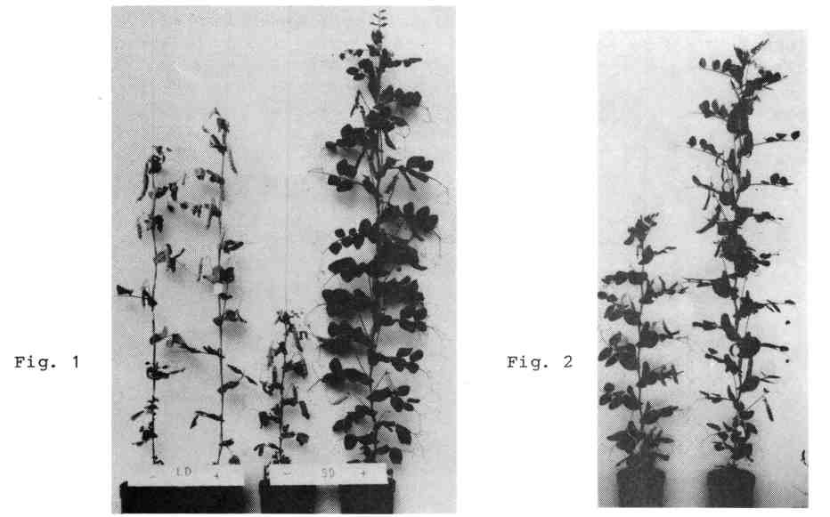
Fig. 1. Gene Sn (with Dne) confers the ability to respond to photoperiod and while the two near isolines 299– (sn) and 299⁺ (Sn) are not distinguishable under long days (left: 24 h = 8 h daylight + 16 h incandescent light), they are easily distinguishable under short days (right: 8 h daylight + 16 h dark) by the prolongation of the reproductive phase in the Sn line. With background lf E Dne hr the node of flower initiation is early and unaffected by photoperiod. These plants (left to right) flowered at nodes 10, 11, 10 and 10. A marked increase in internode length occurs in most pea lines in response to a daylength extension with incandescent light (26).
Fig. 2. Lines 60 (left, lf E Sn Dne hr) and 102 (right, lf E Sn Dne Hr) under a 14 h photoperiod. Hr has prolonged Sn Dne activity and extended the reproductive phase in line 102 which was still growing at this stage (79 days from sowing). Both lines commenced flowering about the same node (10 and 11, respectively).
The Dm locus
Plants homozygous for dm (diminutive; 27) show a 2-fold to indefinite flowering delay depending on the genotype for the other flowering genes, internode length is reduced by 50-65%, leaf size is reduced 40-50% and the flowers are female sterile (27). The mode of action of dm and the chromosomal location are not presently known. dm has no practical value.
The Gi locus
The recessive allele gi (gigas; 27) is responsible for the gigas habit of mutant III/83 obtained by Dr M. Vassileva from cultivar Virtus. Gigas plants usually flower much later than the initial line; they may produce over 130 vegetative nodes in 8 h short days (night temperature 16°C) and remain vegetative indefinitely in some circumstances (27; Fig. 3). Recent studies (C.A. Beveridge and I.C. Murfet, unpub.) indicate that the gi allele may block synthesis of a floral stimulus, that the progenitor can supply the mutant with the missing substance across a graft union, and that a 3-4 week period of vernalization at 3°C will largely remove the flowering difference between the mutant and its progenitor. These studies also show that gi is expressed in both late photoperiodic (e.g. cultivar Virtus) and early day neutral (e.g. lf sn) backgrounds. The gi allele destabilises flowering and appears to have no practical value.
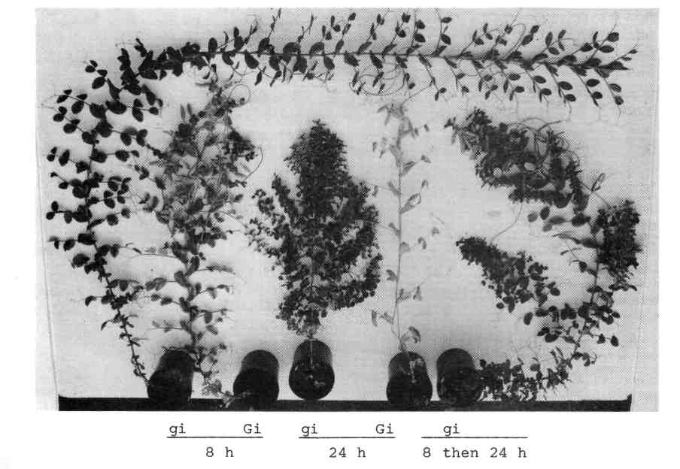
Fig. 3. The gi mutant (plants 1, 3 and 5 from left) and its progenitor, cv Virtus (plants 2 and 4). Plants 1 (laterals regularly excised) and 2, were grown under an 8 h photoperiod and plants 3 and 4 under a 24 h photoperiod (8 h daylight + 16 h incandescent light); plant 5 was transferred from 8 to 24 h when it had 27 leaves expanded. Virtus plants 2 and 4 flowered at nodes 23 and 16, respectively, showing the reaction typical of a late photoperiodic line (Lf Sn Dne hr). Mutant plants 1 and 3 eventually died without flowering after producing 104 and 64 leaves, respectively. Mutant plant 5 flowered transiently at nodes 43-45 before reverting to the vegetative state.
The fds locus
Gottschalk (5, 6) reported that the recessive mutant allele fds (flower development suppressor} was responsible for the failure of the flower buds to develop in several of his lines, e.g. R20E. In recent studies I have been unable to obtain unequivocal evidence for fds. Nevertheless, flower bud development is strongly suppressed in R20E and the results are consistent with the hypothesis that the trait is monogenic recessive and is only expressed in a clear manner under short day conditions and in plants which are both fasciated (fa) and photoperiodic (Sn Dne). The fds locus appears to be on chromosome 4 since fds showed linkage, as well as gene interaction, with fa. Work is continuing on this trait which has no obvious practical merit.
The det locus
The recessive allele det (determinate) causes the shoot to cease growth after the formation of a small number of reproductive nodes (9, 14, 28, 35, 40; Fig. 4). The mutant plants are not determinate in the botanical sense since the "terminal" flower arises from an axillary meristem rather than the apical meristem which simply ceases to grow (39). The det allele does not appear to influence the node of flower initiation but, through correlative effects on the rate of flower bud development, it can reduce significantly the time to first open flower (28). Expression of det is influenced by the genotype at the Lf locus: Lf det shoots produce no more than two inflorescences subtended by a normal leaf but lfª det shoots (which flower as early as node 5) produce up to six inflorescences subtended by a normal leaf before terminating (28). The det locus shows linkage with r (14, 40) and is on chromosome 5 according to the most recent map (44). The det allele may prove of practical value (14, 28).
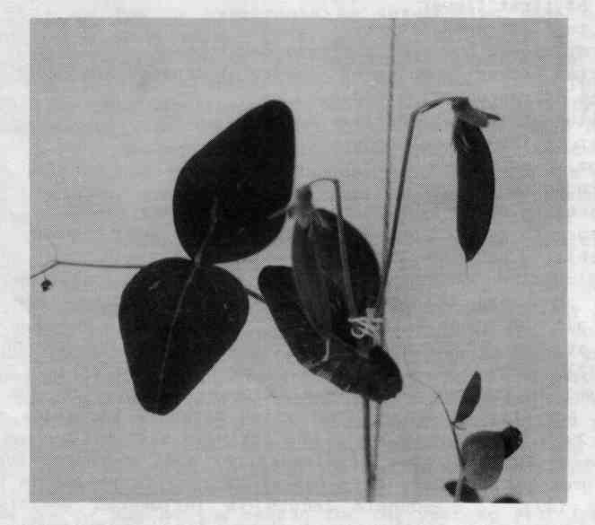
Fig. 4. Top of an Lf sn det plant. The "terminal" pod is supported by a peduncle offset from the vertical which betrays the fact (39) that the inflorescence arises from a lateral meristem.
Quantitative systems
Some major genes for other traits have quantitative effects on flowering. For example, tall (Le) plants tend to produce open flowers before dwarf (le) counterparts flowering at the same node (13) because the rate of leaf appearance is faster in tall plants (33). Polygenic systems have been shown by several authors to contribute to variation within different flowering classes (1, 12, 16, 19, 23). For example, I have been able to select pure lines with the same major flowering genes (Lf sn) which flower on average some 4-5 nodes apart. Polygenes may also contribute to between—class variation, e.g. by modifying the penetrance of Sn (20, 37) or the dominance of E (21).
Flowering genes and breeding strategy
All the major flowering genes are useful for the insight which they may provide into the control of the flowering process. However, Lf, E, Sn, Dne and Hr are of particular practical interest to the plant breeder since various combinations of these genes may be used to obtain a range of cultivars with a diversity of flowering habits. These major genes determine the several response classes described by Marx (10) and Murfet (15), while quantitative systems may be used to fine tune within the classes (12, 20, 23). Identification of these major genes has been assisted greatly by the use of controlled environment facilities, e.g. the effect of Sn is maximised by the use of short days and mild (16°C) night temperatures (1, 15). Nevertheless, these genes do exert significant effects in the field (22). Moreover, a knowledge of the way these genes interact among themselves and with the environment, and of the diversity of effects which certain genes and gene combinations have on various aspects of growth and development, undoubtedly places the breeder in a more informed position to pursue particular breeding strategies and objectives.
Traits of importance to the breeder include the following:-
a) node of first flower
b) time to first open flower
c) rate of flower bud, pod and seed development
d) interval between opening of flowers at consecutive nodes
e) number of reproductive nodes
f) duration of the reproductive phase
g) number of flowers per node
h) peduncle length
i) internode length
j) tendency to produce basal laterals (secondary stetts)
k) tendency to produce aerial laterals at the upper nodes
l) variability and stability of flowering behaviour.
The flowering genes Lf, E, Sn, Dne and Hr all influence traits a) and b). However, in various ways and combinations they can also influence all the other traits listed. Trait c) is influenced by the genotype at the Lf locus and by activity of the Sn Dne system (3, 15, 23, 32). Trait d) is influenced by the Lf locus: in lfª plants the interval is reduced and several flowers may open on the same day (3, 23). Activity of the Sn Dne system markedly increases e) and f) (15, 22, 23, 29, 36; Figs 1,2). Sn Dne activity also influences trait g) and in one cross the number of flowers per node increased from 1-2 in sn Dne segregates, to 2-3 in Sn Dne hr segregates to 2-5 in _Sn Dne Hr segregates (23) Peduncle length is influenced greatly by the flowering genotype. On the same background peduncle length decreases in the sequence lfª, lf, Lf to Lf^{d}: it is generally least in genotype Lf^{d} sn and greatest in genotype lfª Sn Dne (23). Internode length is generally somewhat less in Sn than sn plants with a comparable background (1, 26) and in the upper section of Lf^{d} plants the internodes may become very short leading to clumping of the reproductive nodes (23, 32). Sn Dne activity promotes basal branching, and secondary stems are more common in photoperiodic types, than day neutral types (2, 32). On the other hand, late day neutral types, such as Lf^{d} sn, show a profuse outgrowth of aerial laterals (23, 32; cover photo).
Consistency of flowering behaviour is a trait of considerable practical importance. Lines may be subdivided broadly into three categories in regard to the variability and stability Of their flowering behaviour:-
1) Inert - flowering node much the same from year to year and site to site.
2) Site responsive - flowering node varies widely between sites but is fairly consistent at one site when the plants are sown about the same time each year.
3) Erratic - flowering node inconsistent, behaviour erratic, off types produced, unusually wide variation in a single crop.
The first group is typified by lines whidh are largely insensitive to environmental factors, e.g. genotypes sn and dne (excluding Lf^{d} sn dne Hr) usually fall into this category, especially the early day neutral types; later flowering types such as Lf^{d} sn may show small (2-3 node) responses to photoperiod and vernalisation.
The second group contains lines which show marked responses to photoperiod and temperature, e.g. a midseason or late photoperiodic type like Lf Sn Dne hr developed for spring sowing at latitudes 42-46°N may flower one or two nodes earlier when sown in a cold spring but it will almost certainly perform very differently if grown under short photoperiods such as in winter in southern California or in low latitude regions such as Central America.
The third group constitutes a problem for breeders and growers. Genotype lf e Sn Dne hr represents an interesting case of a type showing this kind of behaviour (15). With combination e Sn Dne the plant has the potential for a late habit but flowering is triggered relatively easily in an lf apex. As a consequence it is possible to breed lines with this genotype which behave as stable late types under certain conditions, e.g. they flower around node 25 under 8 h short days with 16-17°C nights but which flower as early as node 10 if exposed to cold nights (3-5°C). Moreover, by shifting the polygenic background flowering can be de-stabilised to the point where many of the plants will flower at a low node (12-14) even under warm 8 h conditions. For example, in one study under these conditions (37) about half the plants of Hobart line 61a (lf e Sn Dne hr) commenced flowering at nodes 12-16 and half at nodes 21-27, i.e., they segregated into two distinct classes even though the line is genetically pure. I do not have data on the performance of lf e Sn Dne hr lines under field conditions but predict that at sites in Washington or Idaho such lines may well flower over the range of nodes 11 to 16 with the percentage of 11 and 12 node plants increasing following a cold spring or, depending on the remaining genetic background, these 11-12 node plants may occur only sporadically or in cold years. The temperature during the first three weeks after sowing would be of crucial importance in determining the pattern and distribution of the node of first flower. A genotype of lf e Sn Dne hr may be the reason for the year to year instability encountered in some material.
The presence of Lf in combination with Sn Dne tends to stabilise late flowering, possibly by raising the apical threshold so that the level of the flowering signal is less likely to intersect thethreshold during the early stages of seedling growth (17, 20). Nevertheless some late photoperiodic Lf lines do display erratic behaviour. In some cases this may result from the presence of gene E (Lf E Sn Dne) which is thought to cause an increase in the strength of the flowering signal in the young seedling stage (17). Alternatively, since most induced flowering mutations have occurred at the Lf locus (21, 23), it is quite likely that more Lf alleles occur in nature than the four currently symbolised, i.e. Lf^{d}, Lf, lf, lfª (19). Thus alleles at this locus imposing slightly lower thresholds than the standard Lf allele (type line Hobart line 65E = WL2687, reference line Hobart line 24) would tend to decrease stability in late lines. It is difficult to distinguish between two such alleles with fairly similar strength using conventional genetic techniques and resolution of this question must await the use of molecular techniques. Nevertheless, there is already evidence that some of the induced Lf mutations are not identical to lf or lfª (21). Finally, the polygenic background certainly influences stability in genotype lf e Sn Dne (see 37) and such systems are likely also to have some effect in Lf Sn Dne plants. Marx (12) reported the occurrence of impenetrant late types among the progeny of a cross between two established late cultivars, Telephone and Lincoln. I suspect both these cultivars have genotype Lf Sn Dne. Of course, it is also possible by recombination to obtain pure breedinc early photoperiodic lines from a cross between two late lines e.g. a pure lf E Sn Dne hr line can be obtained from cross Lf E Sn Dne hr x lf e Sn Dne hr.
Other genotypes showing unstable flowering behaviour include lf e Sn Dne Hr and lf e sn Dne Hr. These genotypes sometimes produce plants flowering much earlier or later, respectively, than the majority of plants in the sample (18, 29).
The fact that a single gene change in the flowering genotype can result in effects on a whole range of traits suggests there is also a common physiological link underlying the control of these several traits. Hence selection for one of the traits could have concommitent effects on related traits if the genes under selection act via the common pathway. For example, there is a positive correlation between the distance (nodes) the first flower opens below the apical bud, the number of reproductive nodes and peduncle length (27, 29). Thus selection for more reproductive nodes may lead to an unwanted increase in peduncle length. However, if the genes under selection operate after the branch point in the pathway or operate via different pathways or mechamisms, the link between the traits can likely be broken.
The five loci Lf, E, Sn, Dne and Hr alone generate 64 pure genotypes (Lf has four alleles). In the two following paragraphs I have described the salient features and properties of a sample of these genotypes, starting with the day neutral types and concluding with the photoperiodic types.
If a cultivar is required with a short vegetative and reproductive phase, a consistent node of first flower regardless of daylength and temperature, and a growth habit largely devoid of basal and aerial laterals, then genotype lf sn Dne hr meets those criteria. Many important early cultivars, e.g. Alaska, Meteor, Massey and Sparkle, have this genotype. Switching lfª for lf will lower the flowering node from around 9-11 to 5-7 and introduce a tendency to simultaneos opening of the first few flowers (11, 23). However, the flowers in such plants may be too close to the ground and born on long peduncles subject to collapse. Using the higher order alleles Lf or Lf^{d} in the same background (sn Dne hr) will delay flowering by several nodes while retaining insensitivity to daylength, decrease peduncle length, and increase the production of aerial laterals (23, 32). Profuse growth of aerial laterals may have undesirable consequences in a crop situation and I have never found a commercial cultivar with such a genotype. Because mutant dne is leaky, genotype lf Sn dne hr offers the prospect of producing a cultivar fairly similar to common early types (lf sn Dne hr) but with a slightly longer reproductive phase and greater yield per plant (27). To my knowledge the dne allele is not present in wild populations or existing cultivars [it was induced by EMS (42)] and it offers scope for exploitation.
The Sn Dne combination confers the potential for a large yield per plant since Sn Dne activity increases the tendency to produce basal laterals (secondary stems), the number of flowers per inflorescence and the length of the reproductive phase. It also confers a marked response to daylength and temperature. For example, genotypes Lf Sn Dne Hr or Lf^{d} Sn Dne Hr would be expected to take too long to flower in regions where the photoperiod is short throughout the growing season. The Sn Dne system perceives up to 14 h as a short photoperiod and some Sn Dne activity is still detectable at photoperiods of 18-20 h (31). Such genotypes are more suited to temperate regions in high latitudes. With genotype lf E Sn Dne Hr the plant will flower at a low node (10-13) even in short days but the reproductive phase will be very extended unless the photoperiod is in excess of about 16-17 h. Such cultivars direct considerable resources into leaf and stem growth as well as fruit and seed development and they may be more suited to green crop, forage, and silage. Substitution of hr for Hr moderates the size of the photoperiod response and many well known late photoperiodic cultivars have genotype Lf Sn Dne hr, e.g. Torsdag, Parvus, Porta, and Greenfeast. Genotype lf e Sn Dne hr is also a late photoperiodic type at temperatures above about 16°C but, as explained previously, cool night temperatures in the field may cause early flowering since the lf apex is easily triggered and flowering behaviour can be erratic. A stable early photoperiodic type results with genotype lf E Sn Dne hr (e.g. Fig. 1) but peduncle length may be excessive in vigorous plants.
The det mutant offers an opportunity to restructure the reproductive architecture of the plant by forcing growth into a limited number of pods. However, in Lf det plants growth of the mainshoot terminates so rapidly that the resulting crop of seeds is insufficient to trigger monocarpic senescence. Hence further shoot growth occurs from lateral buds and a further cropping phase ensues. The late Dr G.A. Marx had succeeded in increasing the number of pods on the mainshoot of det plants by incorporating the multiple pod habit but if is not yet clear whether that approach can lift the primary seed crop to the point where secondary cropping does not occur. In lfª det plants early flowering and delayed termination of shoot growth lead to a situation where normal monocarpic senescence occurs after a single fruiting cycle (28). Whether or not det can be used to practical advantage is a question which can only be answered by further investigation.
- Barber, H.N. 1959. Heredity 13:33-60.
- Doroshenko, A.V. and V.I. Rasumov. 1923. Trudy Prikl. Bot. Genet. Sel. 22:219-276.
- Duchene, C. 1984. M.Sc. thesis, Univ. of Tas.
- Gottschalk, W. 1979. PNL 11:10.
- Gottschalk, W. 1982. Biol. Zbl. 101:249-260.
- Gottschalk, W. 1988. Theor. Appl. Genet. 75:344-349.
- Hoshino, Y. 1915. J. Coll. Agric. Hokkaido Imp. Univ. 6:229-288.
- King, W.M. and I.C. Murfet. 1985. Ann. Bot. 56:835-846.
- Makasheva, R. Kh. and A.M. Drozd. 1987. PNL 19:31.
- Marx, G.A. 1968. BioScience 18:505-506.
- Marx, G.A. 1972. PNL 4:28-29.
- Marx, G.A. 1975. PNL 7:26-27.
- Marx, G.A. 1975. PNL 7:30-31.
- Marx, G.A. 1986. PNL 18:45-48.
- Murfet, I.C. 1971. Heredity 26:243-257.
- Murfet, I.C. 1971. Heredity 27:93-110.
- Murfet, I.C. 1971. Aust. J. Biol. Sci. 24:1089-1101.
- Murfet, I.C. 1973. Heredity 31:157-164.
- Murfet, I.C. 1975. Heredity 35:85-98.
- Murfet, I.C. 1977. In The Physiology of the Garden Pea, Eds J.F. Sutcliffe and J.S. Pate, Academic Press, London, pp 385-430.
- Murfet, I.C. 1978. PNL 10:48-52.
- Murfet, I.C. 1982. Crop Sci. 22:923-26.
- Murfet, I.C. 1985. In Handbook of Flowering, Ed. A.H. Halevy, Vol. IV, CRC Press, Boca Raton, Florida, pp 97-126.
- Murfet, I.C. 1987. PNL 19:45.
- Murfet, I.C. 1988. PNL 20:29.
- Murfet, I.C. 1988. Ann. Bot. 61:331-345.
- Murfet, I.C. 1989. In Plant Reproduction: From Floral Induction to Pollination, Eds E.M. Lord and G. Bernier, American Society of Plant Physiologists, Rockville, Maryland, pp 11-18.
- Murfet, I.C. 1989. PNL 21:44-47.
- Murfet, I.C. and S.C. Cayzer. 1989. PNL 21:37-40.
- Murfet, I.C. and J.B. Reid. 1973. Aust. J. Biol. Sci. 26:675-677.
- Murfet, I.C. and J.B. Reid. 1974. Z. Pflanzenphysiol. 71:323-331.
- Murfet, I.C. and J.B. Reid. 1985. In The Pea Crop: A Basis for Improvement, Eds P.D. Hebblethwaite, M.C. Heath and T.C.K. Dawkins, Butterworths, London, pp 67-80.
- Murfet, I.C. and J.B. Reid. 1987. J. Plant Physiol. 127:23-29.
- Paton, D.M. and H.N. Barber. 1955. Aust. J. Biol. Sci. 8:231-240.
- Popova, I.A. 1975. Trudy po selektsii i semenovodstvu ovoshchnykh kultur VNIISSOC 3:66-72.
- Reid, J.B. 1980 Ann. Bot. 45:195-201.
- Reid, J.B. and I.C. Murfet. 1980. Ann. Bot. 45:583-586.
- Reid, J.B. and I.C. Murfet. 1984. Ann. Bot. 53:369-382.
- Singer, S.R., L.P. Hsiung and S.C. Huber. 1991. Amer. J. Bot. 77:1330-1335.
- Swiecicki, W.K. 1987. PNL 19:72-73.
- Tedin, H. and 0. Tedin. 1923. Hereditas 4:351-362.
- Uzhintseva, L.P. and K.K. Sidorova. 1979. Genetika 15:1076-1082.
- Weeden, N.F., B.E. Kneen and I.C. Murfet. 1988. PNL 20:49-51.
- Weeden, N.F. and B. Wolko. 1990. In Genetic Maps, Ed. S. O'Brien, Cold Spring Harbor, pp 6106-6112.
- White, O.E. 1917. Proc. Amer. Phil. Soc. 56:487-589.

