A LEGHEMOGLOBIN GENE CLUSTER IS LOCATED NEAR D ON CHROMOSOME 1
Weeden, N.F. Dept. of Horticultural Sciences, NYSAES
Geneva, NY 14456, USA
Leghemoglobin, an important protein in root nodule biochemistry, is coded by a small gene family in soybean (3). In spite of the considerable work on genes involved in the control of nodulation in pea (2), the location and distribution of leghemoglobin genes in this species has yet to be established. Here I present evidence demonstrating that the majority of the leghemoglobin sequences in the pea genome are clustered on chromosome 1 close to D.
The plasmid pALB, containing a 400 bp insert of a leghemoglobin sequence from alfalfa (1), was used for Southern hybridization analysis to reveal restriction fragment length polymorphisms (RFLPs) for pea leghemoglobin sequences. The parents of the cross were pea lines JI1794 and Slow. JII794 is a P. sativum ssp humile accession which when crossed with the Slow tester line gave highly fertile F₁ and F₂ progeny. Young leaflets collected from 3-10 F₃ individuals all derived from a single F₂ plant were bulked and total cellular DNA was extracted by a slight modification of the procedure of Murray and Thompson (4). This procedure was performed on F₃ progeny of each F₂ plant so that the DNA samples reflected the F₂ genotypes. A 10 μg aliquot of each DNA sample was digested to completion with EcoRV, electrophoresed on 0.9% agarose, and blotted onto GeneScreen Plus nylon membranes using the alkaline transfer method of Reed and Mann (5). Southern hybridization conditions were 2 h prehybridization and 16 h hybridization (both in 0.5 M phosphate containing 10X Denhardts solution, 1 mM EDTA, 0.1 mg/ml sonicated calf thymus DNA, 0.6% SDS, and 2.5% dextran sulfate) at 65ºC. She leghemoglobin insert was oligolabeled with ³²P dATP. Membranes were washed three times for 30 min in 2XSSC at 65°C.
The segregation of DNA sequences hybridizing to the pALB insert is shown in Fig. 1. Dense bands indicating multiple copies of the sequence per genome, can be seen in the 18-23 kb region. The Slow line displayed an intense band at 22 kb, whereas JI1794 showed nothing at 22 kb but had an intense 18 kb band (Fig. 1). These bands segregated as if they were alleles at a single locus, giving a ratio in the F₂ not differing significantly from 1:2:1. In addition, several other smaller fragments (e.g. the 2.4 kb band in Fig. 1) co-segregated with these bands, although the 2.0 and 2.9 kb bands showed a different segregation pattern. The number, size and intensity of the co-segregating DNA fragments indicated that most of the leghemoglobin sequences were clustered.
Table 1. Joint segregation analysis of D, Idh and Lghb-1
Locus | N | No. of progeny with designated phenotype* |  |  |  |  |  |  |  |  | χ² | Rec. frac. | SE
Locus | N | 1/1 | 1/H | 1/2 | H/1 | H/H | H/2 | 2/1 | 2/H | 2/2 | χ² | Rec. frac. | SE
Idh/D | 44 | 5 | 1 | 0 | 2 | 20 | 3 | 0 | 1 | 12 | 49.2 | 8 | 3
Idh/Lghb-1 | 35 | 5 | 0 | 0 | 3 | 11 | 5 | 0 | 2 | 9 | 28.8 | 15 | 5
D/Lghb-1 | 35 | 5 | 1 | 0 | 3 | 10 | 2 | 0 | 2 | 12 | 31.4 | 12 | 4
* Phenotypic designations: 1 = Slow, H = heterozygous, 2 = JI1794.
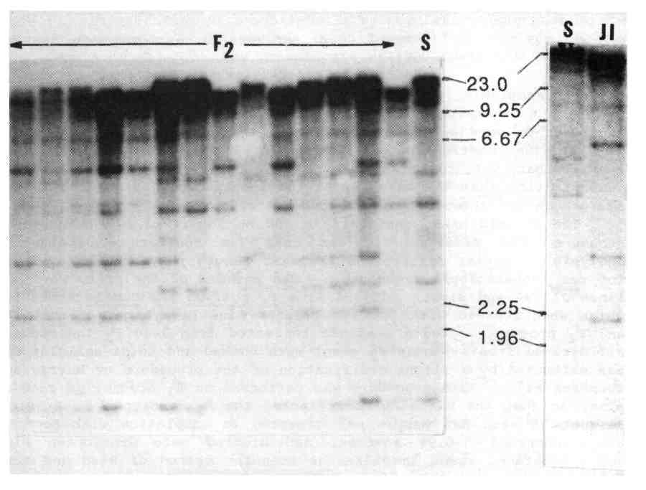
Fig. 1. Autoradiograms showing EcoRV segments of pea genomic DNA hybridizing to the 400 bp alfalfa leghemoglobin insert of pALB. DNA from 3-10 F₃ plants representing individual F₂ plants as well as the Slow parent are shown in the left photo. Parental DNAs were also run side-by-side on a separate gel (the two lanes on the right of the figure). The molecular weight markers can be used to compare patterns on the two gels.
Approximately 70 other single gene markers were segregating in this F₂ population, permitting linkage tests to be made with markers on each arm of all seven chromosomes. The major cluster of leghemoglobin genes, Lghb-1, exhibited linkage only with D and Idh on chromosome 1 (Table 1). The relative recombination values place Lghb-1 on the opposite side of D from Idh. This location is very close to that of Sym-2, the locus controlling strain-specific nodulation in certain pea lines from Afghanistan (2, 6). The author thanks Dr. K. Dunn for her generous gift of the pALB clone.
- Dunn, K., et al. 1988. Molec. Plant-Microbe Interactions 1:66-74.
- Kneen, B.E., T.A. LaRue and N.F. Weeden. 1984. PNL 16:31-34.
- Lee, J.S., G.G. Brown and D.P.S. Verma. 1983. Nucl. Acids Res. 11:5541-5553.
- Murray, M.G. and W.F. Thompson. 1980. Nucl. Acids Res. 8:4321-4326.
- Reed, K.C. and D.A. Mann. 1983. Nucl. Acids Res. 13:7207-7221.
- Young, J.P.W. 1985. J. Hered. 76:207-208.

