LOCUS FOR THE GENE def (DEVELOPMENT FUNICULUS)
Swiecicki, W.K. Plant Breeding Station, Wiatrowo
and B. Wolko 62-100 Wagrowiec, Poland
In 1966 Rozental (3) selected a spontaneous mutation, seeds of which were characterized by a strong connection of the funiculus with the hilum (Fig.1). The original test cross was carried out by Khangildin and Khangildin (2) who found monogenic, recessive inheritance and proposed the name development funiculus for the character and the symbol def for the gene. No information on the chromosomal location of the def locus has been found in the literature.
In 1984-88 linkage studies for the gene def were carried out at Wiatrowo. A line with this gene (Wt11900) was obtained from VIR/ Leningrad collection. Eleven testerlines with morphological and isozymic markers on different Pisum chromosomes were chosen from the Wiatrowo gene bank. The thirteen enzyme systems investigated allowed us to observe the segregation of 19 isozyme markers. Results for dihybrid segregation were analysed using a 2 x 2 contingency table to calculate the joint segregation chi-squared (to detect linkage) and the product-ratio method to calculate the recombination fraction.
F₂ generations were analyzed beginning with cross populations with the biggest number of markers for "strategic" loci for different chromosomes, followed by populations with morphological markers for individual chromosomes as well as isozymic markers. No substantial deviations from dihybrid segregation were observed for def with any of the morphological markers. Thus def is not located in any of the well known chromosome regions which probably explains why the def locus was not found for over twenty years from first identification of the gene.
Isozymic markers provided the chance to investigate less known or completely unknown chromosomal regions and significant deviations from normal dihybrid segregation were revealed for Def with Aldo and Gal-2. (Table 1). These results indicate def is located on chromosome 2 (2). From the dihybrid data for these genes with chi-5 (Table 1), one can assume that the segment Aldo Def Gal-2 is located clearly further than chi-5 (1).
The most recent studies of Weeden and Wolko (6) as well as Swiecicki (4) suggest serious changes in the Lamprecht version of the Pisum linkage map. For example, it is now proposed that the "upper" segment of chromosome 2 (from the oh locus) is located on chromosome 7. Thus on the new map the locus for def is on chromosome 7.
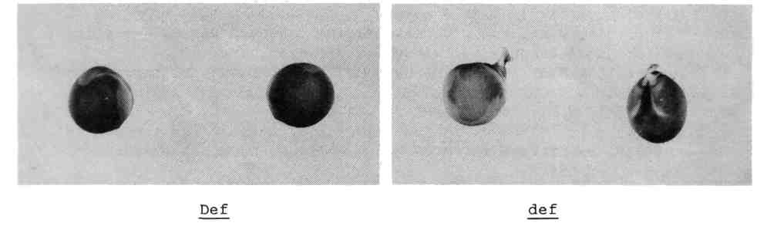
Fig. 1. Normal seeds (left) without a funiculus (Def) and mutant seeds (right) with a funiculus (def).
Table 1. Distribution of phenotypes in F₂, populations segregating for def and chromosome 7 (chromosome 2 in Lamprecht's version) markers Aldo, Gal-2 and Chi-5. The crosses are Wt11900 (def) x tester lines: 1) Wt8905, 2) Wt15063, 3) Wt15045 and 4) Wt15860
Cross | Gene pair | Phase | Phenotype |  |  |  | Total | Joint chi-sq. | Rec.  frac. | SE
Cross | Gene pair | Phase | DD | Dr | rD | rr
1) | Aldo:Def | C | 35 | 3 | 1 | 6 | 45 | 22.37*** | 9.5 | 4.6
2) |  | C | 23 | 1 | 3 | 3 | 30 | 8.73** | 15.7 | 7.3
3) |  | C | 25 | 1 | 6 | 9 | 40 | 16.26*** | 12.7 | 5.7
4} |  | C | 33 | 6 | 1 | 8 | 48 | 19.12*** | 11.8 | 5.0
Total |  |  | 116 | 11 | 11 | 26 | 164 | 62.25*** | 15.2 | 3.1
2) | Aldo:Gal-2 | C | 22 | 3 | 2 | 3 | 30 | 6.00* | 21.4 | 8.6
3) |  | C | 25 | 1 | 5 | 10 | 40 | 19.12*** | 11.1 | 5.2
Total |  |  | 47 | 4 | 7 | 13 | 71 | 25.77*** | 16.1 | 4.8
2) | Gal-2:Def | C | 25 | 1 | 1 | 4 | 30 | 17.98*** | 8.1 | 5.2
3) |  | C | 30 | 1 | 1 | 9 | 40 | 30.87*** | 5.0 | 3.6
Total |  |  | 55 | 2 | 2 | 13 | 72 | 49.79*** | 6.1 | 2.9
3) | Chi-5:Gal-2 | R | 21 | 10 | 9 | 1 | 40 | 1.91 | 30.3 | 14.2
3) | Chi-5:Aldo | R | 16 | 15 | 9 | 1 | 40 | 4.68* | 22.8 | 14.8
3) | Chi-5:Def | R | 22 | 9 | 9 | 1 | 40 | 1.48 | 32.2 | 14.0
*,**,*** Probability less than 0.05, 0.01 and 0.001, respectively.
- Blixt, S. 1977. PNL 9 suppl.
- Khangildin, V.Kh. and V.V. Khangildin. 1969. Woprosy genetiki i sjelekcji sjelskohozjajstwienych rastieniej, Yfa.
- Rozental, A.J. 1966. Bobowyje i ziernobobowyje kultury, Moskwa.
- Swiecicki, W.K. 1990. PNL 22: 62-63.
- Weeden, N.F. 1985. In The Pea Crop. A Basis for Improvement, Eds P.D. Hebblethwaite, M.C. Heath and T.C. Dawkins, Butterworths, London, pp 55-56.
- Weeden, N.F. and B. Wolko. 1990. In Genetic Maps, Ed. S.O'Brien, Cold Spring Harbor, pp 6106-6112.

