LINKAGE OF A GENE CONFERRING TOOTHED LEAVES
Swiecicki, W.K. Plant Breeding Station, Wiatrowo
62-100 Wagrowiec, Poland
Three genes for toothed leaves are known in pea: Inci, Ser and Td. Lamprecht (1) and Blixt (1) described the following differences in phenotype (Fig. 1):
Inci - incisus; leaflets deeply incised.
Ser - serratus; dentation saw-toothed.
Td - scalaris forma dentation.
According to the information kept in the pea gene-bank data base (Blixt, unpublished) and in the supplement to PNL 9 (1) the authors of the characters and gene symbols are as follows:-

Gene | Character |  | Symbol |  | Inheritance | Chromosome
Inci | Post | 1932 | Lamprecht | 1962 | Dominant | Unknown
Ser | Lamprecht | 1962 | Lamprecht | 1962 | Dominant | Unknown
Td | Sutton | 1914 | Wellensiek | 1925 | Dominant | 4
In 1989 at Wiatrowo, linkage tests were carried out analyzing dihybrid segregation in a number of F₂ generations according to the rule: type line for the investigated gene x tester lines starting with markers for strategic loci in several chromosomes, then lines with morphological as well as isozymic markers on particular chromosomes.
In the linkage tests for And (anthocyanin dots; see 3) it was observed that line Wt702 (And) is characterized additionally by strongly toothed leaves similar to those caused by Inci (Fig. 1). In this paper the symbol "Inci" is used in quotations since the identity of the gene is uncertain until the allelism tests have been done. Observations of this character were made in the F₂ generation. In 5 crosses undisturbed monohybrid (dominant) segregation occurred for toothed leaves (Cross 714, chi-square = 0.12, Cross 716, chi-square = 0.27, Cross 718, chi-square = 0.33 and Crosses 713 and 715 in Table 1. In these crosses the following markers were segregating: A D I k wb s st b M cp te gp n fa v wlo Pl r tl. No significant deviations from the normal dihybrid segregation were observed for "Inci" with most gene markers. The exception was the "Inci" - B combination where substantial deviations were found in two crosses (Table 1). The recombination values (10-20%) indicate localization in chromosome 3.
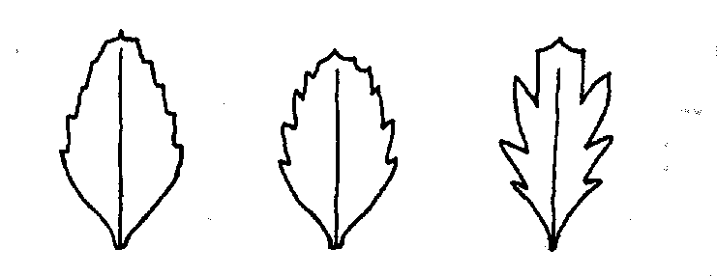
Fig. 1. Toothed leaves: Td (left), Ser (middle) and Inci (right).
Table 1. Phenotypic distribution in F₂ populations segregating for toothed leaves from crosses 713 (Wt702 x Wt11288) and 715 {Wt702 x Wt11238)

Monohybrid segregation
Cross | B | b | Total | Chi-sq. (3:1)
713 | 72 | 17 | 89 | 1.65
715 | 90 | 16 | 106 | 5.55
Total | 162 | 33 | 195 | 6.78
 | "Inci" | "inci"
713 | 76 | 21 | 97 | 0.58
715 | 107 | 37 | 144 | 0.04
Total | 183 | 58 | 241 | 0.11
Dihybrid segregation of B - "Inci" (coupling)

Cross | B Inci | B inci | b Inci | b inci | Total | Joint  chi-sq. | Recomb. fraction | SE
713 | 66 | 6 | 4 | 13 | 89 | 38.0 | 12.9 | 3.8
715 | 80 | 10 | 6 | 10 | 106 | 23.4 | 19.8 | 4.4
Total | 146 | 16 | 10 | 23 | 195 | 61.3 | 16.3 | 2.9
The "Inci" locus will be investigated in three-point crosses and loci B and Lap-1 seem to be the most appropriate markers. In addition, allelism tests will be made against Inci, Ser and Td to identify which gene is present in line Wt702.
The above results show that in a broad project on gene mapping, very precise observations of differences between parents and in segregating offspring are worthwhile since they frequently reveal novel information.
- Blixt, S. 1977. PNL 9 Suppl.
- Lamprecht, H. 1971. Monographie der Gattung Pisum, Graz.
- Swiecicki, W.K. 1990. PNL 22: 59-61.

