MAPPING OF A LEGUMIN SUBUNIT GENE ON PEA CHROMOSOME 7
Smirnova, O.G. Institute of Cytology and Genetics,
Academy of Sciences Siberian Division,
Novosibirsk 630090, USSR
The major pea seed storage protein legumin contains six subunit pairs. They may be divided into three types: conventional (M_{r} 53000-54000), big (M_{r} 55000-58000) and small (M_{r} 35000), referred to as Lg-1, Lg-2 and Lg-3, respectively (6). Each subunit pair consists of α - and β-subunits, joined by disulphide bonds. The majority of legumin is synthesized as precursor molecules, containing covalently linked α- and β-subunits (2,5). So the genetics of β-subunits should follow those of α-subunits.
It has been reported that Lg-1 α-subunits are encoded in a set of closely linked genes at a single locus on chromosome 7, located approximately 7 map units (3) or 17 map units (6) from r_ in the direction of _tl. The genetics of other legumin subunits has not been studied in detail. Lg-2 α-subunits segregated independently from Lg-1 α-subunits in one cross and were linked with them in the other. Linkage was found between Lg-2 α- and Lg-3 β-subunits, but independent segregation for Lg-3 α- and Lg-3 β-subunits was suggested (6).
Three classes of legumin cDNA were identified (4). One class of legumin genes showed linkage to gene r and corresponds to the Lg-1 α-subunits. A second class has been mapped to a locus near a on chromosome 1. A third class of legumin genes also appears to be linked with gene a_ (4). The relationship between the two last classes of legumin genes and particular α- and β-subunits is unknown.
Analysis of the seed proteins of pea line VIR319 (ssp. sativum) by sodium dodecylsulphate gel electrophoresis revealed a legumin subunit pair which could not be identified with any known subunit pair. This polypeptide of uncertain identity is symbolized temporarily as Lg-u. The M_{r} of Lg-u is approximately 3000 less than the M_{r} of Lg-1 (Fig. 1, non-reducing conditions). The difference between Lg-u and Lg-1 subunit pairs is due to their α-subunits, while the β-subunits of these pairs seemed to be identical (Fig. 1, reducing conditions).
Line VIR319 (Lg-u⁺, present) was crossed with line WL1238 (Lg-u⁻, absent). In F₁ hybrid seed Lg-u was expressed in a lesser amount (Lg-u⁺/⁻) than in parent VIR319. An analysis of F₂ progeny (n=196) revealed segregation of Lg-u α-subunit classes + : +/- : - as 47 : 102 : 47, respectively. These results indicate Lg-u⁺ and Lg-u⁻ to be a single allele pair (χ²₁ = 0.33). Segregation of morphological markers and Lg-u α-subunits in F₂ plants showed linkage of Lg-u with genes r and tl (Table 1A). 13 plants showed recombination between genes r and tl, 32 between _tl_ and Lg-u, and 45 between r and Lg-u. Corresponding distances were calculated as 3.3 ± 0.9, 8.2 _± 1.4 and 11.5 _± 1.6 map units, respectively, which generates the following map:
r--3.3--tl 8.2 Lg-u
Mapping of gene Lg-u showed that it is located in the same region on chromosome 7 as gene His-1, coding for histone H1 the slowest fraction. The distance between His-1 and tl was found to be 7.6 crossover units (7) while the data above indicate a distance of 8.2 units for Lg-u and tl. These results were obtained in different crosses and the question arises as to which gene, Lg-u or His-1, is situated closer to gene tl. To answer this question I crossed lines 319.1 and Sprint, which differ not only in molecular variants of legumin and histone H1 the slowest fraction, but also in genes r and tl at one side of Lg-u and His-1, and gene Sa-K9 at the other side. Line 319.1 has genotype r, tl^{w}, His-1 F, Sa-K9 S, Lg-u⁺ and line Sprint has genotype R_, Tl, His-1 S, Sa-K9 F, Lg-u⁻. Only two F₂ plants among 132 had a recombinant phenotype in respect of genes Lg-u and His-1 (Table 1B). Thus, the map distance between Lg-u and His-1 is about 0.8 ± 0.5 map units. Recombinant plants had genotypes Rr Tltl^{w} Lg-u+/- His-1 S, Sa-K9 F and Rr Tltl^{w} Lg-u+/- His-1 F, Sa-K9 S.
These results indicate the following gene order:
r — tl — Lg-u — His-1 — Sa-K9.
The location of gene Lg-u on chromosome 7 coincides with that of Lg-1. Possibly, Lg-u is a member of the Lg-1 gene family and the Lg-u polypeptide may be the result of a deletion in one of the genes of this family. Several variant forms of the Lg-1 polypeptide have been described (1,6,8). Alternatively, Lg-u may be structurally different from the other major legumin polypeptides. Further study, e.g. sequencing or peptide mapping, is necessary to resolve these alternatives.
Table 1. Distribution of F₂ plants into phenotypic classes.
Gene pair |  | Genotypes |  |  |  |  |  |  |  |  | Chi-square | Recomb. fract. | SE
X | Y | XXYY | XXYy | XXyy | XxYY | XxYy | Xxyy | xxYY | xxYy | xxyy | Chi-square | Recomb. fract. | SE
A. Cross VIR319 x WL12138, n = 196
Lg-u | R | 33 | 13 | 0 | 14 | 81 | 10 | 0 | 8 | 37 | 156 | 11.5 | 1.6
Lg-u | Tl | 38 | 9 | 0 | 9 | 86 | 7 | 0 | 7 | 40 | 189 | 8.2 | 1.4
R | Tl | 42 | 4 | 0 | 5 | 97 | 3 | 0 | 1 | 44 | 300 | 3.3 | 0.9
Expected |  | 12.3 | 24.5 | 12.3 | 24.5 | 49 | 24.5 | 12.3 | 24.5 | 12.3 | - | - | -
B. Cross 319.1 x Sprint, n = 132
Lg-u | His-1 | 28 | 0 | 0 | 1 | 71 | 1 | 0 | 0 | 31 | 232 | 0.8 | 0.5
Tl | Lg-u | 24 | 9 | 0 | 4 | 55 | 6 | 0 | 9 | 25 | 116 | 10.6 | 1.9
Tl | His-1 | 24 | 9 | 0 | 5 | 53 | 7 | 0 | 9 | 25 | 111 | 11.4 | 2.0
Tl | Sa-K9 | 23 | 9 | 1 | 9 | 46 | 10 | 0 | 12 | 22 | 80 | 15.9 | 2.2
His-1 | Sa-K9 | 27 | 2 | 0 | 5 | 63 | 3 | 0 | 2 | 30 | 188 | 4.5 | 1.3
Expected |  | 8.3 | 16.5 | 8.3 | 16.5 | 33 | 16.5 | 8.3 | 16.5 | 8.3 | - | - | -

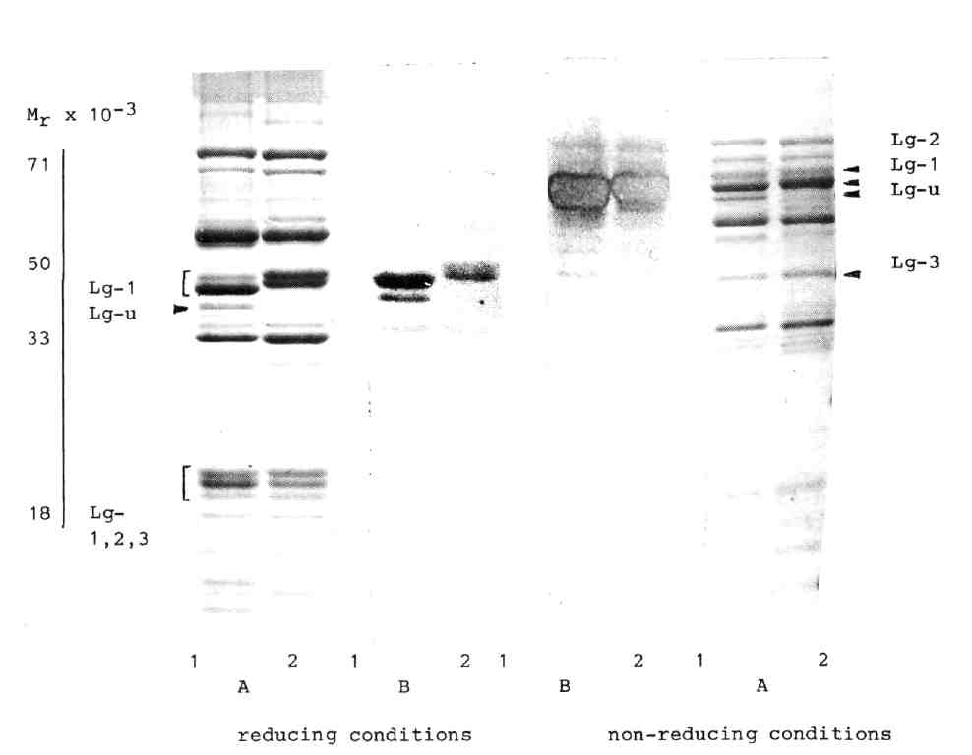
Fig. 1. Sodium dodecylsulphate polyacrylaramide gel electrophoresis of pea seed proteins in lines VIR319 (1) and WL1238 (2).
A - total protein extracts stained by Coomassie R-250,
B - legumin subunits (reducing conditions) and subunit pairs (non-reducing conditions) identified by "Western" blot analysis.
- Casey, R. 1979. Heredity 43:265-272.
- Croy, R.R.D., J.A. Gatehouse, I.N. Evans and D. Boulter. 1980. Planta 148:49-56.
- Davies, D.R. 1980. Biochem. Genet. 18:1207-1219.
- Domoney, R., T.H. Ellis and D.R. Davies. 1986. Mol. Gen. Genet. 202:280-285.
- Lycett, G.W., R.R.D. Croy, A.D. Shirsat and D. Boulter. 1984. Nucleic Acids Res. 12:4493-4506.
- Matta, N.K. and J.A. Gatehouse. 1982. Heredity 48:383-392.
- Smirnova, O.G., S.M. Rozov and V.A. Berdnikov. 1989. PNL 21:66-68.
- Thomson, J.A. and H.E. Schroeder. 1978. Aust. J. Plant Physiol. 5:263-279.

