VARIATIONS IN POD REHYDRATION AND PERMEABILITY IN THREE LINES OF PISUM SATIVUM L.
Miles, Simon N., David Price, Department of Biological Sciences
Maria E. Donkin and Iain Swadling Polytechnic South West, Plymouth
Devon, UK
The dried pea crop is increasing in popularity in the UK as an alternative source of protein for incorporation into animal feed (1). A common problem experienced by the pea grower is the rehydration of the seeds, caused by weather damage, at critical stages during the maturation of the crop, leaving them open to fungal attack and spoilage. The better standing ability of reduced foliage types is helping reduce such losses. However, further improvements could be made by selecting plants with pods which are capable of protecting the seeds in the often damp, crop environment. At present most pods are themselves susceptible to rehydration, causing splitting, spoilage and pre-harvest dispersal of seeds (2). However, given the variation in other pod characteristics, it is likely that variation also exists for characters which could be exploited to improve the housing provided by the pod.
A method has been developed to help quantify the susceptibility to rehydration, by measuring the rates of influx of water into dry intact pods. This involves the submersion of the pods in water at 25°C and neutral pH for periods of up to 24 h and the gravimetric determination of the water content of the pods and their enclosed seeds. The results are expressed as the percentage water content of the wet weight.
Three lines of Pisum sativum L. from the John Innes Accession were compared. JI:141 has a pod wall thickness of approximately 1 mm, with cuticular wax and a layer of sclerenchyma tissue in its endocarp, whilst JI:60 has a thicker pod wall (1.5 mm) and JI:73 lacks the substantial deposition of cuticular waxes. The lines have the following genotypes - JI:60 A r Gp N P V S Pu Pur, JI:73 a_ R gp_ N P V s and JI: 141 a_ r_ Gp N P V S.
All three lines showed a rapid influx of water into the pod walls (Fig. 1a), although the rate of influx into the wall of the JI:60 pods was a little slower in the first 15 min of the experiment, a phenomenon possibly due to their higher water content before submersion. All three lines reached water saturation at levels of 60-70% after 4 h, with JI:73 achieving the greatest increase in water content over the 7 h of the experiment. From the results presented in Fig. 1a alone, the JI:141 pods appeared to be the least easily hydrated and, therefore, possibly the most protective pods.
An evaluation of the rehydration of the enclosed seeds provided a more direct measurement of the pod permeability, as it represented the quantity of water which actually penetrated through the pod tissues (Fig. 1b). Some water was transmitted to the seeds of two lines (JI:141 and JI:73) during the first 2 h of submersion, but in these the rate of influx of water was constant, even when the pods which envelop the seeds became saturated. Even saturated pods must still restrict water uptake by the seeds. Jl:141 possessed seeds with the highest water content of all the varieties.
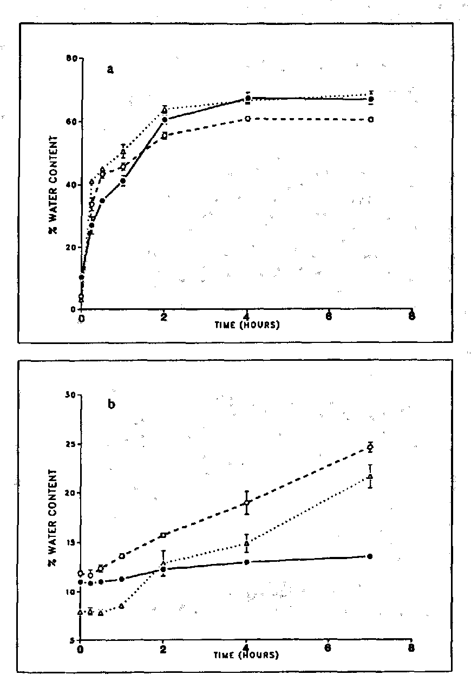
Fig. 1. Mean water uptake of pods (a) and enclosed seeds (b) of three lines of Pisum sativum from the John Innes Accession - JI:60 (● — ●) , JI:73 (Δ ..... Δ) and JI:141 (○ - - - ○). SE above and below the means are shown in some cases.
It can be inferred, therefore, that this variety was actually, inefficient in protecting against rehydration of the seeds despite this pod achieving lower saturated water contents (Fig. 1a). JI:73 showed the greatest overall increase in seed water content of the three lines, which may also be interpreted as producing poor protection of its seeds. JI:60 seeds showed a much slower rate of water uptake and, therefore, appears to possess the most effective barrier to water of the pea lines investigated, despite its pods achieving high water contents (Fig. 1a).
Although measuring the amount of water which is taken into the seeds is a more informative method of estimating the degree of permeability of the pod wall as a whole, it is important to consider the effects that variation in the seed, particularly the testa, may have on the water uptake. To avoid this complication, an alternative electronic method of measuring water infiltration and penetration into the pod is being developed.
The work presented here, which is based on only three lines, is currently being extended to cover a much wider range of pod types.
- Grosjean, F. 1985. In The Pea Crop. A Basis for Improvement. Eds P.D. Hebblethwaite, M.C. Heath and T.C.K. Dawkins, Butterworths, London, pp 453-462.
- Kay, D.C. 1979. TIP Crop and Product Digest No. 3. Tropical Products Institute.

