EVIDENCE FOR A NEW RUGOSUS LOCUS
Hedley, C.L., D.A. Jones, T.L. Wang, John Innes Institute
M.J. Ambrose, A.M. Smith, T.H.N. Ellis, Colney Lane
L. Turner, P. Matthews, M. Bhattacharyya, Norwich NR4 70H
W. Harwood, I.D. Bedford and England
F.N. Green DAPFS Agric. Sci. Services, East Craigs
Edinburgh EH12 8NJ, Scotland
As part of our seed development studies we obtained a number of lines from the U.K. Pisum cultivar collection at East Craigs, Scotland. The seeds of these cultivars had been characterised previously to be wrinkled in shape with smooth or simple starch grains (2), a phenotype normally attributed to genotypes which are homozygous recessive at the rb locus (3). Several independent studies using these lines have shown, however, that one cultivar (JI2110, cv Kebby) has a phenotype which is distinct from that of lines homozygous recessive at either or both rugosus loci (r_ and rb) and may, therefore, carry a mutant allele at a previously unidentified locus. We have obtained information on the parentage of Kebby. It was bred by Sluis and Groot, in the Netherlands, and was a selection from a crossing program between the following varieties: [(Zelka x Lincoln) x Kelvedon Wonder] x Eminent. These lines plus Kebby are being used to study the genetic basis of this new phenotype. Evidence that the new phenotype is the result of a mutation at a previously undescribed locus comes from three independent studies.
Morphological and genetic studies (C.H., D.J., M.A., P.M.)
The seed of Kebby has a shape which is similar to other wrinkled peas (Fig. 1). Crosses between Kebby and wrinkled lines known to be either rr RbRb or RR rbrb, however, gave rise to round seed (Fig. 1). The shape of the starch grains for Kebby is simple and oval, similar to those from round (RR RbRb) seeds, or wrinkled seeds which have genotype RR rbrb (Table 1).
Storage product composition (D.J., T.W., C.H., W.H.)
Comparisons were made between Kebby and lines known to have genotypes RR RbRb, rr RbRb or RR rbrb, for the content of starch, protein and lipid in the dry embryo (Table 1). The data clearly indicate a similarity between the storage product composition of Kebby and the round genotype (RR RbRb) and a difference between Kebby and wrinkled lines with genotypes rr RbRb or RR rbrb.
Biochemical and molecular genetic studies (A.S., T.E., L.T., M.B., I.B.)
There is good evidence (5) that the homozygous presence of the r_ allele results in the absence of both activity and protein of isoform I of starch branching enzyme (SBE 1). A Western blot of material from the dry seed of Kebby was developed using antibody prepared to the RR-specific isoform of this enzyme (Fig. 2A). This shows clearly that Kebby contains the RR-specific isoform of SBE 1 and is not wrinkled because of a mutation in the SBE 1 gene which has been shown to reside at the r: locus (1). To substantiate this conclusion Kebby was compared with lines which were known to be homozygous dominant or recessive for alleles at the r locus by Southern blot analysis, using the SBE 1 cDNA probe (Fig. 2B; 1). This clearly shows that Kebby is similar to the line with the dominant allele (JI1156) and different from the rr line (JI2108).
Table 1. Comparison between round (RR RbRb) and wrinkled (rr RbRb and RR rbrb) pea seeds with those of cv Kebby for starch content and composition, starch grain shape, protein and lipid content
 | Starch |  |  | Protein |  |  | Lipid
Genotype | % Total | % Amylose | Grain shape | % Total | Soluble |  | % Total
RR RbRb | 50 | 30 | simple | 27 | 15 |  | 2.0
rr RbRb | 29 | 65 | compound | 37 | 18 |  | 3.6
RR rbrb | 25 | 5 | simple | 42 | 21 |  | 4.1
cv Kebby | 47 | 20 | simple | 29 | 14 |  | 2.0
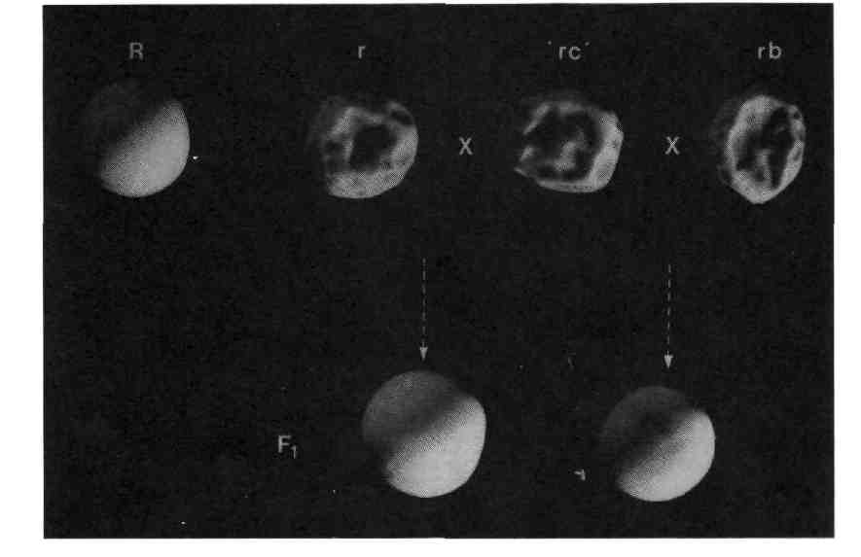
Fig. 1. Comparison for seed shape between known round (R; RR RbRb) and wrinkled (r and rb; rr RbRb and RR rbrb) genotypes and cv Kebby ('rc'), plus F₁ seed following crosses between the wrinkled lines and Kebby.
Further evidence for the genetic status of Kebby with regard to the rb locus was gained by using a vicilin gene probe that identifies the Vc-5 locus (pJC2-7) which is linked to rb (4). Using this probe comparisons were made between Kebby and lines known to be homozygous recessive (JI1156) or dominant (JI2108) for alleles at the rb locus (Fig. 2C). It was clear that Kebby is similar to the line with the dominant allele (JI2108) and different from line JI1156. These results do not provide unequivocal proof of the genotype at the rb locus but they are consistent with the view that Kebby is RbRb.
- Bhattacharyya, M.K., A.M. Smith, T.H.N. Ellis, C. Hedley and C. Martin. 1990. Cell 60:115-122.
- Cousin, R. 1974. Le Pois, Annales de 1'Amelioration des Plantes - Numero hors serie 1974.
- Kooistra, E. 1961. Euphytica 11:357-373.
- Lee, D., L. Turner, D.R. Davies and T.H.N. Ellis. 1988. Theor. Appl. Genet. 75:362-365.
- Smith, A.M. 1988. Planta 175:270-279.
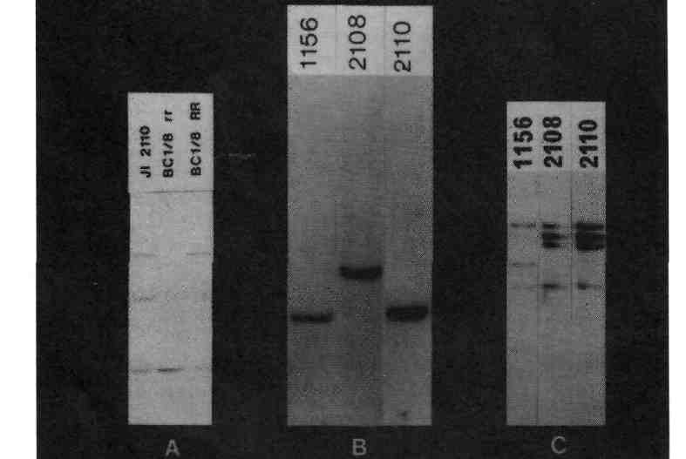
Fig. 2:
A - Western blot analysis of dry seed extracts from cv Kebby (J12210)and a wrinkled (rr RbRb; BC1/8rr) and a round (RR RbRb; BC1/8RR) line using antibody prepared to the RR-specific isoform of starch branching enzyme 1 (SBE 1).
B - Comparison between cv Kebby (JI2110) and lines known to be homozygous dominant (JI1156; RR rbrb) or homozygous recessive (JI2108); rr_ RbRb) for alleles at the r_ locus by Southern blot analysis using the SBE 1 cDNA probe.
C - Comparison between cv Kebby (JI2110) and lines known to be homozygous dominant (JI2108; rr RbRb) or homozygous recessive (JI1156; RR rbrb) for alleles at the rb locus using a vicilin gene probe(pJC2-7) which identifies the Vc-5 locus. Loci Vc-5 and rb are linked(4).

