SHORTENED INTERNODE LENGTH BELOW THE NODE OF FLOWER INITIATION IN PEA
Green, F.N. Dept. Agric. and Fisheries, Agricultural Scientific
Services, East Craigs, Edinburgh EH12 8NJ, U.K.
In 1988, sixty-seven 'leafless'/semi-leafless' pea accessions were grown under glass with the aim of classifying them into flowering and internode length phenotypes. Fifteen lines (supplied by Dr Ian Murfet, University of Tasmania) with known flowering and internode length genotypes were used as standards. The plants were grown under conditions of short daylength (9.5 h day); natural daylight was supplemented by 400 W mercury vapour and 60 W tungsten lights. Temperature was controlled between 20 and 29°C. Seed was sown on October 10 into 15 cm pots filled with John Innes No. 3 compost. Water was supplied by absorption from underlying capillary matting. A maximum of 15 plants were grown per cultivar.
Twenty-nine of the accessions grown had shortened internodes (Fig. 1) below the node of flower initiation. The internodes above (SI+1) and below (SI-1) the shortened internode (SI), were between two and six times longer. In six accessions (four of which came from the same breeder), this trait was expressed on all plants grown. Data for several cultivars in which the trait was frequently and strongly expressed are given in Table 1. In order to indicate the strength of expression, the length of the shortened internode (SI) was represented as a percentage of the mean of the internodes above (SI+1) and below (SI-1); the data are included in Table 1 under the heading SI Index.
Seed from plants expressing shortened internodes in 1988 was harvested in bulk for each accession and grown under conditions of long daylength (18 h) in 1989 to see if the trait was repeated. Although the expression of the shortened internode trait was not clear under long days, the trait was expressed, but only in some of the plants grown (Table 1). Seed was harvested from a single plant which strongly expressed the shortened internode under long day conditions, and grown on to check repeatibility of the expression under short daylength. Again the trait was clearly expressed, particularly in the cultivars Majesty, Brandon and Tsarina, though expression was weaker than that recorded in 1988 (Table 1).
One plant in cultivar Kasino and 4 plants in cultivar Rigel could not be assessed for shortened internodes because SI+1 was too short, (it was the last internode produced). In Tsarina, SI+1 was the last internode in 8 of the plants, although the trait was still clearly expressed. However, the length of SI+1 may have been limited because of this. It may not be possible to judge whether the shortened internode trait is expressed, if the plant does not continue to produce nodes above SI+1.
Expression of the trait was also examined in 62 accessions with an Af/Af (leaflets present) background. Two Af/Af accessions, Nomad and NGB1771 (Wellensiek's Dominant line obtained from the Weibullsholm Plant Breeding Institute), showed strong expression of the shortened internode trait while a further 6 showed some expression.
This trait has been noted before in our field trials, and also by other pea workers (S. Blixt, personal communication), but to my knowledge no information has been published. The regular occurrence of the short internode trait in certain cultivars suggests that the trait has a firm genetic basis and it is clear that the trait is not confined to plants homozygous for allele af because it was also expressed in some Af accessions. The large number of accessions expressing the trait among 'leafless' and 'semi-leafless' cultivars is probably the result of the common parentage found in these types. The data in Table 1 suggest that the expressivity and penetrance of the trait are influenced by the genetic background and by environmental factors since expression of the trait varied among the accessions and between the short day and long day trials.
The position of the shortened internode appears to indicate that it is related to the onset of flowering. With this in mind, it is proposed to cross cultivars expressing the trait, with existing internode and flowering typelines, to study the inheritance of the character.
- Murfet, I.C. and J.B. Reid. 1985. In The Pea Crop: a Basis for Improvement, eds P.D. Hebblethwaite, M.C. Heath and T.C.K. Dawkins, Butterworths, London, pp. 67-80.
Table 1. Length of the shortened internode (SI) immediately below the node of flower initiation, and the internodes above (SI+1) and below (SI-1), for several accessions grown under short day (SD; 9.5 h) or long day (LD; 18 h) conditions. The SI index = 200 x (SI)/(SI+1) + (SI-1).
Accession/Cultivar | Daylength and year | Plants with SI present/  total plants | Mean  internode length (mm) |  |  | SI Index | Number of shortened internode
Accession/Cultivar | Daylength and year | Plants with SI present/  total plants | SI-1 | SI | SI+1 | SI Index | Number of shortened internode
82024 - | SD88 | 15/15 | 14.5 | 3.3 | 12.6 | 24.4 | 20
82029 Ondra | SD86 | 8/15 | 20.5 | 4.8 | 17.9 | 25.0 | 16
83054 Countess | SD88 | 13/15 | 26.6 | 19.7 | 30.3 | 69.2 | 17
84004 Crown | SD88 | 15/15 | 31.4 | 11 .6 | 39.3 | 32.8 | 17
84005 Itrandon | SD88 | 4/14 | 22.8 | 9.3 | 26.8 | 37.5 | 18
84005 | LD89 | 8/14 | 19.7 | 15.4 | 25.6 | 68.0 | 19
84005 | SD69 | 12/12 | 26.8 | 13.0 | 26.2 | 49.1 | 20
84006 Princess | SD88 | 13/14 | 23.6 | 11 .7 | 26.5 | 46.7 | 17
84013 Rigel | SD88 | 6/15 | 33.1 | 18.0 | 34.9 | 52.9 | 21
84013 " | LD89 | 7/12 | 26.4 | 21 .4 | 30.3 | 75.5 | 23
84013 " | SD89 | 9/15 | 35.8 | 29.8 | 38.2 | 80.5 | 24
85001 Diplomat | SD88 | 10/15 | 19.5 | 11.3 | 21.5 | 55.1 | 19
85029 Duchess | SD88 | 13/14 | 27.6 | 12.3 | 29.8 | 42.7 | 19
85)50 Nomad* | LD89 | 13/14 | 23.3 | 18.9 | 28.7 | 71.9 | 19
85383 NGB1771* | LD89 | 12/14 | 35.6 | 16.2 | 39.5 | 43.1 | 24
86018 Hussar | SD88 | 14/15 | 17.4 | 8.8 | 19.9 | 47.2 | 19
86026 Echo (P69) | SD88 | 15/15 | 13.8 | 6.2 | 15.3 | 42.6 | 17
86030 Kasino | SD88 | 14/15 | 16.5 | 9.0 | 19.3 | 50.3 | 19
86030 " | LD89 | 5/15 | 18.7 | 17.6 | 22.8 | 84.8 | 19
86030 " | SD89 | 9/12 | 21.2 | 15.8 | 21.0 | 74.9 | 21
86036 Tsarina | SD88 | 13/13 | 14.1 | 4.2 | 19.2 | 25.2 | 15
86036 " | LD89 | 4/11 | 35.0 | 33.7 | 38.1 | 92.2 | 17
66036 " | SD89 | 14/14 | 15.8 | 7.5 | 13.7 | 50.8 | 20
86040 Majesty | SD88 | 15/15 | 14.6 | 3.4 | 20.6 | 19.2 | 17
86040 " | LD89 | 7/8 | 26.8 | 15.5 | 36.7 | 48.8 | 18
86040 " | SD89 | 15/15 | 18.5 | 7.2 | 16.7 | 40.9 | 19
87010 Anno |  | 13/15 | 18.7 | 7.5 | 21.2 | 37.6 | 18
*Genotype Af/Af; all other accessions af/af.
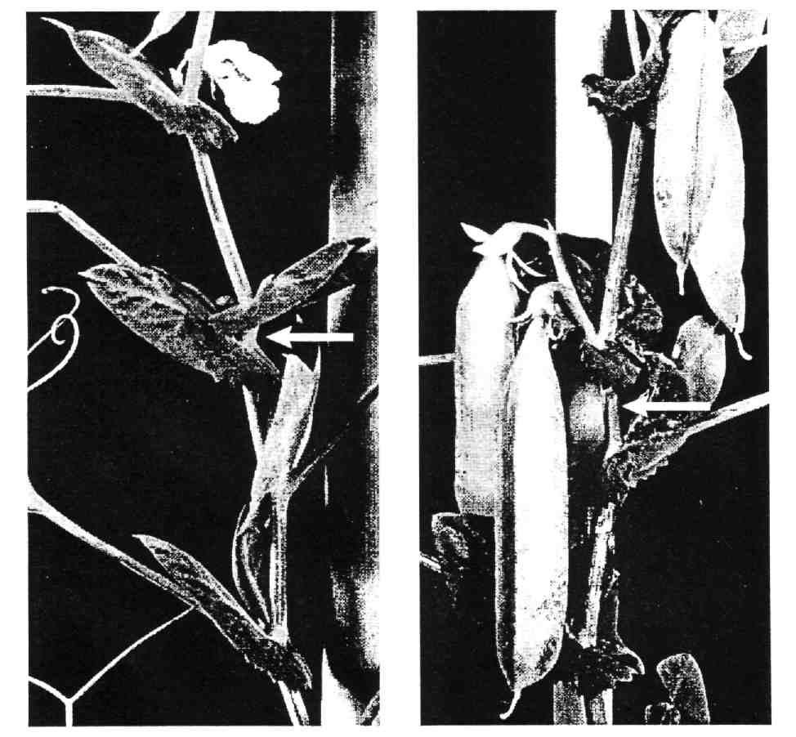
Fig. 1. Plants of Accessions 86036 cv Tsarina (left) and 86040 cv Majesty (right) grown under short days (9.5 h) showing the short internode below the node of first flower initiation. The first two flowers of the Tsarina plant developed to maturity but failed to set in this case. Photographer Sylvia Breslin.

