The following corrections are noted for PNL 21 (1989).
Page 17 in paper by Filippone and Lurquin. Due to an oversight, the incorrect Fig. 2 was submitted. The correct Fig. 2 with legend appears below and a loose copy is enclosed so that the correction can be added to PNL 21, page 17.
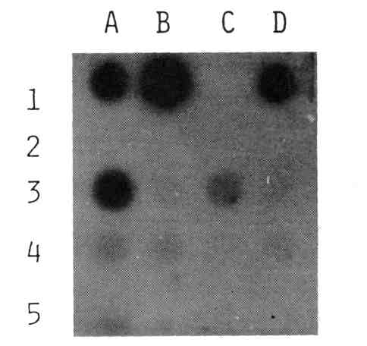
Fig. 2. Identification of the NPTII gene in pea transformed calli. The figure shows dot blots of callus DNA. Legend: A1, B1 and D1, various amounts of DNA isolated from N. tabacum transformed callus (positive control); A2, B2 and D2, DNA isolated from N. tabacum untransformed callus (negative control); A3 through D3, DNA isolated from independent transformed calli originating from pea epicotyl; A4 through D4 DNA isolated from independent transformed calli originating from cotyledonary node bud; A5 through C5, DNA isolated from control untransformed calli originating from pea epicotyl.
Page 37 in paper by Murfet and Cayzer. Paragraph 2, line 2 - change to to of; par. 2, line 3 - add not after can. The first four lines of p. 37, par. 2 should read as follows:
With background lf E Dne all plants flower at a low node regardless of the genotype for the Sn-sn and Hr-hr gene pairs (9). Thus node of flower initiation cannot be used in these circumstances to distinguish the several genotypes. Nevertheless, a clear cut three class segregation
Page 41 in paper by Murfet and Cramp. Add reference (3) at the end of paragraph four after the word recorded.
Page 74 in paper by Swiecicki. Fig. 1 as printed shows the crispoid mutant Wt11300 on the right and the initial line Wt3527 on the left.

