INTERNODE LENGTH IN PISUM. GENOTYPES la cry^{S} lka AND la cry^{S} lkb AND THE PHENOTYPE SLENDER SEMI-ERECTOIDES
Cramp, R.E. Department of Plant Science, University of Tasmania
and Reid, J.B.* Hobart, Tasmania 7001, Australia
The mutations lka (NGB5865) and lkb (NGB5862) both result in plants with a short, semi-erectoides phenotype (3). The response of both mutants to applied gibberellin A₁ (GA₁) is reduced in comparison with that of the tall, wild-type initial line (cv Torsdag) and thus they were classified as GA-insensitive mutants (3). The slender gene combination, la_ cry^{S}, has also been shown to influence aspects of GA sensitivity even though the plants are elongated compared with wild type plants (2). It is therefore of interest to examine the interaction of the gene combination la_ cry^{S} with both lka and lkb.
Mutations lka and lkb were induced in cv Torsdag by Dr K.K. Sidorova at Novosibirsk, USSR. The slender line used for the crosses, L197 (Le la cry⁵ Na Lh Lk Lka Lkb Lm Ls Lw Lv), was selected from a cross between NGB1766 (nana, Le_ La Cry na Lh Lk Lka Lkb Lm Ls Lw Lv) and L133 (slender, le la_ cry^{S} Na Lh Lk Lka Lkb Lm Ls Lw Lv). Growing conditions were the same as those detailed by Reid and Ross (3). Counting of nodes began from the first scale leaf as node 1.
The F₁ plants of crosses L197 x NGB5862 and L197 x NGB5865 possessed the wild type tall phenotype. The F₂ of cross L197 x NGB5862 gave a clear segregation into 43 tall, 34 semi-erectoides, and 4 slender plants when the length between nodes 1 and 5 was compared with that between nodes 7 and 11 (Fig. 1). This segregation is not in accord with the expected ratio of 45 tall (La_ and/or Cry, Lkb) : 16 semi-erectoides (La_ and/or Cry, lkb and la_ cry^{S} lkb) : 3 slender (la cry^{S} Lkb) (χ²₂ for 45:16:3 = 13.43, P <0.001), because the number of semi-erectoides segregates was significantly higher than expected. However, it appears that the deviation may have been due to chance since the segregation in the F₃ was in accord with expectation (see later). One of the F₂ plants from cross L197 x NGB5862 originally classified as semi-erectoides appeared different at the time of harvest and was re-classified as slender semi-erectoides (Fig. 1). It was longer in the early internodes than plants in the semi-erectoides class and had parthenocarpic pods of the inflated form seen in slender plants, rather than the flat parthenocarpic pods occasionally found in the ordinary lkb plants. In addition, the total height of the plant was greater than that of the semi-erectoides plants due to there being more nodes as a result of pod abortion. It was thought that this plant may be of the desired genotype (la cry^{S} lkb) and this was confirmed by the F₃ segregation (see later).
The F₂ of cross L197 x NGB5865 consisted of 53 tall, 23 semi-erectoides, and 3 slender plants (Fig. 2). These numbers are in agreement with the expected 45 (La_ and/or Cry, Lka) : 16 (La and/or Cry, lka and la cry^{S} lka) : 3 (la cry^{S} Lka) ratio (χ²₂ for 45:16:3 = 1.17, P>0.50). Unlike cross L197 x NGB5862, there were apparently no slender semi-erectoides (la cry^{S} lka) segregates in the F₂ generation, even though 80 seeds were planted.
*Corresponding author. Study supported in part by an ARC grant.
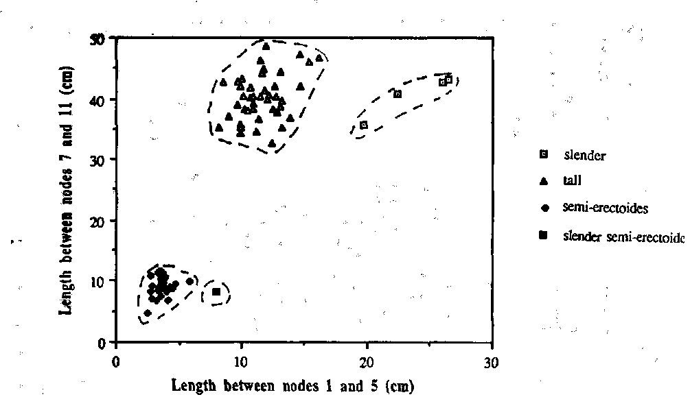
Fig. 1. The stem length between nodes 1 and 5 plotted against the length between nodes 7 and 11 for each F₂ segregate from cross L197 x NGB5862. The broken lines indicate the limits of the three classes - slender (_la cry^{S} Lkb), semi-erectoides (La and/or Cry, lkb) and tall (La and/or Cry, Lkb). The single plant lying to the right of the semi-erectoides group was shown in the F₃ to be of the slender semi-erectoides phenotype (la cry^{S} lkb).
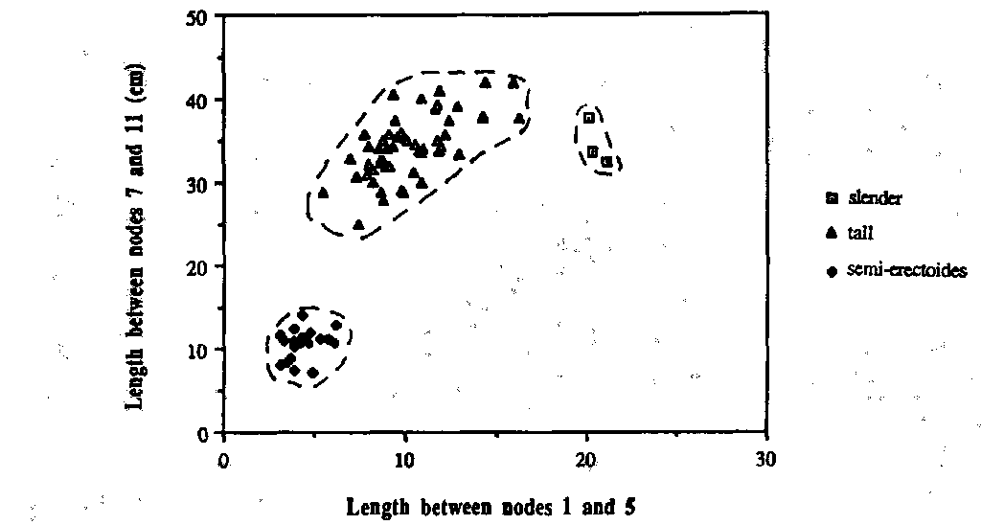
Fig. 2. The stem length between nodes 1 and 5 plotted against the length between nodes 7 and 11 for each F₂ segregate from the cross L197 x NGB5865. The broken lines indicate the limits of the classes slender (la cry^{S} Lka), tall (La_ and/or Cry, Lka) and semi-erectoides (La_ and/or Cry, lka).
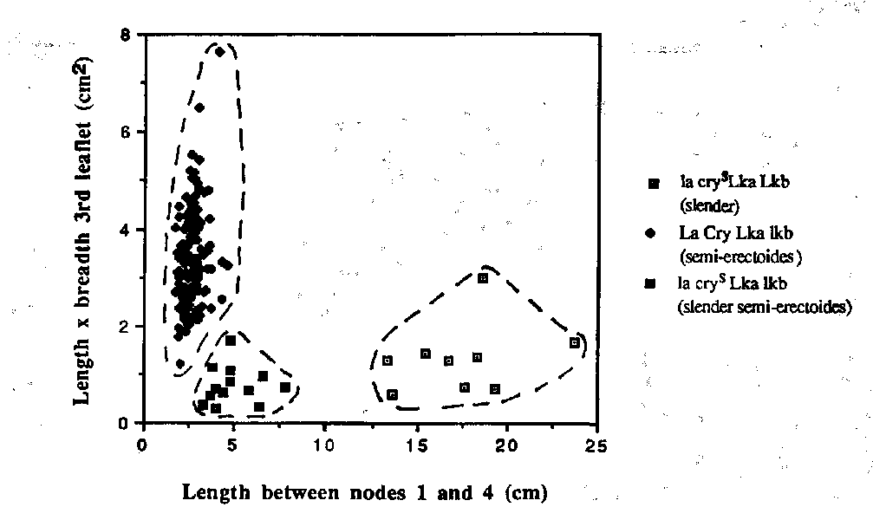
Fig. 3. The stem length between nodes 1 and 4 plotted against the length x breadth of the first leaflet at node 3 for each F₃ segregate from selected slender and semi-erectoides F₂ plants of cross L197 x NGB5862. The dotted lines denote the limits of the three classes - slender (la cry^{S} Lkb), semi-erectoides (_La_ and/or Cry, lkb) and slender semi-erectoides (_la_ cry^{S} lkb).
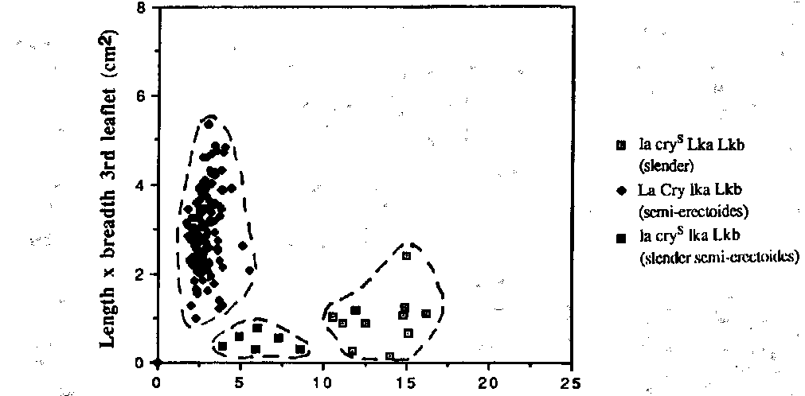
Fig. 4. The stem length between nodes 1 and 4 plotted against the length x breadth of the first leaflet at node 3 for each F₃ segregate from selected slender and semi-erectoides F₂ plants of cross L197 x NGB5865. The dotted lines denote the limits of the three classes -slender (la cry^{S} Lka), semi-erectoides (La and/or Cry, lka) and slender semi-erectoides (la cry^{S} lka).
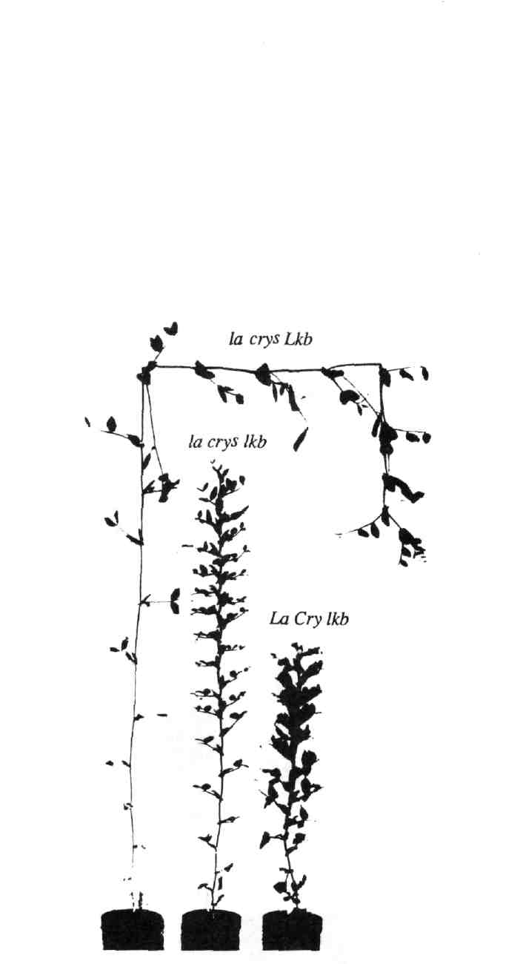
Fig. 5. The phenotype of a slender semi-erectoides plant (la cry^{S} lkb, centre) with the parental lines from cross L197 (slender, la cry^{S} Lkb, left) x NGB5862 (semi-erectoides, La Cry lkb, right).
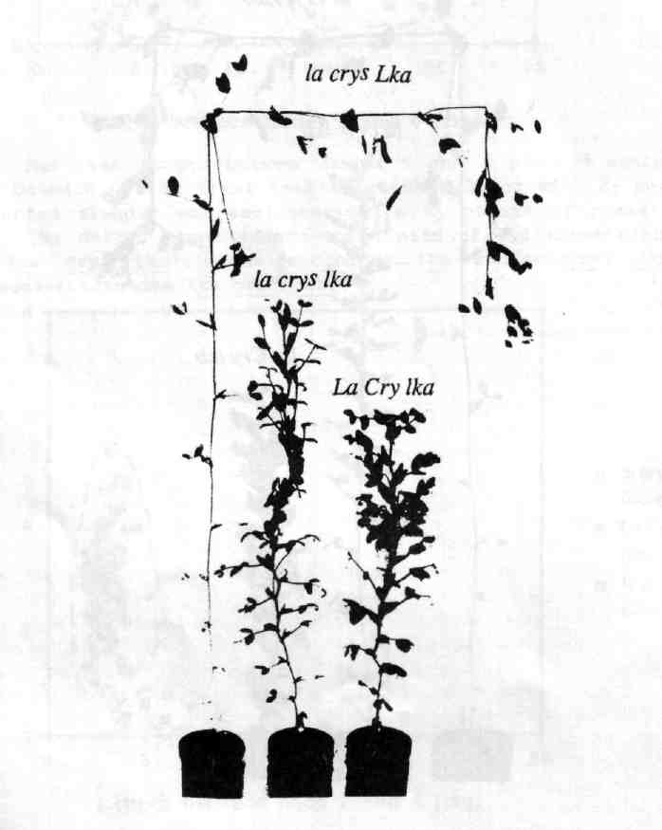
Fig. 6. The phenotype of a slender semi-erectoides plant (la cry^{S} lka, centre) with the parental lines from cross L197 (slender, la cry^{S} Lka, left) x NGB5865 (semi-erectoides, La Cry lka, right).
F₃ progenies (normally 12 plants) were grown from 12 semi-erectoides and 3 slender plants in the F₂ generation of cross L197 x NGB5862, and from 12 semi-erectoides and 2 slender plants in the F₂ of cross L197 x NGB5865. In the F₃ of both crosses, three distinct classes became apparent - slender (la cry^{S} and Lka or Lkb), semi-erectoides (La and/or Cry and lka or lkb) and slender semi-erectoides (la cry^{S} lka or lkb) (Figs 3 and 4). There were 5 slender semi-erectoides (la cry^{S} lka) segregates in 3 progenies from semi-erectoides F₂ plants and 2 in the 13 seeds obtained from slender F₂ plants of cross L197 x NGB5865. The small numbers in the progenies from slender plants preclude the testing of statistical significance. However, the segregation in the progenies from semi-erectoides F₂ plants is in accord with the expected 11:1 ratio (χ²₁ = 3.48 with Yates' Correction, P > 0.05). In cross L197 x NGB5862 there were no slender semi-erectoides (la cry^{S} lkb) segregates in the progenies of slender F₂ plants, but 4 progenies from semi-erectoides plants segregated in the F₃ generation and yielded 9 slender semi-erectoides(la cry^{S} lkb) segregates. This is in accord with the expected 11:1 ratio for semi-erectoides (La and/or Cry, lkb) to slender semi-erectoides (la cry^{S} lkb) types (χ²₁ = 0.67).
The homozygous la cry^{S} lka and la cry^{S} lkb plants were phenotypically similar, and intermediate in height between their respective parental lines (Figs 5 and 6). They had longer internodes in the lower part of the plant than their semi-erectoides parent but the upper part of the plant was similar in length to this parent. Both also had the stem banding characteristics of the semi-erectoides parent (3). Both la cry^{S} lka and la_ cry^{S} lkb plants had a tendency to produce parthenocarpic pods similar to those produced by slender plants. The large number of parthenocarpic pods produced by the slender semi-erectoides plants meant that they had very low fertility. The leaves at the lower nodes of the slender semi-erectoides plants were similar to those of the slender parent, being small and narrow.
The similarity between la_ cry^{S} lka and la_ cry^{S} lkb plants raises the question of whether the phenotypes of NGB5862 (lkb) and NGB5865 (lka) have the same physiological and anatomical basis since the two mutants seem to interact in a similar way with the slender gene combination. However, anatomical studies suggest that this may not be the case (3). The phenotype of la cry^{S} lka and la cry^{S} lkb plants is effectively the superimposed effects of the slender (la cry^{S}) combination and the semi-erectoides (lka or lkb) mutant. Consequently it is suggested that the intermediate stature of plants of genotypes la cry^{S} lka and la cry^{S} lkb reflects the fact that no direct relationships appear to exist between the slender and semi-erectoides genes in regard to the GA response process. There is some evidence that la_ and cry^{S} are directly involved in the GA reception process (2) while it is possible that lka and lkb have no direct involvement in this process (3), possibly acting to increase the wall yield threshhold (1). One conclusion that can be drawn from these observations of the interaction of lka and lkb with the slender gene combination is that, unlike the GA-synthesis genes, le and na (2), both lka and lkb have the ability to reduce internode length on a slender background. It is hoped that the new genotypes, la cry^{S} lka and la cry^{S} lkb may provide valuable insights into the GA response process and the mechanisms underlying the various GA-sensitivity mutants in peas.
- Behringer, F.J., D.J. Cosgrove, J.B. Reid, and P.J. Davies. 1990. Plant Physiol. 94:166-173.
- Potts, W.C., J.B. Reid and I.C. Murfet. 1985. Physiol. Plant. 63:357-364.
- Reid, J.B. and J.J. Ross. 1989. Physiol. Plant. 75:81-88.

