V0LUME21
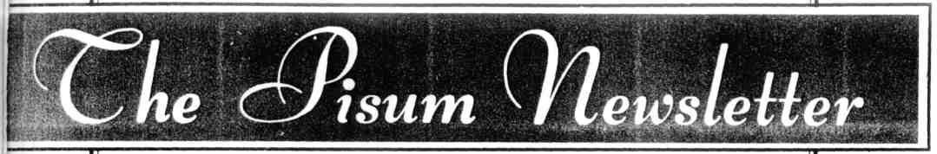
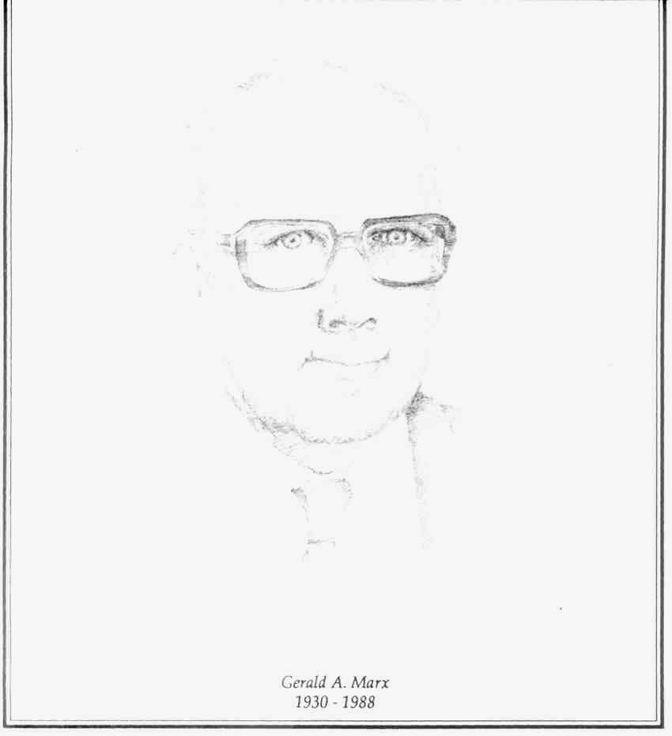
1989

DEPARTMENT OF HORTICULTURAL SCIENCES
The New York State Agricultural Experiment Station
COLLEGE OF AGRICULTURE AND LIFE SCIENCES
CORNELL UNIVERSITY

