PNL Volume 21 1989 RESEARCH REPORTS 75
A NEW GENE HETEROPHYLUS (het) ON CHROMOSOME 7
Swiecicki, W. K. Plant Breeding Station, Wiatrowo
62100 Wagrowiec, Poland
A mutant, with changed morphology of the stipules was induced after seed treatment of line Wt 3527 by a combined dose of 200 r NF + 0.014% NEU (1). The stipules are strongly reduced at the base of stem, narrowed and opened at middle order nodes and different in size at the top nodes (Fig. 1). The mutant line Wt 11291 was included in the Wiatrowo pea gene bank in 1981.
Locus identity tests were made with five other mutation cases of similar type and type lines for stipules reduced (Wt 10232, st), stipulae asymetricae (Wt 11072, stia) and stipula imminuata (Wt 11520, stim). The F1 results showed that the character described above in line Wt 11291 is controlled by a locus different from any of the other genes in the comparison. For these reasons the name heterophylus and the symbol het is proposed.
In linkage studies, the F2 population of cross Wt 11291 (het) x Wt 11744 (tl wsp r) was analyzed in the greenhouse in 1988. Undisturbed monohybrid segregation was shown for het and tl with significant deviations for wsp and r (Table 1A). The data in Table IB show significant deviations from independent assortment for gene pairs tl-r, het-r and het-tl but no deviations for gene pairs involving wsp. The recombination fractions (Table IB) suggest the following gene order:
1. Swiecicki, W.K. 1984. PNL 16:84-86.
Fig. 1. A new gene het.
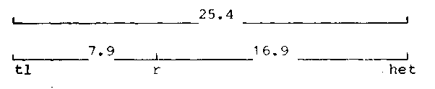
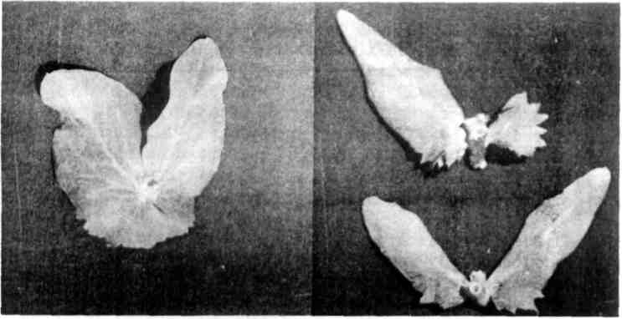

7(,
PNL Volume 21 1989 RESEARCH REPORTS

Table 1. Phenotypic distribution in an F2 population from a cross between Wt 11291 (heterophylus) and Wt 11744 (testerline).

A. Monohybrid F2 segregation
Phenotype |  |  |  |  | Total |  |  | Chi-square (3:1)
Het  154  Tl 173  Wsp  180  R  187 |  |  | het 61  tl 42  wsp  36  r 35 |  | 215 215 216 222 |  |  | 1.3  3.4  8.0  10.1
B. Joint segregation of Het with Tl, Wsp and R
Phenotype |  |  |  |  |  | Total | Joint  Chi-  square |  | Recomb. fract. | S. E. | Phase
Het Tl | Het tl | het Tl |  | het tl
115 | 39 | 58 |  | 3 |  | 215 | 11.8 |  | 25.4 | 6.3 | R
Met R | Het r | het R |  | het r
121 | 33 | 60 |  | 1 |  | 215 | 13.7 |  | 16.9 | 6.6 | R
Tl R | Tl r | tl R |  | tl r
169 | 4 | 12 |  | 30 |  | 215 | 113.9 |  | 7.9 | 1.9 | C
Het Wsp 129 | Het wsp 25 | het Wsp 50 |  | het wsp 11 |  | 215 | 0.2 |  | 51.8 | 5.0 | R
Tl Wsp 141 | Tl wsp 32 | tl Wsp 38 |  | tl wsp 4 |  | 215 | 1.9 |  | 60.7 | 5.7 | C
Wsp R 149 | Wsp r 31 | wsp R 33 |  | wsp r  3 |  | 216 | 2.2 |  | 61.6 | 5.7 | C
*****

