PNL Volume 21
1989
RESEARCH REPORTS
71

THE GENK lk (ERECTOIDES) ON CHROMOSOME 5
Swiecicki, W. K. Plant Breeding Station, Wiatrowo
62100 Wagrowiec, Poland
A number of dwarf and densinodosum mutants were isolated, selected and included in the Wiatrowo pea gene bank in 1981 (2). One of these mutants (Wt 10284), induced in Wt 3527 by 200 r Nf, was clearly different in phenotype from the others. Several crosses were made to observe the mode of inheritance and the expression on different genotypic backgrounds. Monogenic recessive inheritance was found, e.g. the F2 population of cross Wt 3527 x Wt 10284 contained 288 normal and 82 mutant plants (X² = 1.59), and the mutant had a pleiotropic effect on internodes, petioles, peduncles, leaves and pods (Fig. 1). Flowering time was also delayed by a minimum of 20 days in comparison to a standard line and difficulties were encountered in making crosses with the mutant. A number of selections were included in the Wiatrowo gene bank including line Wt 10011 which carries the gene af (afila).
Meanwhile Dr. Peter Matthews of the John Innes Institute sent line JI 1420 which has a similar phenotype to the Wiatrowo mutant and he suggested the name erectoides for the characteristic phenotype. The recessive gene responsible for the erectoides phenotype of JI 1420 was symbolized lk by Reid (1). He designated JI 1420 as the type line for lk and described for gene lk a number of pleiotropic effects similar to those described above for the mutant gene in Wiatrowo line Wt 10284. A locus identity test performed at Wiatrowo by crossing JI 1420 (lk) with Wt 10284 showed that the Wiatrowo mutant is allelic with lk since the F1 plants, sown in the 1988 field planting, all had an erectoides phenotype. Thus Wt 10284 will serve as a representative line for gene lk.
In mapping studies, the F2 generation of cross Wt 11238 (tester line) x Wt 10011 (lk) was analyzed. Linkage was not observed with gene markers from chromosome 1 (a d af i), 2 (k wb s), 3 (b) and 7 (tl r). Linkage was observed with three markers from chromosome 5; gp-lk (recomb. fract. 12.3, Table 1), cp-lk (recomb. fract. 28.4) and cp-gp (recomb. fract. 8.0). Gene cp is not a good marker and monohybrid segregation at the cp locus was strongly disturbed. These results suggest that lk is located on chromosome 5, probably in the gp-cri region. The lk gene, together with the author's genes nec, art-2, gn and lum-3, should be used to update the linkage map for chromosome 5 (3,4,5,6).

1. | Reid, J. B | . 1986 | Ann. | Bot. | 57:577-592.
2. | Swiecicki, | W. K. | 1984. | PNL | 16:84-86.
3. | Swiecicki, | W. K. | 1985. | Gen. | Pol. 26:351-359.
4. | Swiecicki, | W. K. | 1986. | Gen. | Pol. 27:73-80.
5. | Swiecicki, | W. K. | 1987. | PNL | 19:74-75.
6. | Swiecicki, | W. K. | 1988. | PNL | 20:36-37.

72
PNL Volume 21 1989 RESEARCH REPORTS

Table 1. Phenotypic distribution in an F₂ population from a cross between Wt 11238 (testerline) and Wt 10011 (erectoides).

A. Monohybrid F2 segregation  Phenotype Total  Gp. gp  319 107 426  Lk lk  355 87 442 |  |  |  |  | Chi-square (3:1) 0.00 6.66
B. Joint segregation of Lk with Gp  Phenotype Total |  |  |  |  | Joint Chi-square | Recomb. fract. | S.E. | Phase
Gp Lk 244 | Gp lk  73 | gp Lk 106 | gp lk 1 | 424 | 27.9 | 12.3 | 4.8 | R
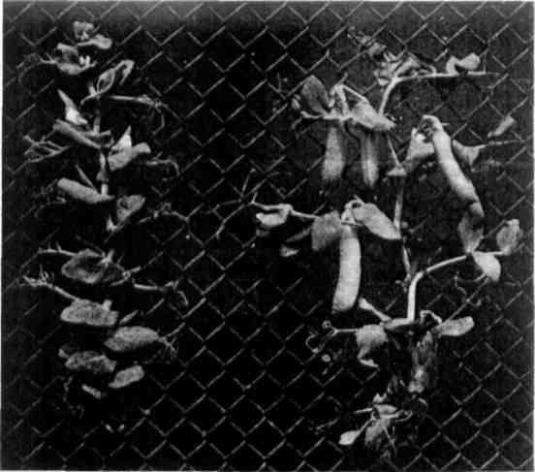
Fig. 1. Normal plant - right; lk (erectoides) mutant on an af (no leaflets) background - left.

