PNL Volume 21 1989 RESEARCH REPORTS
7

LIGHT/DARK CHANGES IN CQ₂ LEVELS IN THE POD SPACE OF GREEN, PURPLE AND YELLOW PODDED LINES OF PISUM SATIVUM L.
Donkin, Maria and Department: of Biological Sciences
David N. Price Plymouth Polytechnic, Plymouth, Devon, UK
Pea pods act as a protective envelope, producing a partially controlled microenvironment in which the seeds develop. One variable in this environment is CO₂ concentration, which in turn is affected by light flux, pod temperature and stage of development. Variations in C0₂ within the pod space could have physiological and metabolic implications for the seed and inner pod layers, particularly in relation to carbon economy. Even in a single line, cv. Greenfeast, C0₂ levels vary from about 0.15% in young pods in the light to over 1.5% in older pods in the dark (2). Given the considerable range of pod types, this variation is likely to be much greater in Pisum as a whole. We have extended the study of Flinn et al. (2) to include a limited varietal comparison, measuring fast light/dark changes at different stages of development in green, purple and yellow podded types.
Four lines were used in this study; JI 141 (green pods); JI 73 (yellow pods); JI 60[P] (purple pods) and JI 60[G] (green pods). JI 60[G] was formed by reversion of the purple line JI 60[P] and therefore these two lines are near-isogenic. Pod space C0₂ was measured using the Infra Red Gas Analyzer technique of Atkins and Pate (1) using a sample volume of 100 pi. Pods were illuminated for short term experiments with a Schott KL1500 lamp with two fibre optic probes. Changes in temperature inside the pod were checked during illumination with a thermocouple linked to an electronic thermometer and it was found that there was no significant difference in temperature change between the pod types.
The effect of short-time light on/off experiments is shown in Fig. 1 for the four pod types. The green and yellow pods exhibited a pattern characterized by a C0₂ decrease in the light followed by an increase in the dark. This pattern was repeatable for up to 3 cycles on a single pod. Stage 2 pods had generally lower C0₂ levels than stage 3 pods. Yellow and purple pods had higher C0₂ levels than either of the green pods. The purple pods appear to show the most aberrant behavior with an initial increase in C0₂ level in the light followed by a further increase in the dark period to a maximum of 3.0%. Responses to the light/dark switching were rapid; in green pods they occurred in as little as 2 minutes.
From the data shown here it would seem that ' the younger actively growing seeds (in stage 2 pods) are mainly exposed to lower levels of C0₂, particularly during very bright conditions. This has been confirmed by field measurements. The level in such pods may fall to 0.1-0.2% cW while older stage 3 pods could have a C0₂ level fluctuating around 0.7-1.0%. It has been shown that plants grown in C0₂ levels of 0.1-0 S% have decreased RUBPcarboxylase/oxygenase and glycolic acid oxidase activity (3) and this may have implications for pod photosynthetic and photorespiratory activity, especially in older stages.
The very high levels of C0₂ found in the purple pods, and the inability of these pods to reduce C0₂ levels in the light, may indicate a lower photosynthetic activity due to poor light penetration through the pod wall (personal observation). This seems to be reflected in the lower seed dry weight found for purple pods compared with a green podded variety in

8 . PNL Volume 21 1989 RESEARCH REPORTS
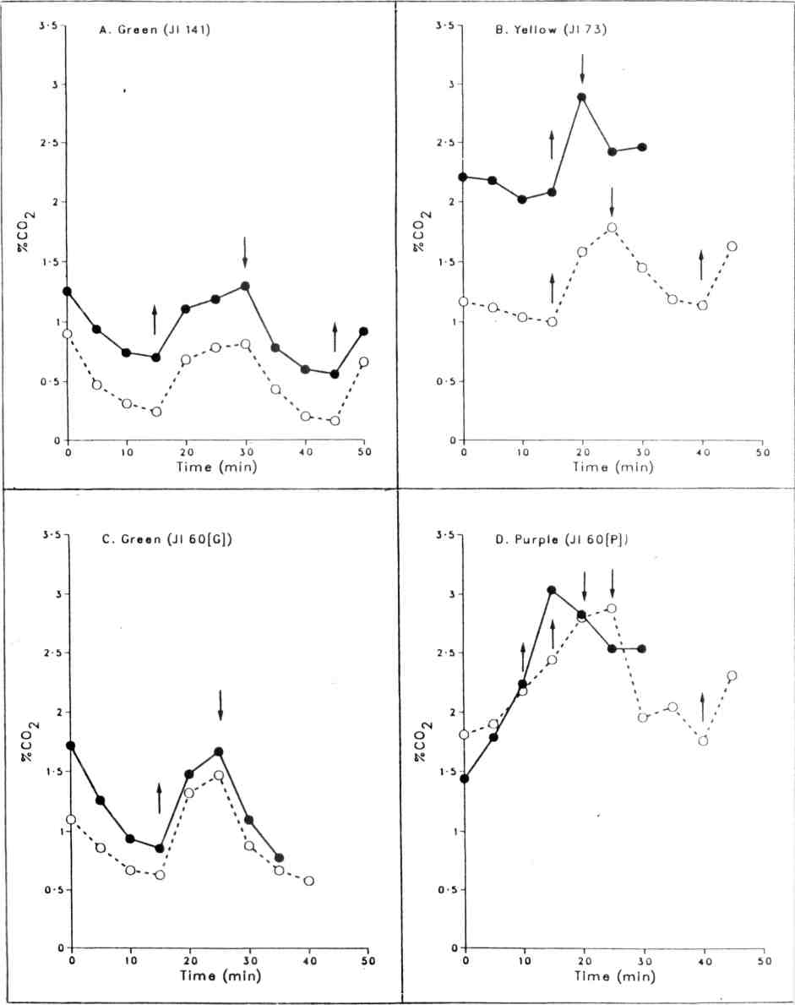
Fig. 1. C0₂ levels in the pod space of green (JI 141, JI 60[G]), yellow (JI 73) and purple (JI 60[P]) pods, during light and dark periods. Down arrows indicate light 0N and up arrows indicate light OFF. The light intensity during the light ON period was 1,146 mkmol m⁻² s⁻¹ at the pod surface. The solid line indicates stage 3 pods, which are approximately 18-20 d from anthesis, and the dashed line indicates stage 2 pods, 12-16 d from anthesis.

PNL Volume 21 1989 RESEARCH REPORTS
9

field studies (unpublished observations). An interesting feature of the JI 73 yellow pods was the large difference in CO₂ levels and CO₂-reducing ability between younger and older pods. This may simply reflect the higher respiratory activity of their seeds in relation to pod size, since JI 73 has very little pod space left at stage 3. The lack of chlorophyll in the mesocarp does not appear to be detrimental for the younger pods and may in fact improve photosynthetic rate due to the increased light reaching the cells of the endocarp.
- Atkins, C.A. and J.S. Pate. 1977. Photosynthetica 11:214-216.
- Flinn, A.M., C.A. Atkins and J.S. Pate. 1977. Plant Physiol. 60:412-418.
- Hicklenton, P.R. and P.A. Jolliffe. 1980. Can. J. Bot. 58: 21 81-2189.
*****

