PNL Volume 21 1989 RESEARCH REPORTS 63
NEW GENES LINKED TO R AND Tl IN PEA: HI STONE HI SLOW FRACTION AND SEED ALBUMIN K9 GENES
Smirnova, O.G., S. M. Rozov, and V. A. Berdnikov
Institute of Cytology and Genetics, Academy of Sciences of the USSR
Siberian Division, Novosibirsk, USSR
Seed proteins are convenient genetic markers. The use of traditional methods of salt extraction followed by sodium dodecylsulphate electrophoresis gave an opportunity to observe already well studied storage proteins vicilin and legumin. Perchloric acid extraction and acetic acid-urea electrophoresis (1) enabled us to study a new group of poorly examined proteins. The major component of a perchloric extract is a protein named by us K9 (it contains nine lysine residues). Protein K9 represents 1% of the total pea seed proteins and has a molecular weight of about 10,000.
Our studies show that K9 has two molecular forms. A fast electropho-retic variant was found only in the wild peas subspecies syriacum and elatius. To map the gene coding for the K9 protein (gene Sa-K9) we crossed line WIR 2524 (ssp. elatius) with the tester-line NGB 1238. An analysis of F₂ progeny (n=115) has shown that the slow and fast K9 molecular variants (K9S and K9F) are coded by codominanl allelic genes. The Sa-K9 gene is located 13.5 ± 2.6 map units from gene tl and 16.5 ± 2.4 map units from gene r.
It was reported earlier that the gene encoding the pea HI histone slowest fraction (His-1) is located near gene r (2). Using the Sa-K9 gene as an additional marker, we investigated the location ol the His-1 gene in relation to the r-tl segment of chromosome in the cross 'Sprint' (alleles R, Tl, His-lS, Sa-K9F) and tester-line NGB 1018 (alleles _r, _tl, His-lT. Sa-K9S). Electrophoretic patterns of K9 and His-1 proteins are shown in Fig. 1. Segregation of analyzed genes in F₂ plants is represented in Table 1. Heterozygous phenotype Tl/tl^{w} was determined as flat tendrils, heterozygotes Rr were revealed from the seed F3 analysis.
- Berdnikov, V.A., and F. L. Gorei. 1975. Molekularnaja Biologija. 9:699-705 (in Russian).
- Rozov, S. M., V. S. Bogdanova, and V. A. Berdnikov. 1986. Genetika (USSR) 8:2159-2166.
                - 64 PNL Volume 21 1989 RESEARCH REPORTS
Table 1. Phenotypic distribution of F'2 plants segregating for genes R_, JJ_, His-I , and Sa~K9 from cross Sprint x NGB 1018 (n=98).
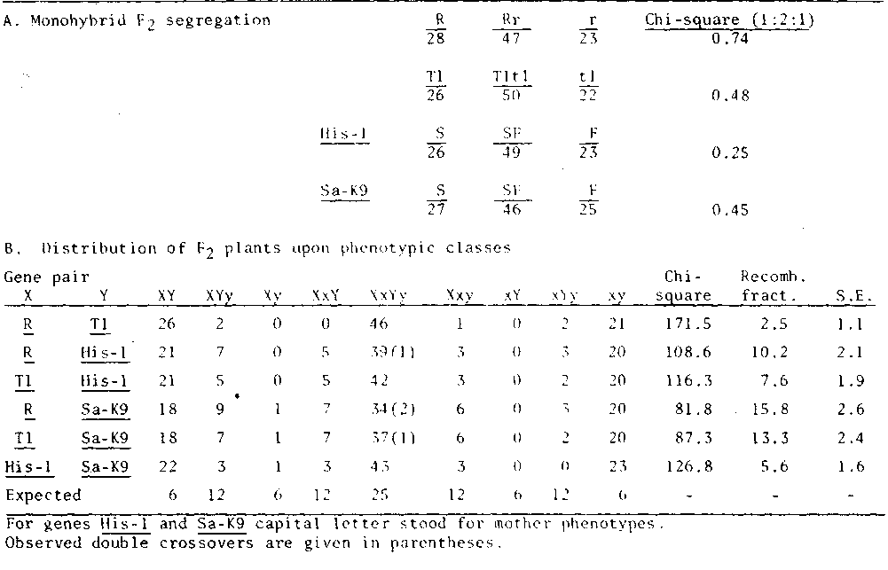
PNL Volume 21 1989 RESEARCH REPORTS 65
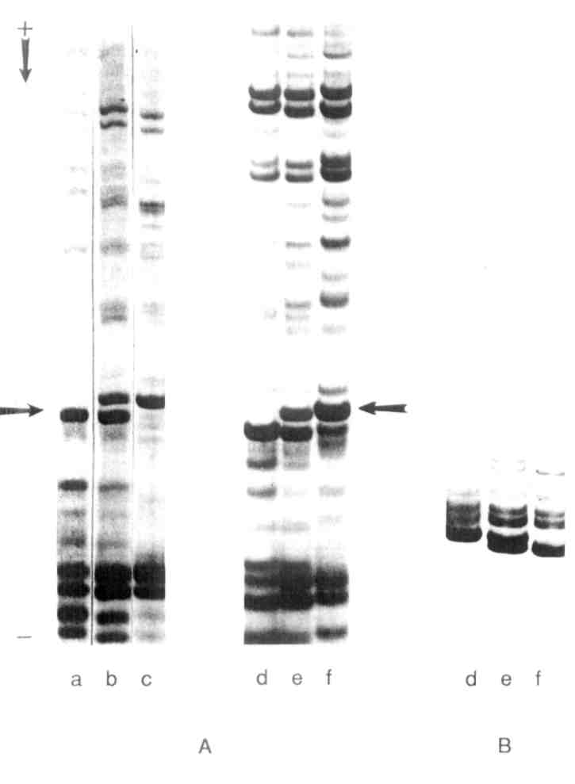
Fig. 1. Acetic acid-urea electrophoretic patterns of pea seed perchloric extracted proteins and pea H1 histone.
A. Seed proteins, arrow indicates K9
B. T3C fragments of HI histone
a) WIR 2524; b) F1 WIR 2524 x NGB 1238; c) NGB 1238; d) Sprint; e) F1 Sprint x NGB 1018; f) NGB 1018
*****

