PNL Volume 21 1989 RESEARCH REPORTS
57

LEAF ABERRATIONS - AN EFFECTIVE SCREENING TECHNIQUE FOR MICROMUTATIONS IN PEAS
Singh, N.P. and B. Sharma Division of Genetics
Indian Agric. Res. Institute, New Delhi, India
Since all the seeds exposed to mutagenic treatments do not have equal genetic damage, it could be of great help if plants with more mutagenic damage are identified in the M-j generation itself. This would facilitate recovery of a high frequency of mutations in the succeeding generations.
The phenomenon of leaf aberrations (a-sectors, 2) due to mutagenic treatment was first reported in peas as early as 1925 (1 ) and it was demonstrated subsequently in a wide variety of crop plants. It was also established by several studies that the degree of leaf aberrations in M1 is strongly correlated with the frequency of macromutations in M2 generation. M1 sterility has also been used as an index of mutagenic damage. Although a positive correlation between leaf aberrations, M1 sterility and M2
macromutation frequency is well established, such a relationship has not been demonstrated for the more complex micromutations.
In the experiment reported here leaf aberrations and sterility were used as screening criteria. Seeds of pea variety DMR-3 were treated with gamma-rays, ethylene imine (EI) and N-nitroso ethyl urea (NEU). The entire M1 population was divided into four groups on the basis of leaf aberrations at seedling stage and again on the basis of sterility at the adult plant stage: low degree of leaf aberrations + low sterility (LL), high degree of leaf aberrations + low sterility (HL), low degree of leaf aberrations + high sterility (LH), and high degree of leaf aberrations + high sterility (HH). Single plant progenies were grown in separate rows in the M2 generation, and observations were recorded for both macromutations (chlorophyll + morphological) and micromutations (five polygenic traits, namely, days to flowering, pods/plant, seeds/pod, 100-seed weight and yield/plant). The promising mutagenized progenies were identified on the basis of higher mean and CV (variability) than the progeny having the highest mean and CV in the control (untreated) population. In the M3 generation, the character mean was used as the criterion for selection of promising progenies, since intra-family variance is expected to be reduced in this generation.
Table 1 shows that the CV values in M2 were highest in the HH group and lowest in the LL group of mutagenic damage. The HL and LH groups were intermediate. This trend was constant for all the five polygenic characters studied and was also confirmed in the M3 generation where only the HH and LL groups were studied more intensively. The comparison of CV values between HL and LH groups in M2 revealed a very interesting picture: the CV values in HL group were higher than in LH group for all the five polygenic traits (Table 1). This suggests that leaf aberrations are a better index of mutagenic damage than sterility. Further, since the CV in the LH group was also significantly higher than in the LL group, the sterility parameter serves as a reliable additional criterion for classifying the mutagenized material further on the basis of genetic damage.
The analysis of macromutations in the M2 generation also revealed a similar pattern as for micromutations (Fig. 1). The groups of mutagenic damage were arranged in the following order on the basis of frequency of macromutations: HH > HL > LH > LL.

58 PNL Volume 21 1989 RESEARCH REPORTS
Thus the grouping of M1 plants on the basis of M1 damage (leaf
aberrations and sterility) can be of great help in identifying plants with
maximum mutagenic damage which are likely to yield a higher frequency of
mutations in the M2 and M3 generations. This helps to reduce the volume
of unwanted (nonmutated or poorly mutated) material, thereby saving time and labor in the isolation of mutations.
- Arntzen, L. and C. Krebs. 1925. Acta Radiol. 4: 5-31.
- Blixt, S. 1965. Agri Hort. Genet. 23: 172-186.
TabLe 1. Effect of grouping on the basis of mutagenic damage in M-| on the magnitude of induced variability (CV%) and means for various characters in M2 and M3 generations.

Character | M2 generation, groups |  |  |  |  |  |  |  | M3 generation, groups
Character | LL |  | HL |  | LH |  | HH |  | LL |  | HH
Character | CV | Mean | CV | Mean | CV | Mean | CV | Mean | CV | Mean | CV | Mean
Days to flowering | 7.3 | 75.1 | 8.1 | 75.5 | 7.7 | 74.9 | 8.6 | 75.8 | 7.7 | 74.3 | 8.7 | 75.3
Pods/plant | 29.1 | 17.0 | 34.2 | 18.0 | 31.3 | 17.2 | 37.7 | 18.8 | 34.7 | 7.1 | 39. 3 | 7. 7
Seeds/pod | 22.0 | .3.5 | 23.6 | 3.7 | 22.6 | 3.6 | 25.4 | 3.8 | 24.3 | 3.3 | 26.3 | 3.5
100-seed weight | 14.3 | 16.8 | 16.4 | 16.9 | 15.6 | 16.8 | 17.5 | 17. 1 | 15.4 | 16.7 | 17.2 | 1 7.0
Seed yield/plant | 36.7 | 7.3 | 38.9 | 7.6 | 37.1 | 7.1 | 40.9 | 8.4 | 38.0 | 3.9 | 41 .2 | 4.2
Note: The groups of mutagenic damage (LL, HL, LH and HH) were assigned on the basis of low or high degree of a-sectors and high or low degree of induced sterility in M1 .
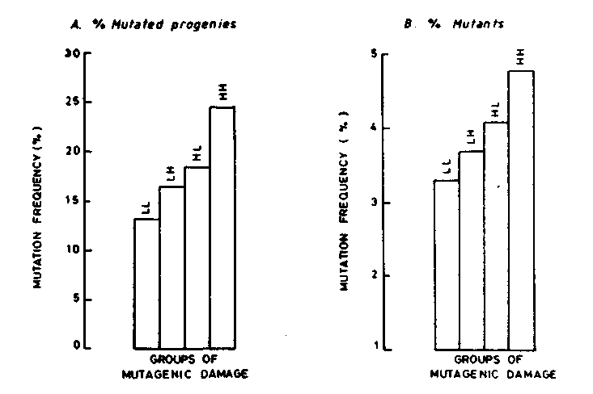
Fig. 1. Total mutation frequency in different groups of mutagenic damage. Mutagenic damage group: LL = Low seedling damage + Low sterility
HL = High seedling damage + Low sterility LH = Low seedling damage + High sterility HH = High seedling damage + High sterility
*****

