52
PNL Volume 21 1989 RESEARCH REPORTS

SURFACE SPREAD SYNAPTONEMAL COMPLEXES IN PISUM SATIVUM
Scheumann, Karin and Institute of Genetics, University of Bonn
Gisela Wolf D-5300 Bonn 1, West Germany
Surface spreading of meiocytes was first applied on animal cells (2,3). A similar method was developed for plant cells (maize) by Gillies (4). Using this method early meiotic prophase configurations (e.g. pachytene) can be analyzed in a way not possible by means of conventional methods unless by the use of electron microscopy and serial sections. Application of the present method destroys the chromatin leaving for observation only the elements of the synaptonemal complex. This structure is composed mainly of proteins (see 5) having a special affinity for silver. After staining with AgN0₃ the distribution of the silvergrains marks the structure of interest.
Investigations were carried out on pollen mother cells of Pisum sativum cv. Dippes Gelbe Viktoria. The spreading and staining technique for the light microscope as well as for the electron microscope was done according to Albini and Jones (1) as modified by Loidl (6) and Loidl and Jones (7).
Fig. 1 shows part of a surface spread zygotene nucleus. Chromatin is not visible, but two parallel elements of the synaptonemal complex are marked by the accumulation of the silver grains. The enlargement of the pairing structure (Fig. 2) shows that it in fact consists of only two elements, namely the lateral elements, while the central element as well as the transverse elements are missing. As there is no reason to presume that the synaptonemal complexes of Pisum sativum differ from the general scheme, we assume that the central elements and the transverse elements, though present, do not react with the AgN0₃ under the applied conditions. Therefore we conclude that the proteins of the lateral elements and the central elements have a different amino acid composition. The distance between the lateral elements measures about 110 nm. This is in full agreement with data given for other objects.
Fig. 3 shows a mid-leptotene stage in which the axial elements are formed, yet apparently not in toto but in small pieces, visible as interrupted lineages. Pairing starts when the axial elements are completed, with alignment beginning distally (Fig. 4). The more terminal regions are closely related, while the proximal ones are not. Loops are visible at the very ends in some bivalents, yet not in all bivalents at the same time. The meaning of these loops is unknown.
Fig. 5 shows a pachytene stage in which the bivalents are mostly aligned. Interestingly, no cells were found in which all bivalents were completely aligned; in each nucleus some unpaired regions were present.
- Albini, S.M. and G.H. Jones. 1984. Exp. Cell Res. 155:588-592.
- Counce, S.J. and G.F. Meyer. 1973. Chromosoma 44:231-251.
- Dresser, M.E. and M.J. Moses. 1980. Chromosoma 76:1-22.
- Gillies, C.B. 1981. Chromosoma 83:575-591.
- Gillies, C.B. 1984. Critical Reviews in Plant Science 2:81-116.
- Loidl, J. 1986. Can. J. Genet. Cytol. 28:754-761.
- Loidl, J. and G.H. Jones. 1986. Chromosoma 43:420-428.

                - PNL Volume 21 1989 RESEARCH REPORTS
53

Fig. 1. Electron micrograph (x 7500): part of a spread nucleus of Pisum sativum in zygotene. AgNo₃ staining.
Fig. 2. Electron micrograph (x 35000): telomere of a Pisum bivalent. AgNO₃ staining.
Fig. 3. Leptotene stage of Pisum meiocytes: forming of the axial elements. Spread nuclei after AgN0₃ staining.
Fig. 4. Zygotene stage of Pisum meiocytes: pairing of homologues. Spread nuclei after AgN0₃ staining.
Fig. 5. Pachytene stage of Pisum meiocytes. Spread nuclei after AgNO₃ staining.

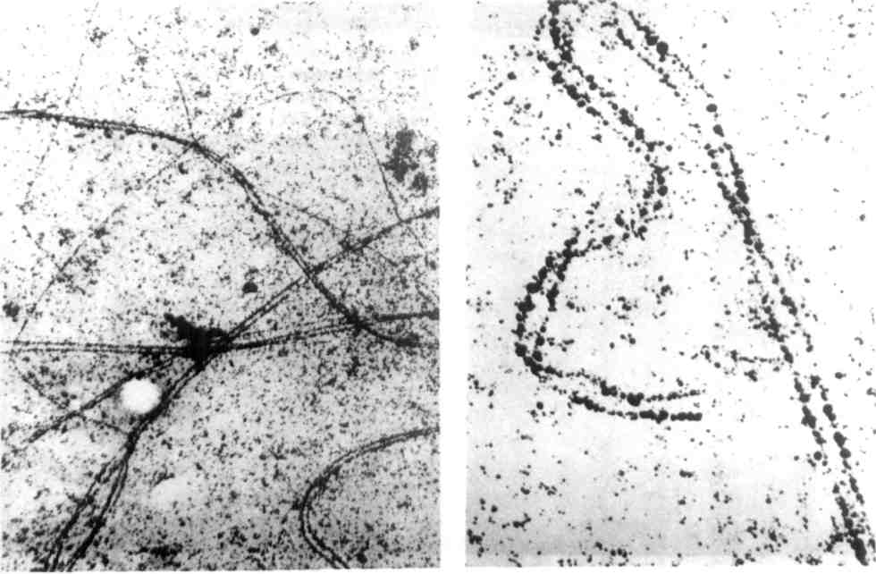

Fig. 1

Fig. 2

54
PNL Volume 21 1989 RESEARCH REPORTS

Fig. 3
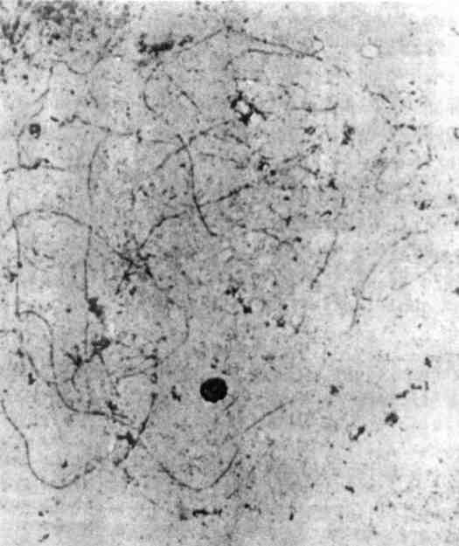
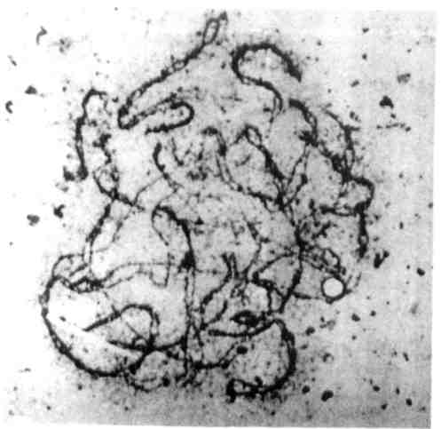

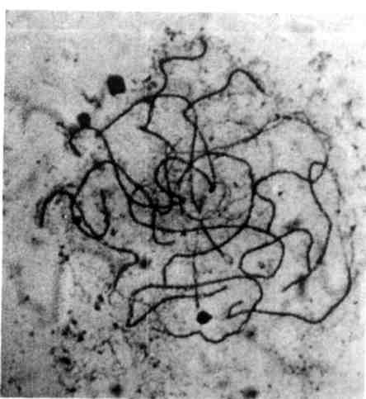

Fig. 4

Fig. 5

*****

